
Y4

Access all areas • Lesson 1 • Portable packages
Lesson 1
Launch
To read the most recent version of this lesson, download associated resources, and view embedded professional learning including classroom videos and work samples, visit: https://primaryconnections.org.au/teaching-sequences/year-4/access-all-areas/lesson-1-portable-packages

Lesson overview
Students connect to the content and context of the sequence by transporting a package, which must always stay in contact with the ground, across different surfaces. They describe how the object moved and record their observations using prior knowledge about forces.

Key learning goals
Students will:
- identify and describe their current thinking about forces and motion.
- observe the effects that different surfaces and terrains have on the movement of an object.
Students will represent their understanding as they:
- contribute to class discussions.
- record their observations in a table.

Assessment advice
In the Launch phase, assessment is diagnostic.
Take note of:
- the vocabulary students use to describe how things move.
- students’ understanding of how pushes and pulls affect an object’s motion and shape, including any ideas about the strength and direction of these forces.
- students’ life experiences as they relate to forces, movement and accessibility.

List of materials
Whole class
- Class science journal (digital or hard-copy)
- Optional: Materials to make a word wall or glossary
- Materials to make a TWLH chart
- Demonstration copy of the Moving around Resource sheet
Each group
- 1 x box. Each group may have a different sized/shaped box, made of a range of materials.
- String or rope to connect to the box, to enable it to be pulled
- Item/s to place inside the box. Have a variety of items available to select from, such as items that are large/heavy/delicate.
- Optional: Digital device to take photograph or record video
Each student
- Individual science journal (digital or hard-copy)

Lesson routine | Estimated time | Task type
Experience & empathise and Elicit | 20 minutes | Whole class/Small group
Anchor and Elicit | 20 minutes | Whole class
Connect | 20 minutes | Whole class

Launch

Experience & empathise and Elicit • How does it slide?
In teams, students will undertake a walk around the school, moving a package across different terrains.

Before the walk
Explain to students that they are going to be responsible for taking a package for a ‘walk’ around the school without lifting it—the package must always remain in contact with the ground.
Look at the assortment of boxes that teams will be using as their package and brainstorm/describe the types of items that could go into it. For example, books might be heavy, something glass (such as a vase) might be fragile, or a pot plant might need to stay upright to avoid spilling the soil.
Next ask students for suggestions about how they might be able to move the package while keeping contact with the ground. If necessary, show students the rope/string they will connect to the package in order to facilitate its movement. Ask students to identify the type of movement they will need to move the packages—either pulling the package using the attached string/rope or pushing it with their hands, prompting them to distinguish between and define a push and pull movement as required.
Discuss what students might have to take into account when moving the package, depending on the type of box and the contents they select. For example, if the contents are fragile, what might happen if they move the package across a very bumpy surface? Or, if it is heavy, what might happen if they attempt to pull it up a steep hill?
In teams, provide time for students to select a box, its contents, and attach a string or rope to it in a manner they deem secure. Monitor this to ensure that students do not put anything too heavy in their boxes, and that the string is strong enough not to break.
Map out a route through the school grounds so that the package travels across as many different terrains as possible, such as up and down slopes, ramps and stairs, across grass, sand, dirt, rocks or uneven areas, carpet, floorboards, or around corners, bends, high traffic areas etc.
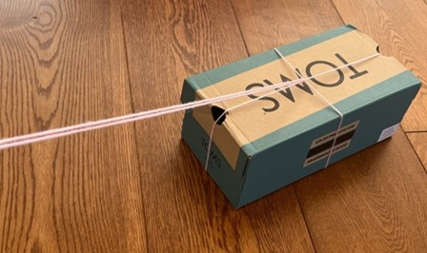

During the walk
Teams undertake their walk, stopping periodically to observe and record the movement of the object on different surfaces and terrains. They might make these observations as notes and diagrams in the science journals, or by taking photos and videos.
Provide the level of supervision on this walk that is required by your students and school environment.
Remind students that they are taking their boxes for a walk around the school, and that moving in another way, like running, will affect the validity of their scientific observations and ability to fairly and accurately compare their experiences to others.
If you have students in your class who use mobility aids, they can make observations about how different surfaces/terrains affect the use of these aids.

After the walk
Upon completing the walk, allow students the opportunity to assess their box and its contents for any damage and record their observations.
Teams share their experiences and reasoning with the class.

Potential discussion prompts
- Was there a connection between the box you selected and the contents you selected? If so, what was it?
- Was there a connection between the package and the way you attached the string/rope? If so, what was it?
- What experiences did you have as you pulled your package across the different terrains? Were some terrains easier/harder than others? Why do you think that was?
- What condition was your package in when the walk was finished? Was there any damage?
- When is it important for an object to move or not move easily?

Anchor and Elicit • How do things move?
Construct and record a shared definition of the terms ‘push’ and ‘pull’ in the class science journal. Refer to the following definitions as required:
- A push: applying a force away from you or in a direction that moves something away.
- A pull: applying a force toward you or in a direction that draws something closer.
Introduce the term ‘force’ if required: a push or a pull between objects that changes their speed, direction, or shape.
Optional: Record these words for the class word wall or glossary.
Demonstrate, or have students enact, some simple push or pull interactions between objects, predicting what they think will happen, and then describing what happens and comparing it to predictions.

Potential discussion prompts
- What will happen when a rolling ball hits an obstacle such as wall?
- If I’m pulling an object towards me, how do I stop it moving? What about an object moving away from me, how does it stop?
- Is it easier to push or pull objects across certain surfaces? What evidence can you draw from our package-moving task to support your ideas?
- If I try to slide, in socks, across a wood floor or carpet, on which surface will I travel further and why?
Support students to expand their push and pull definitions to state explicitly that for an object to move, speed up, slow down, change direction or change shape, a stronger/larger push or pull force from another object must be involved.
Ask the students if they can identify any of the forces acting on their packages as they moved them around the school. You might do this through discussion, drawing a shared diagram of a package in the class science journal, and labelling it, or students might draw individual labelled diagrams in their science journals.
Note: At this point, students may begin to talk about gravity “keeping the object on the ground”, or the force of friction making the box more difficult to pull/slowing it down on certain surfaces. This is not essential knowledge at this point, as it has not appeared yet in the curriculum, but it is worth taking note if students mention these ideas. These terms should not be introduced if students do not offer them.
Explain that over the course of this sequence, we are going to attempt to answer questions about how things move through a series of investigations and observations.
Record what students Think they know and what they Want to know about forces etc. in the T and W sections of a class TWLH chart.

Connect • Local accessibility
As part of your preparation for this sequence, you may have selected a specific local area for students to focus on during the Act phase, where they will design an accessibility solution that provides easy access for people and/or objects across a specific terrain. See the Preparing for this sequence tab in the sequence overview for more details.
Introduce this context now through the following discussion.
Use the Moving around Resource sheet to facilitate a discussion with students about their experiences with forces, to introduce and elicit their thinking about new contexts that link to the Act phase. This resource sheet can be modified to suit your students and context. See the embedded professional learning Adapting to your context for further details on the changes you might make.
As you look at each image, make observations about what students notice and the differences between the two images, where needed:
- An empty shopping trolley and a full one, with the prompt Which would you rather push in a trolley race and why?
- A beach, where dry soft sand, wet sand and breaking waves can all be seen, with the prompt Which would be the easiest part of this beach to walk/run on and why?
- A dry field and a muddy field, with the prompt Which ground surface would it be easier to play soccer on and why?
- A concrete path surrounded by grass, with the prompt On which surface would it be easier to roll a scooter or wheelchair, or push a pram? Why?
Identify for/with students (as is appropriate for your context) what accessibility challenges exist for people in the world. For example:
- some people use wheelchairs or scooters permanently or semi-permanently.
- people with prams can find it challenging to get around.
- people with injuries might use crutches or knee scooters to keep weight off an injured leg.
- older people sometimes can’t move as quickly and easily as other people, or use walking frames for support.
Pose the questions:
- Why is it more challenging for some people to access beautiful landscapes of Australia (and the world more broadly) than others?
- How can weather make accessibility more challenging?
Ask students to identify features in the school that might make it easier for people with accessibility challenges to move around the school.
Next, discuss the broader local community and its accessibility features. Ask students to think about a friend or family member who might find outdoor areas less accessible.
If relevant, introduce the place/s in the school or local area that you have selected for students to focus their accessibility solution designs for, and identify the potential problems with accessing that place, particularly in different weather conditions.
If you are allowing students to select their own location, identify locations that people might have difficulty accessing, and explore why they might have those difficulties.
Explain to students that during the sequence, they will be learning about forces so that they might design an accessibility solution that would make it easier for people—perhaps their family member or friend—to access that place.
Describe how students will need to draw on their scientific knowledge in other areas, considering such things as the materials objects are made from, any animal or plant habitats present in the area, and what the terrain itself is like.
Record any of the students’ initial ideas of people who might like to access the identified location, and what their accessibility issue might be. For example:
- a person in a wheelchair accessing the shoreline at the beach.
- a mother with a pram who has to travel through a park after it has been raining heavily.
- an older person who wants to access their grandchildren's tree-house for an afternoon tea party.

Reflect on the lesson
You might:
- begin a class word wall or glossary related to forces and motion.
- add further questions to the TWLH chart.
- make note of any questions students have about the design challenge.

Y4

Access all areas • Lesson 2 • Feeling friction
Lesson 2
Inquire
To read the most recent version of this lesson, download associated resources, and view embedded professional learning including classroom videos and work samples, visit: https://primaryconnections.org.au/teaching-sequences/year-4/access-all-areas/lesson-2-feeling-friction

Lesson overview
Students explore friction by investigating the amount of force required to pull a shoe across a surface.

Key learning goals
Students will:
- observe how different materials and surfaces impact on friction.
- explore what ‘more’ or ‘less’ friction feels like.
- use arrows to represent forces.
Students will represent their understanding as they:
- use oral, written and visual language (force diagrams) to describe observations of how an object moves across different surfaces.
- carry out investigations about frictional forces between different shoes and surfaces.
- interpret and communicate their findings to describe ways to reduce and increase friction.

Assessment advice
In this lesson, assessment is formative.
Feedback might focus on:
- the accuracy of students’ observations and/or measurements when exploring the friction generated by pulling objects along surfaces.
- how students use evidence to support their claims. Does their evidence confirm the claim they have made?

List of materials
Whole class
- Class science journal (digital or hard-copy)
- A range of shoes (or students’ own)
- Demonstration copy of the Which shoes to choose? Resource sheet
- Demonstration copy of the Variables grid Resource sheet
- Optional: Demonstration copy of the Shoe grip investigation planner Resource sheet
- Demonstration copy of the Force diagram Resource sheet

Each group
- A way to feel or measure the force of friction. The lesson uses the following options:
- LOW TECH: An elastic band or similar, such as an exercise resistance band
- HIGH TECH 1: A push and pull spring meter
- HIGH TECH 2: A Newton meter
- Optional: A mass (e.g. 100g) to put inside the shoes
Each student
- Individual science journal (digital or hard-copy)
- Shoe grip investigation planner Resource sheet
  - If students use the low-tech option described above to measure force, they will need pages 1-3 of this resource sheet.
  - If students use one of the high-tech options described above to measure force, they will need pages 1 and 4-5 of this resource sheet.

Lesson routine | Estimated time | Task type
Re-orient | 10 minutes | Whole class
Question | 15 minutes | Whole class
Investigate | 30 minutes | Small group/Whole class
Integrate | 25 minutes | Small group/Whole class

Inquire

Re-orient
Recall the previous lesson—first revising the definitions of ‘push’, ‘pull’ and ‘force’, then focusing on students’ experiences pulling their packages across different surfaces and different terrains.

Potential discussion prompts
- Which surfaces were easiest to push/pull the package across? Why do you think this was?
- Which surfaces made it harder to pull/push the package? Why do you think this was?
- What might have been happened if you tried to move the contents of the package, without the box?
- What if the box had been made of a material other than cardboard (or plastic, if applicable)? How easy or difficult would these materials be to drag?

Question • In their shoes
Using the Which shoes to choose? Resource sheet, discuss the different types and uses of shoes, with a focus specifically on the design and material of the soles. This resource sheet contains images of a wide variety of shoes including running shoes, soccer/football boots, gumboots, work boots, ballet shoes, thongs and dress shoes. Discuss as many or as few as is relevant for your students and context, and add other examples as required. If possible, having physical examples of different types of shoes for students to examine in person is best.

Potential discussion prompts
- What type of shoe is this?
- What is it used for?
- What types of surfaces/environments is it used on/in?
- What material is it made of?
- Is the sole made of the same material as the rest of the shoe?
- What is the design of the sole like? Does it have any special features or patterns?
- Why do you think the shoe is designed this way?
Explain that students are going to investigate how well different materials grip on different surfaces, by testing how easily it is to drag shoes with different types of soles across different surfaces.
Pose the question: Do some materials grip better on different surfaces?

Investigate • Getting grippy
Ask students to pull a shoe across the carpet. They can use either their own shoe (after removing it) or a demonstration shoe.
Note: Not all students will feel comfortable removing their shoes in the classroom. Alternatives should be offered, such as using spare ‘demonstration’ shoes or having materials available to mimic the soles of a shoe.
After all students have had a go observing how easy or difficult it is to pull a shoe across carpet, use the think-pair-share strategy to brainstorm variables that might change the amount of force required to pull the shoe.
Record these variables using the demonstration copy of the Variables grid Resource sheet, marking the measurable variable—the force required to pull a shoe across a surface—in the centre of the grid with a bold M, and recording the other variables around it. You can add or remove columns/rows as required. Some examples you might provide as prompts include the size of the shoe, mass inside the shoe, pattern of the sole, material of sole, type of surface, gradient/slope of surface.
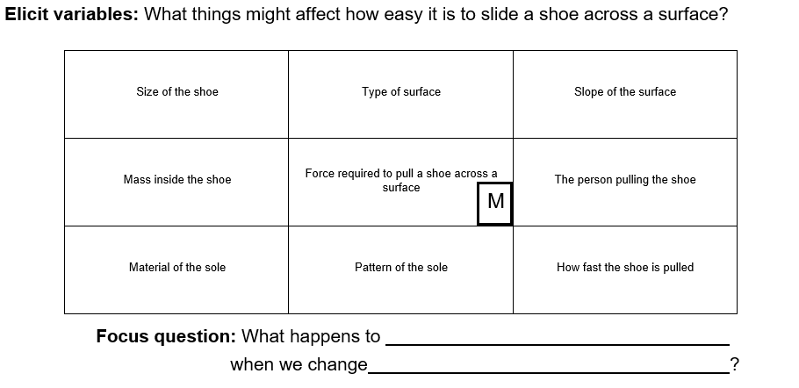 Determine which variable the students will test and write an investigable question using the question stem on the Variable grid Resource sheet. The students’ level of experience with planning and carrying out fair-test investigations will determine if all teams conduct the same investigation, or if they select their own variable to change.
The investigable question might read: What happens to the force required to pull a shoe across a surface when we change [the type of shoe sole, the mass inside the shoe, the slope of the surface etc.]?
Students work in collaborative teams to plan their investigation using page 1 of the Shoe grip investigation planner Resource sheet, including drawing a picture of their plan.
Pose the question: How can we show the type of force that we are using in this experiment?
Two options have been provided for students to measure and record their results. Use only the pages that are relevant for your students and context:
- LOW TECH OPTION: Teams use pages 2-3 to record their experiential observations about the force required to pull the shoe with an elastic band attached to the shoelace, strap, or heel as relevant. These pages include a Predict, Reason, Observe, Explain template, a section to draw a labelled diagram of what they think is happening, and a prompt to make a claim to answer the investigable question.
- HIGH TECH OPTION: Teams use pages 4 and 5 to record the measurement of force (in Newtons) as they pull a shoe across a surface, as shown on a push and pull balance scale or a Newton meter when attached to the shoe. These pages include a data table for recording quantitative data, a column graph to represent that data, a section to draw a labelled diagram of what they think is happening, and a prompt to make a claim to answer the investigable question. Students should take their readings as soon as the shoe begins to move.

Integrate • The force of friction
In this Integrate step, guide students to link their experiences in the investigation to the science concept being explored—in this instance, the force of friction.
Through questioning and discussion, students should come to a consensus that:
- friction is a force that opposes objects sliding or rolling over one another.
- friction makes objects harder to slide or roll, or makes them slow or stop.
- different materials generate varying degrees of friction. This is because surfaces that are rough and uneven have more bumps to ‘catch’ on each other.
- to overcome friction, we must apply a greater push/pull force.
- the direction of a force is represented with arrows that point in the direction that the force is pushing or pulling. These are called force arrow diagrams.
Teams share their investigation data with the class.

Potential discussion prompts
The following questions pertain to an investigation where students pulled the same shoe across different types of surfaces. These questions can be easily adapted to suit different investigations, such as different shoes pulled across the same surface or the same shoe pulled up/down a ramp of varying slopes.
- How would you describe the surfaces you investigated—both the sole of the shoe and the surfaces you pulled the shoe across? Were they smooth, bumpy, gritty, shiny etc.?
- Which surface was it easiest to pull the shoe across? How do you know?
- Did the rubber band stretch more or less when the shoe was harder to pull? Alternatively, did the push-pull spring balance/ Newton meter reach a higher or lower number when the shoe was harder to pull?
- Did you identify any patterns?
  - For example, smoother surfaces were easier to pull the shoe over, or rubber soles were harder to pull than plastic ones.
- What claim did you make to answer your investigable question?
- How did your evidence support your claim?
- Students undertake a gallery walk to examine each other's labelled diagrams of a shoe being pulled across a surface. Ask them to make note of any features of the diagrams they found especially helpful, ones they used themselves, or ones they would like to add to their own diagrams.
Use the huddle method to focus on teams’ work during the gallery walk, drawing attention specifically to the use of arrows to represent pull forces.

Potential discussion prompts
- What features of others’ diagram did you notice that you thought were helpful in explaining what happened?
- Did you notice anyone using arrows to show how the shoe was moving?
- What forces were they showing, a push or a pull?
- If you were to push the shoe, would the arrow face the same direction? Why/why not?
- Were the arrows the same size? Do you think the size of the arrow might mean something specific in a scientific diagram?
  - The direction of the arrow shows the direction of the force, and the length of the arrow identifies the strength of the force.
- Did anyone else use arrows in a different way?
  - Students may have drawn arrows to show the opposing force of friction pushing back in the opposite direction than the shoe being pulled. If so, this is a great opportunity to introduce and discuss friction. If not, the following section suggests how this might be introduced to the students in context.
Explain that, in science, forces are represented with arrows, with the arrow heads always showing the direction of the push or pull.
Introduce the word ‘friction’ and ask students what, if anything, they think they know about it. Record their ideas in the relevant column of the TWLH chart.
Display a diagram showing opposing forces of a push or pull and friction. You may create your own diagram based on the example below or display the example using the Force diagram Resource sheet.
Ask students which arrow they would identify as the pulling force, and label the diagram as such. In the given example, below the pulling force would occur when the shoe is pulled across the grass.
Identify and label the other arrow as the force of friction, pushing back against the shoe/foot, making it more difficult to slide along the grass.
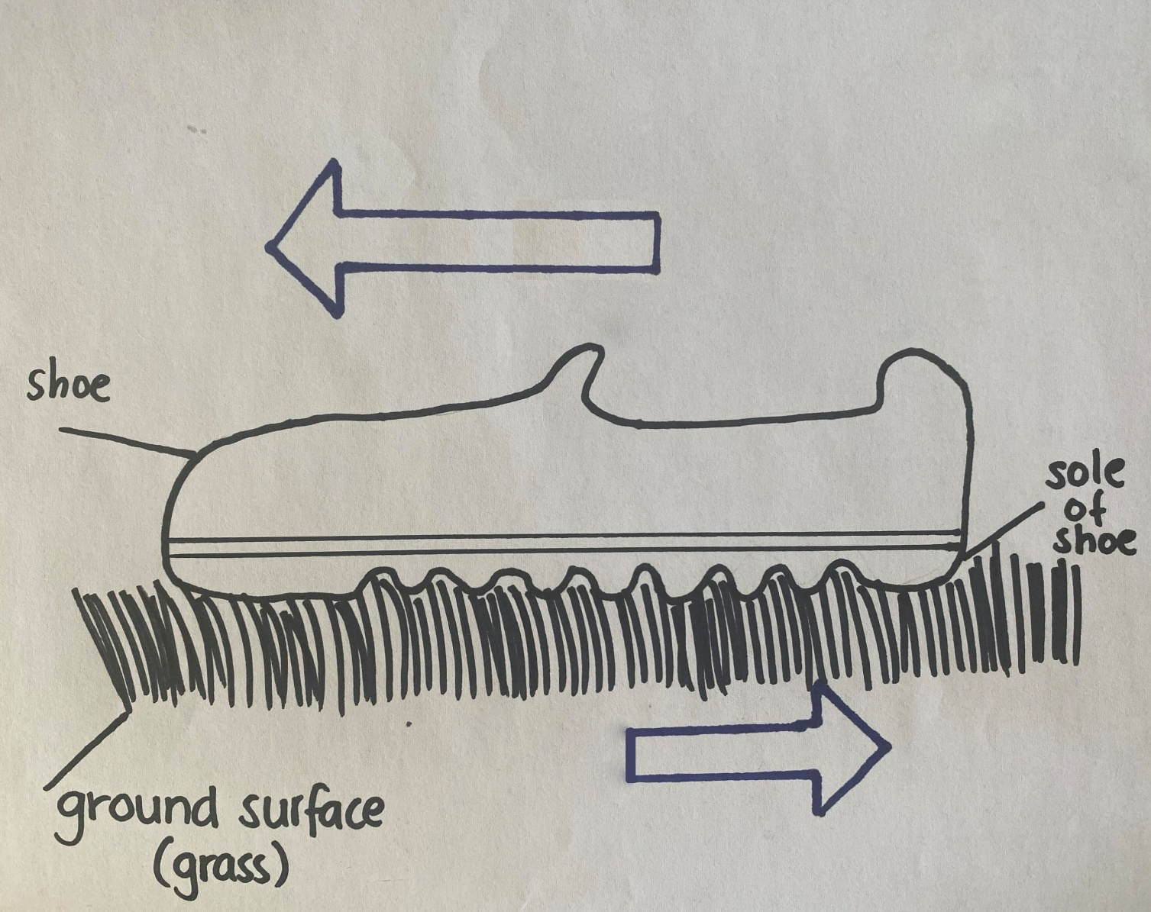
Ask students if they find it difficult or easy to slide their feet along grass and to explain their thinking.

Potential discussion prompts
- Is it easy or hard to slide your feet along the grass?
- Does it depend on the type of shoes you are wearing (or you might be barefoot)?
- Would it be easy to slide your feet if you were wearing football/soccer boots? Why do you think that?
- What about if the soles of your shoes were really smooth? Would it be easier/harder? Why do you think that?
- Do you think the material and surface might have an impact on how difficult/easy it is to slide something against a surface? How do you know? What evidence can you draw from our investigation today and our walk around the school with the package to support your thinking?
Through demonstration or by allowing students time to investigate on their own, explore how smoother surfaces generate less friction than a rough surface when they rub against each other. You might compare a smooth object (a book) and a rough object (a shoe) against a smooth surface (a tabletop) and a rough surface (the carpet, concrete, or a cloth).
As a class, complete the following sentence by selecting the term students think is correct: Smooth surfaces generate (more/less) friction.
Explain/demonstrate that smooth surfaces have fewer ridges and dents to catch on each other when they slide, and that is why they generate less friction.
Ask students how this same idea might apply to rough surfaces: there are more bumps/ridges to catch on each other, making them harder to slide, thus they generate more friction.
Consider how adding weight would also impact this. With extra mass, the ridges and bumps are pressed closer together, making it harder for them to slide against each other; thus, they generate more friction. Heavier objects also need a greater force to accelerate.
Pose the question: If something is hard to push, how might you help it move? Record students’ ideas in the class science journal.
Come to a consensus about a list of key scientific findings from the lesson and record them in the class science journal. See the list at the beginning of this step for guidance on what these key findings might be. Students might not use the most accurate, scientific language when summarising their key findings. This is acceptable at this stage of the sequence. Encourage students to accurately use the terms already explicitly introduced, such as push, pull, force, and friction.
Discuss how what was learned in today’s lesson might help inform the students’ design of their accessibility solutions at the end of the sequence (material choice, mass, surface area contact etc.).

Reflect on the lesson
You might:
- discuss students’ experiences of friction, and choices they might make because of it. For example, selecting specific footwear or clothing, making sure there is a mat/cloth underneath them when sliding down a slide.
- add to the class word wall vocabulary related to friction (e.g. contact, surface, friction, Newton meter, Newton).
- re-examine the intended learning goals for the lesson and consider how they were achieved.
- discuss how students were thinking and working like scientists during the lesson. Focus on using evidence to draw conclusions.

Y4

Access all areas • Lesson 3 • Gravity’s grasp
Lesson 3
Inquire
To read the most recent version of this lesson, download associated resources, and view embedded professional learning including classroom videos and work samples, visit: https://primaryconnections.org.au/teaching-sequences/year-4/access-all-areas/lesson-3-gravitys-grasp

Lesson overview
Students explore how the force of gravity pulls things towards the Earth, and how objects with more mass require more force to move.

Key learning goals
Students will:
- explore gravity’s effect on an object.
- accurately measure and record the force required to move objects of different mass.
- identify that gravity is acting on all objects all the time.
Students will represent their understanding as they:
- use oral and visual language to represent their understanding of gravity.
- record observations and measurements.
- represent findings using force arrow diagrams.

Assessment advice
In this lesson, assessment is formative.
Feedback might focus on:
- the accuracy of students' recorded measurements.
- the comparisons they draw between their findings and the of others.
- how fairly they conducted their investigations.
- the conclusions they drew from these investigations.

List of materials
Whole class
- Class science journal (digital or hard-copy)
- 2 x pieces of A4 paper
Each group
- 1 x inflated balloon
- A variety of objects collected from around the classroom

- One of the following two options for measuring force:
Option 1
- A homemade force meter, either prepared for groups before the lesson or constructed with groups during the lesson. See How to construct a homemade force meter Resource sheet for directions. Materials required:
  - A length of thick cardboard
  - Scissors
  - Sticky tape
  - Blu-tac
  - Elastic bands or springs
  - 2 x paper clips
  - Plastic bag, resealable bag or paper cup
  - 50g weights
- Alternatively, see How to make a force meter (Newton meter) (2:26) or Science for Kids and Tweens: How to Make a Newton Meter (6:30).
Option 2
- 1 x push and pull spring meter or Newton meter. These can be purchased from educational resource suppliers or specialty stores.
Each student
- Individual science journal (digital or hard-copy)
- Moving with force investigation planner Resource sheet

Lesson routine | Estimated time | Task type
Re-orient | 5 minutes | Whole class
Question and Investigate | 15 minutes | Small groups
Integrate | 15 minutes | Whole class
Question | 10 minutes | Small group
Investigate | Variable | Small group/Whole class
Integrate | 20 minutes | Whole class

Inquire

Re-orient
Use the class science journal to review learning from the previous lesson about friction, including how a force occurs when two objects interact, and how friction occurs when two objects touch (in contact).

Question and Investigate • What goes up?
Pose the question: What do we have to do to keep a balloon in the air and not let it hit the ground?
Explain to students that, as a class or in small groups, they will be investigating forces by playing a game. The aim of the game is to keep an inflated balloon in the air and not let it hit the ground.
Before play begins, ask students what they might have to do to keep the balloon in the air, and to predict what will happen if they don’t do anything.
Allow students time to play the game, encouraging them to notice the movement of the balloon when it is:
- hit by the hand.
- moving up after leaving the hand.
- temporarily stopped at the top of its flight.
- moving downwards.

Integrate • Must come down
In this Integrate step, guide students to link their experiences during the game to the science concept being explored—in this instance, that objects cannot remain suspended in the air indefinitely because of the pull of gravity.
Through questioning and discussion, students should come to a consensus that:
- objects can be pushed or pulled into the air.
- friction, caused by air resistance, will slow and stop these objects, and then gravity pulls them down towards the surface.
- gravity is a non-contact force, whilst friction is a contact force.
Discuss with students what happened during their game.

Potential discussion prompts
- How did you get to the balloon into the air?
- Did it stay in the air?
- What happened to it?
- What was the balloon touching during the game? Was it touching anything besides your bodies?
With students’ input, draw a force arrow diagram showing how the balloons were pushed into the air, and what happened to them afterwards. See below for an example.
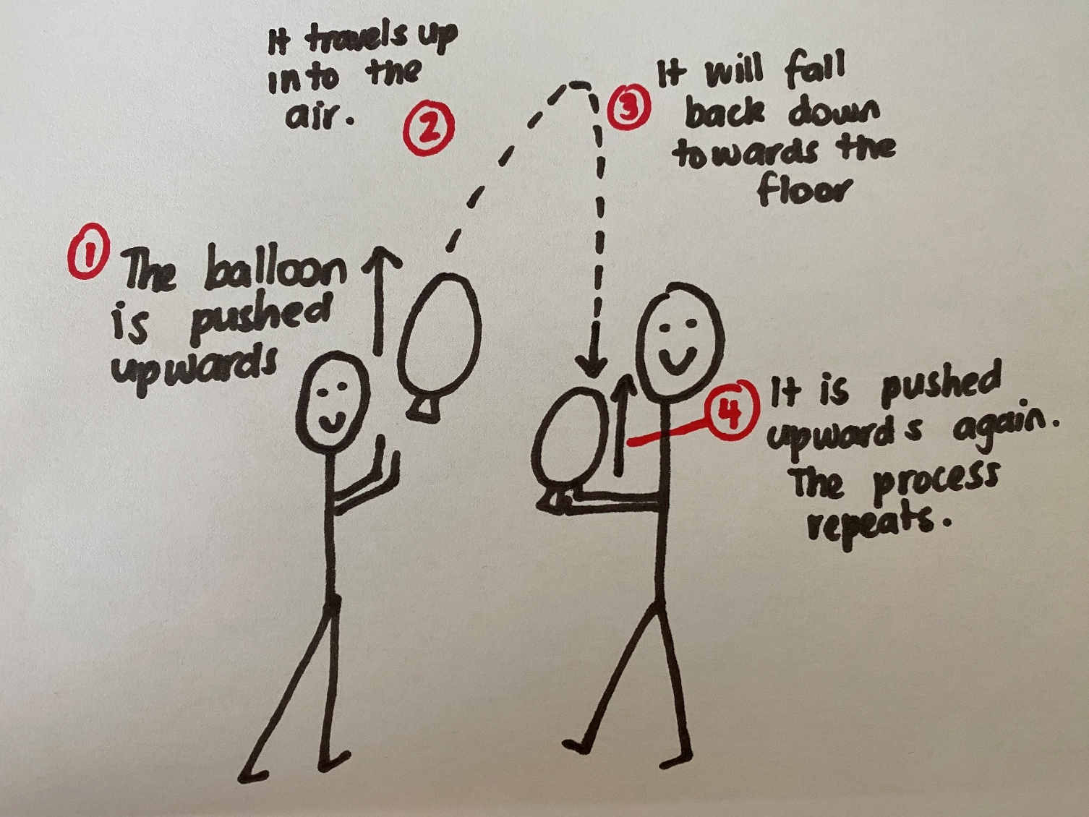
Next, ask students why they think the balloon always falls back down towards the ground eventually, and that this can only be interrupted by another push into the air.
Students might think that the air pushes the balloon back towards the ground. To demonstrate the difference between the ‘force of the air’ and the force of gravity, ask students to hold their arms out and wave them about in different directions, both at a normal speed, and quickly with force. Ask them to describe what they felt—they should describe feeling the air being displaced by the force of their arms. Liken this to the resistance/friction they noticed when pulling the shoes last lesson. Explain that what students are feeling is air resistance, or wind resistance, a type of friction that happens when we push or pull something through the air.
Demonstrate that students can still feel air resistance when they push their arms up through the air, as well as pull them back down. Explain that they are actually making ‘contact’ with the air, just as their shoes had to make contact with the surface of the floor/ground in the previous investigation.
Ask students what else might have been making the balloon fall back towards the ground. If students do not identify the term ‘gravity’ themselves, introduce the term, and ask students what they know about it. Define the term—a force that pulls things towards the centre of the Earth—and add it to the class word wall, glossary or science journal.
Ask students if they can see gravity, or feel it. Explain that, unlike friction, which is a contact force that involves things touching each other, gravity is a non-contact force. We cannot see gravity, or feel it, but we see its effects.

Potential discussion prompts
- How do we know that gravity exists?
- What effects of gravity can we see or experience?
- What does the balloon activity tell us about gravity?
- What might happen if there were no gravity?
Add the same size arrow pointing downwards to each balloon in your force arrow diagram. This represents the pull of gravity that is experienced by the balloon at each stage. Label the new arrow in the diagram as ‘gravity’.

Question • Falling for you
Show students a sheet of A4 paper and ask them to predict how long it will take gravity to pull it to the floor.
Drop the paper and encourage students to count the seconds it takes to reach the floor.
Show students two identical sheets of A4 paper. Ask students to predict how long it will take gravity to pull both pieces of paper to the floor.
Screw one piece of paper into a small ball and compare it to the other piece of paper.
Pose the questions: How have I changed the paper? How would you describe the shape and size of the two pieces of paper?
Discuss how the weight or mass of the paper has not changed (nothing has been added or taken away). The only thing that has changed is the shape of the paper.
Ask students to predict how long it will take gravity to pull both pieces of paper to the floor.
Drop the paper and identify that the ball of paper took less time to reach the floor. Discuss how the ball of paper had less air resistance than the flat paper.
Pose the question: Is the force of gravity the same on all objects?

Investigate • Moving forces
To complete this investigation teams will require a device to measure force—push and pull spring meters, Newton meters, or homemade force meters. See the List of materials above for more information.
Explain to students that to measure force, we use a force meter. Force meters measure in units called Newtons (N). On Earth, 1 Newton is approximately the same as 100 grams of weight.
Model how to measure the pull force of Earth’s gravity by hanging an object from the force meter. Show how students can read and record the number shown on the scale.
Compare this measurement to the amount of force needed to lift an object off a surface. Attach the item to the force meter whilst it sits on a surface, making sure the elastic band/spring has no tension on it. Then lift the item off the surface. The measurement should be taken when the object is just lifting off the surface. If the object is accelerating up, the force may be slightly larger.
Note: The elastic band/spring should stretch the same amount using both methods, and the purpose of doing both is to show students that the same amount of force pulling down on an object is the same as is required to keep it suspended in the air.
If the force meter is sensitive enough, measure both sheets of A4 paper that you dropped in the previous step.
Ask teams to select five objects from around the classroom. They will use their meters to compare the amount of pull due to gravity on these objects. Remind them that the object will need to be attached to their measuring device, so they need to select accordingly.
Ask students to place their objects in order from the object they think will require the least force to lift the object that will require the most force.
Measure the force needed to lift an object from a surface (as just demonstrated).
Using the Moving with force investigation planner Resource sheet, teams plan and carry out their investigation, recording their result, drawing a force arrow diagram, and making a claim about which objects will require more force to move.

Integrate • What did we find?
In this Integrate step, guide students to link their experiences in the investigation to the science concept being explored—in this instance, that the more mass an object has, the stronger the pull of gravity is.
Through questioning and discussion, students should come to a consensus that:
- gravity is acting on objects all the time.
- the size of an object does not always correlate with its mass—a small object can have a large mass.
- the bigger the mass of an object the more the pull of gravity acts upon it.
Teams share their investigation data with the class. Compare the objects that needed the least or most force. Identify that the size of an object did not always indicate that more force was needed.

Potential discussion prompts
- How did you make your predictions about which objects were going to need the most force, and which ones would need the least?
- What object needed the most force to lift it from a surface?
- Did this match your prediction?
- How do you know?
- Did you identify any patterns?
  - For example, objects that felt heavy stretched the rubber band/spring further.
- What claim did you make to answer your investigable question?
- How did your evidence support your claim?
Ask students if forces are represented with arrows in their diagrams, and how they might represent a stronger or larger force.
Explain that the size of a force (whether it is stronger/weaker, larger/smaller) is referred to as its ‘magnitude’, and that the larger the magnitude of the force, the longer the arrow should be.
Demonstrate this using the measuring tool to show that the spring or rubber band stretches further, and how this is represented in the diagram by a longer arrow.
Allow students time to make adjustments to their force arrow diagrams drawn as part of their investigation.
Come to a consensus about a list of key scientific findings from the lesson and record them in the class science journal. See the list at the beginning of this step for guidance on what these key findings might be. Students might not use the most accurate, scientific language when summarising their key findings. This is acceptable at this stage of the sequence. Encourage students to use the terms already explicitly introduced, such as gravity and magnitude.
Discuss how what was learned in this lesson might help inform the students’ design of their accessibility solutions at the end of the sequence, considering weight/mass of part of their design and the users, and how to overcome the forces of gravity if applicable.

Reflect on the lesson
You might:
- discuss students’ experiences of gravity and choices they might make because of it. For example, considering the mass of the materials they select and how gravity might affect those choices.
- add to the class word wall any vocabulary related to gravity and magnitude.
- re-examine the intended learning goals for the lesson and consider how they were achieved.

Y4

Access all areas • Lesson 4 • Magnetic movement
Lesson 4
Inquire
To read the most recent version of this lesson, download associated resources, and view embedded professional learning including classroom videos and work samples, visit: https://primaryconnections.org.au/teaching-sequences/year-4/access-all-areas/lesson-4-magnetic-movement

Lesson overview
Students measure magnetic strength by determining how far apart a magnet and magnetic material can be before the magnetic force is too weak to cause movement.

Key learning goals
Students will:
- identify magnetic and non-magnetic materials.
- describe how a magnetic force is exerted on an object from a distance.
- investigate the strength of different size magnets.
Students will represent their understanding as they:
- record measurements in a table.
- represent their thinking about magnetism using force arrow diagrams.
- discuss and compare magnet strength using their results to draw simple conclusions.
- optionally: identify how magnets are used to support movement.

Assessment advice
In this lesson, assessment is formative.
Feedback might focus on:
- students’ ability to identify how forces can be exerted by one object on another and investigate the effect of magnetic forces on the motion of objects.

List of materials
Whole class
- Class science journal (digital or hard-copy)
- Large piece of paper/cardboard
- A magnet affixed to one side of the large piece of paper/cardboard
- Magnetic item such as a paper clip or similar
Each group
- Magnets of different sizes and strengths, include bar magnets.
Magnets can be rotated around groups if there are resource limitations.
- A variety of items to test for magnetism, including at least one metallic item that is not magnetic (e.g. aluminium foil)
- Sticky tape
- String/thread
- Paperclip
Each student
- Individual science journal (digital or hard-copy)
- Floating paper clip Resource sheet

Lesson routine | Estimated time | Task type
Re-orient | 5 minutes | Whole class
Question | 10 minutes | Whole class
Investigate | 15 minutes | Small groups
Integrate and Question | 10 minutes | Whole class
Investigate | 15 minutes | Individual/Small group
Integrate | 15 minutes | Whole class

Inquire

Re-orient
Revise the difference between friction and gravity as contact and non-contact forces.

Question • A sticky question
Hang or hold up a large piece of paper or cardboard with a magnet attached, ensuring that students can’t see the side with the magnet.
Hold a magnetic object (e.g. a paper clip) against the front of the paper, taking care to place it just above the location of the magnet. Ask students what they think will happen when you let the object go. It is likely, particularly after students' recent learnings about gravity, that they will predict that the object will fall to the floor.
Let go of the object, which will stick to the magnet instead of falling. Ask students why they think it has not fallen to the ground.
Demonstrate multiple times as needed. You might use a variety of magnetic objects (without identifying them as magnetic).
If students don't guess that there is a magnet on the other side of the paper, show them the magnet and demonstrate again how it stops the object from falling to the ground.
Ask students to share what they think they know about magnets, recording their ideas in the class science journal.
Optional: Students draw a labelled diagram showing how they think the magnet stopped the object from falling, including using arrows to show any forces they think are involved.
Ask students if they think this ‘trick’ would work with any item in the classroom and why they think that.
Pose the question: What sticks to a magnet? or What does a magnet stick to?

Investigate • Does it stick?
In teams, provide students with magnets and allow time for them to informally investigate magnetism through play and exploration.
Students’ ideas about how magnets work will guide their exploration. If students are unsure how magnets work, or what they will stick to, prompt them to test a variety of materials to find out which materials magnets will stick to, then look for patterns and draw a conclusion. If they are confident that magnets only stick to metal things, prompt them to see if magnets stick to all kinds of metals.
Students’ findings can be recorded in their science journals in a table such as the following:
Item to be tested | Prediction (will it be attracted/stick?) | Result (was it attracted/did it stick?)
wooden block | X | X
staples | ✓ | ✓
foil | ✓ | X
If using bar magnets, encourage teams to explore how they stick to each other, and make notes on their observations.

Integrate and Question • What did you find?
In this Integrate step, guide students to link their experiences in the investigation to the science concept being explored—in this instance, the force of magnetism.
Through questioning and discussion, students should come to a consensus that:
- magnets are made of metal.
- not all metals are magnetic objects that react in a magnetic field.
- magnetic objects are ‘pulled’ towards magnets.
- (if students used bar magnets) one of the ends of bar magnets will pull towards each other, while the other ends will push away from each other.
Share and compare the results of teams’ investigations.

Potential discussion prompts
- Did everything you tested stick to the magnet?
- What did/did not stick to the magnet?
  - Through this discussion, determine that some objects that are made of metal will be attracted to magnets, meaning they will stick to the magnet. We call this property 'magnetism', and the metal is labelled a 'magnetic object'. However, not all metals are magnetic. For example, aluminium (like foil) is not considered magnetic and will not stick to a magnet.
- Did you feel or observe anything interesting during your investigations?
  - Students would likely have felt or observed a ‘pulling’ sensation.
  - They may have observed some of the objects moving towards the magnet from a distance.
  - They may also have noticed a ‘pushing’ force if using bar magnets and placing the two same poles facing each other. The scientific reasoning behind this is not appropriate for this stage of development and is not addressed in this sequence. However, if students make this observation, acknowledge that strong magnets have 'poles', North and South, and that when the same poles are pointed towards each other they will repel (that is, push away from) each other.
- Do you think that some magnets are stronger than others? Why do you think that?
Pose the question: Do magnets need to touch an object to have an effect on it? Is magnetism a contact or non-contact force?

Investigate • Can a paperclip float?
Working in teams, students use the Floating paper clip Resource sheet and the equipment provided (sticky tape, string/thread, paperclip, a magnet) to see if they can get the paper clip to ‘float’ in the air without being touched by the magnet. Discuss why the string/thread needs to be tied to the paper clip and then attached to the table: it stops the paper clip from touching the magnet because it provides a limit to how far the paperclip can move.
Model the setup of the investigation as required.
Students record their observations on the Floating paper clip Resource sheet by drawing two force arrow diagrams, showing the forces at work when:
- the paperclip is in the air.
- the magnet is removed and the paperclip is falling.

Integrate • What did we find?
In this Integrate step, guide students to link their experiences in the investigation to the science concept being explored—in this instance, the force of magnetism.
Through questioning and discussion, students should come to a consensus that:
- a magnetic object will be pulled towards a magnet until it sticks to it.
- despite this, magnetism is considered a non-contact force because the pull starts from a distance.
- magnets have been used in many technological advances to help things to move.
Teams share their claim in answer to the original question: Do magnets need to touch an object to have an effect on it? Is magnetism a contact or non-contact force?
Ask students how their evidence supports the claim that magnetism is a non-contact force.
Next, ask students to identify any instances of magnetism being used to help things move. You might prompt them with common examples such as:
- refrigerator doors use magnetic strips to remain closed and sealed.
- magnets are used to secure important documents to the fridge door.
- games often use magnet, like fish-catching games, or magnetic building blocks.
- cupboards, especially in the kitchen, use magnets to help them open and close.
- laptop, watch and other device chargers can use magnets to hold the chargers in place.
Optional: Discuss and look at images of other examples of technological innovations involving magnetic forces, for example magnetic levitation trains or magnetic levitation conveyor belts.

Reflect on the lesson
You might:
- brainstorm how magnets could be used in students' accessibility solution.
- add to the class word wall of vocabulary related to magnetism.
- re-examine the intended learning goals for the lesson and consider how they were achieved.

Y4

Access all areas • Lesson 5 • Floating free
Lesson 5
Inquire
To read the most recent version of this lesson, download associated resources, and view embedded professional learning including classroom videos and work samples, visit: https://primaryconnections.org.au/teaching-sequences/year-4/access-all-areas/lesson-5-floating-free

Lesson overview
Students observe how liquids exert an upward force that enables objects to float. They then test how different raft shapes affect buoyancy by measuring how much weight each raft can hold before sinking.

Key learning goals
Students will:
- explore the upward force of buoyancy through a floating and sinking investigation.
- investigate the relationship between the shape of a vessel and the weight it can carry before it sinks.
Students will represent their understand as they:
- use force diagrams to explain the concept of buoyancy.

Assessment advice
In this lesson, assessment is formative.
Feedback might focus on:
- students’ ability to use provided scaffolds to plan and conduct investigations to answer questions or test predictions, including identifying the elements of fair tests, and considering the safe use of materials and equipment.
OR:
In this lesson, assessment is summative.
Students working at the achievement standard (science inquiry) should:
- be able to compare findings with those of others, consider if investigations were fair, identify questions for further investigation and draw conclusions from data.
Refer to the Australian Curriculum content links on the Our design decisions tab for further information.

List of materials
Whole class
- Class science journal (digital or hard-copy)
- Demonstration copy of the Observations in water Resource sheet
- Demonstration copy of the Nature’s rafts Resource sheet
- Demonstration copy of the Variables grid Resource sheet
- Optional: Demonstration copy of the Floating shapes investigation planner Resource sheet

Each group
- A large container filled with water
- A variety of materials that will sink or float, including:
  - at least one air-filled ball, such as a basketball
  - items that are made of the same material, but are shaped differently, such as a metal tray and a pair of scissors/plastic plate and plastic fork
  - at least one weighted ball, such as a heavy medicine ball
  - small metal weight
  - orange fruit
- 2 x foil sheets, as close to the same length/width as possible
- Weights for students to place on their rafts. These must be all the same item and the same size, for example: dominoes, uni-fix cubes, marbles.
Each student
- Individual science journal (digital or hard-copy)
- Observations in water Resource Sheet
- Floating shapes investigation planner Resource sheet

Lesson routine | Estimated time | Task type
Re-orient | 5 minutes | Whole class
Question | 10 minutes | Whole class
Investigate | 15 minutes | Small group/Whole class
Integrate and Question | 15 minutes | Whole class
Investigate | 25 minutes | Small group/Whole class
Integrate | 15 minutes | Whole class

Inquire

Re-orient
Revise the forces that students have learnt about so far (friction, gravity and magnetism) and whether they are considered contact or non-contact forces.

Question • Experiences with water
Discuss students’ experiences with water, such as playing in a pool, swimming or having a bath.
Pose the question: What happens to different objects when placed on/in water?

Investigate • Float or sink?
Text Show students the variety of objects they will be investigating to see what happens when they are placed on/in the water.
Using the demonstration copy of the Observations in water Resource sheet, tally students’ predictions on whether they think each object will float or sink. Include some of the students’ reasoning for their choices.
Set up large containers of water in an appropriate place in the school, such as in a wet area or outdoors. If required, discuss safety rules with students including being careful around any spills, notifying an adult if a spill occurs, not splashing water.
In teams, students test if each object floats or sinks. Ask them to push any items that do float under the water, and observe what happens—do they float back to the surface, or stay submerged?

Integrate and Question • Our observations
In this Integrate step, guide students to link their experiences in the investigation to the science concept being explored—in this instance, the force of buoyancy.
Through questioning and discussion, students should come to a consensus that:
- some objects float and others sink.
Record teams’ observations about each item on the demonstration copy of the Observations in water Resource sheet and compare the observations to the predictions recorded as a class. Make notes on what students observed and felt, particularly for any objects that floated and were pushed under the water.
With input from students, draw a diagram showing an air-filled ball floating on water (see the image below for a sample of what this might look like). Discuss with students where an arrow might be placed to show the forces acting in the situation. Remind them of what they felt and observed when they pushed the air-filled ball into the water, and any other objects that floated back to the top after being submerged: in this instance, the students used a downward pushing force to submerge the ball into the water, but when they removed that pushing force, the upwards pushing force of the water was too strong for the ball to remain submerged. When the ball is not being pushed into the water, gravity is still acting upon it and pulling it down, but the force of gravity is not enough to overcome the upward push of the water.
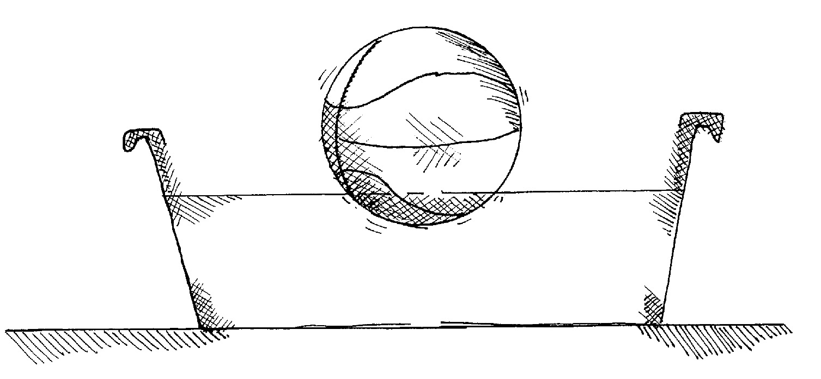
Discuss which objects floated, which sank, and any that may have initially floated but stayed submerged after being pushed into the water. Ask students why they think these objects initially floated but didn’t come back to the surface like the air-filled ball did.
Introduce the term ‘upthrust’: the pushing force of water on an object that has been submersed in it. Explain that objects float when the upward pushing force is greater than the force of gravity, and they don’t float when the pull of gravity is greater than the upthrust.
Examine the shapes of the objects that floated, looking for any patterns. Note that objects that had a larger volume and a wide base, but weren’t heavy (large mass), tended to float.
Ask students what they think would happen if you started to add more weight to the floating object. Would it still float?
Pose the question: Does the shape of something affect how heavy it can be before it sinks?

Investigate • What shape is a raft?
Using the demonstration copy of the Nature’s rafts Resource sheet, examine the images of the lilypad and the water lily. Compare and contrast the shapes of each, asking students to consider which they think would hold the most weight before sinking in the water.
Pose the broad question: What things might affect how much weight a shape can hold before it sinks?
Use the Variables grid Resource sheet to brainstorm the potential variables, marking what will be measured (the amount of weight held) and what will be changed (the shape of the floating vessel) before adding other variables to the remaining cells. These might include the weight of the vessel, how much weight is added each time, the volume of water it’s floating in.
Determine the question for investigation: What happens to how much weight a raft can hold when we change the shape of the raft?
Explain to students that each team will receive two identical pieces of foil with which to design and make their rafts, and that they must use the whole piece (without cutting or tearing any foil off) to design their rafts to ensure both are the same weight/mass. These will then be floated on water, with weight added in increments, to measure how much weight each raft can fold before it sinks.
Allow time for students in collaborative teams to plan their investigation using the Floating shapes investigation planner Resource sheet, including designing and making the shape of their rafts. After the rafts have been made teams can carry out their investigations, recording on a data table how much weight was added to each before it sank.

Integrate • What did we find?
In this Integrate step, guide students to link their experiences in the investigation to the science concept being explored—in this instance, the force of buoyancy.
Through questioning and discussion, students should come to a consensus that:
- the shape of an object can determine whether it floats or sinks.
- if the force of the upthrust is stronger than the pull of gravity an object will float.
Share teams’ investigation results, including the designs of their rafts and how many objects were added before each sunk.

Potential discussion prompts
- How were your rafts the same? How did they differ?
  - All of the rafts had the same mass/weight, because the original pieces of foil provided were the same size.
- Were both of your rafts able to hold the same amount of weight before they sank?
- How much weight could each raft hold?
- Why do you think this happened?
- What did your force arrow diagrams look like?
- Considering we know that to overcome one force, the opposing force has to be stronger, what could you claim about why things float or sink?
Discuss how having a flatter base surface with short sides allowed a raft to hold more weight. The flat surface displaces more water, therefore increasing the upthrust force on the raft. When the upthrust force is larger than the pull of gravity, then the raft stays floating.
Optional: Compare the volume of a flat piece of foil (no volume) to the larger volume of a flat-bottom raft shape with small side panels. This will emphasise that volume is important in the upthrust buoyancy force.

Reflect on the lesson
You might:
- brainstorm how buoyant/floating objects could be used in students' accessibility solution.
- add to the class word wall any vocabulary related to buoyancy
- re-examine the intended learning goals for the lesson and consider how they were achieved.
- discuss how students were thinking and working like scientists during the lesson. Focus on accuracy and if students think they would get the same results if they repeated the investigation.

Y4

Access all areas • Lesson 6 • Reliable rollers
Lesson 6
Inquire
To read the most recent version of this lesson, download associated resources, and view embedded professional learning including classroom videos and work samples, visit: https://primaryconnections.org.au/teaching-sequences/year-4/access-all-areas/lesson-6-reliable-rollers

Lesson overview
Students explore toy rollers made and played with by First Nations children in inland Australia, and investigate how they can be changed to suit specific conditions.

Key learning goals
Students will:
- investigate how a toy roller moves across terrain.
- record data to show how the toy roller moved.
Students will represent their understanding as they:
- pose questions to identify the relationship between one variable and the way a toy roller moves.
- plan and conduct an investigation of the effect of one variable on the movement and speed of an object.
- construct an investigation question for a fair test investigation.

Assessment advice
In this lesson, assessment is summative
Students working at the achievement standard (science inquiry) should:
- be able to use provided scaffolds to plan and investigate to answer questions or test predictions, including identifying the elements of fair tests, and considering the safe use of materials and equipment.
Refer to the Australian Curriculum content links on the Our design decisions tab for further information.

List of materials
Whole class
- Class science journal (digital or hard-copy)
- 1 x toy roller for demonstration purposes. These can be constructed in the following ways:
  - using tin cans and lengths of craft wire as shown on the Museums Victoria website. Take care to use tins that do not have sharp edges (e.g. baby formula tins).
  - using empty spherical drink containers and string as in the image below.
  - using various other materials, as long as the basic design of the roller is followed:
    - 2 cylindrical objects, one shorter (and thinner if possible) than the other.
    - An axle runs through the smaller cylindrical object and connects (via loops or hooks) to an axle running through the larger cylindrical object.
    - Both ends of the axle of the larger object are joined together or connected to form a handle.
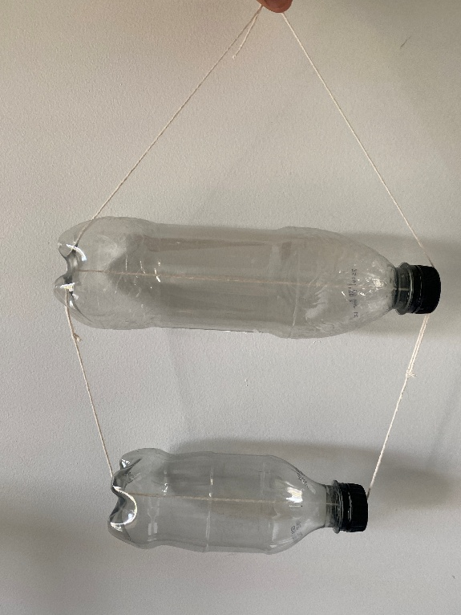
- Demonstration copy of the Variables grid Resource sheet
- Optional: some simple toys, such as self-propelled cars, doll prams, toy lawnmowers, pool toys, or toy pets on leads.
Each group
- A variety of materials to construct a toy roller, as described above
- A variety of materials that students might use to vary something about their toy roller, for example:
  - different materials to use for the axle, e.g. string and modelling wire.
  - sand and water to fill the containers and change their mass.
  - cylindrical objects of different sizes.
Each student
- Individual science journal (digital or hard-copy)
- Toy roller investigation planner Resource sheet

Lesson routine | Estimated time | Task type
Re-orient | 10 minutes | Whole class
Question | 15 minutes | Whole class
Investigate | 30 minutes | Small group/Whole class

Inquire

Re-orient
Remind the students of the forces that have been investigated so far:
- friction
- gravity
- magnetism
- upthrust/buoyancy
Discuss how there are often many forces interacting when an object moves. This is what makes designing and building things that move really complex engineering!
Recall some of the investigations students have engaged in over the course of this sequence and the forces they have witnessed, such as opposing push and pull forces during the shoe investigation and pushing forces, friction and gravity when keeping the balloon afloat.
Optional: Examine some simple toys and consider the forces involved that make them work. Ideas might include self-propelled cars, doll prams, toy lawnmowers, pool toys, or toy pets on leads.

Question • Rolling along
Show students tin rollers from the Australian Children’s Folklore Collection, Museums Victoria. Read the page for details about how First Nations children used tin cans to create tin rollers and how they played with them.
Optional: With input from the students, construct a force arrow diagram showing the forces involved when the tin rollers are raced. Use a single arrow to represent each force, adjusting the length for the size of the force and the arrowhead to show the direction of the force.
List the names of other push or pull-along toys that children still play with today.
Show students the sample toy roller that you have prepared and demonstrate how it works.
Ask students how they think might change the design of the toy rollers to meet different needs, for example to slow them down or increase their stability when rolling over bumpy terrain.
Discuss why this information might be useful when designing their accessibility solutions (including making rolling vehicles more safe for users, or able to move over difficult terrain).
Explain that this is sometimes what engineers do: they try to design things to work better than the versions that already exist, or to better meet different people’s needs.
Pose the question: How can we make a toy roller move more slowly/stably over a chosen terrain?

Investigate • How can we change the toy roller?
Use a variables grid to brainstorm What things might affect how slowly/stably the toy roller moves?
What you measure should be placed in the centre of the grid and marked with an M. In this case you may choose to measure the time it takes for the toy roller to move over a specific distance, or you might use the push and pull spring meters/Newton meters to measure the force required to pull the toy rollers. Other variables might include: the surface the toy roller is used on, the type of string/axle used, the size of the containers used, the mass of the containers, the surface area of the containers, if there’s anything inside the containers (besides air), how much is inside the containers.
Use the scaffold to determine the investigable questions that students will answer: What happens to __________ when we change __________?
If students are experienced in these types of investigations, teams may test a variable of their choice. This makes managing the investigation more complicated, but it can result in a wider variety of data to analyse. Alternatively, teams might also answer the same investigable question. This can allow students to compare data across teams and consider variations in results and why they might have occurred. Select the approach that is most appropriate for your students and context.
Teams use the Toy roller investigation planner Resource sheet to plan and carry out their investigation, including building their toy rollers with guidance as needed, recording observations and data, and evaluating their investigations.
Support teams to determine the data they will record according to their investigable question. For example, if they are going to change the type of string/axle used, help them determine the different types of equipment available and list them on the data table provided. If they are going to change the mass of the containers, support them in determining what they will fill the toy roller's containers with, in what increments, and how they will measure those increments.
You might also need to provide support and scaffolding when teams represent their data on a column graph.

Integrate • What did we find?
In this Integrate step, guide students to link their experiences in the investigation to the science concept being explored—in this instance, that design choices can impact the forces at play in rolling objects.
Through questioning and discussion, students should come to a consensus that:
- changing the design of something changes the forces at work.
Teams share the results of their investigations, including any graphs or other representations (such as force arrow diagrams) they have made of their observations and data, any claims they have made, or improvements they would make to the investigations. Encourage other teams to use the science question starters to further the discussion.
Discuss some of the design changes that have occurred over time in moving vehicles and toys that have made them more efficient and/or effective.
Some examples are given below.
Making things go faster
- Bicycle design: Engineers noticed that sitting upright on a bike creates wind resistance that slows you down. So they tweaked racing bikes to let riders lean forward in a streamlined position, helping them cut through the air more easily and go faster.
- Toy car wheels: Engineers discovered that smooth, round wheels roll much better than bumpy or wobbly ones. They also found that making wheels from hard plastic instead of soft materials reduces friction, so the car rolls farther.
Making things move more smoothly
- Skateboard bearings: Engineers added tiny metal balls inside the wheels. These ball bearings help the wheels spin freely with less friction, making the skateboard glide smoothly instead of feeling jerky or slow.
- Playground slides: Engineers learned that using smooth, polished materials and creating a gentle curve (instead of sharp angles) helps children slide down more smoothly and safely.
Making things easier to control
- Scooter handlebars: Engineers tweaked the height and width of handlebars to make scooters easier to steer. They also added rubber grips so hands don’t slip when turning.
- Remote control cars: Engineers adjusted the size and position of wheels. Bigger back wheels help the car grip better when turning, while smaller front wheels make it easier to steer quickly.
Discuss how students will be using some of these design principles when designing (and possibly building) their mobility vehicle during the Act phase.

Reflect on the lesson
You might:
- add to the class word wall any vocabulary related to forces.
- re-examine the intended learning goals for the lesson and consider how they were achieved.
- discuss how students were thinking and working like scientists during the lesson. Focus on observation and testing.

Y4

Access all areas • Lesson 7 • Access allowed
Lesson 7
Act
To read the most recent version of this lesson, download associated resources, and view embedded professional learning including classroom videos and work samples, visit: https://primaryconnections.org.au/teaching-sequences/year-4/access-all-areas/lesson-7-access-allowed

Lesson overview
Students consolidate their learning by designing an accessibility solution that facilitates access to difficult terrain by using and/or overcoming forces. They represent what they know about forces by drawing a labelled/annotated diagram of their accessibility solution.

Key learning goals
Students will:
- review their learning during the sequence, using the class science journal and word wall.
- create a drawn model of their accessibility solution, using force arrow diagrams to demonstrate where the forces are working.
Students will represent their understanding as they:
- contribute to team discussions about forces acting on objects.
- use visual and oral language to represent and describe forces using arrows.
- use oral, written and visual language to describe forces and reflect on their learning during the sequence.

Assessment advice
In the Act phase, assessment is summative.
Students working at the achievement standard should:
- be able to explain the effect of frictional, gravitational and magnetic forces on the motion of their model accessibility solutions.
- be able to communicate their understanding of their ideas to persuade people to use their accessibility solutions.
Refer to the Australian Curriculum content links on the Our design decisions tab for further information.

List of materials
Whole class
- Class science journal (digital or hard-copy)
- Optional: Demonstration copy of the Accessibility solution plan Resource sheet
- Optional: Demonstration copy of the Accessibility solution evaluation Resource sheet
Each group
- Optional: Various materials to make a prototype of their accessibility solution

Each student
- Accessibility solution plan Resource sheet
- Accessibility solution evaluation Resource sheet

Lesson routine | Estimated time | Task type
Anchor | 10 minutes | Whole class
Connect | Variable | Whole class
Design | Variable | Whole class/Individual
Communicate | Variable | Whole class/Individual

Act

Anchor • What have we learned?
Remind students about the amazing landscapes of Australia: beautiful beaches, mountains and deserts. Everybody should be able to enjoy these landscapes, and we can use our understanding of forces to make it easier for people who may be less mobile to visit these places.
Re-examine the data and ideas collected in the class journal over the course of the teaching sequence.
Discuss what conclusions students have drawn about:
- the shape of the vehicle that might be best for different terrains, e.g. a larger surface area on sand.
- the material of the vehicle/parts of the vehicle that increase friction, allowing the vehicle to grip the surface to move.
- the material of the vehicle/parts of the vehicle that reduce friction, allowing the vehicle to move easier.
- the possible use of magnets to attract/repel the vehicle or to reduce friction.
- the weight of the vehicle and the person in it, and how this might affect movement.

Connect • What do people need from our design?
Discuss the properties accessibility solutions would require. Relate the discussion to any specific context/location you have selected (see the Preparing for the sequence tab on the Sequence overview page for more details).
If there are particular members of the community that would use the accessibility solution, students could be invited to explore their perspective.
Optional: Survey the school or local community about an area they think needs to be more accessible, and/or how it may be made more accessible.

Potential discussion prompts
- What sort of people/things might need to be transported on your chosen terrain?
- What forces will you need to consider?
- What properties are important for your particular accessibility solution?
- What else do you have to consider?
- How might the vehicle need to change/adapt for different weather conditions?
Use the identified properties to produce a set of criteria for designing the accessibility solution that students can use as an evaluation and reflection tool.
See the Accessibility solution evaluation Resource sheet for an example that can be used as is or modified to suit your needs.

Design • Designing an accessibility solution
Using the steps of the design thinking process, students use their understanding of forces and motion to design their accessibility solution.

Define
In order to create the design brief for the challenge as a class, outline the problem in a simple manner.
How can we create an accessibility solution using our knowledge of forces to allow somebody less able to access your chosen landscape/terrain?
These are some example question prompts. These should be modified and added to suit any specific design focus/context you have selected.
- Who will you design for? A baby who can’t walk yet, somebody who is less able/a wheelchair user?
- How is the terrain more difficult/less accessible?
- What materials will you use?
- What else will be important to consider to support movement?
Alternatively, you might provide a pre-prepared design brief to the students.

Ideate
Brainstorm ideas related to the design of an accessibility solution. At this stage, to support creative thinking, every idea offered by students should be recorded in the class science journal. No idea should be discounted, as the practicality/possibility of each idea will be considered in the next stage of design.
As students offer ideas, ask probing questions (Why do you think… or How do you know that…) to draw out the reasoning and evidence behind the idea.

Potential discussion prompts
- What/who are you transporting?
- What properties are important?
- What will happen if it rains?
- What forces will you need to consider?

Prototype
Provide students with time to draft design ideas for their accessibility solutions. Students might create several models during this process. At each stage of the design process, encourage students to consider how the design would work for their chosen terrain. Encourage students to keep each prototype drawing (even if they decide that it is not appropriate) so they can record how their thinking has changed and their design has improved over time.
At the end of the allocated time, students should have one clearly identified, labelled, and annotated final design, naming parts of the accessibility solution, the materials that they have selected, why they have selected them, and using force arrows to show the force involved, including their direction and magnitude.
Optional: Once students have drawn their design, they can use available materials to create a prototype for their design. Encourage students to be creative about the idea of their prototype.

Test
Students use the Accessibility solution plan Resource sheet to develop a testing procedure for their preferred design. Discuss what criteria students’ accessibility solution would need to meet in order to satisfy the design brief, e.g. grip to the terrain, not sink into the sand, float in heavy rain.
Brainstorm ideas for testing the solutions against the criteria, such as testing the models in the school sandpit. Ask students to record what criteria each students’ accessibility solution need to meet in the ‘Criteria’ section of their Accessibility solution plan Resource sheet.
Ask students to negotiate what tests they will use and to provide reasons for their choices. For example: We chose to pull our models across the sand/through the school terrain to see how easily they would move with a 200g weight.
Allow students time to complete their planning and (optionally) to conduct their tests.

Communicate • Sharing our designs

Share
Ask students to discuss their design with others. Encourage students to ask questions to provide peer support and informal peer assessment of students’ model and advert. Students might ask questions such as:
- Is the material carefully considered to reduce/increase friction? Why did you use that material?
- How did you use magnets?
Students share their designs with an appropriate audience, pitching their accessibility solution and its properties. They might do this by organising a class presentation, by recording a video of the students’ design pitches, or by taking photographs of each design for students to annotate.
Use the Accessibility solution evaluation Resource sheet for self- and peer assessment.

Reflect on the sequence
You might:
- refer to the list of student questions asked in the TWLH chart during the Launch phase. Determine which questions have been answered throughout the learning sequence, what the answers to the questions are, and the evidence that supports these claims. Address questions that have not been answered during the learning sequence, discuss why they might not have been addressed, and potential investigations that might support students to answer them.
- consider what students have learned about forces and motion, and how ideas can be used to support accessibility and equity.
- discuss why it is important to understand how forces interact to make movements easier or more challenging. Discuss kinds of jobs that would need to use this understanding, how it might apply to everyday life and how it might make you think about the ways you move things around.
- look up Mechanical Engineer Rafsan Chowdhury on the Primary Science Teaching Trust's A Scientist Just Like Me page and discuss what a materials scientist does.

