Moving around
Which would you rather push in a trolley race and why?
Year 4



Shopping Venture, Shopping, Chrome Steel, Peggy_Marco, via Pixabay
Einkaufswagen, Tim Reckman, CC BY 2.0, via Flickr

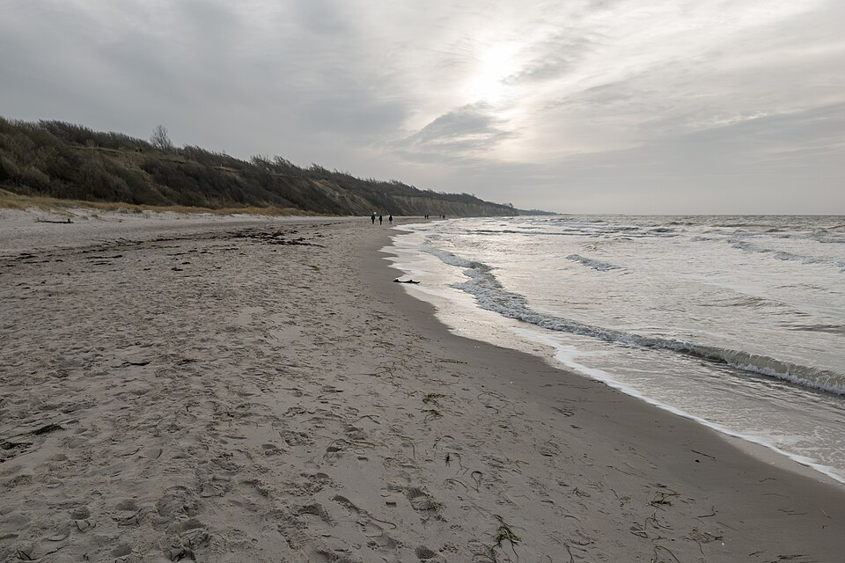
Which would be the easiest part of this beach to walk/run on and why?

Beach, Darss-Fischland, Matti Blume, CC BY-SA 2.0, via Wikimedia Commons
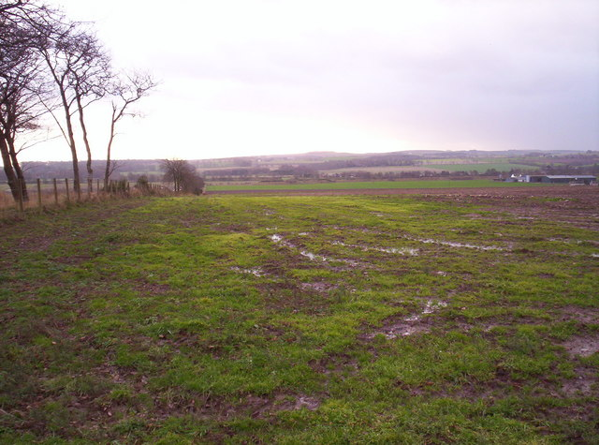
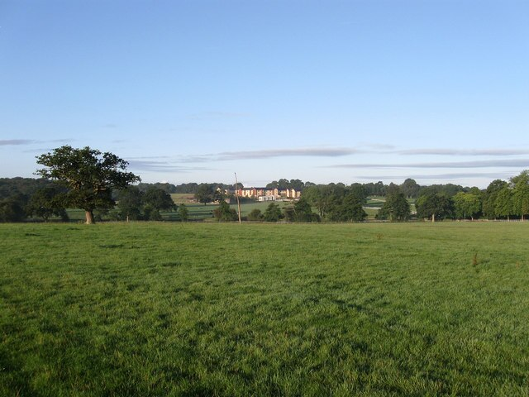
Which ground surface would it be easier to play soccer on and why?

Muddy Field, Dominic Dawn Harry and Jacob Paterson,
CC BY-SA 2.0 via geograph.co.uk
Dry Pit Field, Simon Carey,
CC BY-SA 2.0 via geograph.co.uk

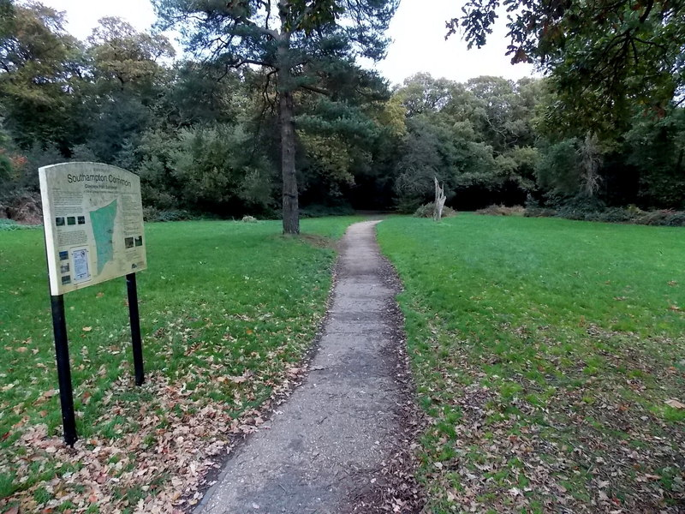
On which surface would it be easier to ride your bike or roll a wheelchair or pram? Why?

Concrete Path entrance to Southampton Common, Jaggery, CC BY-SA 2.0 via geograph.co.uk

