Which shoes to choose?
Year 4
Year 3
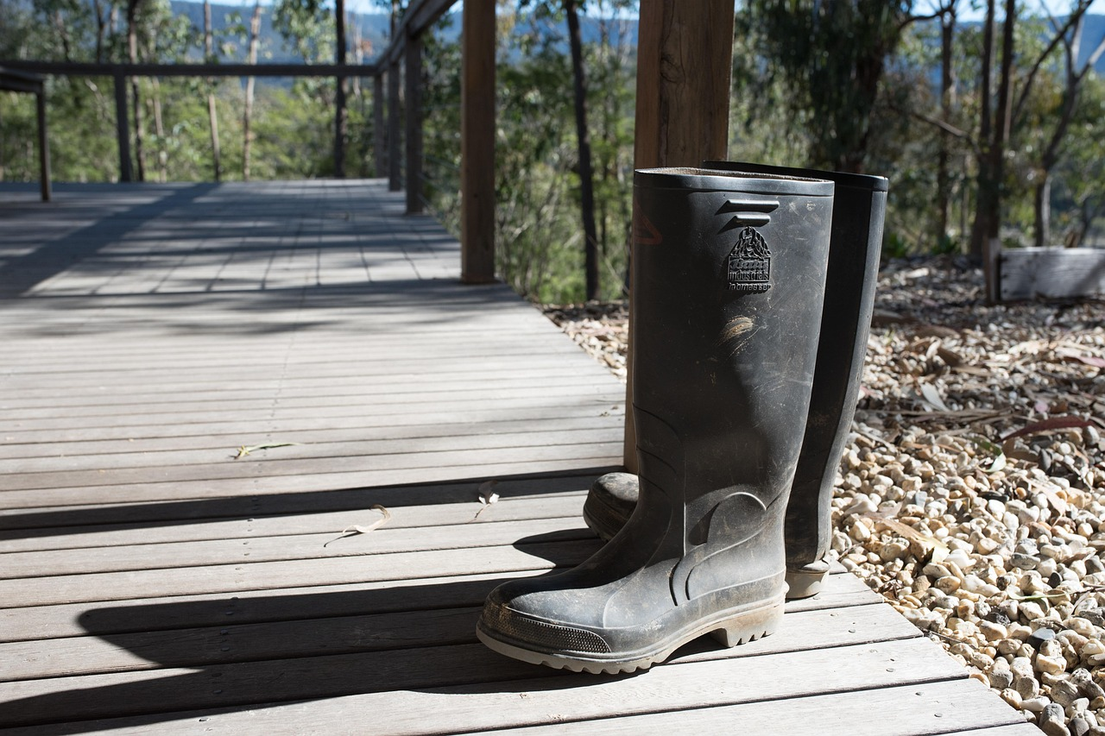

Gumboots, Mud, Dirt, pen_ash, via Pixabay

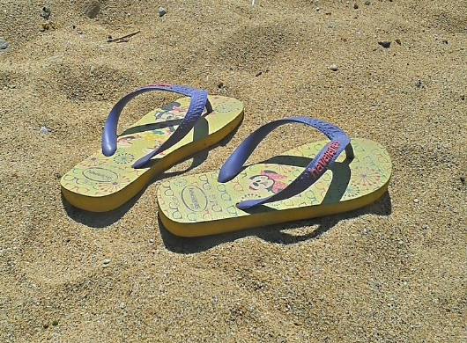

Flip flops, Shoes, Summer, freegr, via Pixabay

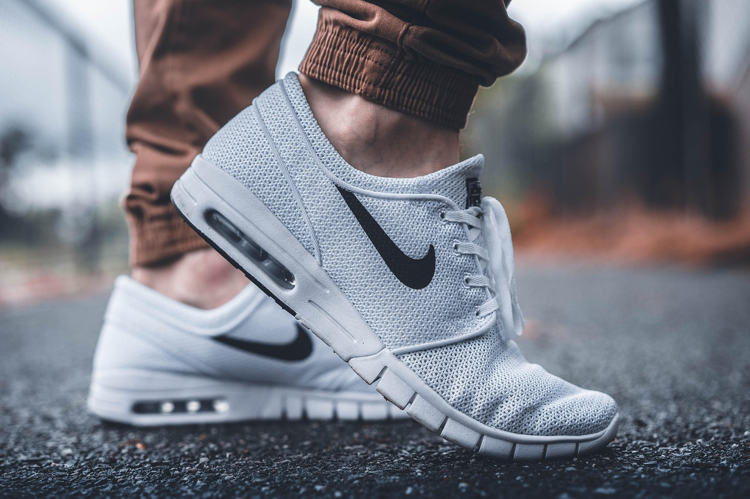

Feet, Footwear, Nike, Pexels, via Pixabay

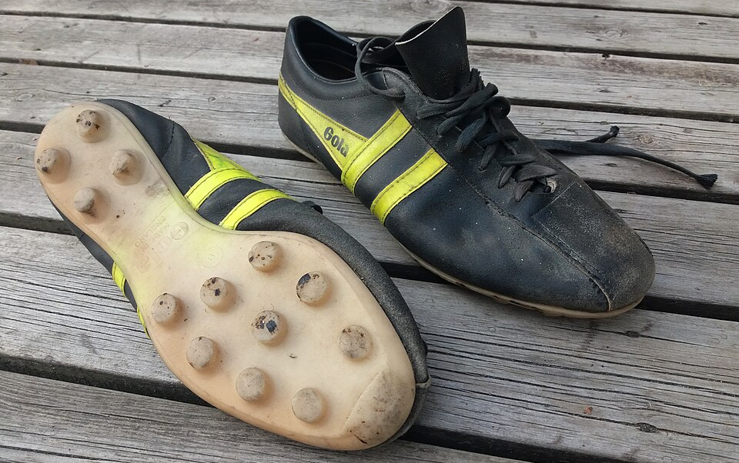

Gola Speedster soccer shoes, Metham, CC BY 4.0, via Wikimedia Commons

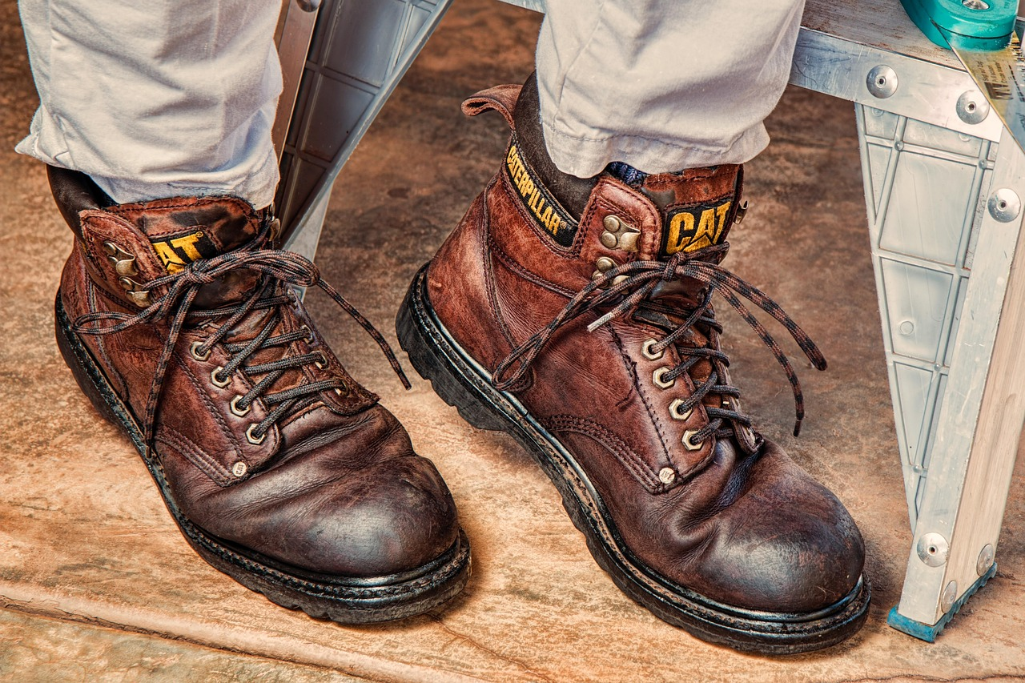
Work boots, Footwear, Protection, stevepb, via Pixabay

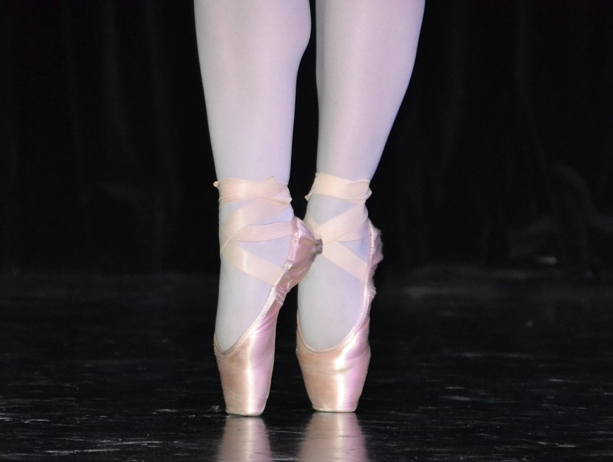

Ballet, Top, Ballerina, Innviertlerin, via Pixabay
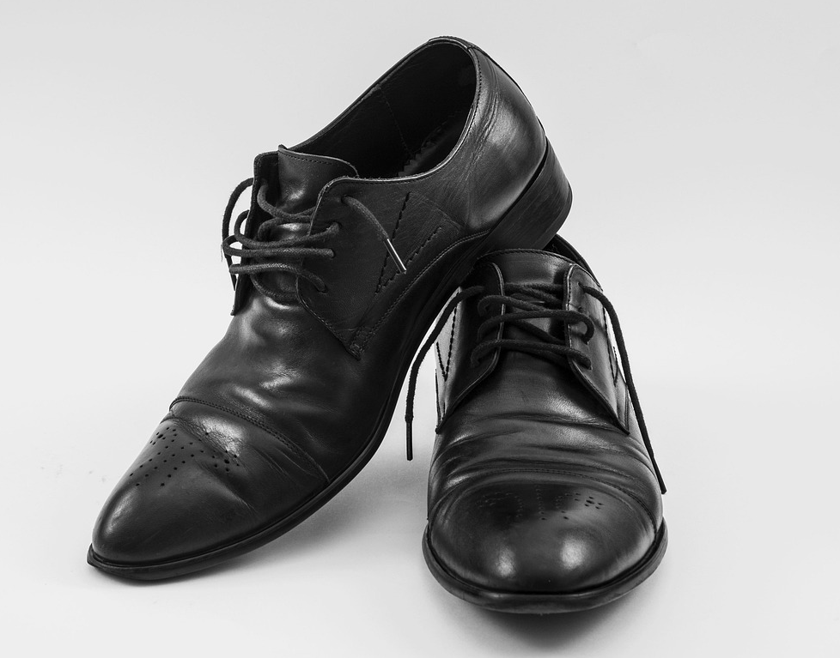

Black shoes, Leather shoes, Used shoes, xaytham, via Pixabay

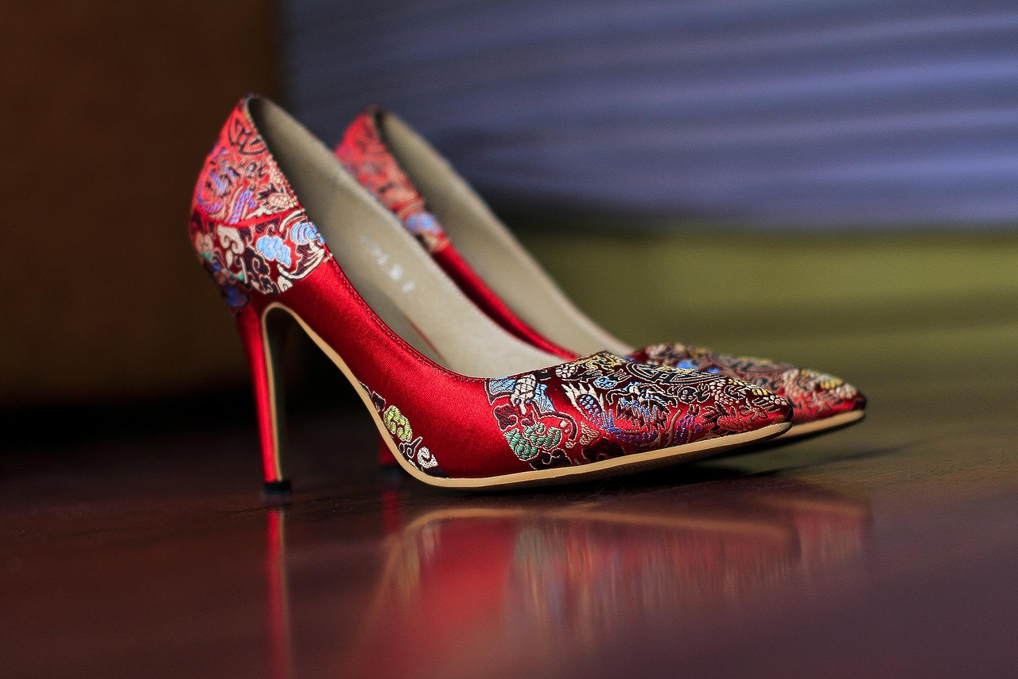

Fashion, High heels, Shoes, Pexels, via Pixabay

