How to construct a homemade force meter
Year 4
Year 3
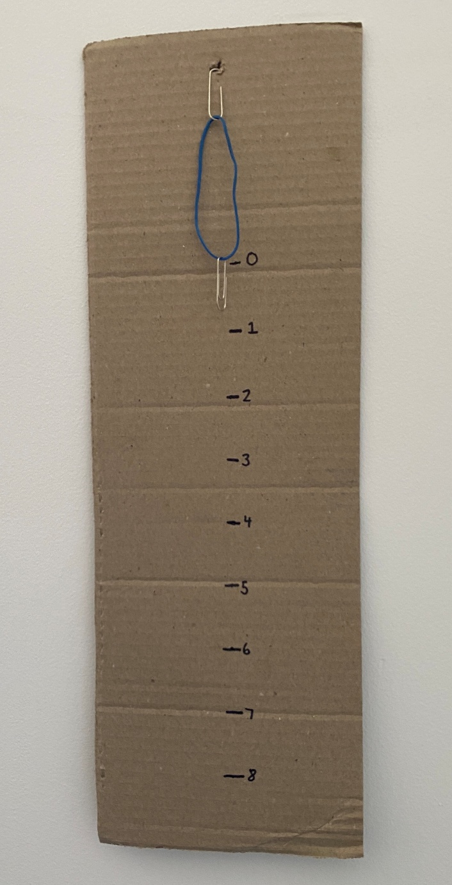
A force meter is a piece of equipment that measures how much force is required to move something.
They can be made using springs or other elastic materials, such elastic bands.
The more the spring or elastic band stretches when an object is attached to it, the more force is required to move that object.
Below are instructions on how to make your own force meter.
How to make the force meter
- Cut the cardboard into a long strip, at least 40cm long and 5 cm wide. You can use the sticky tape to attach 2 pieces of cardboard together if needed.
- Punch a hole at one end of the cardboard (short edge).
Alternatively, push a split pin through the cardboard.
- Attach a paper clip to this hole/split pin.
- Attach a spring or elastic band to this paperclip.
- Attach another paper clip to the other end of the spring/ elastic band.
- Attach a cup or small bag to the bottom paper clip.

You will need:
- Scissors
- Sticky tape (optional)
- A piece of thick, strong cardboard, at least 40 cm long
- Hole-punch/split pin
- 2 x paper clips
- 1 x elastic band or spring
- 1 paper cup or small plastic bag
- Pencil
- Permanent marker
- Blu-tac
- Weights

Calibrating the force meter
- With the cup empty, place a mark in pencil on the cardboard where the bottom paperclip is attached to the elastic band.
- Place 100g in the cup.
- Record where the elastic band stretches to by marking the cardboard at the new spot where the bottom paperclip is attached to the elastic band.
- Repeat steps 2 and 3, placing 100g more in the cup each time, and marking the next spot on the cardboard.
Repeat these steps until you run out of room on your cardboard strip
(the weight stretches the band/paperclip past the bottom of the cardboard).
- Optional: To make your force meter as accurate as possible, measure the distance from the first mark you made when the cup was empty, to the last mark you made and find the average distance between each mark. Now measure this average distance from the first mark and mark it with permanent marker.
For example, if the distance from the first mark to the last is 28cm, and you made 8 marks, then the average distance is 3.5cm.
Make marks at 3.5cm intervals. Label the first mark 0, the second 1, the third 2 etc.

Using the force meter
- Set the force meter against a wall, using blu-tac to hold it in place.
- Place an item to measure in the cup and see how far the elastic band/ spring stretches. Record the number it stretches closest to.
Alternatively, you can hold the force meter, placing the cup on a flat surface, and making sure the tension in the rubber band has the end of the bottom paper clip sitting at zero.
Lift the cup off the flat surface and see how far the elastic band/spring stretches.

FACT: A force meter measures in Newtons, named after scientist Isaac Newton, believed to be the first person to formulate ideas about gravity.

