Nature’s rafts
Year 4
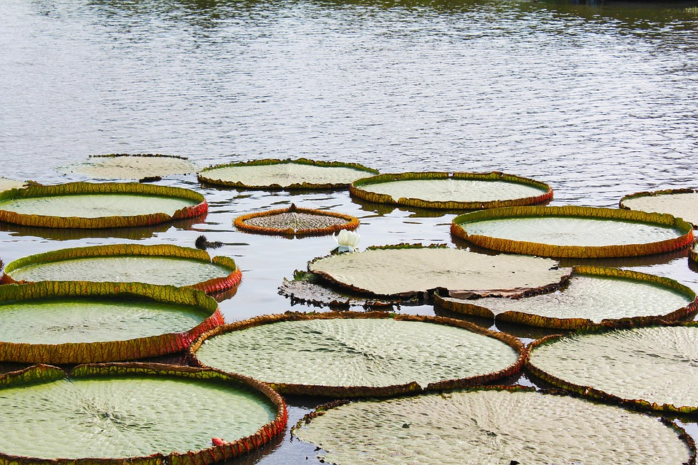

Nature, River, Lotus image, _erbluhende, via Pixabay

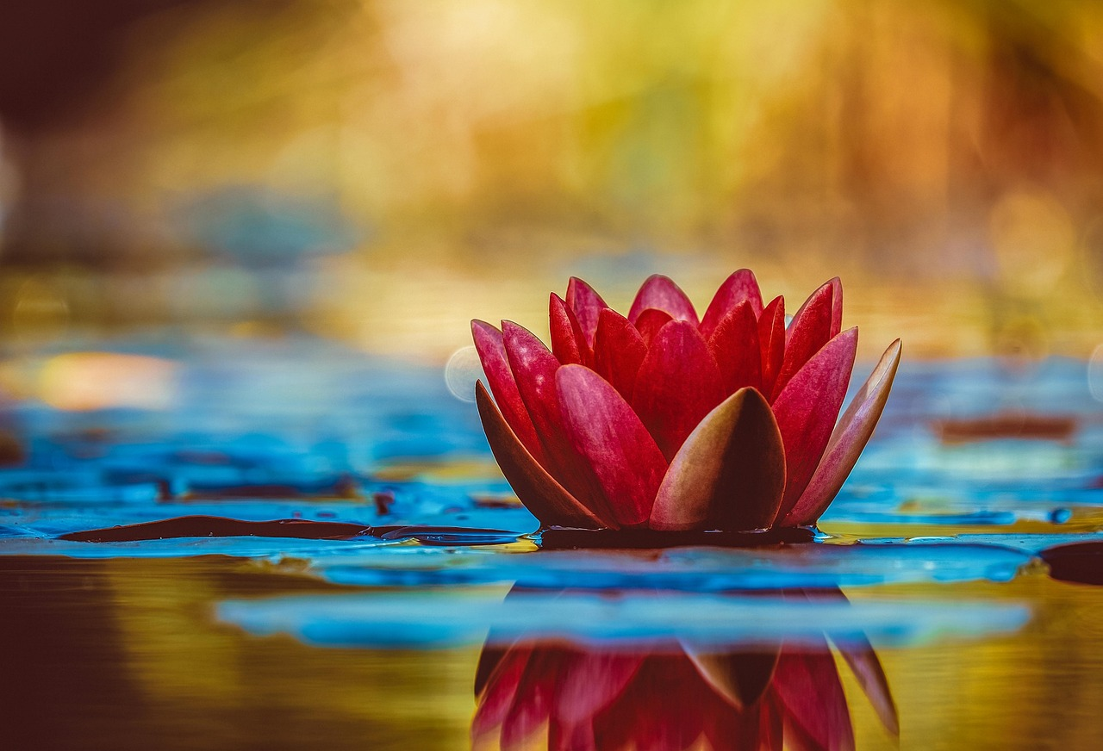

Water lily, Wallpaper hd, Flower, Couleur, via Pixabay

