Habitats
Year 5

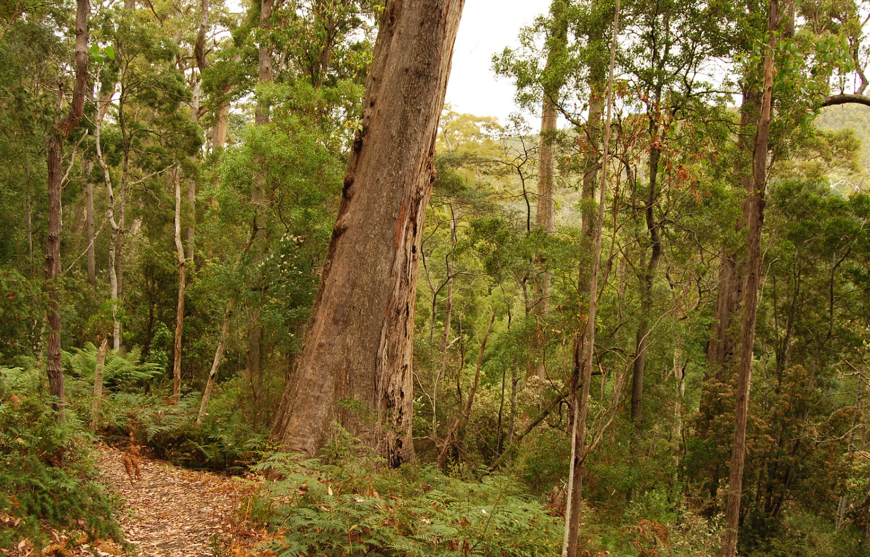
Forest
Giant gum tree, Nicolás Boullosa, CC BY 2.0, via Flikr
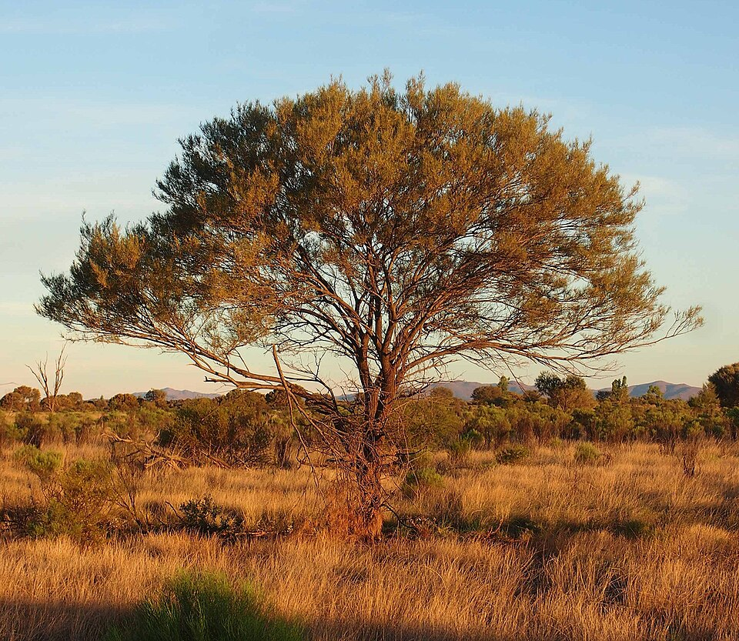
Grassland
Acacia aneura habit, Mark Marathon, CC BY-SA 3.0, via Wikimedia Commons

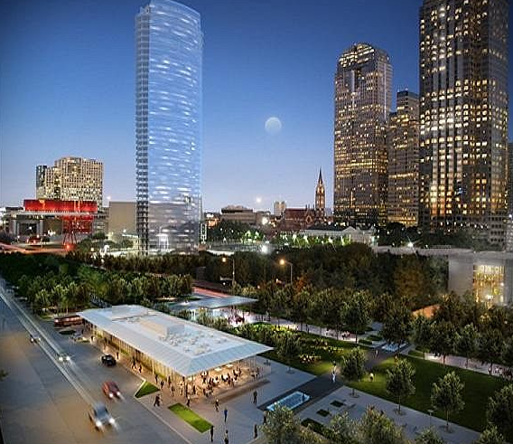
Urban
Museum Tower rendering by The Park (the Woodall Rodgers Urban Park group), 12-03-10, skys the limit2, CC BY 2.0, via Flickr

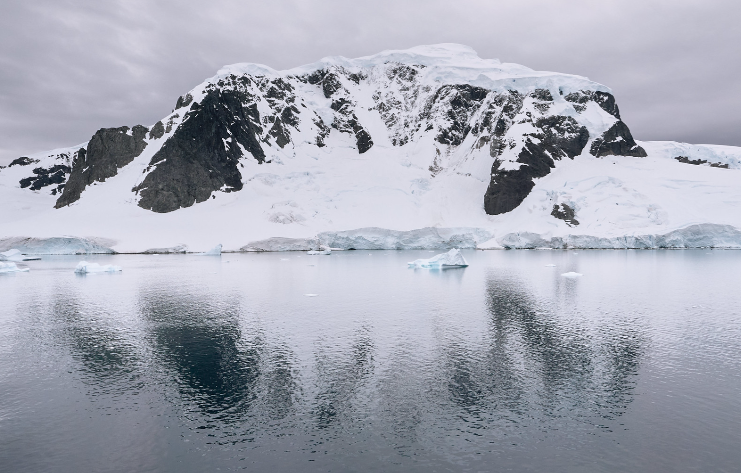
Arctic
Antarctica landscape, Pedro Szekely, CC BY-SA 2.0, via Flickr

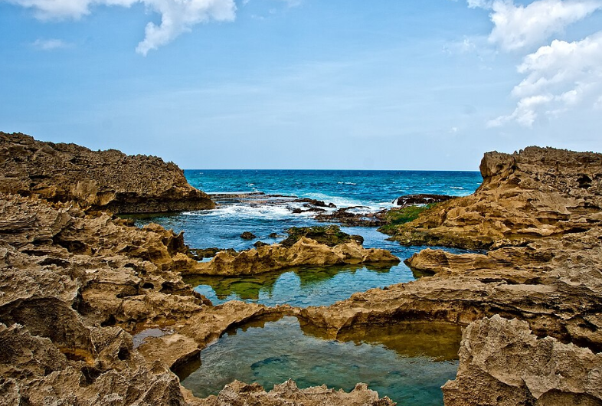
Rockpool
Vega Baja tidepools, R9 Studios FL/ Ricardo Mangual, CC BY 2.0, via Flickr

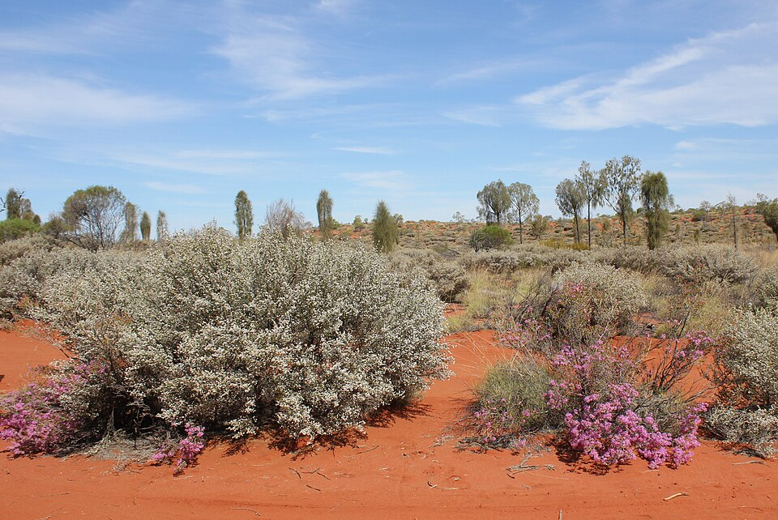
Desert
Springtime in the desert, Annette Teng, CC BY 3.0, via Wikimedia Commons

