Plant survivor
Year 5
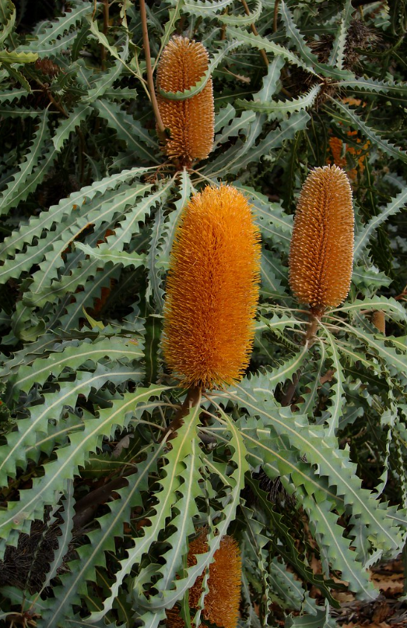
Ashby’s Banksia, Tatters, CC BY-SA 2.0 via Flickr

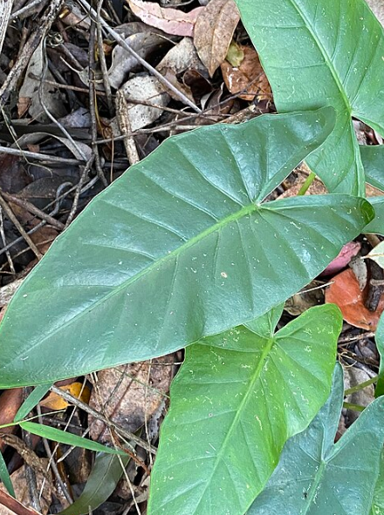
Alocasia brisbanensis 155068473, Greg Tasney, CC BY-SA 4.0, via iNaturalist

