Ants
Year 5

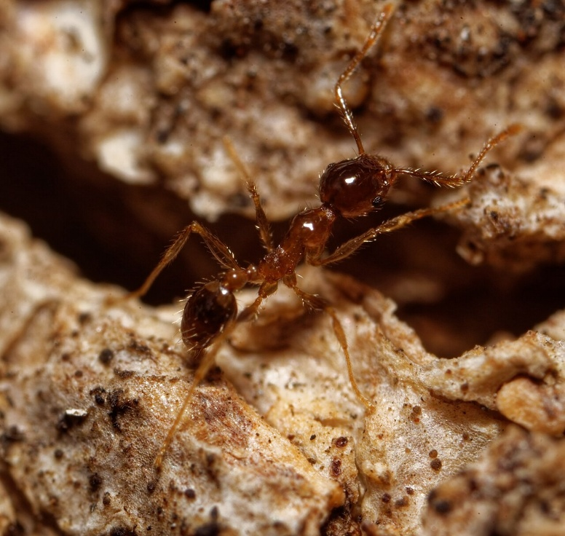
Coastal brown ant (Pheidole megacephala)
Species
Classification
Genus
Kingdom
Phylum
Class
Order
Family
megacephala
Pheidole
Formicidae
Hymenoptera
Insecta
Arthropoda
Animalia

Facts
Size
Adults are 2-4mm long

Information
- Yellow brown, reddish brown or black in colour.
- 2 types of worker ants- major and minor.
- Major workers are twice as long as minor ones, with a large head and powerful mandibles to crush seeds
- Considered invasive, it is a threat to native ant populations.

Distribution
Found across Australia.
Click here to see a map of reported sightings on Atlas of Living Australia.
Information sourced from the Atlas of Living Australia.

Pheidole megacephala minor worker, by Bradley Rentz, CC BY-SA 4.0, via Wikimedia Commons

Meat ant (Iridomyrmex purpureus)
Year 5
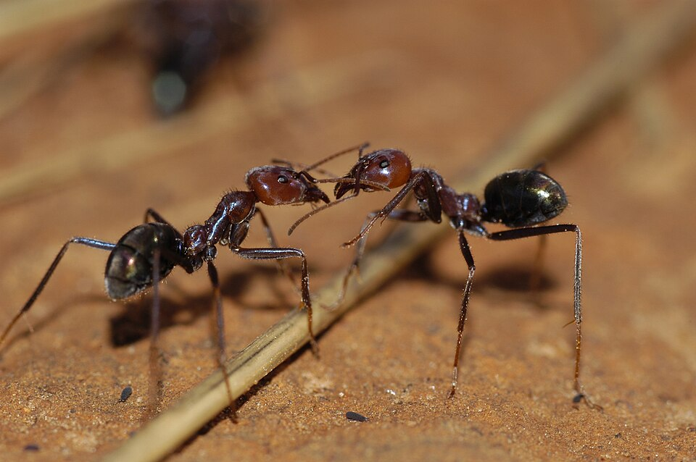
Classification
Species
Genus
Kingdom
Phylum
Class
Order
Family
purpureus
Iridomyrmex
Formicidae
Hymenoptera
Insecta
Arthropoda
Animalia

Facts
Size
Adults are 6-12mm long

Information
- Live in warm, open area, in oval shaped mounds with many entrance holes.
- Forage during the day.
- Is an omnivore, eating insects including caterpillars, and sweet substances such as nectar and honeydew.

Distribution
Found across Australia.
Click here to see a map of reported sightings on Atlas of Living Australia.
Information sourced from the Atlas of Living Australia and the Australian Museum.

CSIRO ScienceImage 3225 Meat ant Iridomyrmex purpureus Formicidae, by CSIRO, CC BY 3.0, via Wikimedia Commons

Green headed ant (Rhytidoponera metallica)
Year 5
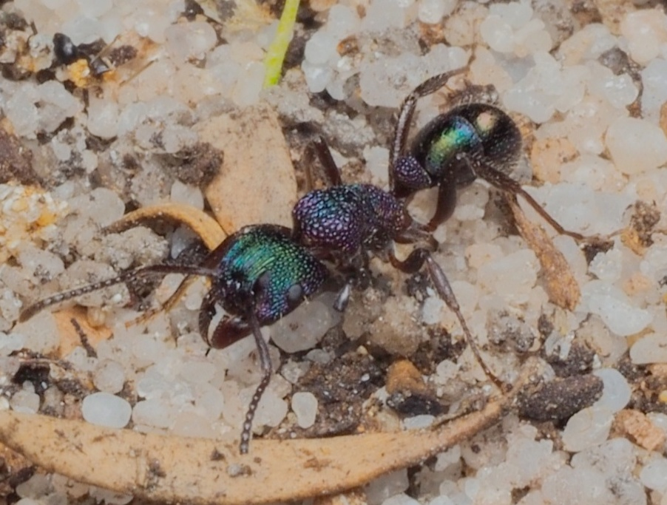

Classification
Species
Genus
Kingdom
Phylum
Class
Order
Family
metallica
Rhytidoponera
Formicidae
Hymenoptera
Insecta
Arthropoda
Animalia

Facts
Size
Adults are 5-7mm long

Information
- Dark bodies with a distinctive metallic green-purple sheen.
- Strong predators that hunt and forage during the day.
- Known for their painful sting which can cause anaphylaxis.
Distribution
Found in every state in Australia.
Click here to see a map of reported sightings on Atlas of Living Australia.
Information sourced from the Atlas of Living Australia.

Rhytidoponera metallica, by kjvy, CC BY-NC 4.0, via The Atlas of Living Australia

Year 5

Golden bearded sugar ant (Camponotus aurocinctus)
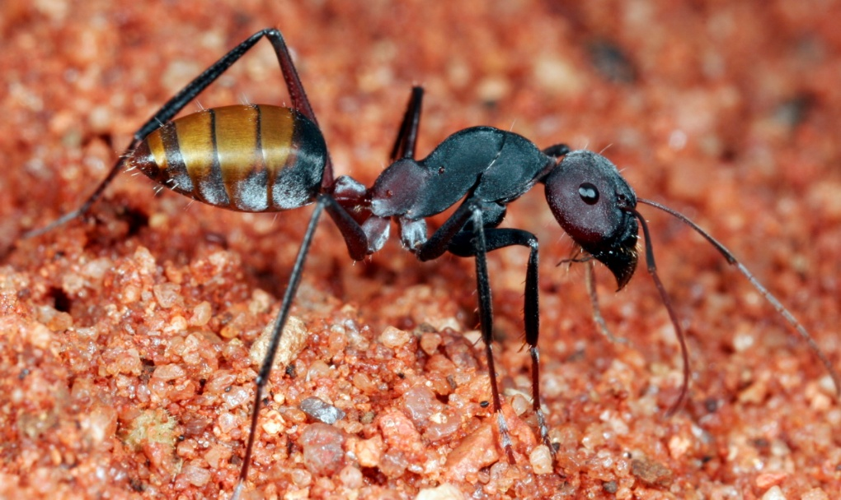
Classification
Species
Genus
Kingdom
Phylum
Class
Order
Family
aurocinctus
Camponotus
Formicidae
Hymenoptera
Insecta
Arthropoda
Animalia

Facts
Size
Adults are 8-10mm long

Information
- Has a strong preference for sandy soils.
- Forages during the day.

Distribution
Found across Australia.
Click here to see a map of reported sightings on Atlas of Living Australia.
Information sourced from iNaturalist.

Camponotus aurocinctus, Yulara, NT, by Steve Shattuck, CC BY 2.0, via Flickr

Year 5

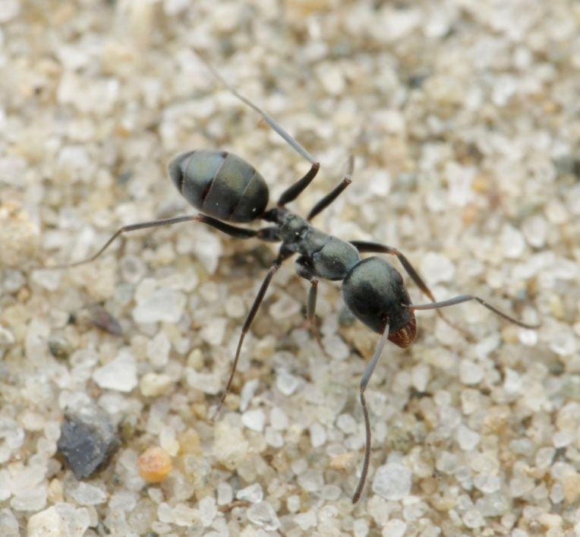
Black trail ant (Iridomyrmex bicknelli)
Classification
Genus
Kingdom
Phylum
Class
Order
Family
bicknelli
Iridomyrmex
Formicidae
Hymenoptera
Insecta
Arthropoda
Animalia
Species
Facts
Size
Adults are 2-5mm long

Information
- Fast moving, opportunistic feeders. Eat insects, nectar, seeds etc.
- Use chemical communication to find, secure and defend food.
- Recruit other workers ants rapidly when a source of food is located.
- Workers follow scent trails left by others to food sources.
- Mandibles specially designed to carry food.
- They often work as a team to carry food back to the nest.
- Live in soil, under rocks, logs and other debris, crack in footpaths etc.
- Most active in warmer temperatures.
- Not especially aggressive. No stingers.
Distribution
Found in every state in Australia.
Click here to see a map of reported sightings on Atlas of Living Australia.
Information sourced from Wikipedia and Fourmiculture.
Iridomyrmex bicknelli, by Daniel Kurek, CC BY-NC 4.0, via The Atlas of Living Australia

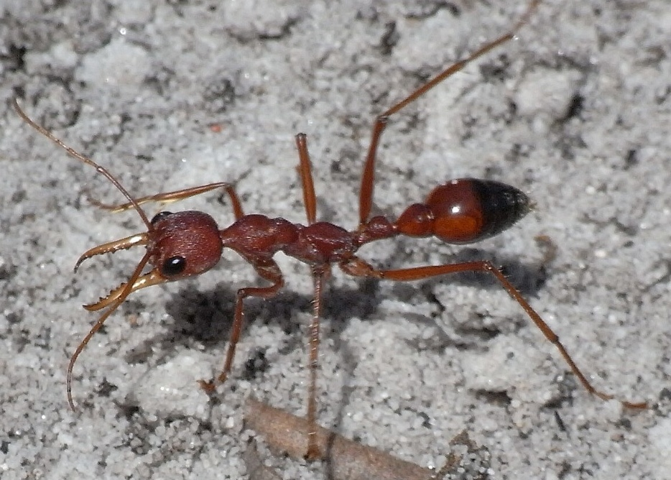
Red bull ant (Myrmecia gulosa)
Classification
Species
Genus
Kingdom
Phylum
Class
Order
Family
gulosa
Myrmecia
Formicidae
Hymenoptera
Insecta
Arthropoda
Animalia
Year 5

Facts
Size
Adults are 15-30mm long

Information
- Also known as the giant bull ant or bulldog ant.
- Have exceptional vision and can track movement from 1-2m away.
- Do not use chemical communication, relying solely on sight for navigation and finding food.
- Long, powerful serrated mandibles used for grasping prey and for defence.
- Hunt alone. Do not recruit others to food sources.
- Adults feed on nectar, honeydew and liquids from insects. Larvae are carnivorous, so insects must be taken back to the nest to feed young.
- Known to be aggressive and possess a powerful sting.
- Nests are built underground and often extend several metres deep.

Distribution
See included map.
Information sourced from the Atlas of Living Australia.

Red Bull Ant Sand, by Quartl, CC BY-SA 3.0, via Wikimedia Commons
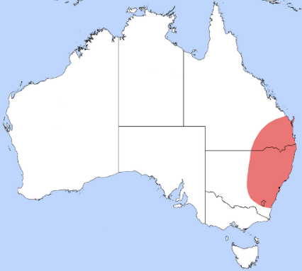

Labelled diagram of an ant
Year 5
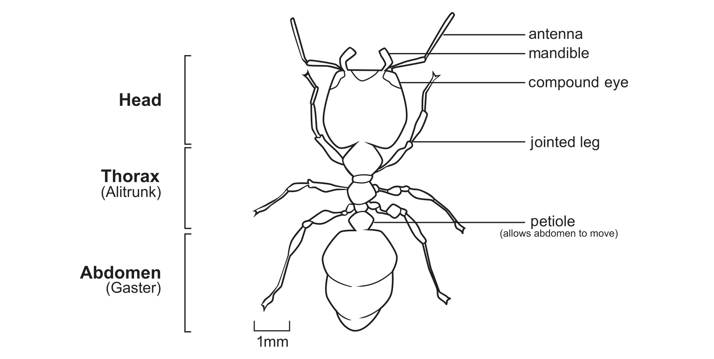

Black trail ant (Iridomyrmex bicknelli): a close up
Year 5
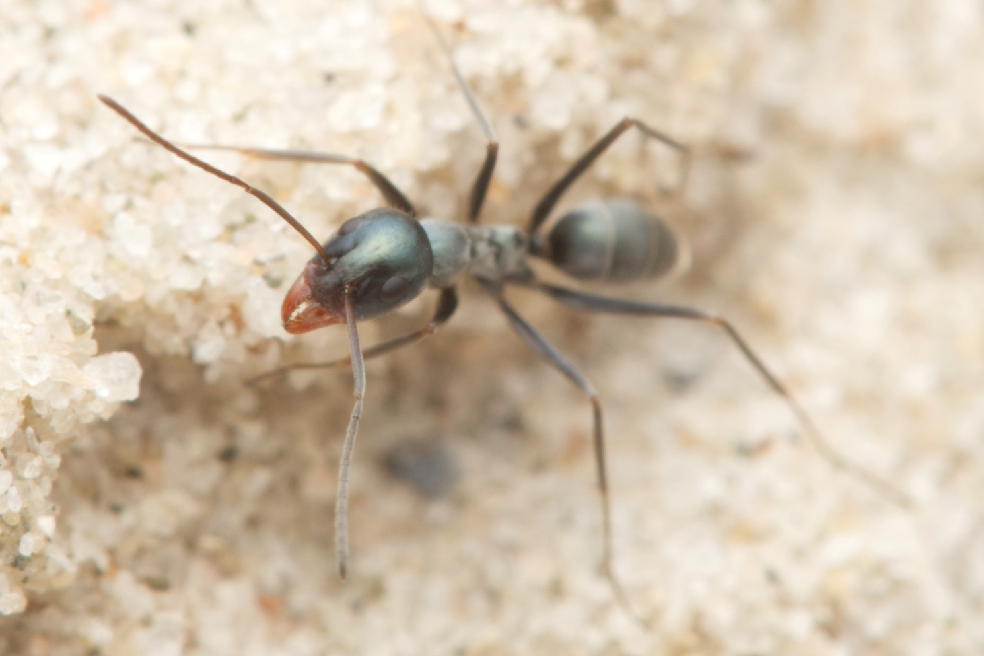

Iridomyrmex bicknelli, by Nigel Main, CC BY 4.0, via The Atlas of Living Australia

Red bull ant (Myrmecia gulosa): a close up
Year 5
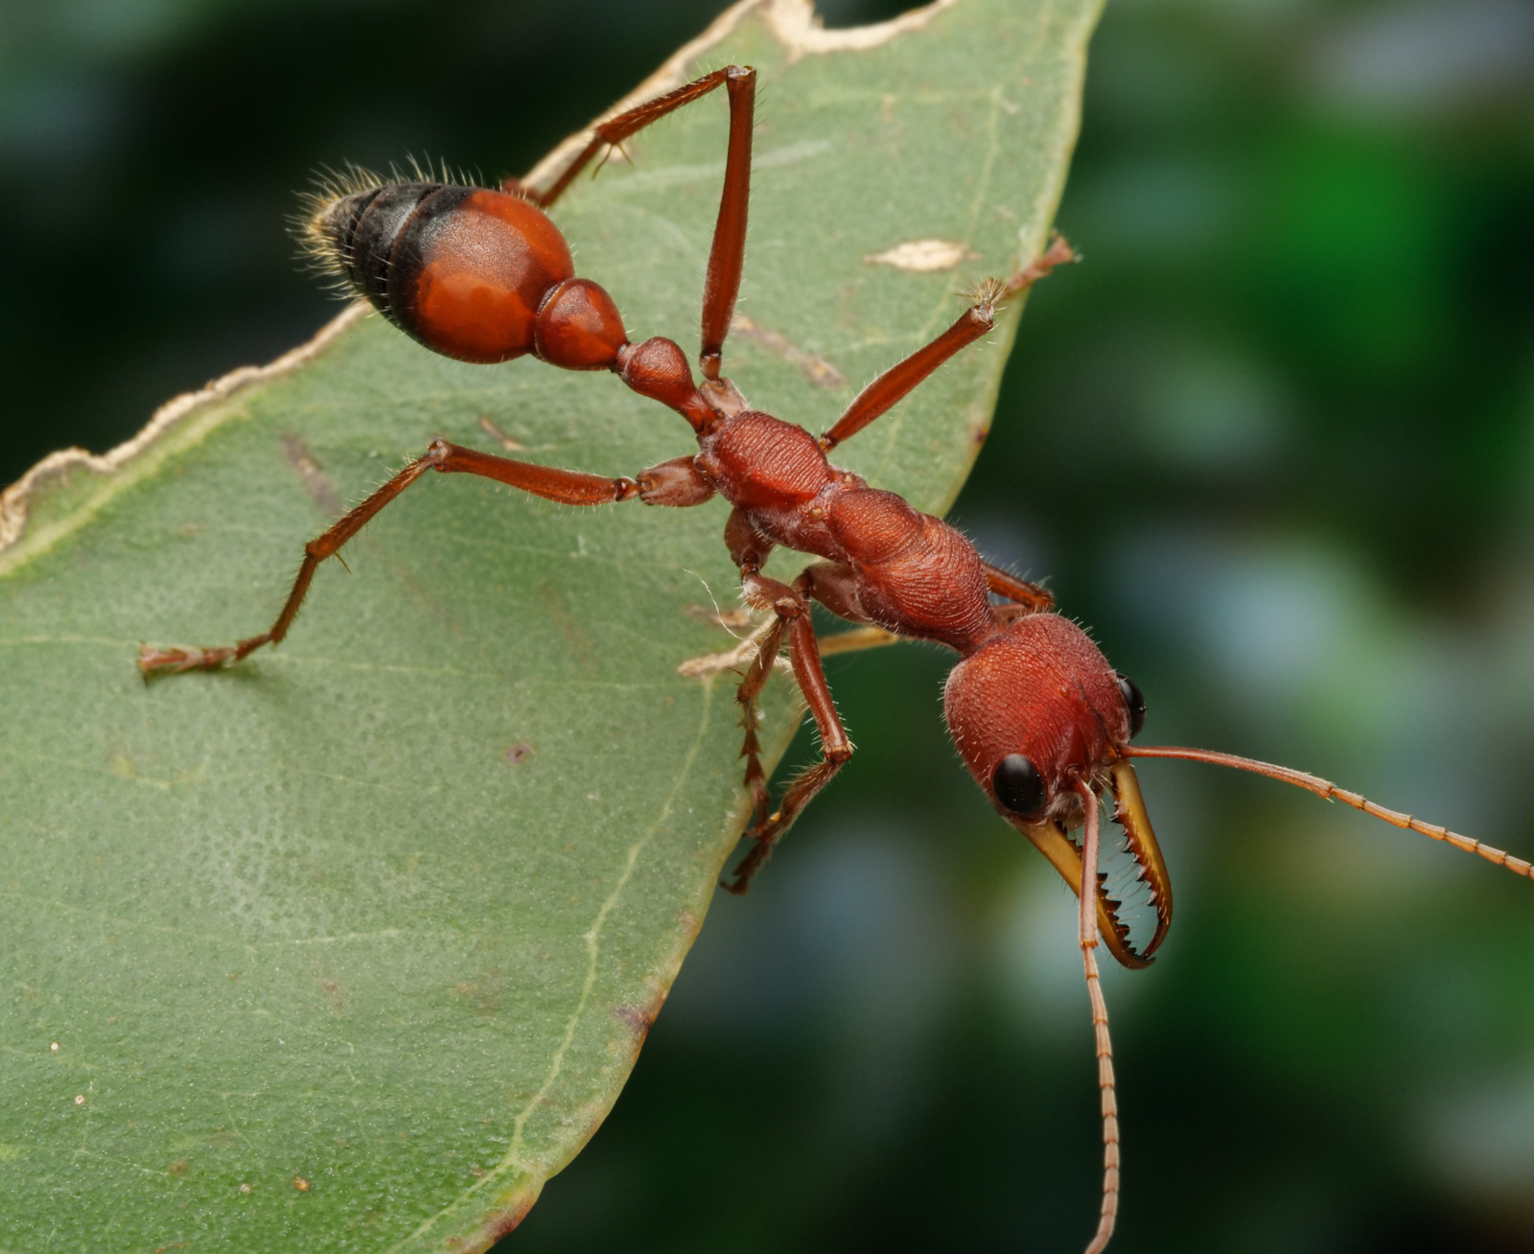

Myrmecia gulosa, by Gunter Maywald, CC BY-NC 4.0, via The Atlas of Living Australia

