Code for caring and hygiene
Year 5

Code for caring
1. As much as possible, look but don’t touch.
2. Search carefully, disturbing the surroundings as little as possible.
3. Replace stones and logs after searching under them.
4. Leave all plants and gardens undisturbed- don’t remove anything.
5. Leave all dangerous small animals alone.
6. Wear gloves to avoid bites and stings.
7. Use spoons and damp brushes to avoid crushing small animals.

Code for hygiene
1. Always wash your hands with soap and water after you’ve been touching leaves, rocks, soil and animals.
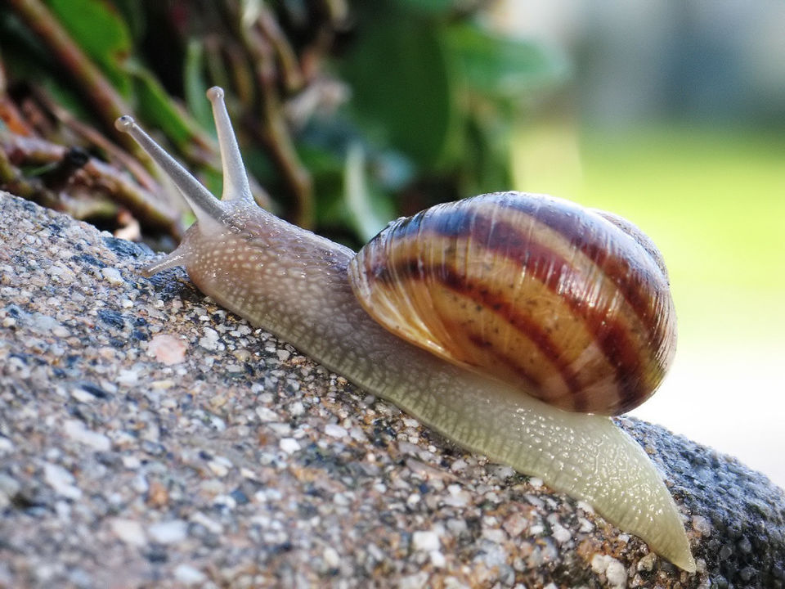
2. Take extra care if you have touched snails, slugs or their slime. Don’t touch your mouth afterwards and wash your hands with soap and water.

The champ, by John D, CC BY 2.0, via Flickr

