Desert and forest leaves
Year 5
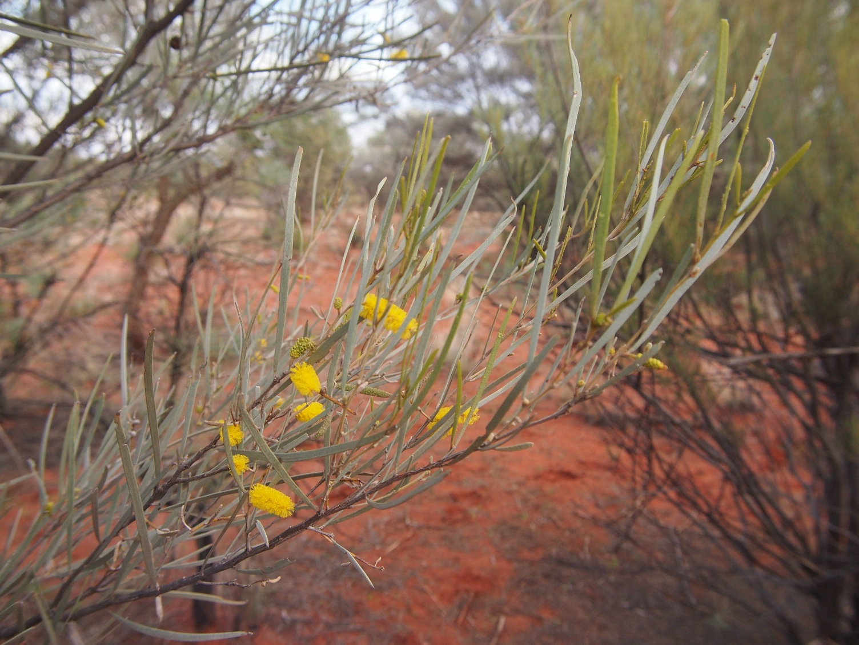

Classification
Species
Genus
Kingdom
Phylum
Class
Order
Family
aneura
Acacia
Fabaceae
Fabales
Magnoliosida
Plantae

Magnoliophyta

Leaves of the Mulga tree (Acacia aneura)
Acacia aneura foliage and flowers 2, by Mark Marathon, CC BY-SA 3.0, via Wikimedia Commons
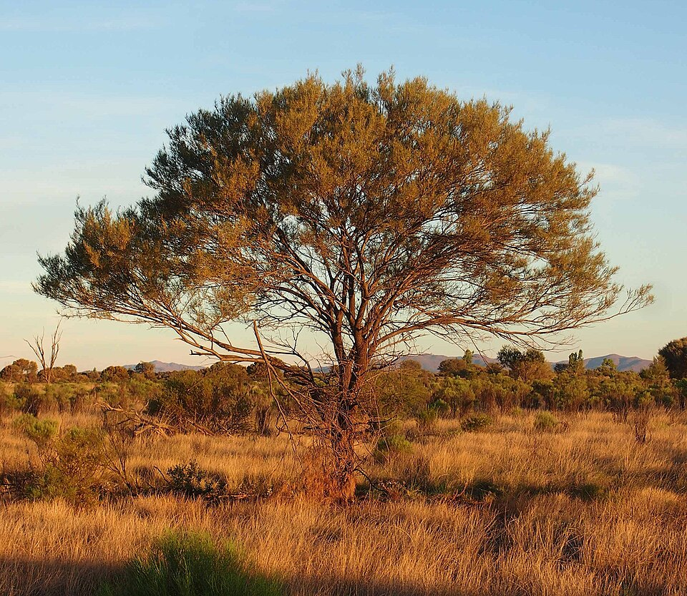
Year 5

The form and typical habitat of the Mulga tree
Acacia aneura habit, by Mark Marathon, CC BY-SA 3.0, via Wikimedia Commons

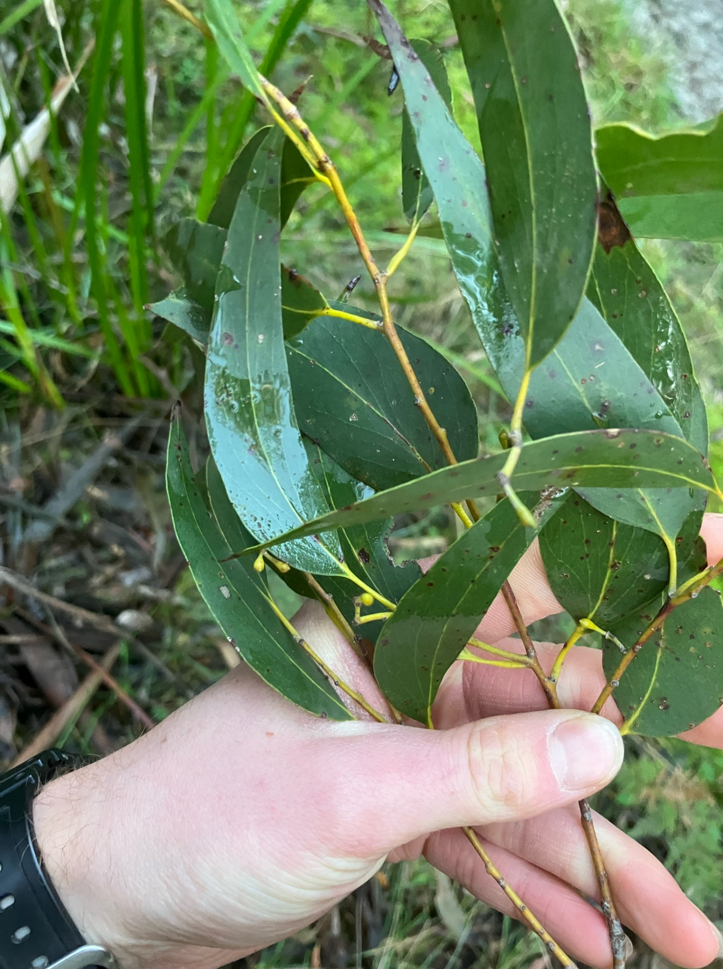
Year 5

Leaves of the Mountain ash tree (Eucalyptus regnans)
Eucalyptus regnans, by Montgomery Hall, CC BY-NC 4.0, via The Atlas of Living Australia
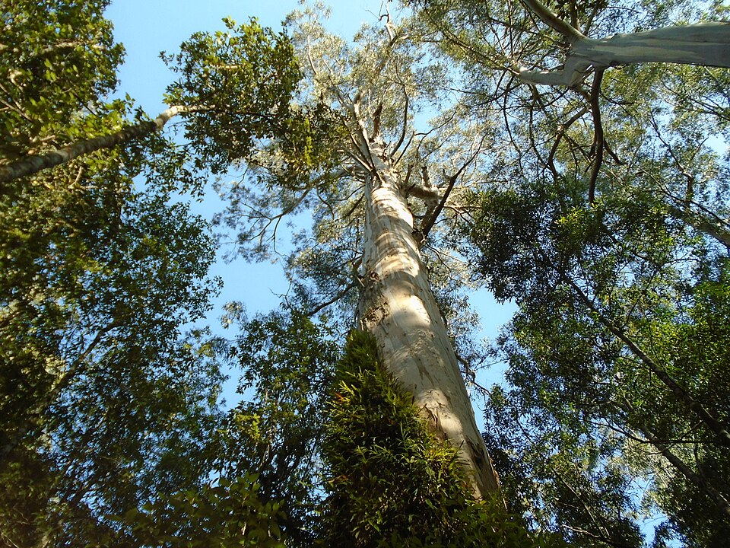
Year 5

Classification
Species
Genus
Kingdom
Phylum
Class
Order
Family
regnans
Eucalyptus
Myrtales
Magnoliopsida
Tracheophyta
Plantae

Myrtaceae

The form and typical habitat of the Mountain ash
Blahovičník královský (Eucalyptus regnans), by Pimlico27, CC BY-SA 4.0, via Wikimedia Commons

