Transpiration investigation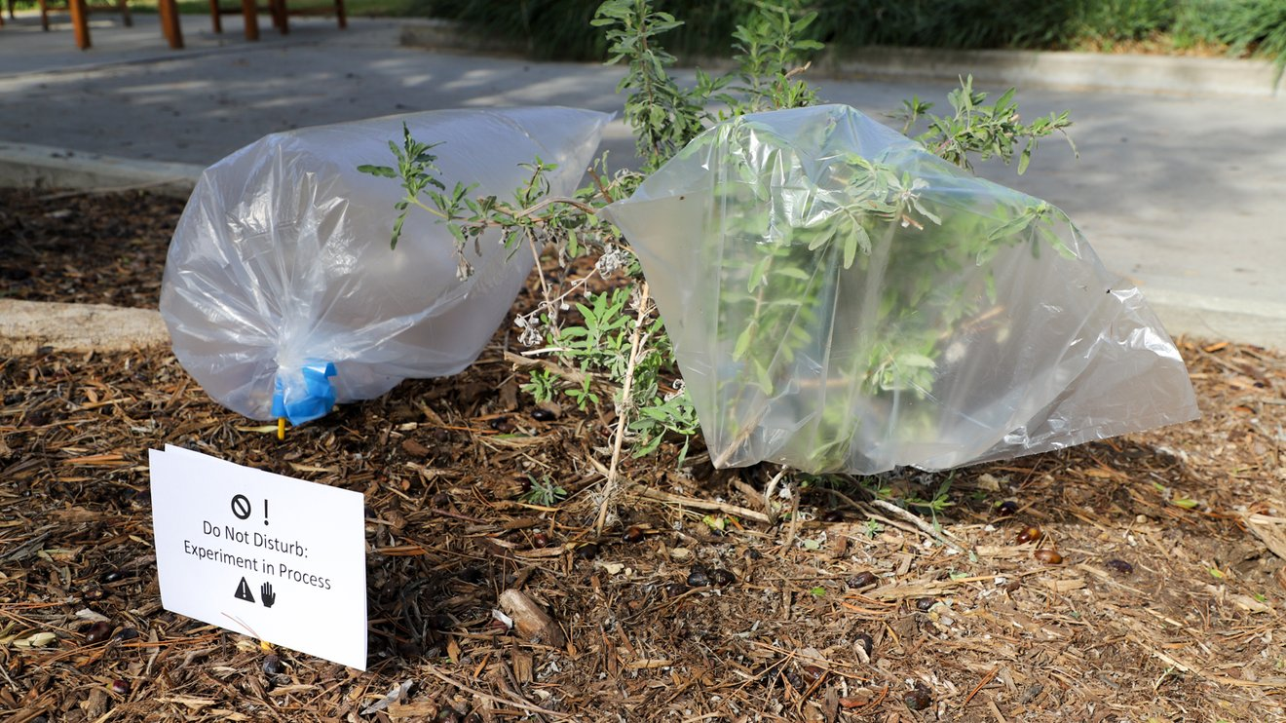
Year 5

Transpiration setup by NASA, is in the Public Domain

