What’s in a tree?
Year 5
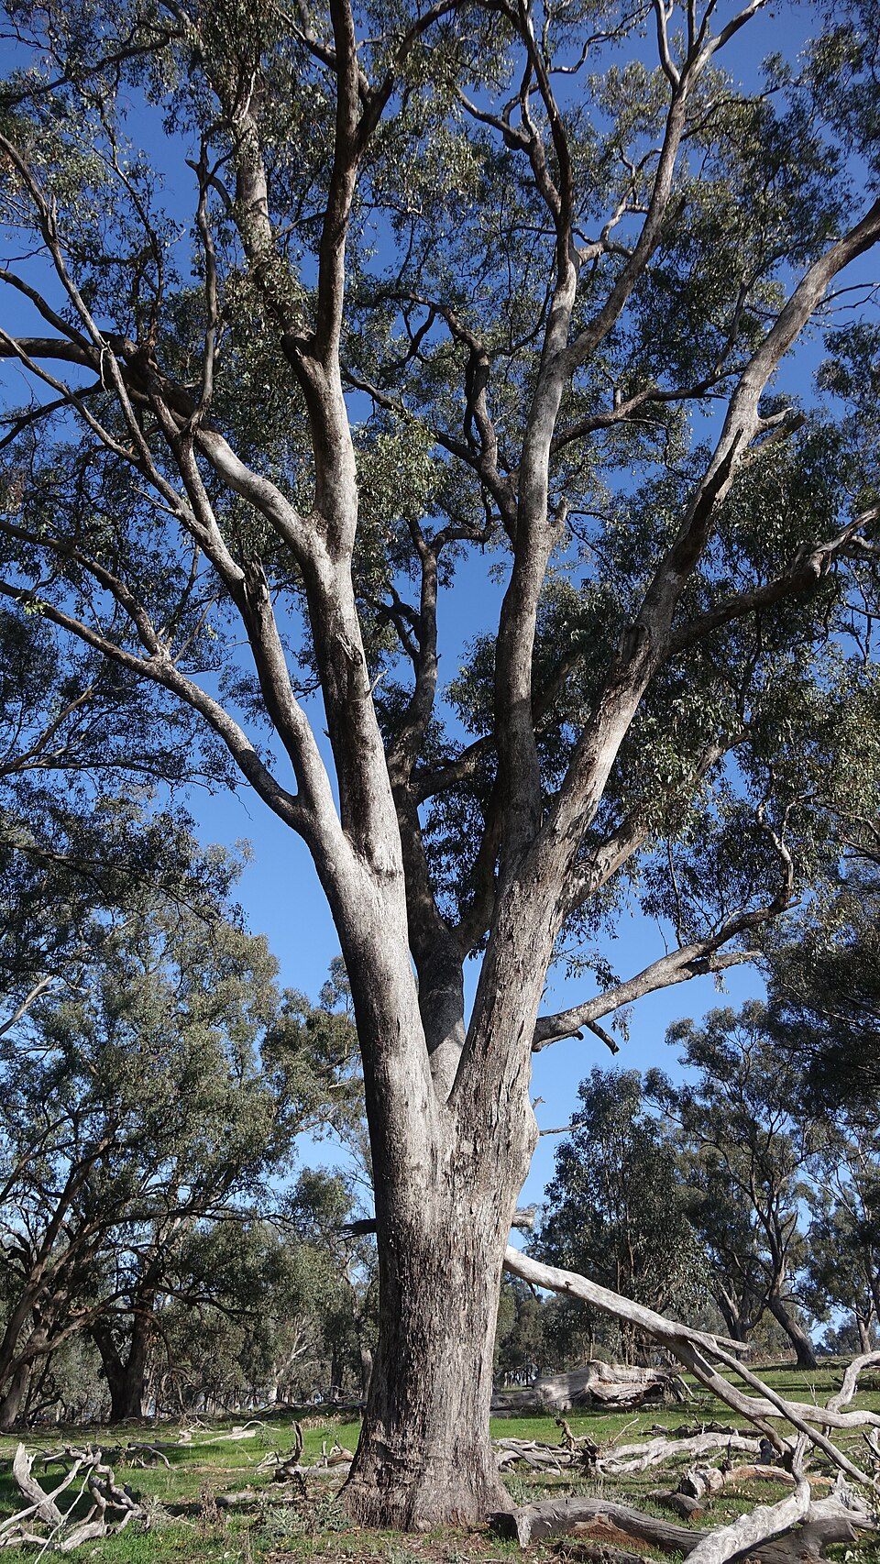
Eucalyptus microcarpa - Dookie by Neb, CC BY-SA 4.0, via Wikimedia Commons

