A sundew and a pitcher plant
Year 5

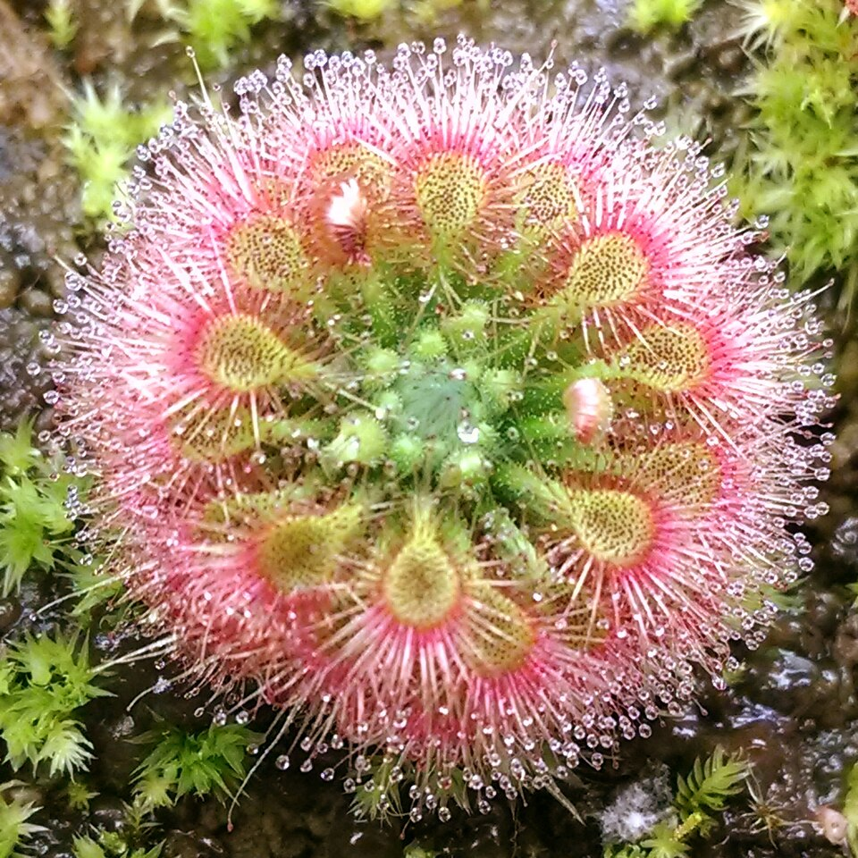
Pygmy sundew
Drosera allantostigma close, DevOhm, CC BY-SA 3.0, via Wikimedia Commons

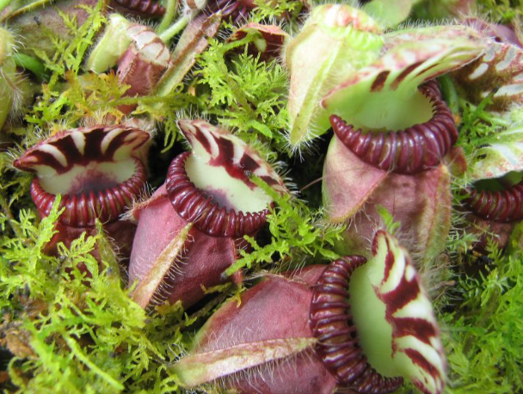
Albany pitcher plant
Albany Pitcher Plant | Cephalotus follicularis, Jean Ogden Just Chaos Photography, CC BY 2.0 via Flickr

