Aussie animal adaptations
Year 5

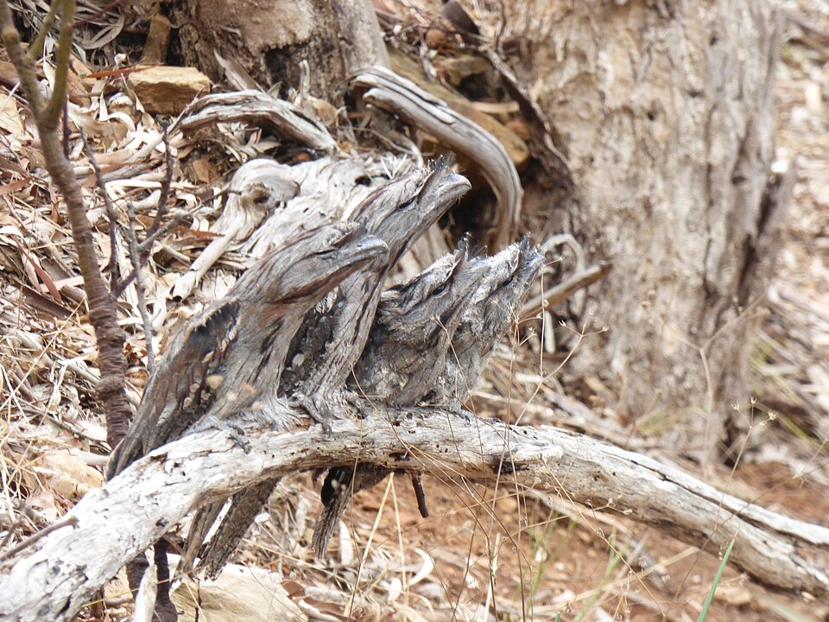
Tawny frogmouth (Podargus strigoides)

Podargus strigoides - Family of four - camouflage position, by Garrytre, CC BY-SA 4.0, via Wikimedia Commons

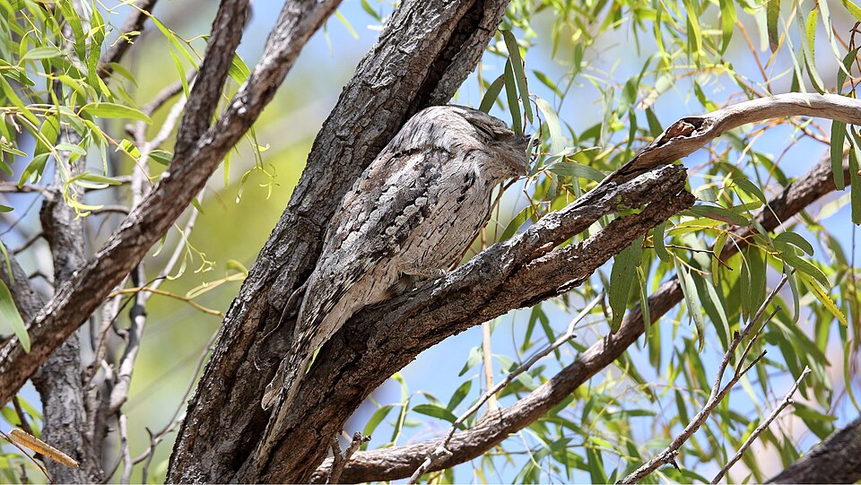

Tawny frogmouth (Podargus strigoides), by Dominic Sherony, CC BY-SA 2.0, via Flickr

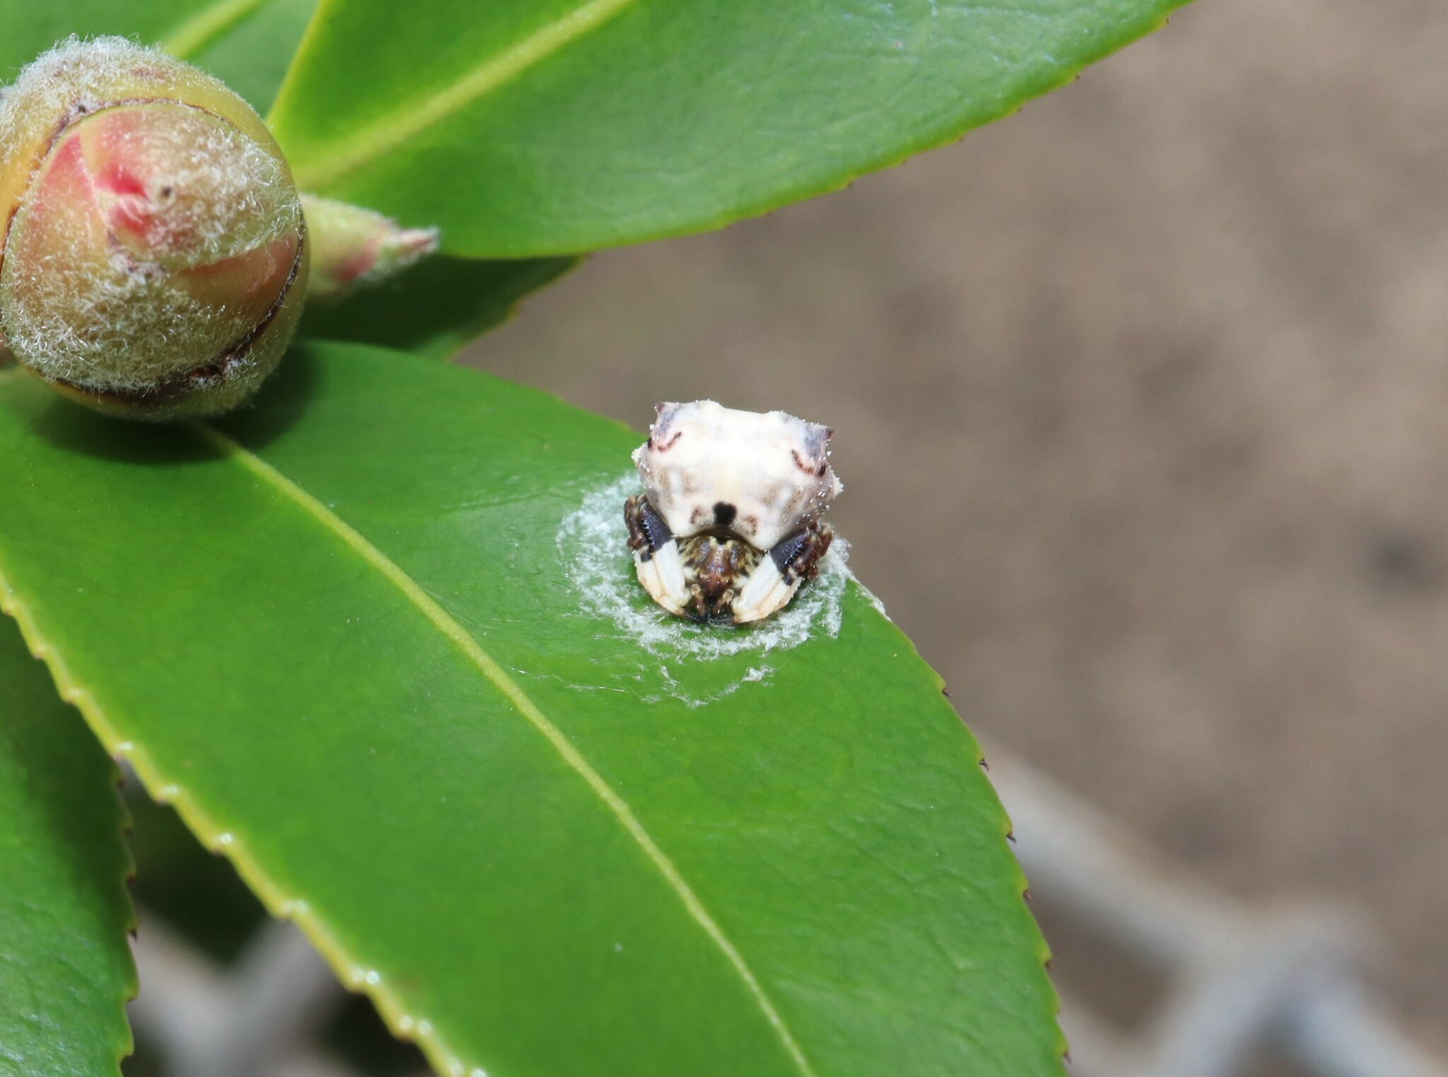
Bird-dropping spider (Celaenia excavata)

Common bird-dropping spider, by Thomas Mesaglio, CC BY 4.0, via iNaturalist

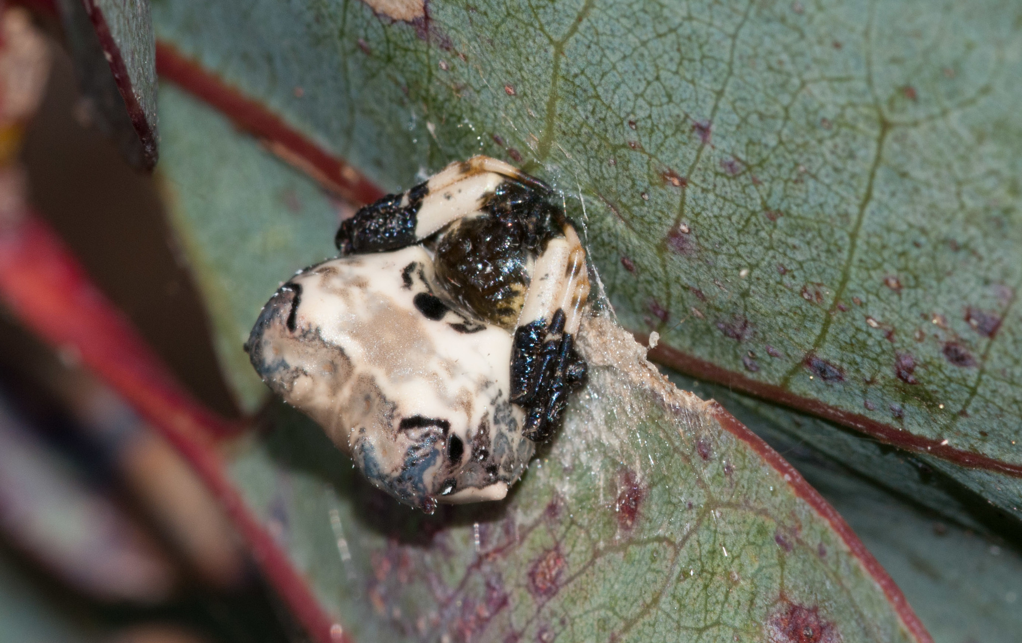

Common bird-dropping spider, by Rolf Lawrenz, CC BY 4.0, via iNaturalist

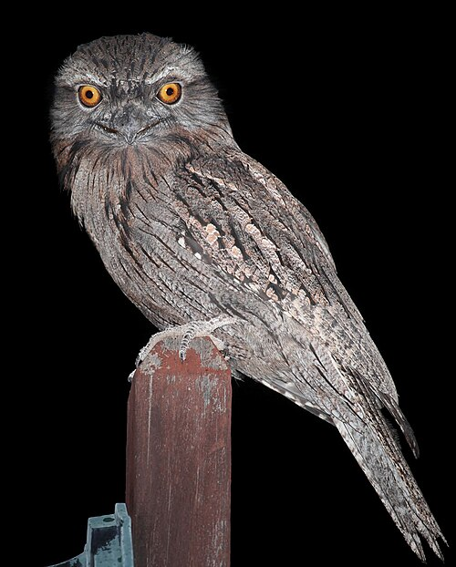
Tawny frogmouth (Podargus strigoides)
Native to Australia and found in all states and territories, the tawny frogmouth is a large, big-headed, nocturnal bird.
Tawny frogmouths have silvery grey feathers that are flecked with white, black and brown streaks. This helps them to blend into their environment.
In fact, frogmouths often choose to perch in pairs and in a section of tree that shows signs of breakage, angling their heads upwards so that they can more seamlessly blend into their surroundings.
This appearance provides excellent protection from predators during the day when the birds are resting.
As an insectivore, they survive mostly on moths, but will eat other insects such as cicadas, beetles, wasps, and ants as well as spiders, scorpions, slugs, snails and centipedes. They catch their prey with their beaks.
They are often confused with owls who are also nocturnal, however an owl is a carnivorous bird of prey that uses its strong feet to catch and eat mice and rats, small birds, lizards, snakes, frogs and fish.

Information sourced from
Wikipedia and the Australian
Museum.

Species
Classification
Genus
Kingdom
Phylum
Class
Order
Family
P. strigoides
Podargus
Podargidae
Podargiformes
Aves
Chordata
Animalia

Podargus strigoides – Christopher Watson, by Christopher Watson, CC BY-SA 3.0, via Wikimedia Commons

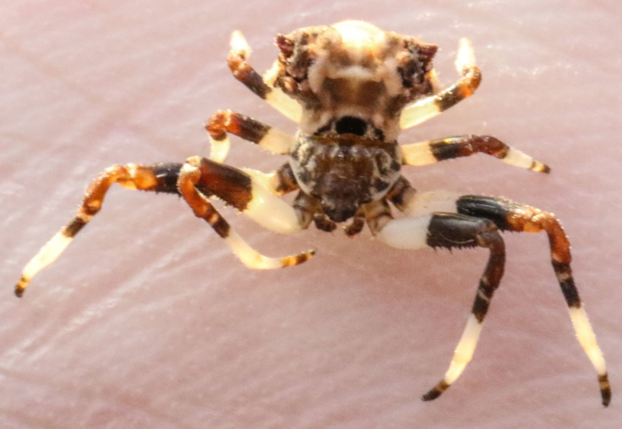
Bird-dropping spider (Celaenia excavata)
Species
Classification
Genus
Kingdom
Phylum
Class
Order
Family
C. excavata
Celaenia
Araneidae
Araneae
Arachnida
Athropoda
Animalia

With its wide triangular abdomen which is concave along the centre line, black and white colouring, rough texture and tendency to sit with its legs tucked under its body, this spider’s appearance makes it look a lot like something else–bird poo!
The bird-dropping spider can often be found on leaves during the day but is commonly overlooked by both humans and predators because of its appearance and lack of movement.
Their diet is made up almost exclusively of male moths and it uses an interesting method to catch them. At night it hangs from a short silk thread and releases a chemical scent that smells a lot like a female moth. When a male moth gets too close, deceived by the scent, the spider grabs it with its powerful front legs.
Information sourced from Australian Geographic and the Australian Museum.

Common bird-dropping spider, by Shaun Lee, CC BY 4.0, via iNaturalist

