Little Penguin (Eudyptula minor)
Year 5

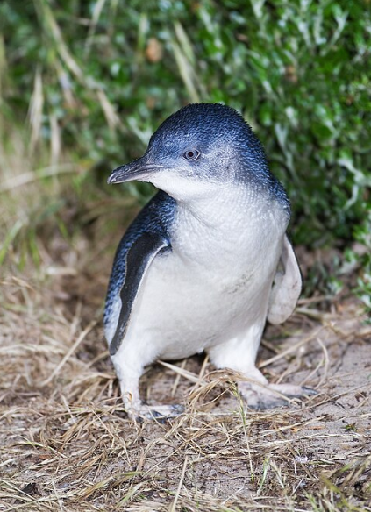
Eudyptula minor Bruny 2, by JJ Harrison, CC BY-SA 3.0, via Wikimedia Commons

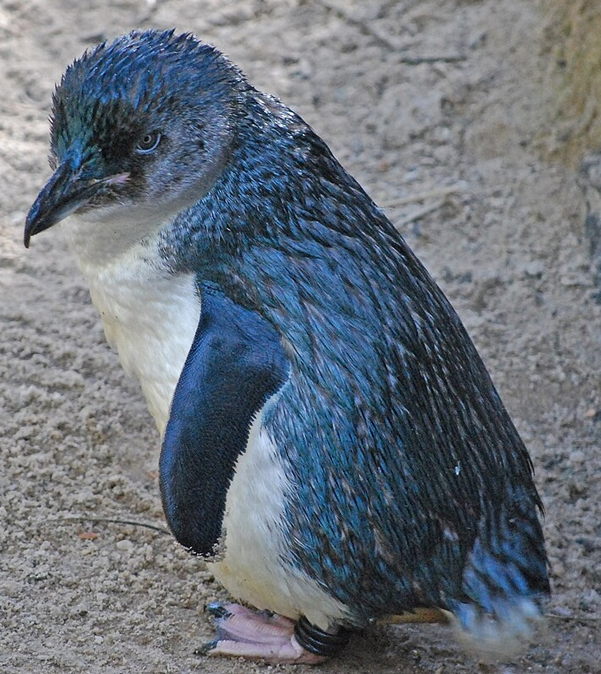

Little Blue Penguin (Eudyptula minor) -Adelaide Zoo, by Tanya Dropbear, CC BY 2.0, via Wikimedia Commons

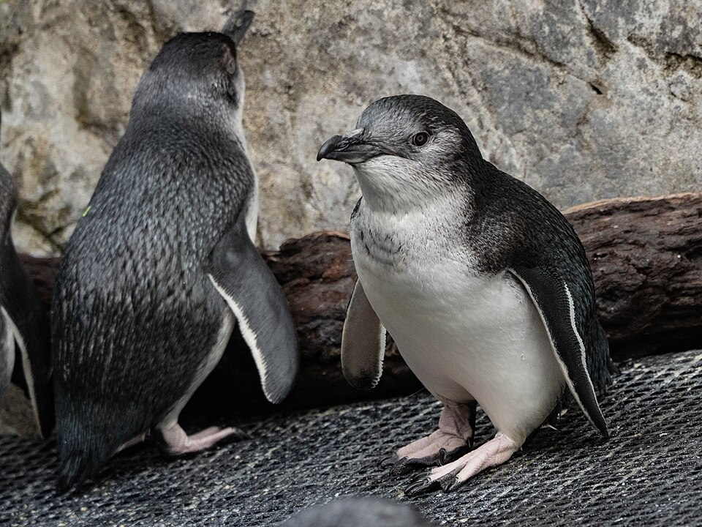

2025-03-12 Eudyptula minor Auckland Zoo 02, by Carina Gsottbauer, CC BY-SA 4.0, via Wikimedia Commons

Little penguins are the smallest penguins in the world- they stand about 30 cm tall and weigh about 1kg.

They are native to the cold waters of southern Australia and New Zealand.

They have blue/black feathers on their backs and a white underside.

They spend much of their time (about 80%) in the water looking for food.

When at sea they are at risk of being eaten both from above, by sea eagles and other birds of prey, and from below, by sharks, seals and snakes.

On land they live and raise their chick in sandy burrows dug into the dunes, or sheltered places such as caves, rock crevices or man-made structures such as nesting boxes.

Information sourced from Wikipedia and the Australian Museum.

