Animal migration and the bogong moth
Year 5

Information sourced from On the move: Exploring Animal Migration Across the Globe

Bogong moth (Agrotis infusa)
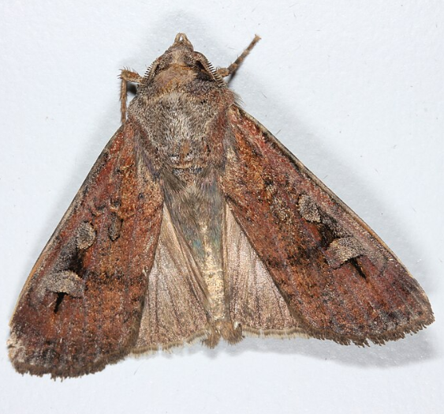
Bogong Moth, by John Tann, CC BY 2.0, via Flickr

Bogong moths are found along the lowland coastline of Southern and Eastern Australia, most commonly from South Australia to Southern Queensland, and in Tasmania. They have also been spotted in Western Australia and further inland.
During the spring, as the hot summer approaches, bogong moths from all across Australia head to the cooler mountain climate of the Australian Alps.
Once they’ve reached their destination they rest in the caves for about four months, waiting out the hot summer.
This period of dormancy, called aestivation (pronounced “ee-stuh-vay-shun”), is similar to hibernation except that it takes place in the summer months (whereas hibernation is an animal’s “winter sleep”).
During the peak of aestivation there can be up 17,000 moths per square metre!
When they wake up from this period of sleep, adult moths return to the place they were born, reproduce and then die.
By the time the caterpillars (called black cutworms) hatch the adults are all dead, meaning they grow, head to the mountains for their aestivation, the to breed all by instinct, starting the cycle all over again.
Information sourced from Wikipedia and the Australian Museum.

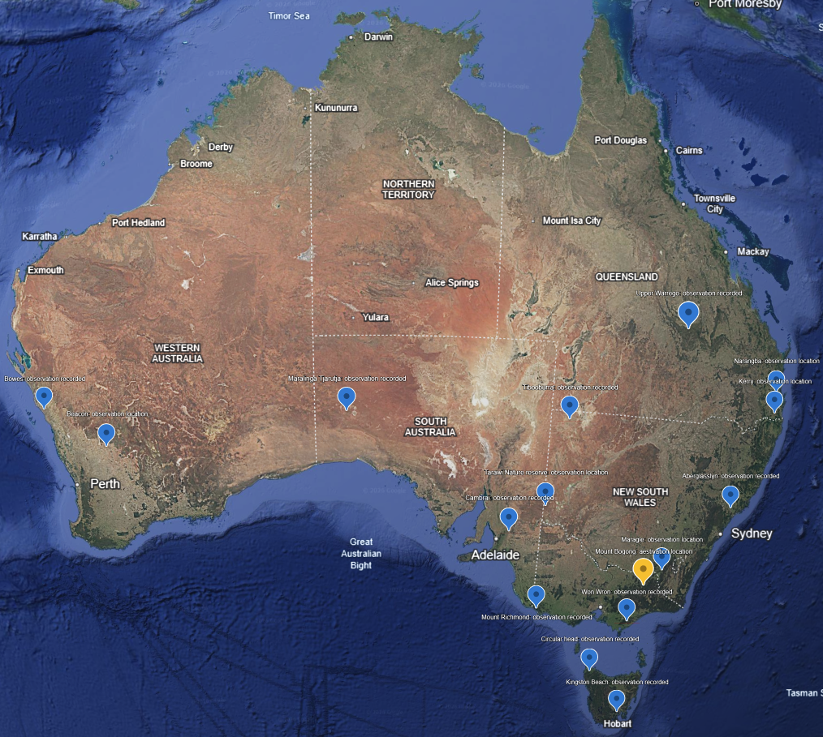

Bogong moth observations recorded
Map data ©2015-2021 Google, Data SIO, NOAA, U.S. Navy, NGA, GEBCO, Landsat / Copernicus, IBCAO, U.S. Geological Survey, PGC/NASA
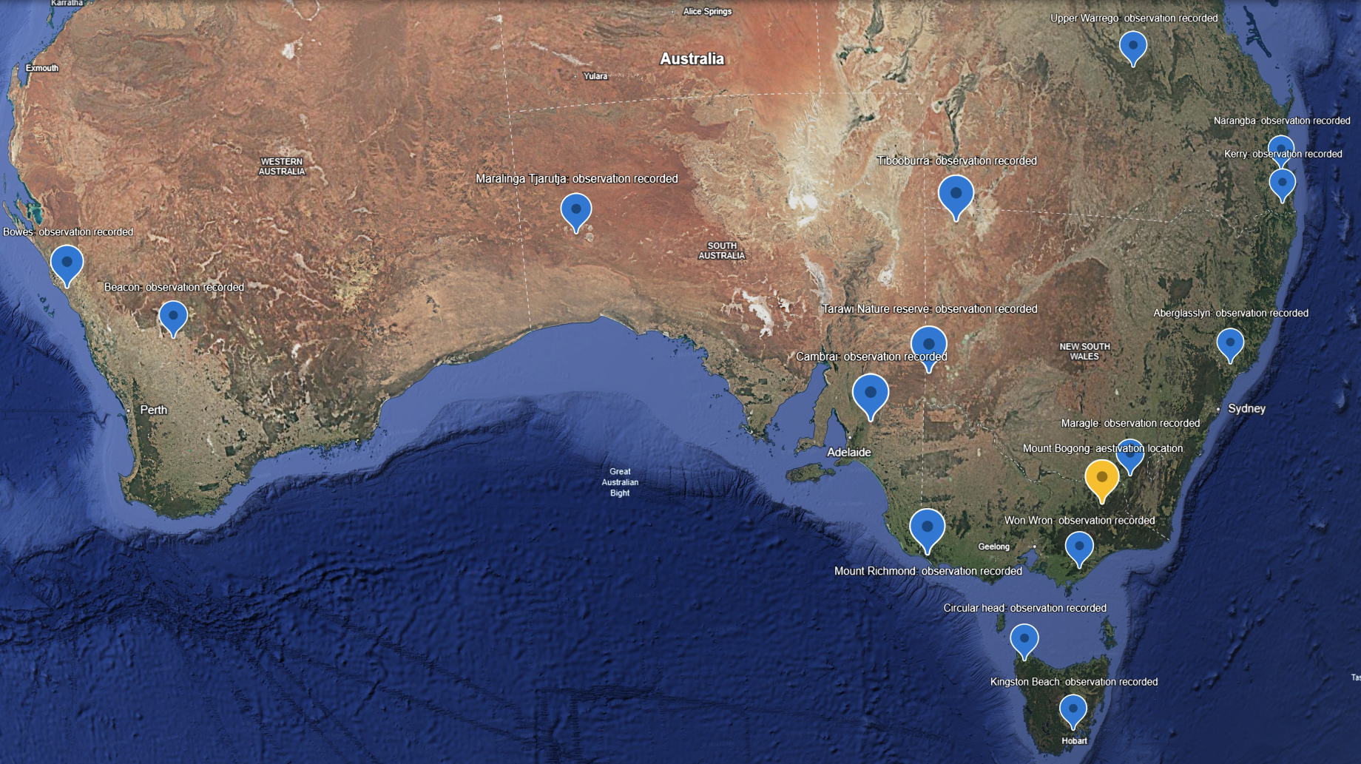
Bogong moth observations recorded: zoomed in version
Map data ©2015-2021 Google, Data SIO, NOAA, U.S. Navy, NGA, GEBCO, Landsat / Copernicus
Observation data found on The Atlas of Living Australia

