
Y5

Adapt to survive • Lesson 1 • Models in biology
Lesson 1
Launch
To read the most recent version of this lesson, download associated resources, and view embedded professional learning including classroom videos and work samples, visit: https://primaryconnections.org.au/teaching-sequences/year-5/adapt-survive/lesson-1-models-biology

Lesson overview
This lesson introduces the structural and behavioural adaptations of plants and animals that allow them to survive in a habitat and how models are used to explore and communicate scientific ideas and research.

Key learning goals
Students will:
- recognise that plants and animals have specific body features and behaviours that enable survival in specific habitats.
- identify what they think they know about these body features and behaviours that enable plants and animals to survive in specific habitats.
- experience using models to consolidate scientific ideas.
Students will represent their understanding as they:
- participate in partner and class discussions.
- share stories about their plant/animal encounters.
- ask questions about plant and animal adaptations.
- Optional: create a labelled diagram of a leaf.

Assessment advice
In the Launch phase, assessment is diagnostic.
Take note of:
- students’ ideas about structural features and behaviours of plants and animals that enable their survival in specific habitats.
- consider the ethics students bring to discussions about living things. Promoting respect for all living things is important.
See the embedded professional learning Students’ conceptions and alternative conceptions in the Elicit step of this lesson.

List of materials
Whole class
- Class science journal (digital or hard-copy)
- Optional: Demonstration copy of the Plant survivor Resource sheet
- Demonstration copy of the Habitats Resource sheet
Each group
- A different feeding tool for each student in the team, for example:
  - peg
  - toothpick
  - tweezers
  - tongs
  - wet paintbrush
- Paper plate containing items to represent a variety of foods. Select items that are different in size, shape and weight, but small enough to fit into a paper cup, for example:
  - grains of rice
  - dried lentils
  - sultanas
  - elastic bands
  - paper clips
  - paper confetti
- SAFETY NOTE: Beware of any allergies when selecting foods items for this task.
- Timer
- Feeding time Resource sheet (or students can make their own data table)
Each student
- Item Individual science journal (digital or hard-copy)
- Sticky notes/slips of paper
- Paper cup
- Optional: A green leaf, selected from the ground whilst on a walk in the school environment

Lesson routine | Estimated time | Task type
Elicit | 25 minutes | Whole class /Individual
Experience and empathise | Variable | Small group
Anchor and Connect | 15 minutes | Whole class
Question | 15 minutes | Whole class /Individual

Launch

Elicit • What do we think we know
Explain to students that over the course of this sequence they will undertake investigations about different plants and animals. This will begin by looking at what they already know, first by thinking broadly about the natural environment, before focusing in on the specific topics of plants, animals, and habitats.
The following activity is designed to elicit students’ current ideas about how the body features and behaviour of living things enable their survival. See the embedded professional learning Student conceptions and alternative conceptions for information to support you in recognising and addressing any alternative conceptions students may hold.
Note: The terms “body features” and “behaviours” are used in this lesson. The specific scientific terms “structural and behavioural adaptations” will be introduced as the sequence progresses.
Thinking broadly
Revise with students the difference between living and non-living things. Students should have already learned about this in Year 3. For this sequence it is not necessary for students to have a specific scientific definition—they might note that living things eat, breathe, move, reproduce, react, etc. This is enough for this activity.
Introduce the term “organism” as a term that identifies an individual thing that is alive. If required, clarify that anything that is considered alive (including students) can be called an organism, and give/acknowledge examples as needed.
Pose the broad question: What do living things/organisms need to survive?
Using the think-pair-share strategy (or any other brainstorming strategy you prefer), students consider what they already know in answer to the question. Record ideas in the class science journal.
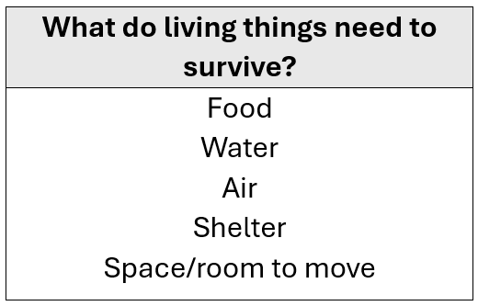
Focusing on animals
Pose the question: What body features and behaviours allow organisms to get the things they need to survive?
Students might focus on general features shared by many animals, for example “some animals have fur to keep warm”, or focus on a feature of a specific animal, for example “fish have gills to help them breathe underwater”. Share these examples with students if needed.
Students record each of their ideas on a separate sticky note/slip of paper.
Either as a class or in small groups, group similar ideas together.
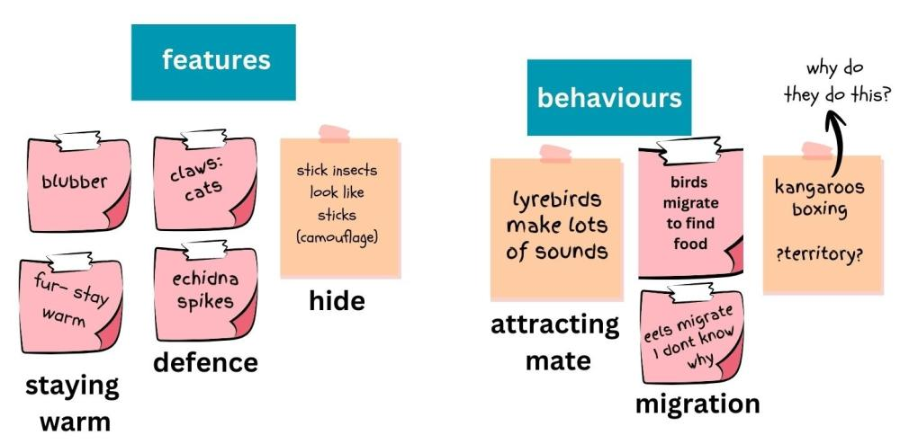
If students have shared ideas about organisms such as bacteria, fungi, or single-celled organisms, discuss why it might not be possible to investigate these types of organisms in the classroom. With the exception of mushrooms, which students often consider as plants, investigating fungi (such as mould and yeast), bacteria, and other single-celled organisms often requires the use of specialised equipment and protective measures. It is not possible or safe to investigate them in a classroom environment. For this reason, the focus will be on plants and animals that students can easily see and safely access.
Optionally, you might introduce these ideas as a discussion if appropriate for your students.
Focusing on plants
Pose the question: What body features and behaviours allow plants to get the things they need to survive?
Two activities are described below. Select the one that is most suited to your students and context.
Plants in hands
Students walk around the school grounds or local area and select a fallen leaf that is still green. They sketch the leaf and label its key features, such as colour, texture, shape, and size. Place the leaves on display on a wall or shelf to create a “leaf museum”.
Discuss similarities and differences between the size, shape, thickness, shiny coating, and smell of leaves. Explore students’ ideas about how the features may help the plant to get the things it needs to survive. Record their ideas in the class science journal.
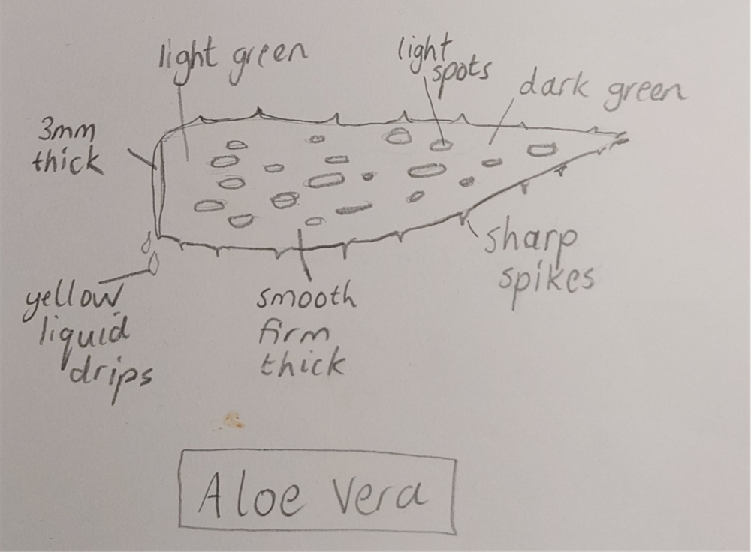
Plants on screen
Display the demonstration copy of the Plant survivor Resource sheet.
On sticky notes, for each image/plant, students write:
- one plant feature, for example: narrow leaves, brightly coloured flowers.
- what they think about how that feature helps the plant get what it needs to survive.
  - For example, they might think that narrow leaves reduce water loss, make the plant difficult for animals to eat, or attract birds for pollination.
Invite students to share their ideas and record them in the class science journal.
Focusing on habitats
Review what is meant by the term “habitat”: the natural home of a plant, animal or other organism, that typically provides the things they need to survive.
If required, distinguish between the terms “habitat” and “environment”, and explain why “habitat” is more accurate and will be used throughout this sequence:
- Environment is a broad term that includes all the living and non-living things in an area.
- A habitat is the specific location that an organism visits and where its needs are met.
- A habitat for a small skink might be a garden bed containing shrubs, leaf litter, small insects etc., whereas the environment would be the suburban area surrounding that garden bed, including the houses, roads, other gardens, and domestic animals.
Display the demonstration copy of the Habitats Resource sheet. Examine each image of a specific habitat and, based on discussions about plants and animals, encourage students to suggest ideas about the types of plants and animals (or features of plants and animals) that would be able to survive in that habitat and why they think that.
Potential discussion prompts
- Which plants or animals do you know that survive in this habitat (or that you think do/might)? Why do you think that?
- What features of the plant/animal make it suitable for this habitat?
- What features of this habitat make it suitable for this plant/animal?
- Could a plant/animal that normally lives in a desert survive in the ice or snow? Can you give me an example?

Experience and empathise • Feeding time
Working in teams of 2-4 students:
- Each team is provided with a set of “feeding tools”, a paper plate containing different “foods” (see the List of materials above for examples), and a paper cup for each student.
  - The size of the teams will depend on the number of different feeding tools available—if two different tools are available (e.g. pegs and toothpicks) students should work in pairs, if three tools are available (e.g. pegs, toothpicks, tongs) students should work in teams of three, and so on. Teams should not exceed four students.
- Each student selects a feeding tool.
- Students use their feeding tools to collect one piece of food at a time from the central plate of different foods and “feed” the food into their paper cup (which represents a stomach).
- Students collect food for a set amount of time (such as 20 seconds).
- At the end of the time limit, students count the number of food items collected in their cup and record it in a data table (students can use Feeding time Resource sheet or draw up their own table).
  - Optional: Students can also tally the types of food they collected, and how many of each.
- Students swap tools and repeat the feeding challenge several times.
Remind students not to eat any food items, and to use only their tool to collect the food and place into the “stomach”.
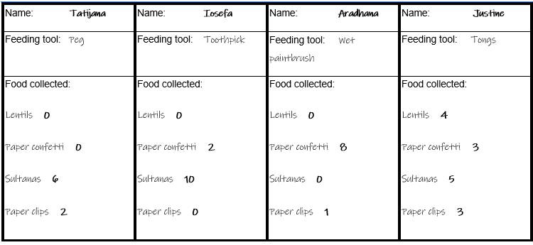

Anchor and connect • Catching prey
Share, discuss and compare the data that students collected from the feeding tool investigation.
Lead a discussion about the effectiveness of each feeding tool and why certain tools might have been more effective collecting some foods compared to others. Support students to:
- see the activity as a form of scientific modelling (see the embedded professional learning Role-play as a form of scientific modelling for more information).
- determine what they were modelling: the structure and function of animal mouths.
- determine how the structure and function of an animal’s mouth supports the animal to get the food they need to survive.
Potential discussion prompts
- Which tool collected the most food? Why do you think that was?
- Was one food type harder to collect?
- Did the shape or size of the tool make it difficult to collect the food? Was one tool okay for collecting some foods, but not others?
  - You might record some statements in the class science journal to links results with students’ reasoning. For example:
    - The toothpick could collect lots of sultanas because it's easy to poke a soft sultana with a toothpick.
    - The toothpick couldn't get into the lentil because the lentils are too hard when they're dried.
    - Tongs were good for picking up large bits of food, but couldn't pick up the small pieces one at a time.
- What would you call this type of activity? Would you agree that it is a role-play or a model?
- What do you think you were role-playing/modelling? How do you know?
  - The role-play/model represented animals grabbing and eating food.
- What did each piece of equipment used in the model (the tool, the cup, the items being collected) represent?
  - They represent an animal’s mouth/tongue/teeth, the stomach, and food source respectively.
- What animal’s mouth might have been mimicked by each tool?
  - The peg could be a crocodile’s jaws or a large bird’s beak, a wet paint brush could be an echidna or chameleon’s sticky tongue, the tweezers are like the mandibles of an ant, etc.
- How were the feeding tools used in the role-play limited in what we could experience regarding real animals feeding?
  - The tools selected were too simple to mimic a real mouth. Real mouths are complicated. The outer structures might be soft, like lips, or hard like beaks. The inner structures can include teeth and tongues of varying size, shapes and ways of moving. The tools selected for the role-play cannot mimic all of these features.
- Do you think the shape and size of an animal's mouth are related to the type of food it eats? How so? Can you give an example?
  - You might use the think-pair-share strategy to help students formulate and refine their thinking before answering this question.
- What do you think would happen to an animal if its preferred food suddenly became less available, or completely unavailable? Why do you think that?
Explain to the students that during this sequence they will investigate how the body features of plants and animals and their behaviours enable their survival in specific habitats.
If you have selected the task for the Act phase, introduce it now. For example, students will use this knowledge, along with the design process, to:
- model the adaptive features and behaviours of an existing plant or animal.
- model the adaptive features and behaviours of an imaginary plant or animal.
- (optionally) write a “cli-fi” (climate fiction) narrative to accompany their models. See Lesson 8 for more details.

Question • Generating questions
Referring to sticky notes and discussions from this lesson, use the Question Formulation Technique to brainstorm questions about structural features and behaviours of living things and how they enable their survival in specific habitats.

Reflect on the lesson
You might:
- begin a “bird watch” board and encourage students to add any birds they see locally in the coming weeks.
  - Encourage students to observe beak shapes, for example cone shape beaks (zebra finch) are for cracking nuts and seeds while longer straight beaks (superb fairywren and laughing kookaburra) are for snapping up small animals such as insects and worms
- begin a nature table in the classroom, for students to add plant and animal material such as flowers, leaves, sticks, weeds, antlers, feathers, shells and insect exoskeletons that have been shed.
- begin a word wall or glossary of relevant words and images that students will likely use throughout the sequence.
- begin a TWLH chart about plants, animals, habits and ecosystems. Use the questions generated using the QFT as the W section of the chart.

Y5

Adapt to survive • Lesson 2 • Habitat survey
Lesson 2
Inquire
To read the most recent version of this lesson, download associated resources, and view embedded professional learning including classroom videos and work samples, visit: https://primaryconnections.org.au/teaching-sequences/year-5/adapt-survive/lesson-2-habitat-survey

Lesson overview
Students explore local habitats in the school grounds, conduct a survey, and graph results. They examine adaptations in different ant species.

Key learning goals
Students will:
- recognise that habitats provide for the survival/needs of a range of plants and animals.
- identify plants and animals in a survey area.
- examine an animal (or plant) species more closely.
Students will represent their understanding as they:
- use a table to tally survey information.
- create a bar graph using survey data.
- describe how a feature or behaviour of one species helps them to survive.

Assessment advice
In this lesson, assessment is formative.
Feedback might focus on:
- students’ habitat survey and bar graph. Have students clearly represented their observations of plant and animal species?
- students’ observations about ants (or another species). Have students identified structures/functions that enable survival? Can they explain how the feature/behaviour enables survival in the habitat? What happens if the habitat changes? Why would a habitat change and what are the consequences for some species?

List of materials
Whole class
- An aerial map/Google Earth/similar which shows a birds-eye view of the school grounds
- Class science journal (digital or hard-copy)
- Demonstration copy of the Sample habitat survey Resource sheet
- Demonstration copy of the Code for caring and hygiene Resource sheet
- Demonstration copy of the Ants Resource sheet. Alternatively, see the embedded professional learning Adapting to your context in the Question step of this lesson for guidance on changing the focus of this investigation.
- Access to a safe and suitable location in or near the school grounds, to conduct a habitat survey. See the embedded professional learning Habitat survey in the first Investigate step of this lesson.
Each group
- Habitat survey Resource sheet
- Clipboard
- Pen/pencil
- Hula hoop, rope or similar to create a defined boundary
- Laptop/tablet/digital camera for photographs & videos
- Optional: Small container for specimen
- Optional: Spoon or damp paint brush for picking up safe specimen
Each student
- Individual science journal (digital or hard-copy)

Lesson routine | Estimated time | Task type
Re-orient | 5 minutes | Whole class
Question | 10 minutes | Whole class
Investigate | Variable | Whole class/Small group
Integrate | 20 minutes | Whole class/individual
Question | 5 minutes | Whole class
Integrate | 20 minutes | Small group/Individual

Inquire

Re-orient
Recall the previous learning, focusing on the different body features that enable animals to survive in their habitats.

Question • What’s around us?
Using an aerial map, Google Earth or similar display a birds-eye view of the school grounds, including buildings, ovals, gardens etc.
Re-visit the term “habitat”: the specific location that an organism visits and where its needs are met. A habitat provides the organisms that live there with food, water, shelter, and enough space to move and survive.
Discuss the types of habitats likely to be found in the school grounds and the plants and animals that might live there. Refer to the aerial map shown to locate these habitats.
Potential discussion prompts
- What habitats do we have in/close to our school grounds?
  - The answer to this question will depend heavily on your school’s location and context.
  - Some schools might have access to wetlands, ponds, and grassland, whereas others in more urban environments may have only access to garden beds, school ovals, etc.
  - Some animals have adapted to living in urban environments. Examples include insects (spiders, flies, and black cockroaches), seagulls, and possums.
  - Regardless, there will be plant and animal life living in your school grounds for students to study.
- What plants and animals survive in these habitats?
- What challenges do plants and animals face in our school grounds?
  - They might get stepped on, have balls hitting them, lawn mowers cutting them, large amounts of sun, loud sounds, etc.
Pose the questions: How can we collect data on plants and animals in the school grounds/local area? What data is needed? How can we ensure the plants and animals remain safe while we collect data?

Investigate • Habitat close up
Students survey the plant and animal species within a marked space in a habitat.

Before the habitat survey
Explain the survey procedure to students: they will identify a specific habitat in or near the school grounds, mark out a confined space using the hula hoop or rope, then carefully collect data on the plant and animal species found within that space.
Define the term “species”: a group of organisms that can naturally interbreed and produce healthy offspring/babies that are also capable of reproducing.
Discuss why scientists survey habitats, the purpose of using the hula hoop/rope, what students think they will find, and the ethics and safety considerations of looking closely at plants and animals in the school grounds.
Potential discussion prompts
- Why do you think scientists survey and study habitats?
  - To identify the number and type of organisms living there.
- What information might they collect?
- How do you think they record this information?
- Why would we only be studying a small, defined area (i.e. inside the hula hoop) instead of the entire habitat?
  - To keep the same size for each survey and help students concentrate on one representative area of the habitat.
- What other equipment (besides the hula hoop) might we use to ensure a successful survey?
  - Digital devices for photos/videos, magnifying glasses, small containers for leaf samples/invertebrates, small hand shovel (if appropriate).
- What would we need to consider if we tried to collect data in a larger area?
- What types of plants and animals do you think you will find in our school environment?
- How can you ensure not to harm the plants or animals in and around the area you are surveying?
- How can you ensure that you are not harmed when conducting your survey?
- What hygiene standards might we have to adhere to?
Optional: Create or refer to a class “code for caring and hygiene” that contains the expectations and responsibilities of students whilst undertaking the survey. An example of one can be found on the Code for caring and hygiene Resource sheet, which can be modified as needed to suit your students and context.
Display the Habitat survey Resource sheet and discuss the purpose of the tables—to record information and data about plants and animals.
Using the Sample habitat survey Resource sheet as an example of what might be found during the survey, model how to thoroughly search the specified area and record data of what was found. Focus on:
- how to list plants and animal species when we don’t know their specific name (such as “Grass 1”, “long narrow leaves”).
- the usefulness of taking photos or drawing pictures where needed.
- how to determine what is inside or outside the hoop.
  - For example, if the roots are inside the hoop or a part of an animal is in the hoop, then it should be recorded in the survey.
- searching the area methodically (perhaps top to bottom or left to right).
- drawing an identifying feature for each species, where possible.
- mapping where each species existed in the hula hoop habitat.
- whether or not students will collect a specimen to bring back to the classroom.
- how to record the species diversity with individual organism tallies.
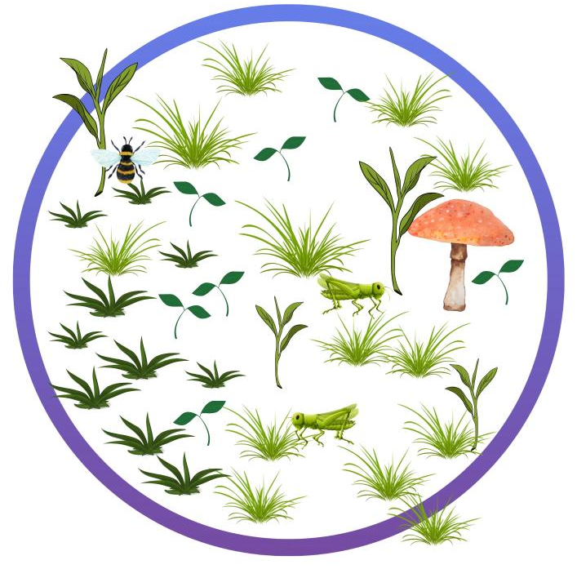
During the survey
In teams, allow students time to conduct the survey in a suitable and safe location in or near the school grounds, recording their information on their Habitat survey Resource sheet.
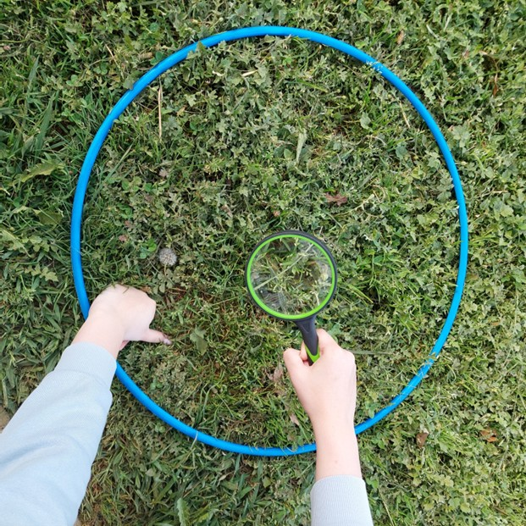

Integrate • Representing the data
In the following Integrate routine, students are guided to link their experiences surveying plant and animal species in the school grounds to the upcoming investigation, where they will look at one of the species they saw in more detail.
Through modelling, questioning and discussion, students should come to a consensus that:
- the school grounds contain a variety of living organisms.
- these organisms have features that help them to survive in this environment.
Discuss any challenges the students faced completing the survey, such as accidentally counting the same plant/animal twice, ants and beetles moving around, or plants growing close together and appearing to be one larger plant.
Ask students to help define the terms “species list” and “population count”, as the terms will be used to create a graph showing the results of the habitat survey:
- Species list: A list of all the different species (plants and animals) present.
- Population count: The number of individual organisms of one specific species.
Teams describe the results of their habitat survey, including describing the area they surveyed and the plants and animals found there. Create a combined species list of all the plants and animals found in the school/area surveyed, including any relevant descriptions students created, and a running tally of how many of each species were counted.
Students independently use their group’s data to create a bar graph showing their species list and population count. They can do this on graph paper, using digital tools, or both. If required, model how to create a bar graph by making one as a class using the collated data from the species survey.
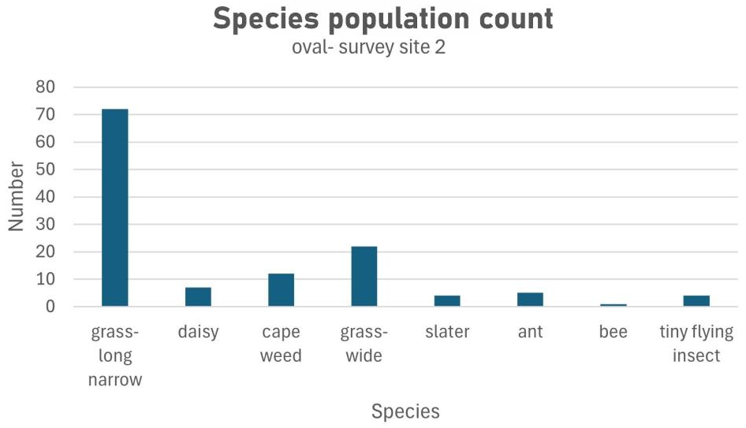
Describe and discuss other habitats in and near the school, and how the results of a habitat survey in those areas may or may not differ from the surveys students have undertaken.

Questions • Species specifics
Refer back to any ants that students observed during their habitat survey (or see the embedded professional learning Adapting to your context on changing the focus of the investigation) and determine if they were all the same type of ant, or if more than one type of ant was observed. Size and colour are often the easiest way to distinguish between sub-species of ant.
Introduce the term “family” as the umbrella term scientists use to describe animals that are similar, but that can’t reproduce together (unlike those in a species, as defined earlier in the lesson, that can). Explain that (for example) ants are all from the family Formicidae because they are all similar, but they can only reproduce with ants of the same species.
Review the definition of “species” discussed earlier in the lesson.
Pose the questions: What are the similarities and differences between species of ant? Why might they have developed these differences?

Integrate • Getting antsy
In this combined Investigate and Integrate routine, students are guided to link their observations about the structural features of an ant’s body with its habitat, food gathering, and other general behaviours.
Through questioning and discussion, students should come to a consensus that:
- different species of ants are different in size, colour and behaviour.
- their size, colour and behaviour is typically related to their habitats, and the food available in those habitats.
Using the images on the Ants Resource sheet, examine the visible shared body features of different species of ants in the ant family, and read the information provided about their behaviour, diet etc.
Using the diagram of an ant provided on page 7 of the Ants Resource sheet, identify the similarities between the body structures of the different species of ants, and how they vary. Record these similarities and differences, and any others that students note, on a T-chart.
Optional: Examine the scientific classification of ants as provided and discuss scientific classification in general. See the information found on Britannica Kids.
Look at the extreme close-up images of the black trail ant and the red bull ant found on pages 8 and 9 of the Ants Resource sheet. Identify the specific differences between the two species of ants, with a focus on their eye size and position and the size and shape of the mandibles.
- The red bull ant’s eyes are much larger and in a more forward position on the ant’s head (close to the mandibles). A black trail ant’s eyes are smaller and set further back, further away from the mandibles.
  - It may be difficult to see the specific size of each ant’s eye as they are both in close up, but remind students that a red bull ant worker is up to 3 cm long, whilst a black train ant worker is only 5 mm long.
- The mandibles of the red bull ant are long, thin, and deeply serrated. The mandibles of the black trail ant are much shorter, thicker, triangular, and not as serrated.
Review what each ant eats, and how it finds and captures its food.
Ask students to draw some conclusions about the size, shape, location of the eyes and mandibles, and how they might be related to the food it eats, how it captures its food, and any general behaviour it may exhibit.
Potential discussion prompts
- What are the visible differences between the red bull ant and the black trail ant that you can observe?
- What might be the advantages of the black trail ant being small and quick?
- Why do you think they work as a team to carry food back to the nest?
- Why do you think a red bull ant has such large eyes and exceptional vision?
- Why are their mandibles serrated?
- What body structures and behaviours can you relate to them being lone hunters?
- How do you think the ants’ different habitats influenced their body structure and behaviours?
  - To support students in answering this question, it may be helpful to look at a variety of images of the red bull ant and black trail ant in their natural habitat, available through the Atlas of Living Australia.
- What do you think might happen if these ant species were placed in another, entirely different, habitat?
- What might the consequences, both positive and negative, be?
Introduce and define the term “adaptation”: a structure, function or behaviour of a plant or animal species that helps the organism to survive in a specific habitat. Note for students that a feature of a plant or animal's body that allows them to survive is called a “structural adaptation”, and a specific behaviour is called a “behavioural adaptation”.
Discuss which features of an ant students think are structural and behavioural adaptations.

Reflect on the lesson
You might:
- add vocabulary related to adaptations and surveys to the class word wall or glossary.
- add to the W and H sections of the TWLH chart.
- search for the local community groups or organisations that monitor and are interested in entomology or animal species, or plants, for example, Coastcare or Landcare groups, lepidopterists’ societies, or gardening and biodiversity groups. Determine ways in which interested students might get into contact, with appropriate supervision, with these groups.
- construct a class map of the habitats in the school grounds. Compare data across classes. If available, compare this year’s data to data collected in previous years and consider the reasons for any similarities and differences.

Y5

Adapt to survive • Lesson 3 • Surviving the dry
Lesson 3
Inquire
To read the most recent version of this lesson, download associated resources, and view embedded professional learning including classroom videos and work samples, visit: https://primaryconnections.org.au/teaching-sequences/year-5/adapt-survive/lesson-3-surviving-dry

Lesson overview
Students use cloth or paper towels as a model to investigate the evaporation rates of leaves with different surface areas.

Key learning goals
Students will:
- use a model to investigate the evaporation rates of leaves with different surface areas.
- recognise that evaporation rates correlate with leaf surface area.
Students will represent their understanding as they:
- draw a line graph to compare the evaporation rates of folded and unfolded wet cloths.
- make a claim with supporting evidence about the effect of surface area on evaporation rate.
- participate in discussions, sharing information, experiences, and opinions.

Assessment advice
In this lesson, assessment may be formative
Feedback might focus on:
- students’ claims with supporting evidence about leaf surface area. Have students used investigation data to support their claim?
- students’ line graphs. Have they accurately represented the evaporation data?
In this lesson, assessment can also be summative.
Students working at the achievement standard for Science inquiry should have:
- planned safe, repeatable investigations to identify patterns, test relationships, and make reasoned predictions.
- identified variables to be changed, measured, and controlled.
- used equipment to generate and record data with appropriate precision.
- constructed representations to organise and process data and information and describe patterns, trends, and relationships.
Refer to the Australian Curriculum content links on the Our design decisions tab for further information.

List of materials
Whole class
- Class science journal (digital or hard-copy)
- Image of a prevalent local tree species or a tree on the school grounds, or demonstration copy of the What's in a tree? Resource sheet
- Demonstration copy of the Transpiration investigation Resource sheet (or take your own photo showing similar)
- At least 2 x large, clear plastic bags
- A means of securing the plastic bags closed around a tree branch, for example masking tape, zip ties or similar
- Demonstration copy of the Desert and forest leaves Resource sheet
- Optional: Demonstration copy of the Surface area investigation planner Resource Sheet
- Demonstration copy of the Variables grid Resource sheet
- Optional: 2 x pieces of paper of different shapes but the same surface area, for example one long and thin (1 x 9 cm) and one short and wide (3 x 3 cm)
- Optional: 1 cm x 1 cm cubes or 1 cm x 1 cm graph paper, to be used to measure the surface area of the two shapes above if using
- Digital scales
- Timing device such as a classroom clock
- Drying rack/string over a drip-proof surface
- Note: The investigation in this lesson is best carried out on a sunny day, as it will yield results more quickly. However, it will still work in other conditions, it just may take a longer time to observe results. Consider the season/weather when planning this lesson. In colder months, or overcast weather, you may need to begin the investigation early in the week, and return to finish the lesson on a later day.
Each group
- 2 x absorbent cloths or pieces of paper towel
- 2 x binder clips/bulldog clips
- Water
- Masking tape to name clips
Each student
- Individual science journal (digital or hard-copy)
- Surface area investigation planner Resource Sheet

Lesson routine | Estimated time | Task type
Re-orient | 10 minutes | Whole class
Question | 10 minutes | Whole class
Investigate | Variable | Whole class
Integrate | 20 minutes | Whole class
Question | 15 minutes | Whole class
Investigate | 30 minutes | Whole class/Small group
Integrate | 20 minutes | Whole class/Individual

Inquire

Re-orient
Recall the previous lesson, focusing on the plants found during the habitat survey and their leaf size and shape.
Brainstorm what students think they know about leaves and record it in the class science journal.
Referring to the data/graph from the previous lesson, discuss which type of plant was the most common in the school environment and why students think that was the case.

Question • What's in a tree?
Show students an image of a prevalent local tree species or a tree on the school grounds, or use the image on the What’s in a tree? Resource sheet.
Ask students to name the main parts of the tree, including those that can be seen and not seen (trunk, branches, leaves, roots), and what they know about each part.
Focus students’ attention on the tree’s roots and discuss their function: to draw in water and nutrients to the tree.
Pose the question: Where does the water a tree absorbs go? Does it all stay in the tree?

Investigate • Where does the water go?
The following investigation is best carried out on a sunny day, as it will yield results more quickly. However, it will still work in other conditions, though it may take a longer time to observe results. Consider the season/weather when planning this lesson. In colder months, or overcast weather, you may need to begin the investigation early in the week, and return to finish the lesson on a later day.
Explain to students how the investigation will be carried out: a plastic bag will be secured around the leaves of a healthy green tree for a few hours/days. Students will then make careful observations of what can be seen inside the bag to see if anything has changed. Use the image found on the Transpiration investigation Resource sheet (or prepare your own) to support students to visualise how the investigation is set up.
Ask students what claim about trees and water they think the investigation might be testing and why they think that. Students should have learned about evaporation and condensation in Year 4 Earth and space sciences, and may have already learned about the three states of matter as it appears in Year 5 Chemical sciences.
If required, present the claim to students that trees lose water through their leaves.
Discuss how the investigation might show the claim to be supported or incorrect.
Find a suitable tree/trees in the school ground and attach clear plastic bags as securely as possible, using either masking tape, zip ties (take care not to make them too tight and cut into the tree) or similar. Ensure that plenty of live leaves are inside the bag and that the bag is sealed around the stem/branch.
Place a “dead” stick (one no longer attached to a live tree and quite dried out), a pencil, or other piece of wood (that is approximately the same thickness as the stem/branch attached to the live leaves) into a plastic bag. Place the bag near the live leaves.
Ask students why the stick has been included in the investigation, and explain, if necessary, that this will allow students to compare the effects of live wood and leaves to those of dead wood. Any differences will be a result of this single variable.
Consider using labels or a sign to warn other members of the school community that a science investigation is in progress, to prevent anyone from “cleaning up” the bags.
Leave the plastic attached to the tree for long enough that condensation begins to form inside the plastic bag. The time frame required will depend on the weather. Periodically send students to make observations of the live and dead wood.

Integrate • Transpiration
In the following Integrate routine, students are guided to link their experiences and observations in the investigation to the science concept being explored—that is, living plants lose water through their leaves, and that this process is called transpiration.
Through questioning and discussion, students should come to a consensus that:
- trees and other plants lose water through their leaves.
Once enough time has passed that condensation can be observed inside the bags wrapped around the leaves, the investigation can be concluded.
Take students to observe the bag/leaves and discuss their observations in situ.
Potential discussion prompts
- What can you see inside the plastic bags wrapped around the live leaves?
  - Students might describe the condensate that has formed as steam, sweat, fog etc. That is fine at this stage.
  - If students use the term “sweat” it might be necessary to think about the different meanings of that word to avoid reinforcing misconceptions. See the embedded professional learning Condensation and “sweat” for more information.
- What do you think it is made of?
- Where do you think it comes from?
- Is the same thing present in the plastic bag wrapped around the stick we used as a control?
  - If the dead wood was completely dried out, and the plastic bag was completely dry, there should be no condensation present. If there is water present, it is important to discuss with students where it came from. For example, it may have been formed by a water droplet getting into the bag or by moisture still inside the wood. You might test the wood by attempting to break it. If moisture is still present the inside might still appear green, rather than completely brown.
- Why do you think that is?
After returning to the classroom, if required, introduce the term “condensation”: the process where water droplets are formed when water in its gaseous state (water vapour, steam, fog) contacts a cooler surface or cooler air and reverts to its liquid state.
Present (or re-present) the claim that trees lose water through their leaves and ask students if and how they think the investigation supports that claim. Students should conclude that the presence of condensate in the plastic bag around the leaves shows that water vapour must be escaping from the leaves of the live plant. The absence of any water vapour in the bag around the dead wood confirms that living trees, and indeed all other living plants, lose water.
Introduce the term “transpiration”: the process of trees and other plants losing water through their leaves.

Question • Desert leaves vs forest leaves
Display a demonstration copy of the Desert and forest leaves Resource sheet.
Discuss the visible similarities and differences between the leaves of the two plants on display, the mulga (Acacia aneura) and the mountain ash (or giant ash, Eucalyptus regnans), and the habitat of each tree species.
Potential discussion prompts
- How are the leaves similar?
  - Both are growing from a branch, both are green in colour.
- How are the leaves different?
  - Mulga leaves are narrow, straight, silvery-grey and mostly pointed upwards.
  - Mountain ash leaves are darker green, with no silvery tinge. They are wider, larger and are mostly pointing towards the ground.
- What type of habitat do you think both tree species typically grows in? Use the visual clues in the images to support your thinking.
- What is different about these two habitats?
  - The mulga grows in flat grasslands, where there is much less rainfall—typically between 50 ml to 250 ml per year (although it can survive in places with up to 500 ml rainfall per year). It is found in Western Australia, the Northern Territory, South Australia, Queensland and New South Wales, mostly in the drier parts of those states.
  - The mountain ash grows in cool mountainous areas that receive a lot of rainfall—at least 1000 ml a year. It is common in Victoria and Tasmania.
- Now that we know that trees lose water through their leaves, why do you think we might be investigating more about the size of leaves and the relationship between leaf size and habitat?
- What structural adaptations might the trees have to be best suited to these different habitats?
- Which of the tree species has smaller leaves? Why do you say that?
- Do you think that the size of a leaf affects how a tree survives?
Explain that describing the leaves as “bigger” or “smaller” can sometimes be ambiguous, vague and inaccurate, and that there is a better way to determine the size of something.
Introduce the term “surface area”: a measure of how much of an object is in contact with the outside world (often the air). Record an agreed definition of surface area in the class science journal.
Optional: You might demonstrate surface area by showing students two pieces of paper (with the same surface area, but don’t explain this yet), one long and thin (1 x 9 cm) and one short and wide (3 x 3 cm). Discuss what students think of the size of the pieces of paper, if one is larger than the other, and why/why not. Demonstrate that the surface area is the same by covering the paper in 1 cm x 1 cm cubes or 1 cm x 1 cm graph paper. Conclude that two items might appear to be different sizes because of their shape, but their surface area may be the same.
Pose the question: Now that we know that trees lose water through their leaves, does the size of the leaves affect how much water they lose? Or in simpler terms, Do big leaves lose more water than small leaves?

Investigate • Modelling transpiration
Explain to students that they will use folded or unfolded cloths as models for different sized leaves as a means of investigating if a leaf’s surface area has an impact on how much water it is able to retain/lose. They will wet the cloths and then collect data on how much water is lost over time, by weighing the cloths on digital scales a minimum of twice at appropriate intervals.
NOTE: The length of the intervals will be dictated by the climate and the weather conditions on the day of the investigation. In warmer weather the cloths can be expected to dry more quickly, so data should be collected every 15-30 minutes. In mild to cool conditions data can be collected at hourly intervals. It may be helpful to consult the weather forecast and conduct your own informal test investigation the day before to determine the right interval. Discuss/explain this to students if appropriate.
Explain that when scientists want to test, explore, or investigate phenomenon that require intricate equipment, sometimes they will build and use a model. For biologists (scientists that study living things), models provide insights without having to use (and potentially harm) real specimens.
In this case using absorbent cloths as a stand in for leaves is an efficient classroom model because the cloths hold water that is then evaporated at different rates depending on the conditions. Transpiration is one type of evaporation (the evaporation of water from leaves into the atmosphere).
Discuss with students the advantages and disadvantages of using models, and how the cloths replicate the two different leaf shapes looked at, the mulga (the wrapped cloth) and the mountain ash (the open cloth).
Pose the general question: What things might affect how much water a cloth loses over time?
Using a demonstration model of Variables grid Resource sheet, record what students will be measuring in the centre of the grid (water loss) and mark it with an “M”. Brainstorm and record possible variables for the investigation around this. These might include the type of cloth, the size of cloth, the temperature of the classroom, the location of the cloth (in the breeze or not), the exposed surface area of the cloth etc. Add or remove columns and rows as required.
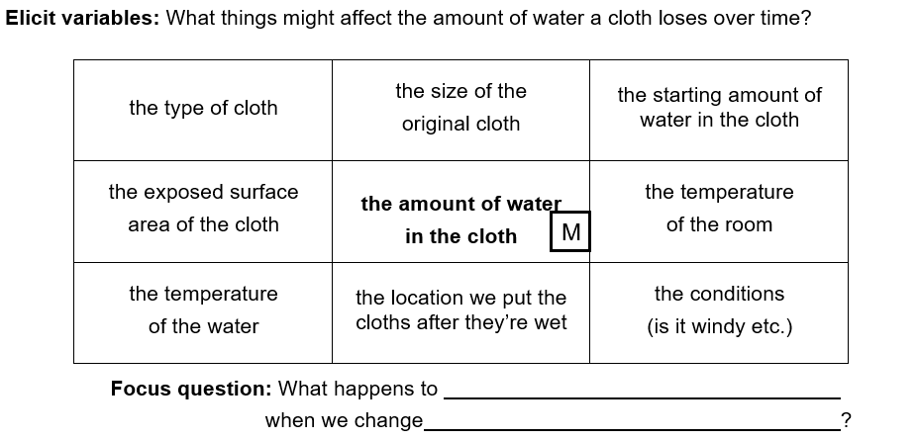
Mark what is going to be changed (the surface area of the cloth) with a “C”, and what is going to remain the same (all the other variables) with an “S”.
Model how to use the question stem to write a question for the investigation: What happens to the amount of water in the cloth when we change the exposed surface area of the cloth?
Use a demonstration copy of the Surface area investigation planner Resource sheet to discuss in more detail how to plan the investigation, conduct the investigation, and record data, if required.
Discuss how to change the exposed surface area of the cloth while controlling the other variables, for example:
- fold the second cloth in half four times and fix it together with a binder clip. The first cloth will stay flat with a binder clip attached to the side for consistency.
- the amount of water in each cloth needs to be the same at the beginning. This can be achieved by squeezing water out until they weigh the same or by measuring how much water to put on them.
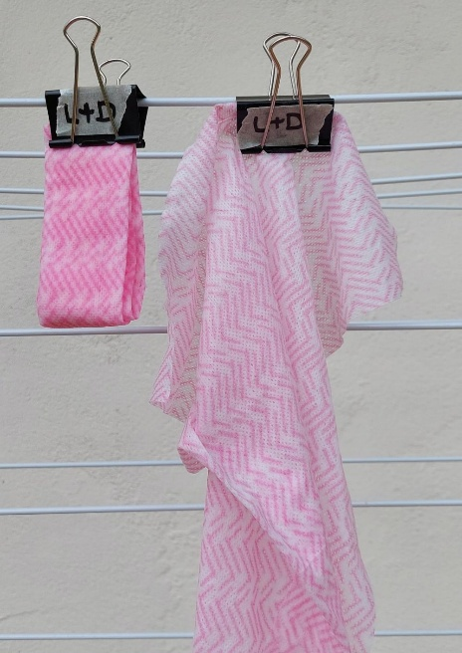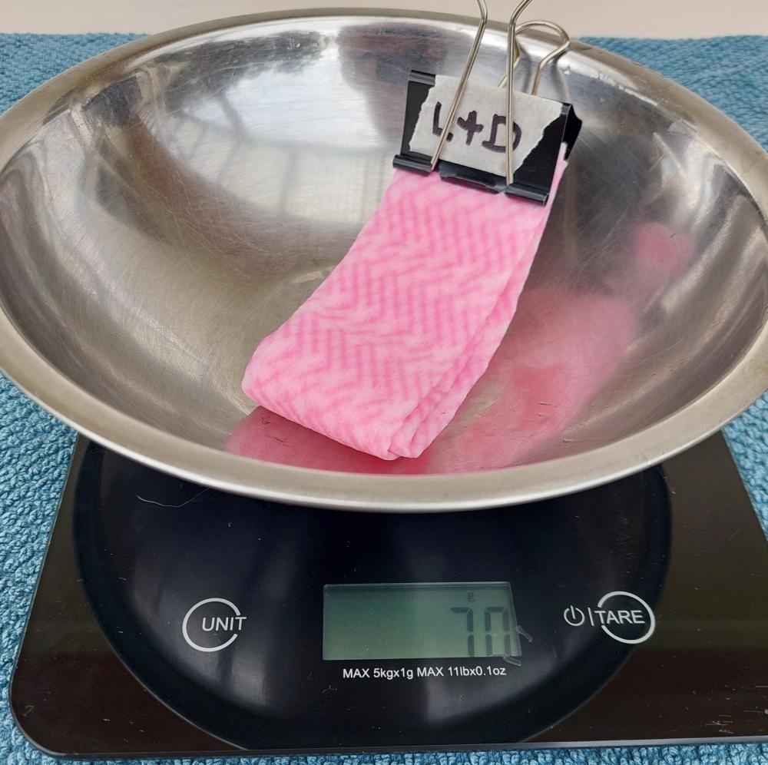
In collaborative teams, students plan and conduct their investigation, recording their results using pages 1 and 2 of the Surface area investigation planner Resource sheet. Ensure all students first complete the “predict” section of the planner before beginning the investigation process.

Integrate • Changes over time
In the following Integrate routine, students are guided to link their experiences in the investigation to how surface area can affect how much water a tree loses—leaves with large surface areas lose more water than smaller ones—and that trees in drier habitats often have the structural adaptation of smaller/narrower leaves to help retain water because they have less access to it.
Through questioning and discussion, students should come to a consensus that:
- smaller leaves lose less water.
- plants in drier environments have structural adaptations of smaller leaves to help retain water.
Students share the results of their investigations, specifically how the mass of each cloth changed over time.
Discuss the change and compare it to students’ initial predictions. Encourage students to probe deeply into groups’ results (and later in the discussion, their claims) using the science question starters.
Optional: If each group used the same brand/type of cloth in the same size and folded in the same manner (so their results are comparable), record the groups’ results of how the mass of the cloth changed over time in the class science journal and determine the average change. Alternatively, you might talk about the differences in groups’ results and how these factors contributed to these differences.
Discuss with and model for students how to construct a line graph to visually represent the data they recorded, including:
- the conventions of constructing a scientific graph: the vertical (or $y$) axis usually represents the variable we measure, and the horizontal (or $x$) axis represents the variable that we change.
- how to draw the two axes and what scale to use on the $y$ axis, for example, one box represents 10 g.
- how to draw two lines on their line graph in different colours, one for each cloth “shape”.
- how to record which cloth corresponds to which colour on the graphs using a key.
- how drawing two lines allows you to compare what is happening in each cloth.
If students are already experienced in constructing line graphs, they can do this independently. You might also provide them with exemplar line graphs and allow them to identify the key features before constructing one on their own.
Students analyse their graphs to look for patterns and relationships, and to make a scientific claim, supported by evidence, about leaf shape and its relationship to the habitat a tree might live in.
Potential discussion prompts
- What “story” does your graph tell?
- Did the different cloths lose a different amount of water over time? What data supports your answer?
- Which cloth type lost more water?
- Was that what you predicted? Why do you think the result was different from your prediction?
- What claim can you make about which type of cloth loses more water? For example, “Cloth A lost more water because it weighed less after # time.”
- How do you think this might relate to the shape of leaves in different habitats?
- What type of leaves did the tree living in the wetter habitat have?
- What type of leaves did the tree living in the drier habitat have?
- Why would their leaves be shaped differently, and how is this difference influenced by their natural habitats?
- Do you still agree with the reasons you provided for your predictions?
- How does the data of the investigation confirm or change your thinking?
- From these results, what claim could be made about the structural adaptations of plants that might help prevent water loss?
  - Leaves with a smaller surface area help plants survive because they lose less water through transpiration.
- What evidence do you have to support your claim?
  - The model of the folded cloth with a smaller surface area weighed more after # hours because it retained more water.
Explain that the claims about plants need to be conditional (using the word “could”) since the results are based on a model and not actually biological samples of plants in dry habitats. For example, “Having leaves with smaller surface area could help plants survive because there is less leaf surface for transpiration to take place.”
Further explain the reasons plants in drier habitats have smaller leaves, such as:
- Plants have openings in their leaves, called stomata, through which transpiration occurs.
- Having smaller and fewer leaves decreases the number of stomata and therefore the amount of water loss/transpiration.
- Some plants also have fewer and smaller stomata.
- The plants’ stomata close to reduce water loss.
Optional: Take an observation walk through the school grounds to consider and compare leaf surface area and the likelihood that the plant is adapted to dry conditions. Alternatively, leaves collected for a nature table or leaf gallery (from Lesson 1) could also be used.
Optional: Invite a botanist to attend the classroom (virtually or physically) to provide some local examples. Ask a horticulturalist or farmer to explain what they do to support their plants in hot weather.
Optional: Investigate other plant adaptations for dry conditions, for example:
- View the video David Attenborough—The fascinating life cycle of desert plants (5:41).
- Carry out a waxy leaves investigation: Discuss how wet cloths could also be used to investigate the claim that waxy coatings on leaves help to reduce water loss. For example, by comparing two wet folded cloths, with one wrapped in baking paper.

Reflect on the lesson
You might:
- add vocabulary related to surviving in dry environments to the class word wall or glossary.
- add to the W and H sections of the TWLH chart.
- revisit initial brainstorm and add to it—this represents what you learned.
- discuss how the learning from this lesson will be relevant for building a model of a plant or animal’s adaptations, including:
  - using alternate materials when modelling.
  - leaf adaptations that enable survival in habitats with limited water.
  - where else might models be useful in considering how things work?

Y5

Adapt to survive • Lesson 4 • Carnivorous plants
Lesson 4
Inquire
To read the most recent version of this lesson, download associated resources, and view embedded professional learning including classroom videos and work samples, visit: https://primaryconnections.org.au/teaching-sequences/year-5/adapt-survive/lesson-4-carnivorous-plants

Lesson overview
Students explore Australian carnivorous plants then create models to simulate two different trapping adaptations

Key learning goals
Students will:
- recognise that carnivorous plants survive in nutrient poor soils by using structural/functional adaptations to obtain nutrients.
- identify the different trapping structures of Australian pitcher plants and sundews.
- use models to investigate how different structural adaptations help carnivorous plants capture prey and compare their effectiveness.
Students will represent their understanding as they:
- create models to represent trapping adaptations.
- contribute feedback during the gallery walk to improve models.
- create labelled diagrams to identify carnivorous structural features.
- refine models and testing methods to best represent carnivorous adaptations.

Assessment advice
In this lesson, assessment is formative.
Feedback might focus on:
- students’ carnivorous feature models. Can students use feedback from the gallery walk to refine their representations?
- labelled diagrams. Have students clearly labelled their model diagrams to show the carnivorous features they represent?
- the feedback students contribute during the gallery walk to improve models.

List of materials
Whole class
- Class science journal (digital or hard-copy)
- Demonstration copy of the Sundew and pitcher plant Resource sheet
- Real life carnivorous plant (optional)
- Videos:
  - Australia is a hotspot for carnivorous plants (7:33)
  - Drosera erythrorhiza sticky droplets (0:15)
  - Drosera salina (salt lake sundew) in the wild (1:00)
  - Australian pitcher plant traps slater (0:21)
  - Wild carnivorous plants—Albany pitcher plant (5:16)
- Magnifying glasses (optional)
Each group
- Tub/container partially filled with sand
- Small paper insects or beads
- Sticky tape/masking tape strips
- Small cups/jars with a little water
- Food colouring for water (optional)
- Construction materials such as cardboard, scissors, textas
- Sticky notes
Each student
- Individual science journal (digital or hard-copy)
- Carnivorous plant modelling Resource sheet

Lesson routine | Estimated time | Task type
Re-orient | Variable | Whole class
Question | 10 minutes | Whole class
Investigate | Variable | Whole class/Small group
Integrate | Variable | Whole group/Small group

Inquire

Re-orient
If required, allow time to review and make observations about the leaves placed in the bag in the previous lesson.
Review and discuss the data collected last lesson about leaf surface area and evaporation rates.
Potential discussion prompts
- What difference does surface area make to the evaporation of water from cloth?
- Do you think the type of cloth matters?
- Could changing other conditions change the data?
How does this model relate to plants?

Question • What plants need
Discuss and brainstorm what students think they know about the things plants need to survive.
Potential discussion prompts
- What do plants need to survive?
  - Light, water, nutrients, shelter.
- What are nutrients, and what sort of nutrients do you think plants need?
  - Plants need small amounts of key minerals from the soil to survive. All their energy needs are produced through photosynthesis.
- Can plants survive without these things?
- Where do you think plants draw their nutrients from?
Pose the question: How do you think plants survive in soils with very few nutrients?

Investigate • Comparing carnivorous plant traps
In this investigation, students learn about two specific Australian carnivorous plants, then use models to support them to better understand the plants’ trapping structures.
Ask students what they think the word “carnivorous” means: something that relies primarily or exclusively on the flesh of other animals to get their nutrients. Ask if they think plants can be carnivorous. If students think carnivorous plants exist, record what they think they know about carnivorous plants and the reason for this adaptation in the class science journal.
Confirm that carnivorous plants do exist, and that in fact Australia has one of the world's most diverse carnivorous plant floras, with around 250 recognised species.
Show the video Australia is a hotspot for carnivorous plants (7:33) to demonstrate the diversity of Australian carnivorous plants due to our low-nutrient soils.
Students share something they found interesting or something new they learnt about carnivorous plants from the video. Record their ideas and any questions they have in the class science journal.
Ask if they have observed carnivorous plants in their local environments. Discuss where they now think carnivorous plants might exist.
Using the demonstration copy of the Sundew and pitcher plant Resource sheet discuss the different structural features of each plant. Allow students time to share their ideas first, before explaining/confirming that:
- Drosera (sundew) has fine hairs that produce a sticky dew-like substance to attract and trap prey. The dew contains digestive chemicals/enzymes to break down prey so the nutrients can be absorbed by the leaf.
- Cephalotus follicularis (Albany pitcher plant) has a pitfall trap filled with digestive liquid. The prey falls in and cannot escape. You may need to discuss the meaning of the term “pitcher”—a large container for liquids.
- These structural features allow the plants to absorb nutrients from prey that they cannot get from the soil. Carnivorous plants are a good example of a plant adaptation. They adapted other nutrient-gathering strategies to enable them to live in nutrient-poor soils.
Show some videos of sundews and pitcher plants in their natural habitats with a focus on their carnivorous adaptations, for example:
- Drosera erythrorhiza sticky droplets (0:15)
- Drosera salina (salt lake sundew) in the wild (1:00)
- Australian pitcher plant traps slater (0:21)
- Wild carnivorous plants—Albany pitcher plant (5:16)
Students work in collaborative teams to create a model that simulates the trapping structures of a sundew or a pitcher plant. Ensure that there is a spread of groups modelling each plant.
Referring to the demonstration copy of the Carnivorous plant modelling Resource sheet, discuss the criteria for the model design, for example, “it resembles the trapping structure of the plant” and “the trapping structure works in the same/a similar enough way”.
Looking at the resources available (cups, bowls, water, sticky/masking tape, cardboards, blu-tac, glue, pieces of confetti paper, small beads etc.) determine which would be most appropriate to be used for each model, for example:
- cups or bowls + water resemble the pitfall trap with the digestive juices of a pitcher plant.
- sticky/masking tape resembles the sticky dew on the fine hairs of sundew leaves.
- confetti paper represents insects falling into/landing on the trap.
Discuss ways to create and test a prototype model, including:
- For each plant, what should your model highlight?
- How can you recreate the trapping structure of each plant?
- What resource might not be useful? Why?
  - For example, blu-tac may seem like a useful resource to recreate a sundew, but it is not sticky enough to “capture” items falling past it.
- How might we test the trapping structure? What could we use?
- To test the trapping feature, how should we drop the fake bugs? Directly from above? Thrown from a distance?
- How do these fake bugs differ to real insects?
- How do the models differ to actual carnivorous plants?
Referring again to the Carnivorous plant modelling Resource sheet, discuss why students think the prototyping process has been structured in the following way:
- Design, build and test first protypes.
- Personal and peer feedback.
- Refine design, build and test second prototypes.
- Consider opportunities for further improvement.
Students should design the models themselves, but if required, provide students with the following examples.
Sundews | Pitcher plants
Place strips of sticky tape or masking tape onto cardboard or other flat surface. | Place cups/jars upright in the sand and add a small amount of water.
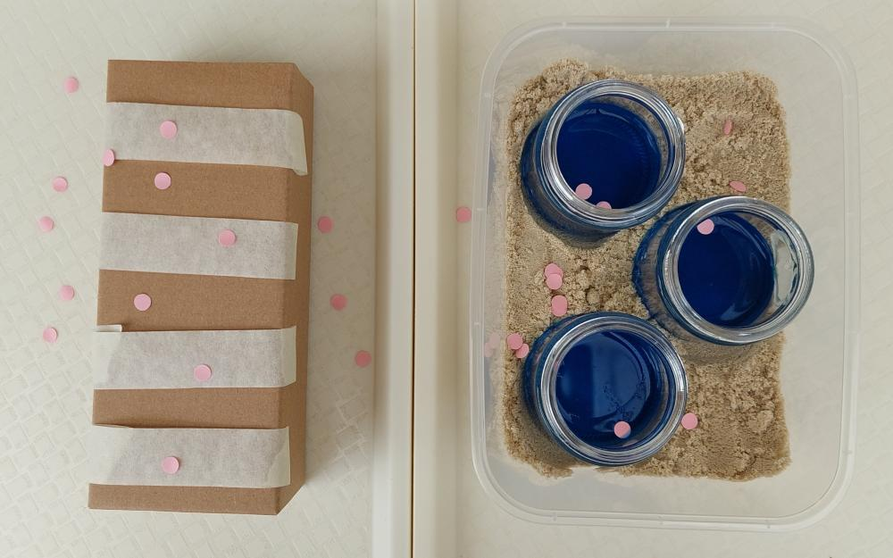
Allow time for teams to plan, build, test, and evaluate a prototype model of one of the carnivorous plants.

Integrate • Refining models
In the following Integrate routine, students are guided to link their experiences building a model of a carnivorous plant to the scientific practice of peer review, where their first prototype will be scrutinised by peers, and to the concept of adaptation–considering why some plants have adapted to consume insects.
Through modelling, questioning and discussion, students should come to a consensus that:
- peer review can help scientists improve their work. It is an essential scientific practice.
- some plants that live in poor soils have adapted over time to be able to consume insects in order to get the required nutrients.
Introduce the scientific process and purpose of peer review.
- In science, peer review is the process whereby a scientist’s ideas, methods, and conclusions are scrutinised by fellow scientists before publication. Peer review ensures that only reliable, accurate, and scientifically sound research is published.
- Scientists who don't allow their work to be peer reviewed lose credibility in the scientific community—that is, people no longer trust their claims.
Conduct a gallery walk for students to offer feedback on other groups’ models using the section provided on page 3 of the Carnivorous plant modelling Resource sheet or sticky notes. Each group’s model should be reviewed by at least one other group, but more than one review is preferable if time permits.
Students use the gallery walk feedback to make improvements to their models, testing methods, and data representation as required, recording any changes on their Carnivorous plant modelling Resource sheet.
They make the changes, re-test and re-record the data, and evaluate the effectiveness of these changes.
Using photos and the video watched earlier in the lesson to prompt student thinking, discuss with students why some plants have structural adaptations that allow them to eat insects/be carnivorous as a means of survival.
Potential discussion prompts
- How do most plants get their nutrients?
- What happens to a plant if they can't get enough nutrients from the soil?
- What is different about carnivorous plants?
- Is this a structural or behavioural adaptation? Why do you think that?
- In what type of habitats/soils do carnivorous plants grow?
- What nutrients might a carnivorous plant get from the insects it consumes?
- What might some of the advantages be for a carnivorous plant? What about the disadvantages?
Optional: Introduce a real-life carnivorous plant and discuss how its structural features for trapping are similar or different to sundews and pitcher plants. Magnifying glasses can assist observation of tiny features such as the small trigger hairs inside Venus flytrap leaves. The plant can be kept as a class pet (see Preparing for this sequence for more information).

Reflect on the lesson
You might:
- add vocabulary related to carnivorous plants to the class word wall or glossary.
- add to the W and H sections of the TWLH chart.
- revisit the initial brainstorm and add to it in a different coloured pen to represent what has been learned.
- discuss how the learning from this lesson will be relevant for building a model of a plant or animal’s adaptations, including:
  - modelling carnivorous adaptive features such as sticky dew or pitfall traps.
  - modelling may require multiple prototypes to make changes and improvements to the design.

Y5

Adapt to survive • Lesson 5 • Animal adaptations
Lesson 5
Inquire
To read the most recent version of this lesson, download associated resources, and view embedded professional learning including classroom videos and work samples, visit: https://primaryconnections.org.au/teaching-sequences/year-5/adapt-survive/lesson-5-animal-adaptations

Lesson overview
Students explore structural adaptations of animal species, including camouflage and mimicry, and learn about how peppered moth populations have changed over time.

Key learning goals
Students will:
- explore and compare camouflage and mimicry as structural adaptations.
- examine the story of the peppered moth and consider how it demonstrates the mechanism of natural selection.
Students will represent their understanding as they:
- discuss structural features of animals and how they enable survival.
- discuss and justify how some structural adaptations serve a similar purpose (for example defence from predators).
- model camouflage by creating a moth (or similar) to camouflage in the classroom.
- contribute to discussions and a storyboard about peppered moths and how the population has changed over time.

Assessment advice
In this lesson, assessment is formative.
Feedback might focus on:
- students’ moth camouflage design. Do their moths camouflage with the colours, textures and patterns in the position they are placed?
- students’ discussions about adaptations. Do they recognise that animal populations change slowly over time as the mutation with a survival advantage breed?

List of materials
Whole class
- Class science journal (digital or hard-copy)
- Demonstration copy of the Aussie animal adaptations Resource sheet
- Video: Natural selection and the peppered moth (1:52)
- Optional: Demonstration copy of the Peppered moth storyboard Resource sheet
- Moth outlines from Moth template Resource sheet, cut up and ready to distribute to students (determine how many moths you would like each student to camouflage and hide, and print as many copies as required)
Each group
- Sticky notes
Each student
- Individual science journal (digital or hard-copy)
- Scissors
- Textas, pencils
- Blu tack/sticky tape

Lesson routine | Estimated time | Task type
Re-orient | 5 minutes | Whole class
Question | 15 minutes | Whole class
Investigate | 20 minutes | Whole class/Small group
Integrate | 20 minutes | Whole class

Inquire

Re-orient
Revise the meaning of the term “adaptation” and discuss animal and plant adaptations that students have so far explored, including:
- different mouth shapes supporting feeding on different food sources.
- differences between ant species and the possible explanations for these differences.
- leaf size and shape, and which is best suited to wetter and drier environments and why.

Question • Hiding in plain sight
Using a demonstration copy of the Aussie animal adaptations Resource sheet observe and discuss the images of the animals shown on pages 1-4 (a tawny frogmouth and a bird-dropping spider).
Potential discussion prompts
- How many animals can you see in the first image?
  - There are four tawny frogmouths in the first image, two adults and two juveniles.
- What type of animal is a tawny frogmouth? How do you know?
  - A bird. While they are often mistaken for owls, their feet are weaker without the curved talons of an owl.
- Do you think a tawny frogmouth would be easy to spot in real life? Why do you think that?
- What structural adaptation has the tawny frogmouth developed and how do you think it might help them?
  - Similar colouring to a tree branch or trunk.
- Why do you think this spider is called the bird-dropping spider?
  - Because it looks like common bird droppings.
- Does the spider use the same method as the tawny frogmouth to hide from prey? Why do you think that?
  - The bird-dropping spider looks like one specific object (bird droppings), while the tawny frogmouth has the colouring of most tree branches.
- What method does the bird-dropping spider use to hide?
Read the information about tawny frogmouths and bird-dropping spiders found on pages 5-6 of the Aussie animal adaptations Resource sheet.
With/for students, define the terms “camouflage” and “mimicry” as required:
- Camouflage: a disguise that helps something blend into its surroundings.
- Mimicry: imitating, either by appearance or behaviour, something else.
Discuss the difference between camouflage and mimicry, specifically referring back to the tawny frogmouth (camouflage) and bird-dropping spiders (mimicry) as examples.
Discuss any other animals that students think they know that use camouflage and/or mimicry as a means of hiding from predators, or any that use it as a means of helping them catch prey.
Optional: View a collection of videos to observe and discuss the wide variety of animals that use the adaptive feature of camouflage, such as:
- World’s best disguised predator fish (stone fish) (1:19)
- How many lizards do you see? (0:16)
- Tawny Frogmouths are the masters of camouflage (0:21)
Pose the question: How do camouflage and mimicry adaptations help an animal to survive?

Investigate • Moth search
Investigation part 1
Explain that moths are a popular food source for many animals the world over, including bats, birds, spiders, small mammals, lizards, frogs. As such, moths have become experts at camouflage and mimicry.
Next explain to students that for the first part of their investigation they are going to “decorate” some paper moths and hide them around the classroom (or school grounds) for their classmates to find. The goal is to camouflage the moths so well that they cannot that be found. This can be done in teams or as an individual task. A template has been provided on the Moth template Resource sheet.
- Lay out some ground rules for hiding the moths, including:
  - Moths must be hidden within a specified “hiding zone”, so that students can be adequately supervised.
  - Moths must be hidden in plain sight and rely on their shape/colouring to hide. Being hidden underneath or inside an object does not utilise camouflage and mimicry.
- Allow students/teams time to inspect the hiding zone and plan how they might decorate their moths. Taking photos for future reference with a digital device can be helpful.
- Allow students/teams time to decorate their moths, writing their names on the back so that moths can be identified when they are found. Every student/team should have the same number of moths.
- Students/teams hide their moths within the hiding zone. They should note where they hide the moths so they can be retrieved later if not found.
- Students/teams try to find the moths hidden by other students/teams. They should note where they find each moth and how easy the moths were to spot in their hidden location.
- Students/teams share the moths that they found, where they were located, how easy they were to locate, and why they think that was so.
- Tally how many of each student/team’s moths were found to determine if there are any left still camouflaged in the hiding zone.
- Teams with any moths remaining in the hiding zone can retrieve their moths, taking photos of the moth before retrieval, or taking the class to see it in situ.
Discuss why some moths may have been more successfully hidden than others.
Investigation part 2
Watch the video Natural selection and the peppered moth (1:52), stopping at intervals so that students can record key words they have heard. Re-watch the video as required.
In teams, students use the Peppered moth storyboard Resource sheet to retell the story of the peppered moth.

Integrate • Natural selection
In the following Integrate routine, students are guided to link their experiences in the investigation with the science concept being explored, that is, that some animals have adapted to use camouflage and mimicry as a means of avoiding and/or catching prey.
Through modelling, questioning and discussion, students should come to a consensus that:
- many animals use camouflage and mimicry to avoid predators or to sneak up on prey.
- this adaptation, as all adaptations are, is the result of natural selection.
- natural selection is the process where favourable traits are passed along because those within a species with those traits are more likely to survive and reproduce.
- the process of natural selection takes many generations.
Teams share their peppered moth storyboards. Allow opportunities for storyboards to be added to based on details shared by other teams.
Optional: Create a class version of the storyboard for the class science journal.
Introduce the term “natural selection”: a mechanism of evolution whereby individuals of a species who are better suited to their environment are more likely to survive, breed and pass on those favourable traits to their offspring (nature selecting for or against certain traits).
Using the story of the peppered moth, consider how this definition of natural selection applies. See the embedded professional learning The story of the peppered moth for more information.
Discuss how peppered moths use camouflage to blend into their environment, and how, when their environment changed, the species was able to adapt so quickly.
Potential discussion prompts
- How were the peppered moths able to survive when the pollution turned the trees black?
- Why were they able to adapt so quickly?
  - The mutation that caused the black moths already existed, so when the trees turned black those moths were able to flourish.
Return to the Aussie animal adaptations Resource sheet and read the information about the tawny frogmouth and the bird-dropping spider found on pages 5 and 6. Discuss what might need to change in these animals' environments for them to adapt as the peppered moth did, and why it's unlikely.
Potential discussion prompts
- What do you think would happen to the tawny frogmouth or the bird-dropping spider if their habitat suddenly and dramatically changed?
- Do you think they would be able to adapt and survive? Why do you think that?
  - For a species to change, it must have some individuals in the environment that are capable of surviving to have babies. If (for example) all trees were to turn blue, the tawny frogmouth would not survive because they do not have any individuals that could camouflage against the blue trees. Blue feathers do not appear on demand.
- Which species do you think would adapt more quickly? Why do you think that?
  - Note for students that the average lifespan of the tawny frogmouth is up to 14 years in the wild (up to 30 in captivity). They reproduce only once per year, laying between 1-3 eggs, with about 60-65% of chicks surviving beyond 30 days.
  - Also note that the average lifespan of the bird-dropping spider is about 1 year. They usually reproduce once in this time, laying 10+ egg-sacs containing up to 200 eggs each; however, only between 1-10% of the spiderlings survive.
- Do you think most animal adaptations take a long time or a short time? Why do you think that?
  - All animal adaptations take many generations to affect the whole species.

Reflect on the lesson
You might:
- add vocabulary related to camouflage and mimicry the class word wall or glossary.
- add to the W and H sections of the TWLH chart.
- discuss how students were thinking and working like scientists during the lesson. Focus on grouping adaptations with similar purposes and establishing a timeline of peppered moth populations in the storyboard.
- invite responses about animal species adaptations that seem creative, inspiring or interesting.

Y5

Adapt to survive • Lesson 6 • Surviving the cold
Lesson 6
Inquire
To read the most recent version of this lesson, download associated resources, and view embedded professional learning including classroom videos and work samples, visit: https://primaryconnections.org.au/teaching-sequences/year-5/adapt-survive/lesson-6-surviving-cold

Lesson overview
Students investigate little penguins and cold climate adaptations by comparing the insulation effect of feathers, fur and blubber using waterproof mittens.

Key learning goals
Students will:
- draw reasoned conclusions about the structural adaptations of little penguins and their purpose.
- construct waterproof, insulated mittens to model cold climate adaptations.
- compare feathers, fur and blubber as insulators.
Students will represent their understanding as they:
- select/devise a fair method to compare the insulators.
- discuss findings about feathers, fur and blubber as insulators.
- discuss challenges and improvements for the investigation.

Assessment advice
In this lesson, assessment is formative.
Feedback might focus on:
- students’ observations and findings. Did students recognise that feathers, fur and blubber are all insulators? Have they used qualitative and quantitative language as appropriate to their data collection method to compare the insulators?
- students’ discussions about challenges and limitations. Are they able to identify limitations with the investigation? Can they suggest improvements to collect accurate data?

List of materials
Whole class
- Class science journal (digital or hard-copy)
- Demonstration copy of the Little penguin Resource sheet
- 2 or 4 sandwich-sized resealable lunch bags
- A material to use as a model for blubber e.g. vegetable shortening such as Copha, animal shortening such as Fairy or Superfry, or regular butter or margarine (see the embedded professional learning Adapting to your context below for further guidance)
- Optional: Waterproof tape such as gaffer tape
- Tub of cold water
- Ice to make water colder
- Thermometer
- Video: How do whales, penguins, and polar bears keep warm? (3:44)
Each group
- A material to use as a model for feathers e.g. craft feathers, feather boa, doona/duvet feathers and down
- A material to use as a model for fur e.g. wool, faux fur, old vintage fur from coat/hat
- 4 sandwich size resealable lunch bags
- Access to a thermometer
- Optional: Waterproof tape such as gaffer tape
Each student
- Individual science journal (digital or hard-copy)

Lesson routine | Estimated time | Task type
Re-orient | 5 minutes | Whole class
Question | 15 minutes | Whole class
Investigate | 45 minutes | Whole class/Small team
Integrate | 15 minutes | Whole class

Inquire

Re-orient
Recall the previous lesson, focusing on camouflage and mimicry, and how it supports animals to survive.

Question • Little penguins
Display the demonstration copy of the Little penguin Resource sheet and read the information about little penguins.
Ask students to draw a reasoned claim based on this information, and in reference to what they have learned about camouflage, about the possible advantages of the little penguins’ specific colouring.
As required, explain that:
- the blue/black feathers on their back help them camouflage when in deeper water, making it difficult for birds of prey to spot them from above.
- when viewed from below, their white belly blends with the bright, sunlit sea above, making it difficult for predators below them in the water to see them.
- being dark across the back and light on the front is known as counter-shading.
Ask if they are aware of any other animals that use this two-toned colour strategy, e.g. whales, birds, snakes and lizards, deer. It is a common camouflage strategy found in the animal kingdom.
Discuss other structural adaptations that students can see in the images and think may increase the little penguins’ chances of survival.
Potential discussion prompts
- What observations can you make about the little penguin’s beak shape that make you think it is well adapted to catching wet, slippery prey like fish, squid, and prawns?
  - Their beaks have sharp edges to grip the slippery prey and a slight hook on the end to assist with holding onto the food.
- What observations can you make about the little penguins’ feet that you think might assist them to survive in their natural habitat?
  - Their webbed feet make them good swimmers because the skin between their toes can move a greater volume of water, making them swim faster. This also applies to moving sand or soil when digging burrows, which is also aided by their sharp claws.
Draw students’ attention to the location where little penguins typically live, the cold waters of Southern Australia and New Zealand (both close to Antarctica).
Pose the question: What adaptations might little penguins have developed to help keep them warm in the cold southern oceans?

Investigate • Surviving cold waters
Discuss what students already know about feathers, fur and blubber and list animals that have them. Record their ideas in the class science journal.
If required, define “blubber”: the thick layer of fat that sits directly under the skin of marine animals, including mammals such as whales, seals and dolphins and birds such as penguins. Polar bears also have blubber whilst not strictly marine animals. Blubber insulates heat keeping the animal warm, stores energy and increases buoyancy.
Note for students that little penguins have both blubber and feathers, and explain that in this investigation they will work in teams to explore how animals keep warm in cold climates by creating mittens to compare the insulating effect of feathers, fur and blubber.
Display and examine the materials that students have available to use as insulation for the investigation and determine which ones are the best models for feathers, fur and blubber and why.
- Feathers: craft feathers, feather boa, doonah/duvet feathers and down (soft fluffy feathers beneath a bird’s outer feathers).
- Fur: wool, faux fur, old vintage fur from coat/hat.
- Blubber: vegetable shortening such as Copha, animal shortening such as Fairy or Superfry, or regular butter or margarine.
Explain and model how to create the mittens by creating one or two “blubber” mittens that will be shared between groups to reduce wastage:
- Place a sandwich-sized plastic bag inside another bag of the same size.
  - Sandwich-sized resealable bags are ideal. Turning the inside bag inside out means the resealing mechanism can still be used to help seal the bags.
- Put a large amount of the insulating material between each side of the two layers of plastic.
- Seal the edges of the bags together so the insulating material cannot escape.
  - Grey electrical tape/gaffer tape is ideal for this as it is wide and waterproof.
- Manipulate the insulating material between the bags so it is spread out in an even layer.
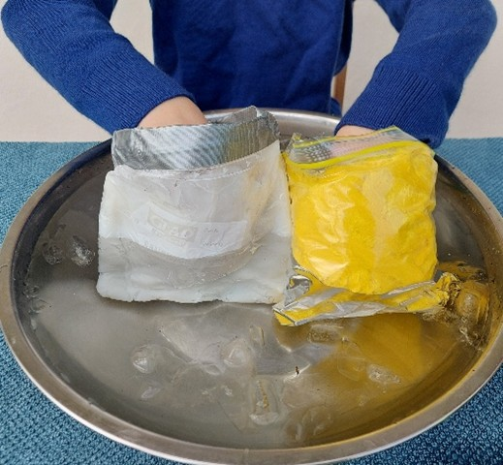
Comparing insulation with blubber (Copha) mitten and yellow feather mitten in iced water.
Discuss and determine:
- why plastic bags are being used.
  - As this is a model exploring the insulating effect of blubber, feathers, and fur in water, there has to be a means of ensuring that the mittens are waterproof. Plastic is the best material to ensure this.
- how students will undertake the investigation.
  - Students will place a hand inside each mitten in turn, then place this hand/mitten into a bowl of iced water for a set period of time.
- how students might collect fair, accurate and comparable data.
  - Determine how long each hand/mitten can stay in the iced water.
  - Take temperature readings of the water to ensure it is at the same/similar temperature when each mitten is placed in the water.
  - If the temperature of the water rises significantly, add more ice until the temperature returns to the same baseline as when the first test was carried out.
  - Determine how students will rate the effectiveness of each insulating material.
    - For example, will they dip their hands simultaneously in the iced water with a different insulator on each hand? Will they leave one hand ungloved as a comparison? Will they use a thermometer (without touching the bulb at the base, as this will affect the reading)? Will they rate the “coldness” after an elapsed time? Will they take notes?
Allow teams time to make their feather and fur mittens, carry out their investigation, and record observations and results using the agreed-upon method.
Optional: Teams take photos during their investigation.

Integrate • Comparing methods and findings
In the following Integrate routine, students are guided to link their experiences building a model of animal insulation features with the science concept being explored, that is, that some animals have adaptation that help them to survive in cold climates.
Through modelling, questioning and discussion, students should come to a consensus that:
- feathers, fur and blubber can help keep an animal warm in cold environments.
- animals with these adaptations often live in habitats that can get cold.
Allow teams to share their results and the methods they used to compare the insulating properties of feathers, fur and blubber.
Determine if one was a more successful insulator and why/why not.
Consider how some animals, like the little penguins, have more than one insulating feature (feathers and blubber). List other animals the students think also have multiple insulating features, and any animals that only utilise one (and why they think that might be the case).
Discuss challenges and limitations that students faced during the investigation, such as differences in judgement about warmth/cold, variations in scoring and changing water temperatures over time.
Potential discussion prompts
- What challenges did you face when comparing the feathers, fur and blubber?
- Do you think everyone has the same tolerance for cold?
- Did you find that everyone in the team agreed with each other or did you have different opinions?
- How could this investigation be modified to collect accurate and measurable data?
  - For example, matching jars could be filled with warm water, each wrapped in feathers/fur/blubber, and we could use multiple thermometers to measure heat loss over time.
Show the video How do whales, penguins, and polar bears keep warm? (3:44).
Optionally:
- explain and discuss the following:
  - Little penguins have both feathers and a thin layer of blubber to keep them warm.
  - Larger penguins, like emperor penguins, have more blubber to survive colder conditions in Antarctica.
  - Little penguins have many more feathers than other birds, around 10,000 in total. The feathers interlock to trap warm air and create a waterproof layer. The trapped air also helps with buoyancy.
  - Penguins have an oil gland near their tail and spend a significant amount of time oiling their feathers by running their beak through the feathers to distribute the oil. This is known as preening and assists with waterproofing.
- Show the video Little blue penguins (1:14) for an explanation of moulting and the importance of feathers.
- Show the video 10 things you didn’t know about Australia’s little penguin (7:39) to explore more structural features and behavioural adaptations of little penguins, including three eyelids and crossing beaches in groups.
- show the live video feed Little penguin burrow camera at Phillips Island to observe penguin features and behaviours (such as preening) in real time.
- consider (or research) if the animals found during Lesson 2’s habitat survey can warm themselves or if they are affected by the environmental temperature. Discuss how this affects their need for insulating layers such as feathers and fur.

Reflect on the lesson
You might:
- add vocabulary related to body covering and surviving cold temperatures to the class word wall or glossary.
- add to the W and H sections of the TWLH chart.
- review what’s been added to the class science journal during the lesson, determining if the ideas are supported by evidence, if further investigation or research is required to confirm them or making additions and amendments where needed.

Y5

Adapt to survive • Lesson 7 • Seasonal survival strategies
Lesson 7
Inquire
To read the most recent version of this lesson, download associated resources, and view embedded professional learning including classroom videos and work samples, visit: https://primaryconnections.org.au/teaching-sequences/year-5/adapt-survive/lesson-7-seasonal-survival-strategies

Lesson overview
Students investigate the relationship between the bogong moth and mountain pygmy possum and their behavioural adaptations of migration, hibernation and aestivation.

Key learning goals
Students will:
- explore how the behavioural adaptation of migration can help an animal to survive.
- participate in a migration simulation.
- compare winter dormancy (hibernation) and summer dormancy (aestivation) and consider how the mountain pygmy possum and bogong moth use these adaptations to survive.
Students will represent their understanding as they:
- discuss the behavioural adaptations of migration, hibernation and aestivation.
- complete the Survival behaviours Resource sheet.

Assessment advice
In this lesson, assessment is formative.
Feedback might focus on:
- students’ discussions about migration. Are they able to describe how migration can help a species to survive? Can they explain why the bogong moth migrates?
- students’ discussions about hibernation and aestivation. Do they recognise the similarities and differences between the two?
- students’ responses on the Survival behaviours Resource sheet. Do students accurately identify and record migration, aestivation and hibernation as survival behaviours of the bogong moth and mountain pygmy possum?

List of materials
Whole class
- Class science journal (digital or hard-copy)
- Video: On the move: Exploring animal migration across the globe (3:31)
- Demonstration copy of the Animal migration and the bogong moth Resource sheet
- Stopwatch or timer
- Heat stress token for each student (counters, red paper pieces, blocks, or pom-poms)
- Cool down token for each student (that look different to heat stress tokens, such as blue paper pieces)
- Cones, hoops, desks, cloths, or tape or similar to mark spaces on the floor/yard
- Signs or a visible key displayed in the classroom to mark the features of the landscape for the bogong moth simulation—Mount Bogong, eucalypts, grevilleas and crevices. For example, a key might look like:
  - Desk = Mount Bogong
  - Green markers = eucalypts
  - Red markers = grevilleas
  - Black circles = crevices
- Space for students to safely move around
- Videos:
  - Mysteries of the bogong moth (3:42)
  - Moths, mountains and marsupials (6:17)
Each student
- Individual science journal (digital or hard-copy)
- Survival behaviours Resource sheet

Lesson routine | Estimated time | Task type
Re-orient | 5 minutes | Whole class
Question | 15 minutes | Whole class
Investigate | Variable | Whole class
Integrate | 15 minutes | Whole class
Investigate | 15 minutes | Whole class
Integrate | 20 minutes | Whole class/Individual

Inquire

Re-orient
Recall the adaptations that help animals survive in their natural habitats that have been investigated in the sequence to date, including camouflage and body coverings.

Question • Introducing animal migration
Discuss what students understand about the meaning of the term “migration”: the movement of people or animals from one place to another, often over long distances, to settle permanently or temporarily.
Asks students what they think they know about animals that migrate from one place to another and why the animals might do so.
Explain that students are going to watch a short video, On the move: Exploring animal migration across the globe (3:31), with the purpose of answering the question: When and why do animals migrate?
Ask students to use a note-taking method such as the 10-keyword strategy, where they write down 10 keywords or phrases they hear in the video clip that they think are relevant to the question.
Show the video, pausing or replaying as required.
When students have their list of 10 keywords, use the cumulative listing strategy to tally the most frequently occurring terms.
Present the chart found on page 1 of the Animal migration and the bogong moth Resource sheet to students. Determine if they agree that the information presented reflects their keyword summary and the information presented in the video.
Look at the image of the bogong moth found on page 2 of the Animal migration and the bogong moth Resource sheet and read the information about them.
Pose the question: What does a bogong moth experience during migration?

Investigate • Migration simulation
Students participate in a simulation of the migration of the bogong moth, becoming a bogong moth and creating a movement-based model of the process.
Preparing for the simulation
- In reference to the maps found on pages 3-4 of the Animal migration and the bogong moth Resource sheet, and using the equipment noted in the List of materials above, set up a space that can act as the “bogong moth habitat zone”. Within this zone, include markers or labels for the following:
  - Mount Bogong (marked with a yellow pin on the maps)
    - Mount Bogong is found in the Australian Alps and is a location where many bogong moths return to for aestivation.
    - As a place of high altitude, it is much cooler than the low-lying places where the moths spend the first part of their lives.
    - Place a pile of “cool down” tokens at the “base” of Mount Bogong.
      - Students will exchange a “heating up” token for a “cool down” token once they reach the mountain for aestivation.
  - Grevillea bushes and eucalypt trees
    - The flowers of these plants make up a large proportion of the bogong moth’s diet.
  - Crevices
    - Bogong moths rest in dark crevices during the day, as they are nocturnal.
- Explain each of these markers and their meaning to the students.
- Ask teams/students to spread out within the habitat space. It would be ideal if their locations in the space reflect locations where sightings of bogong moths have been recorded (marked with blue pins on the map).
- Provide each student with a “heating up” token, which they should clasp in a closed fist, so that they can feel the “rising temperatures” as summer approaches.
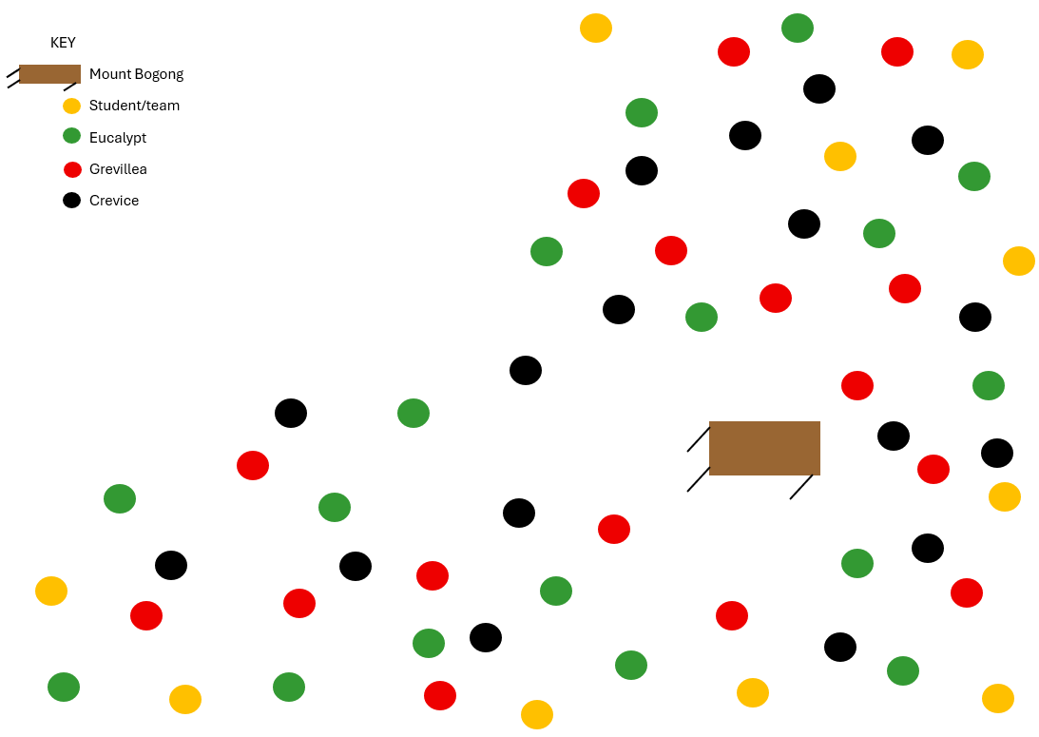
A mock-up plan showing how to set up a habitat zone.
Running the simulation
- Use a stopwatch or timer to indicate to students the changeover between day and night. Each should last for a set period e.g. 20 seconds.
- Students make their way from their location towards Mount Bogong.
- As the bogong moth is small and the distance to travel is vast, students should take small steps as they move.
- During the “day”, students must find a “crevice” to rest in.
- During the “night”, students must move towards Mount Bogong, feeding at least twice by stopping at either a grevillea or eucalypt for that period of time for at least five seconds.
  - Discuss how students might ensure they are feeding for the required amount of time, as simply counting to five is not an accurate measure of time elapsed. Adding a long word between each count can make it more accurate, for example, “one hippopotamus, two hippopotamus” or “one bogong moth, two bogong moth”.
- Once students reach Mount Bogong (which may occur at different times depending on their starting location in the habitat zone), they exchange their “heating up” token for a “cool down” token, making a mental note of the temperature difference between the tokens as they exchange them: the "heating up" token will have warmed in their hand during the simulation, but the "cool down" token will still be room temperature.
You may need to run the simulation a few times to allow students to fully understand each requirement and complete it successfully.

Integrate • Bogongs on the move
In the following Integrate routine, students are guided to link their experiences simulating bogong moth migration to the science content being explored, that is that animals migrate for a variety of reasons.
Through modelling, questioning and discussion, students should come to a consensus that:
- bogong moths migrate in summer to escape the heat.
- they travel at night to escape heat and avoid predators.
- they feed extensively along the way to build up their fat stores for their period of rest.
Discuss students’ experiences with the migration simulation.
Potential discussion prompts
- What did you think about the migration simulation? Do you think it helped you understand how and why an animal might migrate? Why or why not?
- Why do you think the Bogong moths migrate to the mountains?
- Why would they move at night and sleep during the day?
- Why do you think they feed so much along the way?
Show the video Mysteries of the bogong moth (3:42) then provide students with an opportunity to record their ideas on:
- how the bogong moths find their way in and out of the breeding ground.
- the 2019-2024 population decline of bogong moths.
  - Climate change, pesticides in breeding areas, habitat destruction, and artificial lights have all been identified as factors in the population decline.
- what humans can do to help struggling bogong moth populations.
  - For example, turning lights off, planting/leaving out nectar-rich foods, recording any sightings on Zoos Victoria’s Moth Tracker, the Atlas of Living Australia, or iNaturalist.

Question and Investigate • Waking up
Explain that the mountain pygmy possum lives in the same mountains where the bogong moth migrates to, and pose the questions: How is the survival of the mountain pygmy possum linked to the bogong moth? and What might happen if either species suddenly disappeared?
Show the video Moths, mountains and marsupials (6:17).
Ask students to use the 10-keyword strategy (or any other note-taking method they are familiar with) to record 10 keywords or phrases they hear in the video clip that they think are relevant to the questions.
Pause and/or rewatch the video as required.
When students have their list of 10 keywords, use the cumulative listing strategy to tally the most frequently occurring terms.

Integrate • Refining understanding
In the following Integrate routine, students are guided to link the information they have gathered in the video with the science concept being explored, that is, that the mountain pygmy possum has adapted to survive on the bogong moth, and that their survival depends on the survival of the moth.
Through modelling, questioning and discussion, students should come to a consensus that:
- mountain pygmy possums consume bogong moths in large quantities in order to prepare for their winter hibernation.
Discuss the adaptive behaviours of the mountain pygmy possum, including the “perfect timing” of the arrival of the bogong moths.
Potential discussion prompts:
- How are the bogong moth behaviours of migration and aestivation (summer dormancy) important to the mountain pygmy possum?
  - While the bogong moths are aestivating in the caves in summer, the mountain pygmy possums eat them to build up fat reserves before going into hibernation themselves for the winter.
- How are the periods of dormancy similar for the bogong moth and mountain pygmy possum?
  - Both slow their metabolism and use very little energy.
- How is the hibernation of the mountain pygmy possum different to the aestivation of the bogong moth?
  - Hibernation is in winter, aestivation is in summer.
- How are the mountain pygmy possums dependent on the bogong moths?
- What do you think happened to the possums when the bogong moth populations suddenly dramatically decreased?
Students record their thinking and answer the questions on the Survival behaviours Resource sheet.
Optional extensions:
- Students could create an infographic, storyboard or simulation to explain mountain pygmy possum hibernation.
- Students could investigate whether any of the animals found during Lesson 2’s habitat survey (such as slaters, snails and ants) migrate, hibernate (winter dormancy) or aestivate (summer dormancy.)
- Discuss how students can get involved in citizen science by using the Moth Tracker app, as explained in Bogong Moth Tracker - Behind the News (3:24)

Reflect on the lesson
You might:
- add vocabulary relating to the migration of the bogong moth to the class word wall or glossary.
- add to the W and H sections of the TWLH chart.

Y5

Adapt to survive • Lesson 8 • Designing a model
Lesson 8
Act
To read the most recent version of this lesson, download associated resources, and view embedded professional learning including classroom videos and work samples, visit: https://primaryconnections.org.au/teaching-sequences/year-5/adapt-survive/lesson-8-designing-model

Lesson overview
Students create and share a model of the adaptive features and behaviours of a real or imaginary plant or animal. They explain how the adaptive features are a response to the plant or animal’s habitats.

Key learning goals
Students will:
- design and create a model of a real or imaginary plant or animal, showing the structural features and behaviours that enable survival and how those features are a response to the plant/animal’s habitat.
- explain the structural features and behavioural adaptations displayed on their model.
Students will represent their understanding as they:
- create a model.
- create an explanatory diagram to accompany their model.
- communicate their understanding of structural and behavioural adaptations with a selected audience.

Assessment advice
In the Act phase, assessment is summative.
Students working at the achievement standard should have:
- demonstrated an understanding of how the form and behaviour of living things enables survival. Evidence might include:
  - answers to probing questions about how features and behaviours enable survival.
  - model features.
  - labels and descriptions that accompany the model.
  - sharing and explaining the structural and behavioural adaptations of the model with an audience.
Refer to the Australian Curriculum content links on the Our design decisions tab for further information.

List of materials
Whole class
- Class science journal (digital or hard-copy)
Each student
- Individual science journals (digital or hard-copy)
- Materials to construct a model such as craft supplies, natural items such as twigs, leaves and stones, or iPads/laptops for digital representations (see embedded professional learning Using and Adapting Scientific Models in the Design step of this lesson).

Lesson routine | Estimated time | Task type
Anchor | 10 minutes | Whole class
Connect | 10 minutes | Whole class
Design | Variable | Whole class/Individual
Communicate | Variable | Whole class

Act

Anchor • What have we learned
Review the learning that has occurred over the course of the sequence using the class science journal.
Anchor to the core science concept by reminding students that all our investigations in this unit have been about the structural and behavioural adaptations of plant and animal species that have enabled them to survive in their habitat.
Optional: Show the video How living things adapt (5:34). Note for students that when the video uses the term “animal” it is referring to all animals of that species, not an individual of that species.

Connect • Models in science
Review the methods used to learn about plants and animals throughout the sequence, such as surveys, observing living plants and animals, experiments/testing, modelling carnivorous plant trapping features, researching, and watching videos.
Discuss the benefits of using models in science.
Potential discussion prompts
- How do models help us to understand how plants and animals survive?
  - Models are immobile and therefore easier to observe in detail; making the model requires us to think about every feature and how it helps survival; models are ethically more responsible than displaying live animals for long periods of time.
- How do models help scientists to understand living things?
  - Sharing knowledge between scientists, promotes close observation and critical thinking etc.
- What limitations do models have?
It can be difficult to show every feature when using a model; their construction is limited by available materials, some which might be difficult to work with; it can be difficult to represent the complexity of the real world which is constantly changing.

Design • Designing and making a model
In this section, students will design a model of either a real or imaginary plant or animal, which explains the features and behaviours that enable survival in a specific habitat.
Consider whether students will model:
- a real plant or animal, perhaps one they have surveyed in the school grounds, thrives locally or is of particular interest to them.
- an imaginary plant or animal that they have designed for a specific habitat.
They will then create an accompanying text, labelled diagram, presentation (or any combination of these) to explain:
- the structural and behavioural adaptations the plant or animal has, and how these adaptations have been shown.
- what habitat features these adaptations are in response to.
  - You might consider posing a challenge such as asking students to show how their animal might respond to change in their habitat such as increasing temperature or decreasing food supplies.
Consider if you will require students to design their model in teams, and if so, how you will determine these teams. Alternatively, students can work independently, however this can require more time and classroom resources and places greater demands on the teacher.
Consider who the audience will be when students communicate information about their model, and the appropriate methods of communication for this audience. The audience may include other students, parents at an evening school fair, or the broader community at a local event.
Define
Define the challenge, such as:
How can we use the available materials to make a model that shows the features and behaviours of a (real or imaginary) plant/animal that help it to survive in its habitat?
Ideate
Brainstorm ideas related to the plant/animal model.
At this stage, to support creative thinking, every idea offered by students should be recorded in the class science journal. No idea is discounted, as the practicality/possibility of each idea will be considered later.
As students offer ideas, ask probing questions (How does that feature/behaviour enable survival? or What habitat is the feature/behaviour best suited to? How will the animal fight off predators?) to draw out how students are applying their understanding.
Prototype
Allow teams/students time to design and construct their plant/animal model using available materials.
All models should require at least an explanatory labelled diagram, identifying:
- the main features the enable survival in the selected habitat.
- behaviours that help the organism to survive.
- the type of habitat the organism thrives in and how the adaptations are well suited to the habitat.
Students may be provided with research time to support them to consider details for their model, such as beak shapes, eye placement, fur patterns.
Optional: Students/teams are provided opportunities to share their ideas and receive peer feedback (download AITSL's guide for more on peer feedback).

Communicate • Sharing models
Communicate
Students share their models with their chosen audience using appropriate methods of communication. You might consider using the CROWN tool to support students in this.
Students should be prepared for any possible questions the audience may ask them about how they created the model, the science concepts on display, or how they felt about it.
Optional: Students display their plant/animal models with a suitable habitat, using an image (digital or printed), a diorama or a nature table filled with selected items such as plants, rocks, sticks, sand or shells.
Optional: Students compose a cli-fi narrative in which their species, or an individual within their species, responds to a change in their habitat and/or surrounding environment. See the embedded professional learning Climate fiction (cli-fi) for more information.

Reflect on the sequence
You might:
- refer to the list of student questions asked in Lesson 1. Determine which questions have been answered over the course of the learning sequence, what the “answers” to the questions are, and the evidence that supports these claims. Address questions that have not been answered during the learning sequence, discuss why they might not have been addresses and potential investigations that might support students to answer them.
- review students’ responses elicited about pants and animals in Lesson 1, comparing students’ initial ideas to what they think now and considering how their thinking has changed.
- consider what students have learnt about the features and behaviours of living things that enable survival in particular habitats.
- ask students to represent this learning in words, symbols and pictures.
- discuss why it’s important to have a good understanding about features and behaviours of living things: What kinds of jobs would require you to understand this? What about in your everyday life? Why is it important for humans to protect the habitats of these plants and animals?

