Australians in space
Year 2

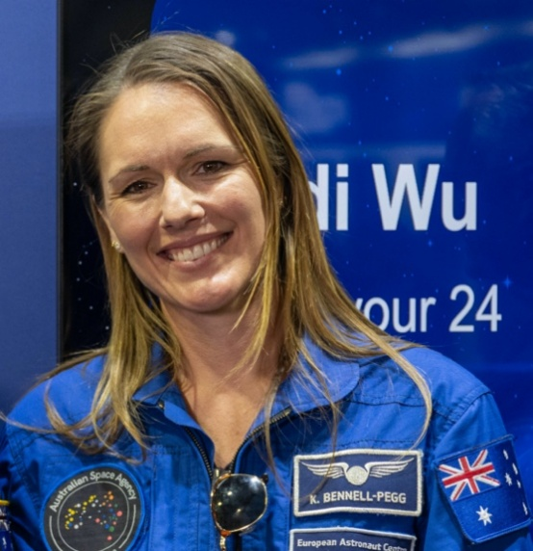
Katherine Bennell-Pegg
Born: 1984

Nationality: Australian
Born in Sydney
Now lives in Adelaide

Occupation: Director of Space Technology at the Australian Space Agency (Aeronautical and Space Engineer)

Space Missions: LISA Pathfinder—an uncrewed spacecraft (2015)

"Katherine Bennell-Pegg" by Aden Brown is in the Public Domain.

What does Katherine do as an Aeronautical and Space Engineer?
Katherine is a trained astronaut, but as of March 2026 she has hasn’t actually been into space—yet! Her work so far has all been done on Earth.
Katherine uses space technologies to learn more about our home planet, making observations about Earth. She uses the information to come up with solutions for real-life, Earth based problems such as managing natural disasters like bushfires and floods, monitoring algal blooms in oceans and river, and helping the people who live and work in some of Australia’s most remote (hard to get to) places.

Fun facts
In high school, when asked to write down three different career options, Katherine only wrote down one—astronaut—and refused to add any others!
In 2026 Katherine was named the Australian of the Year.

Paul Scully-Power
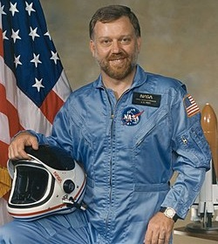
Born: 1944

Nationality: American/Australian
Born in Sydney
Now lives in the USA

Occupation: Oceanographer
(A scientist that studies the ocean)

Space Missions: STS-41-G Challenger (1984)

"Astronaut Paul Desmond Scully-Power" by NASA is in the Public Domain.

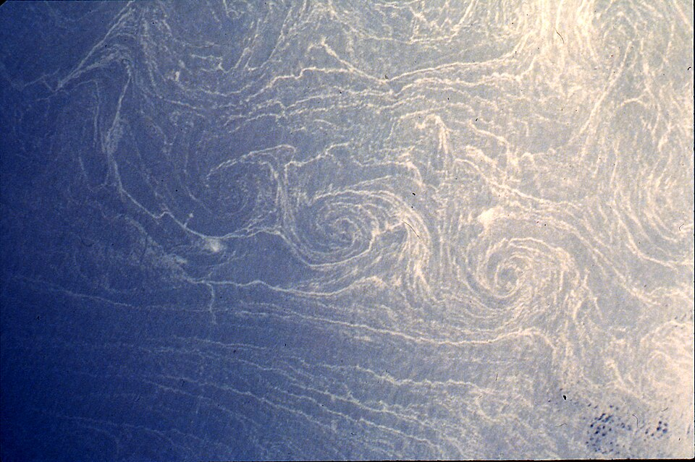
What did Paul do as an oceanographer and astronaut?
In 1984 Paul was chosen to go to space as a Payload Specialist. Payload Specialists carry out one specific job—in Paul’s case this was to observe spiral eddies in Earth’s oceans. He was chosen for this job because he was an oceanographer.

Spiral eddies are ocean currents that move in spirals. They help mix the oceans water and bring nutrients from deep in the ocean up to the surface.

"Spiral eddies" by Paul Scully-Power is in the Public Domain.

Understanding them helps us to better understand the ocean environment.

Scientists first thought that spiral eddies were rare, but Paul proved they were not. In fact, he took this picture of one with a camera pointed out the window of the spacecraft! The observations he made during his trip to space helped us to better understand Earth’s oceans.

Andy Thomas
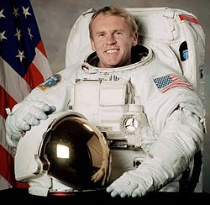
Born: 1951

Nationality: Australian/American
Born in Adelaide
Now lives in the USA

Occupation: Aerodynamic Scientist (NASA)

Space Missions:
- STS-77 (May 1996)
- Mir Space Station (1998)
- STS-102 (March 2001)

"Astronaut Andy Thomas” by NASA is in the Public Domain.
- STS-114 (July-August 2005)

What did Andy do during his career as an Astronaut?
Andy spent a total of 177 days in space over 4 different missions.
On these missions Andy’s focus was on space safety procedures and building and improving the International Space Station (ISS).
In 2001 he became the first Australian citizen to undertake a spacewalk when he spent 6 and a half hours installing parts on the outside of the ISS.
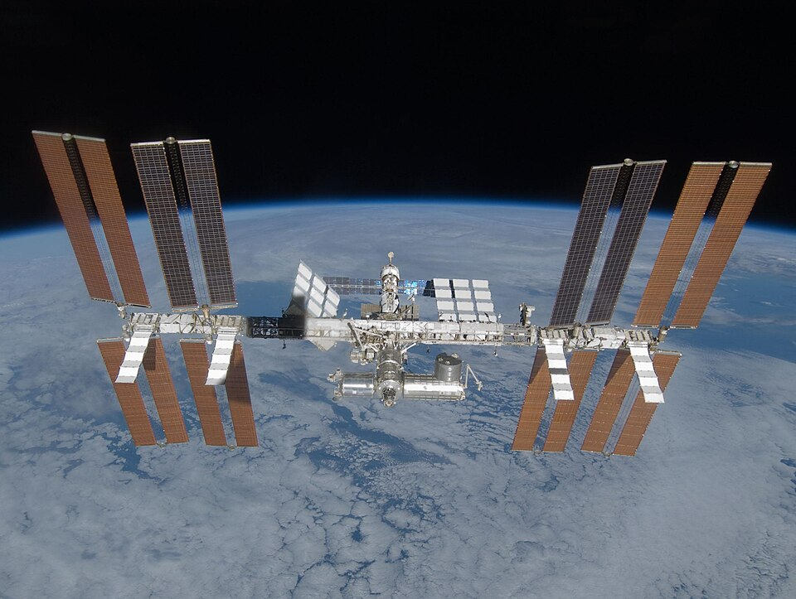
So, what is the International Space Station?
The ISS is a large space craft that circles around the Earth.
Astronauts and cosmonauts live on the spacecraft conducting experiments and making observations that will hopefully help humans travel further into space.
It’s about the size of a big house—with six bedrooms, 2 bathrooms, a gym, and a living area with windows all the way around.

"ISS March 2009” by NASA is in the Public Domain.
Up to 7 people can live there permanently, with enough space for a few visitors coming for short stays.
It took about two years to build, and many different countries contributed.

