Our home planet Earth
Year 2

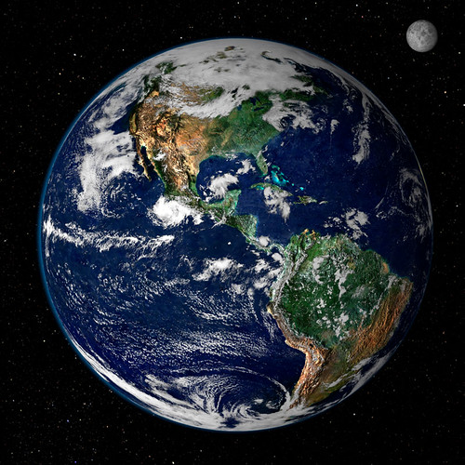
"Earth from Space" by NASA Goddard Photo and Video is licensed under CC BY 2.0.

