Earth from above
Year 2

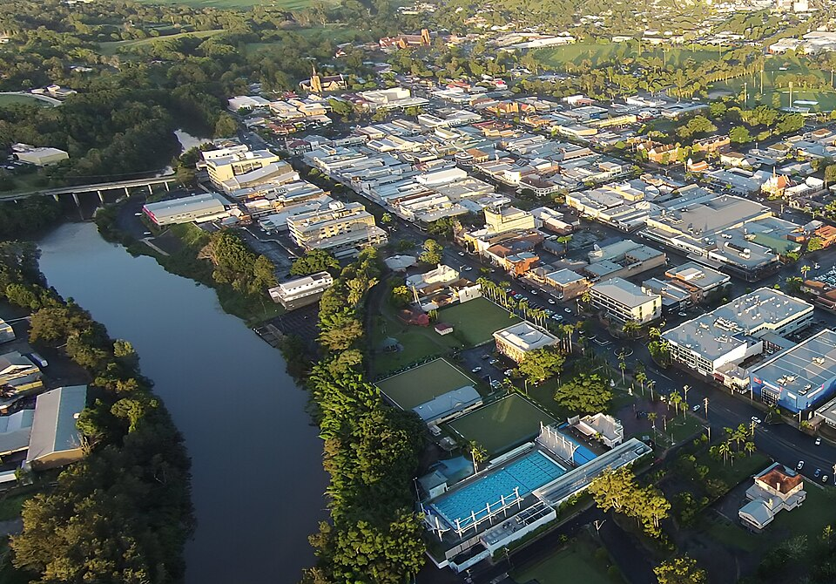
"Lismore-NSW-Australia-Aerial-View-2-cropped" by Kingyj is licensed under CC BY-SA 3.0.

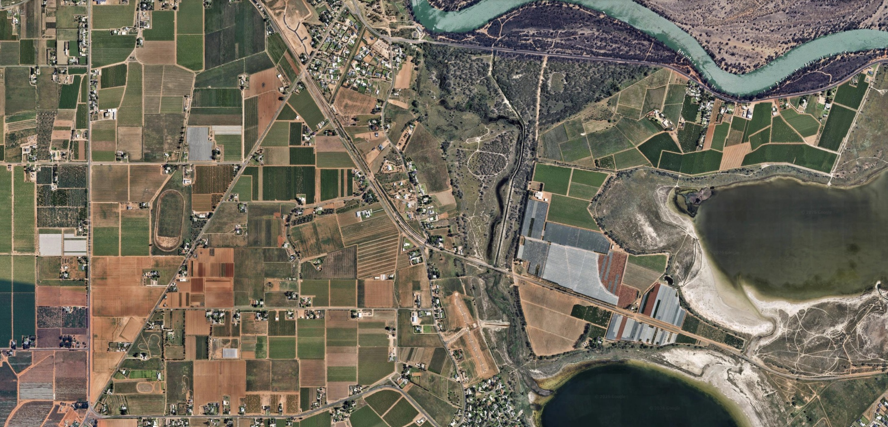
Birdwoodton and Mildura, Victoria: Map data ©2022-2025 Google, Airbus

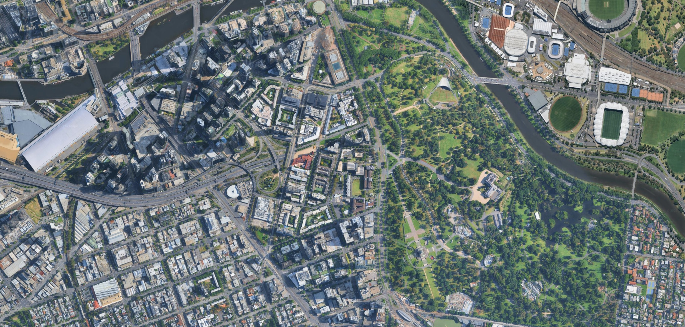
Southbank, Melbourne: Map data ©2023-2024 Google, Vexcel Imaging US, Inc.

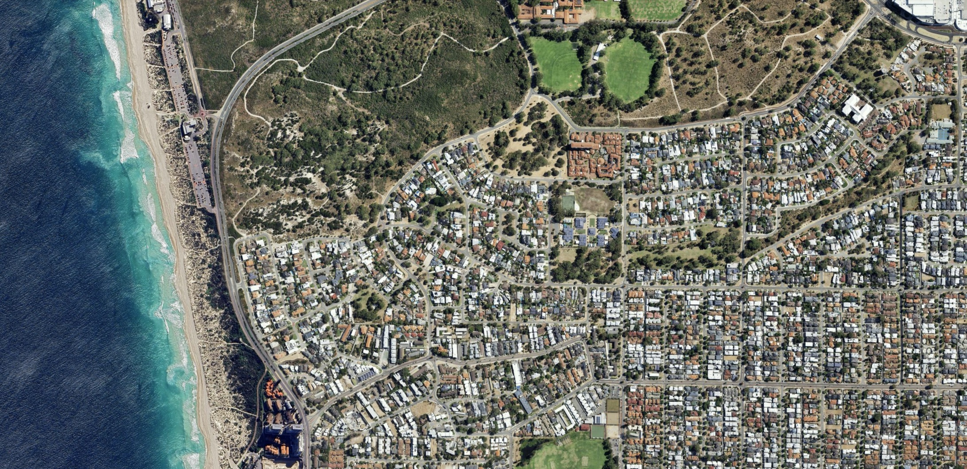
Scarborough Beach, Perth: Map data ©2022-2025 Google, Airbus, Maxar Technologies

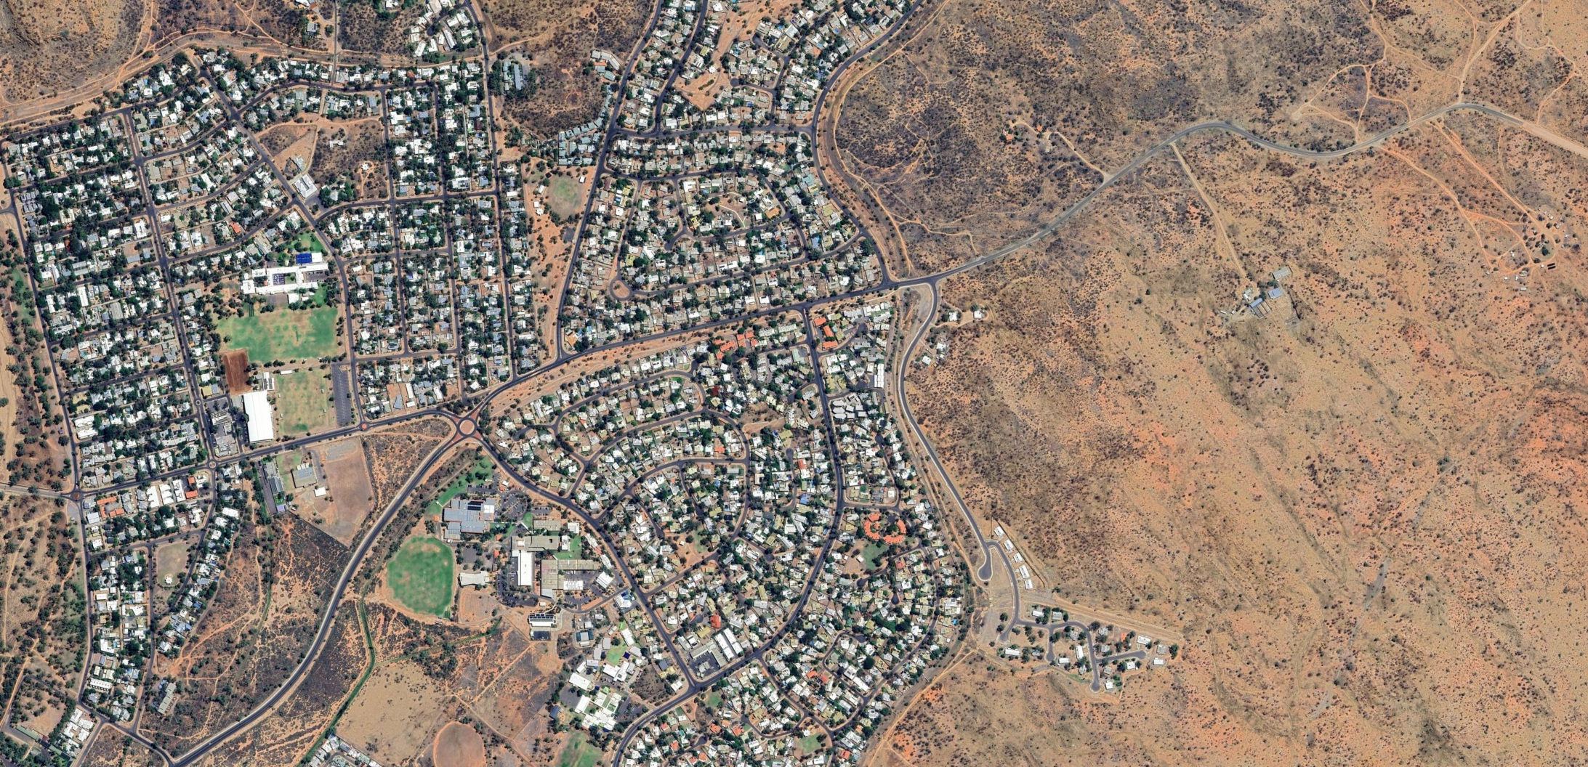
Alice Springs: Map data ©2024 Google, Airbus

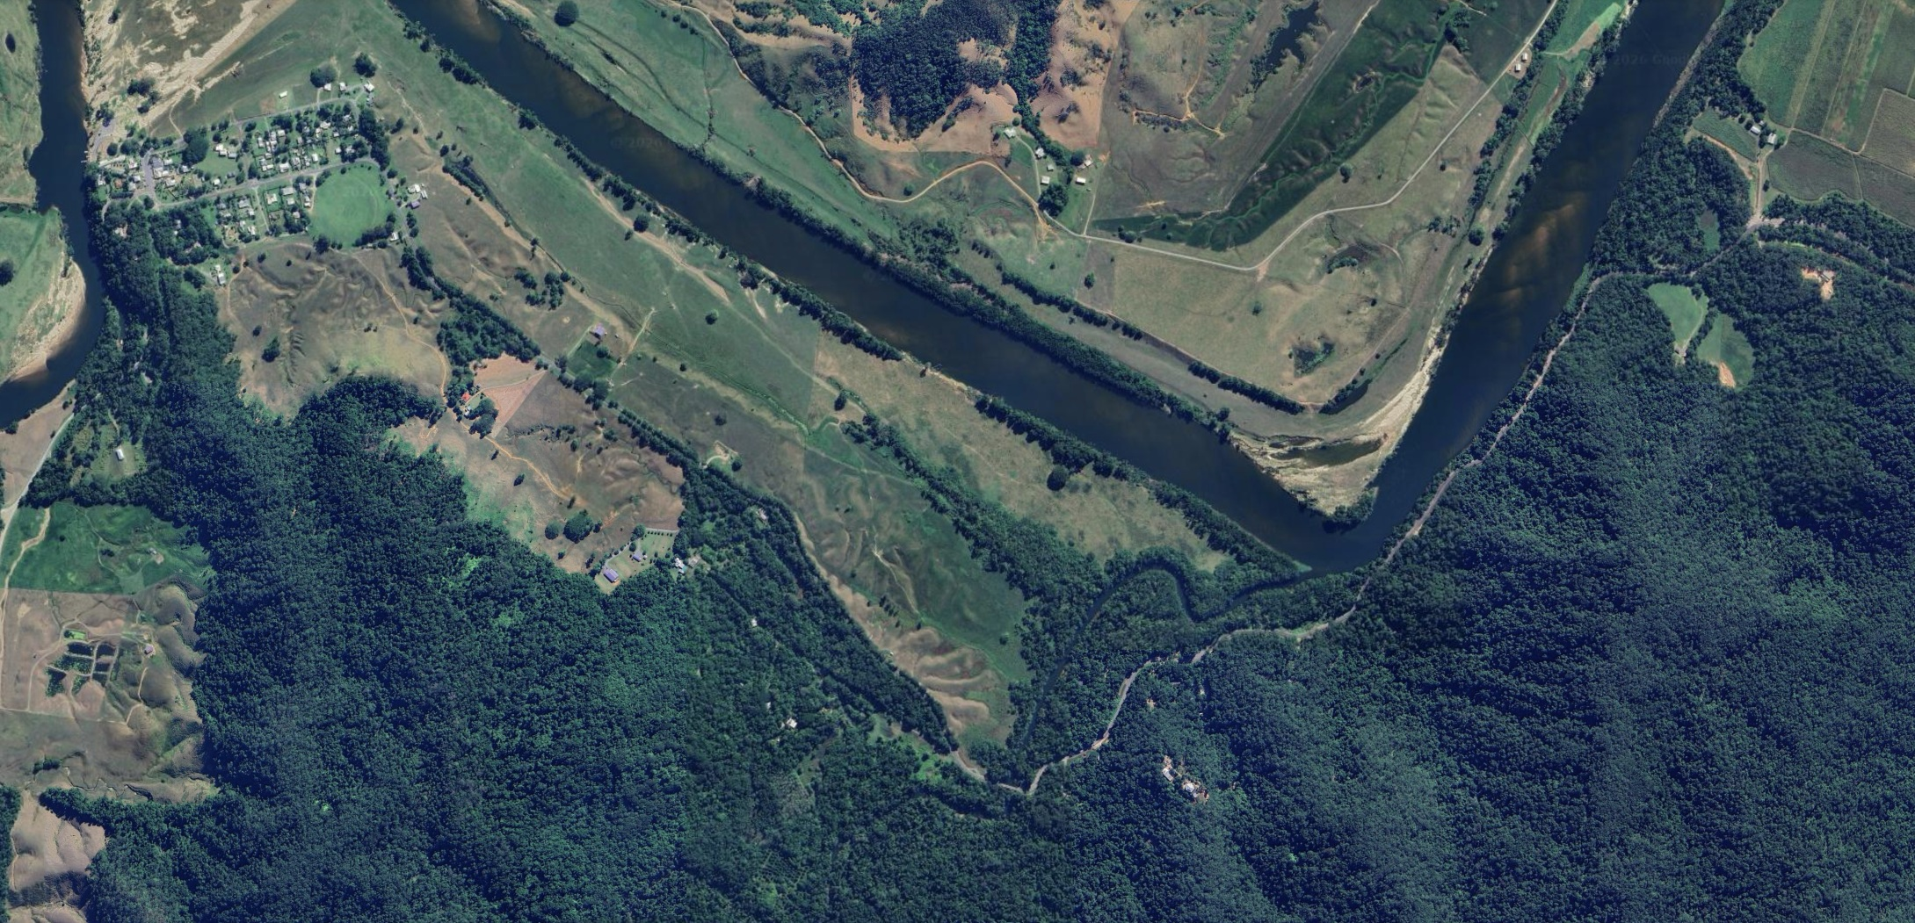
Daintree rainforest: Map data ©2024 Google, Airbus

