Spiral eddies
Year 2
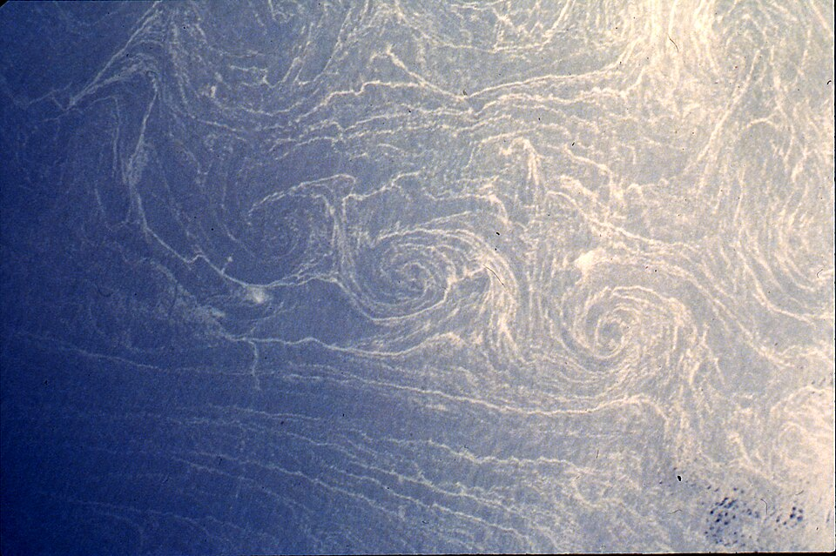

"Spiral eddies" by Paul Scully-Power is in the Public Domain.

