Moon images
Year 2
Each student will need one section of the following to make their Moon wheels. Print off as many of this page as required.

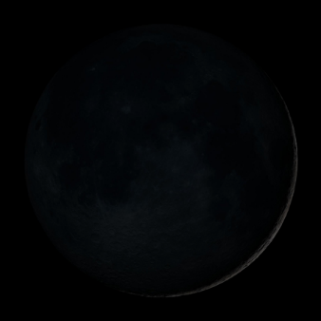
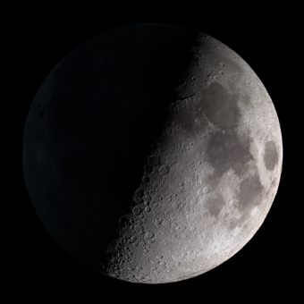
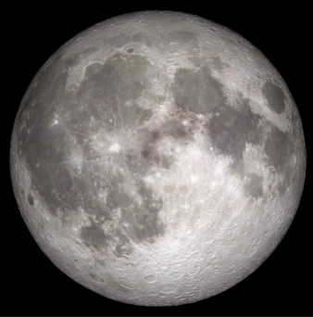
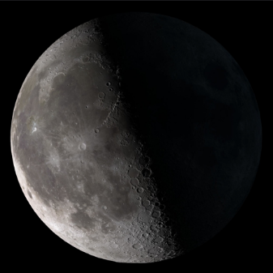

All images are from NASA/Goddard Space Flight Center Scientific Visualization Studio and are in the Public Domain.

