Phases of the Moon
Year 2
New Moon  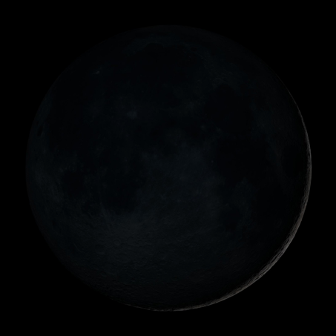 | First Quarter  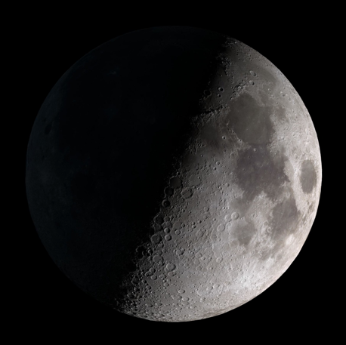
Full Moon  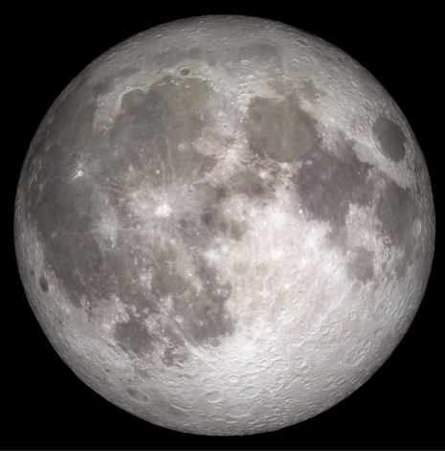 | Third Quarter  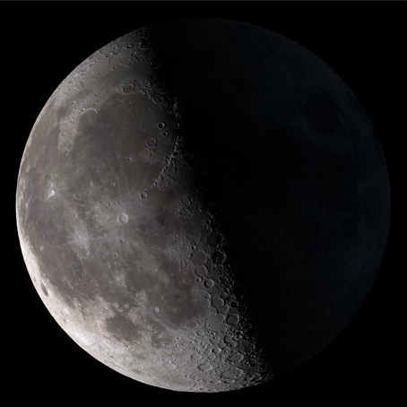
All images are from NASA/Goddard Space Flight Center Scientific Visualization Studio and are in the Public Domain.

