The same Moon?
Year 2

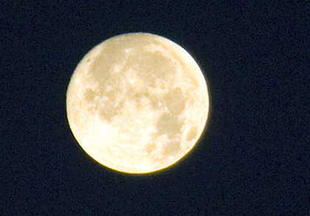
"Wolf's Moon" by Anindo Ghosh is licensed under CC BY 2.0.

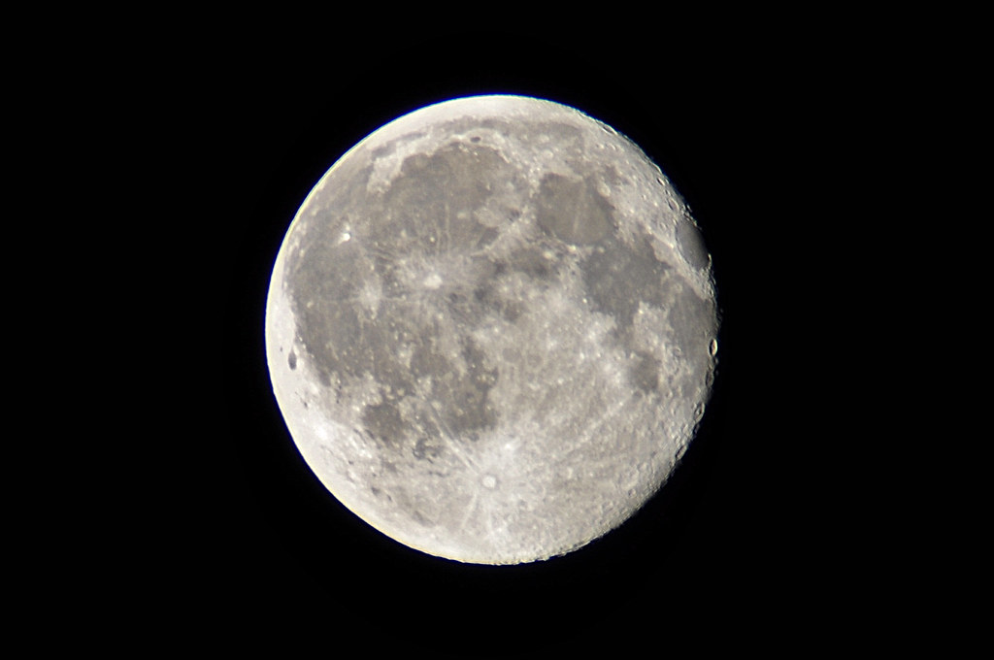
"A mini-guide to our wonderful Moon" by dingopup is licensed under CC BY-SA 2.0.

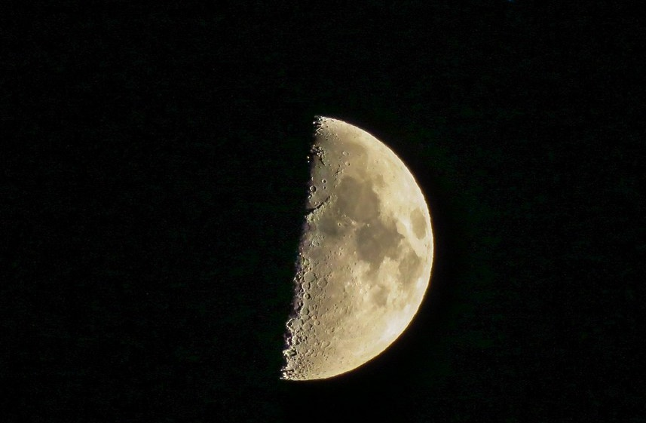
"Moon and Spica 168" by Rocky Raybell is licensed under CC BY 2.0.

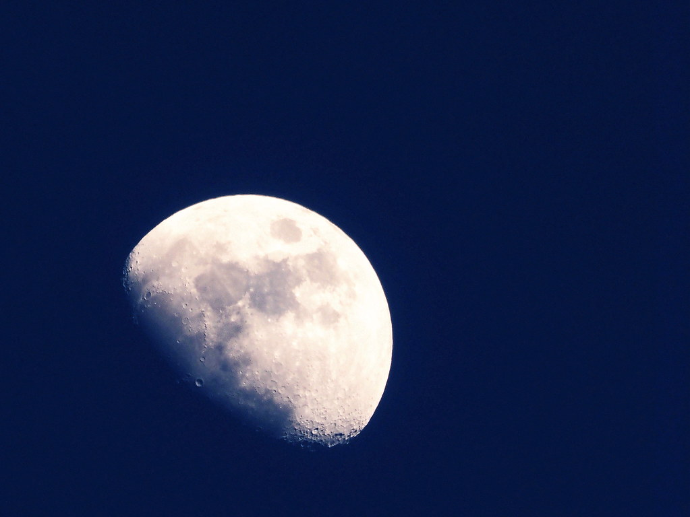
"Moon" by 456PHOTOS is licensed under CC BY 2.0.
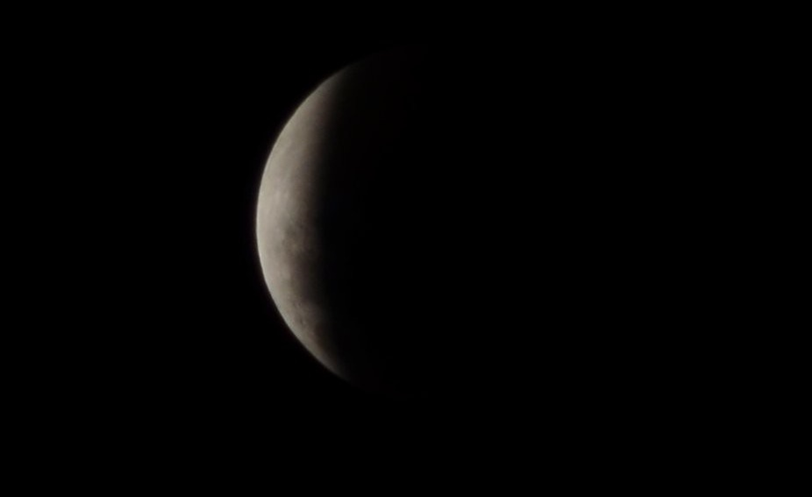
"Super/Blood Moon 2015" by SoulRiser is licensed under CC BY-SA 2.0.

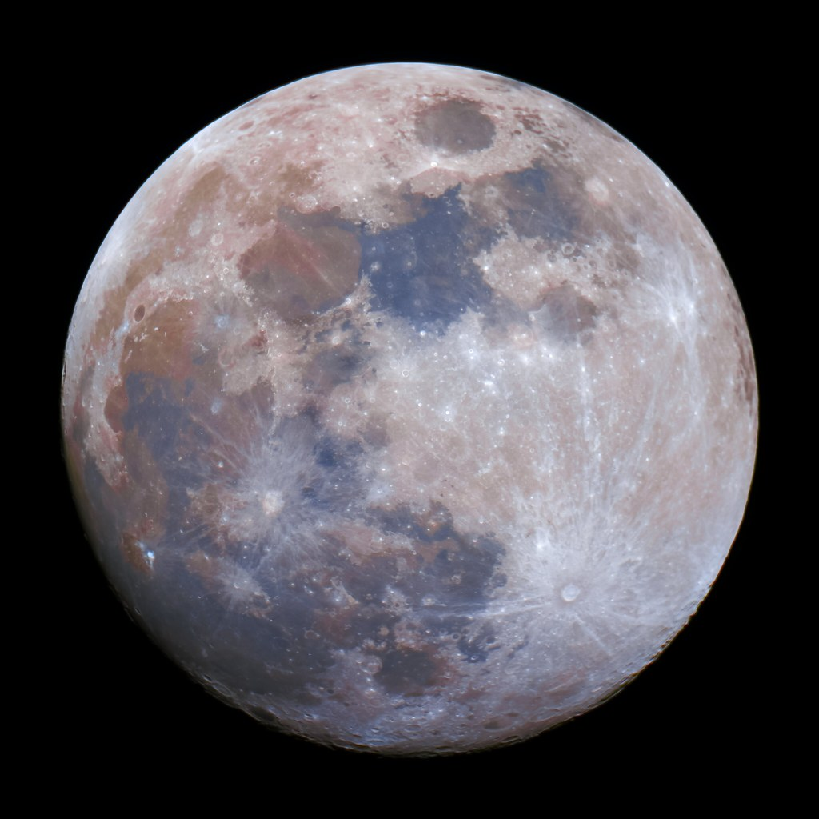
"Moon - December 6 2022" by Kevin M. Gill is licensed under CC BY 2.0.

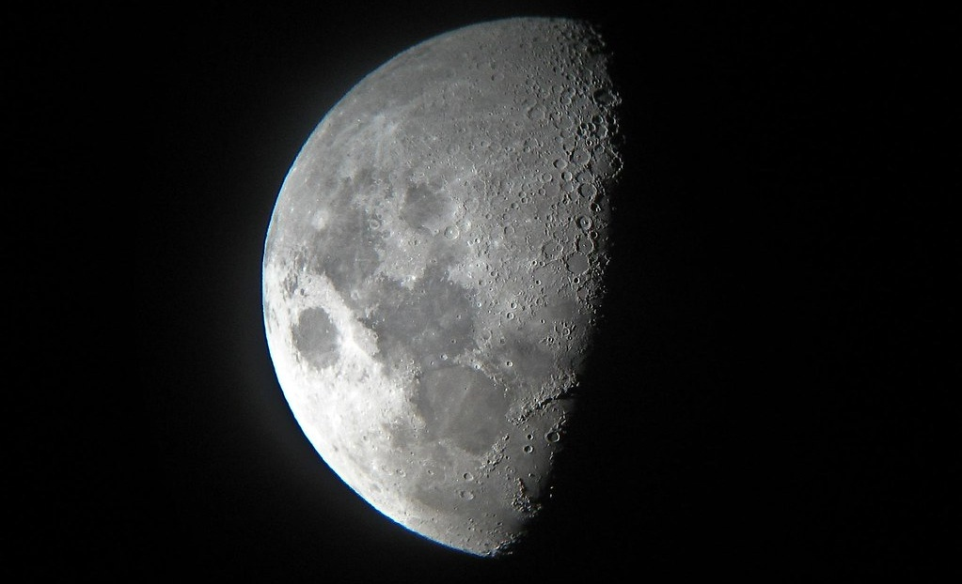
"Moon" by the real Kam75 is licensed under CC BY-SA 2.0.

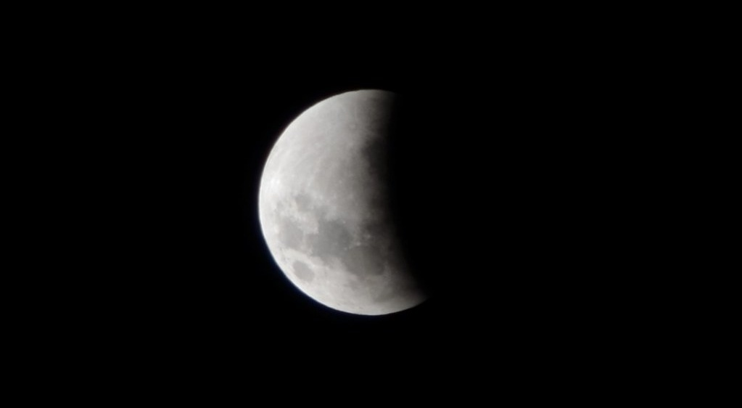
"Super/Blood Moon 2015" by SoulRiser is licensed under CC BY-SA 2.0.

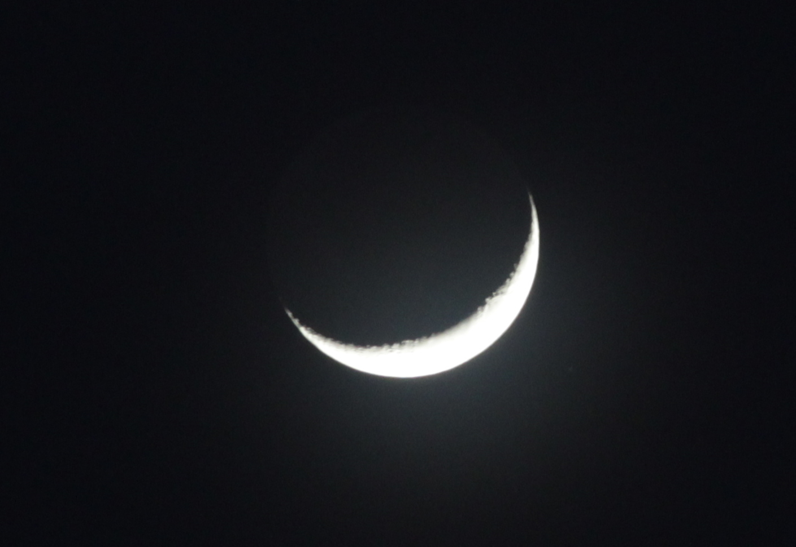
"Crescentmoon" by Ragul krish is licensed under CC BY 4.0.

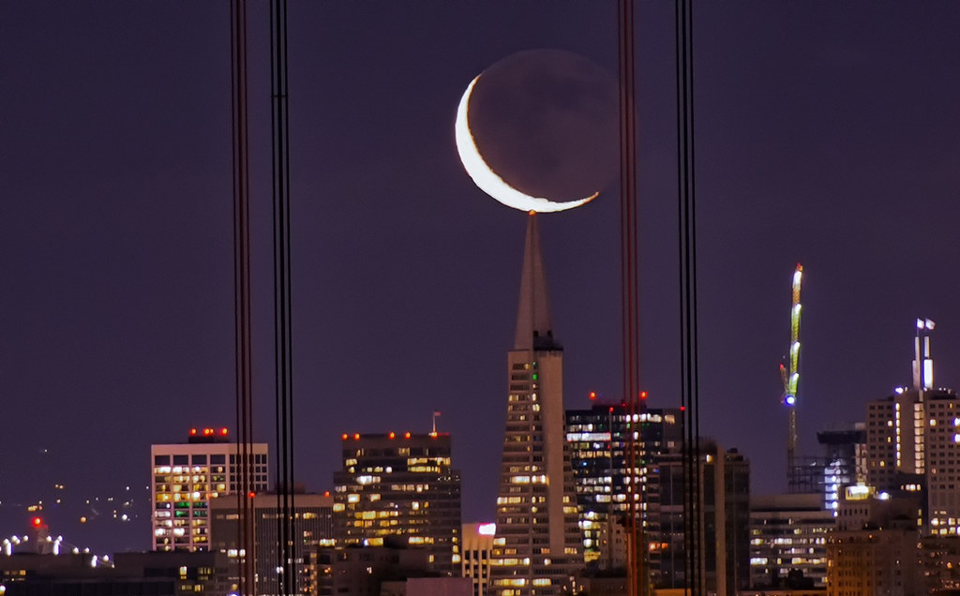
"Sickle" by Jaykhuang is licensed under CC BY 2.0.

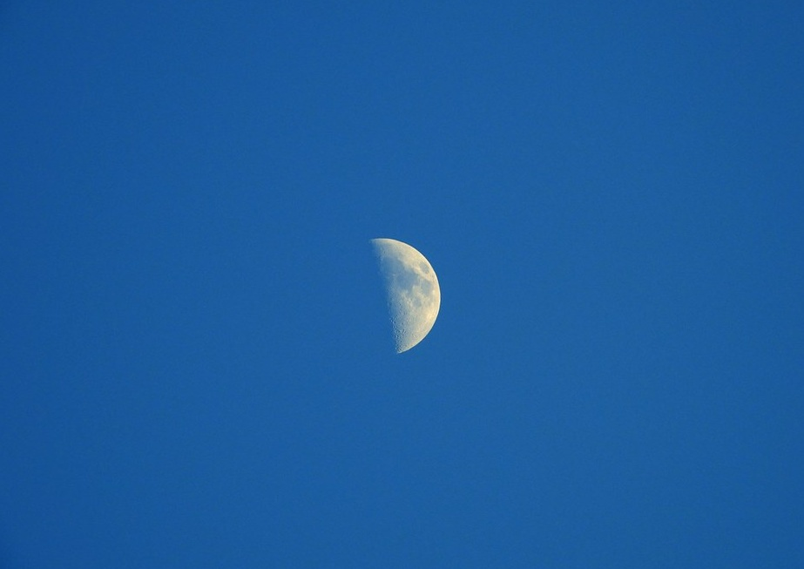
"8pm Half moon." by pete beard is licensed under CC BY 2.0.

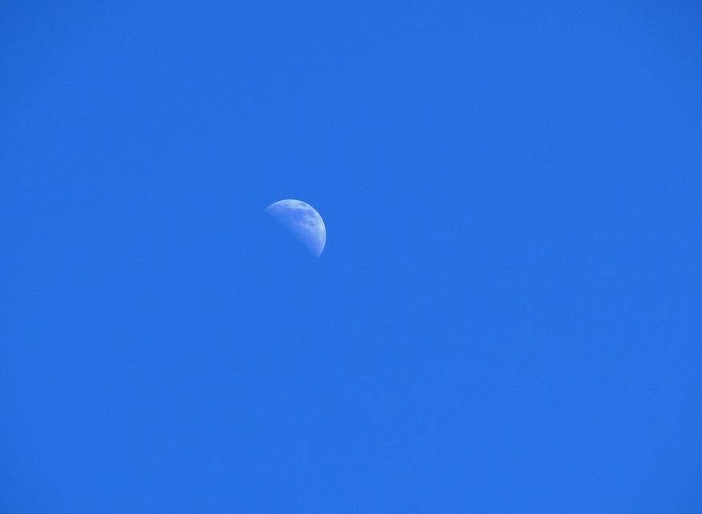
"Day Moon" by Michael is licensed under CC BY 2.0.
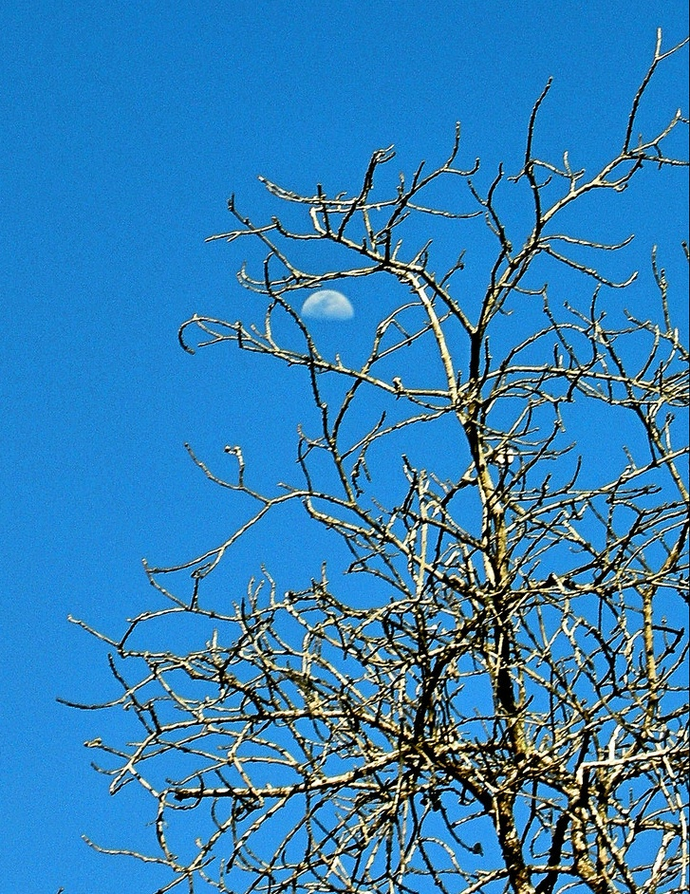
"day-moon" by Alan L is licensed under CC BY 2.0.

