Emu in the sky
Year 2
When Australia’s First Nations Peoples look up at the night sky they see more than just stars. Like people the world over, they see objects and stories written in the sky.
One of these significant objects is the Emu in the sky. The Emu is known by different names depending on the language and traditions of the Country you’re on.
The Emu is formed by the dark spaces between the stars in the Milky Way (a giant cluster of stars). Its head is found near the Southern Cross and its stretched legs and feet end near the Scorpius constellation.
Some First Nations stories says that when the emu’s body looks big and strong in the sky, it is time to collect emu eggs because the real emus on the ground are laying them. Later in the year, the emu in the sky looks like it is sitting down. That means the eggs have hatched, and it’s not the right time to collect them anymore.
By observing the patterns and position of the Emu in the sky over time, First Nations People were able to track the movements and behaviour of animals and the lifecycles of plants and use this knowledge to care for Country.
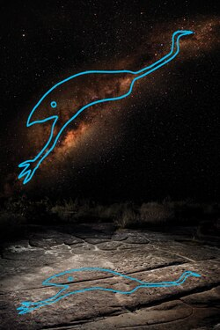
Emu in the sky with a tracing of the rock engraving, Barnaby Norris and Ray Norris,
CC BY-SA 4.0, via Wikimedia Commons
Information for this text was drawn from Tutt, Corey (2021) The First Scientists. Hardie Grant Explore, Wurundjeri Country, Melbourne; and https://en.wikipedia.org/wiki/Australian_Aboriginal_astronomy

