Star patterns
Year 2
Scorpius constellation
Orion constellation

Orion constellation
Scorpius constellation

A story in the stars
In Europe, thousands of years ago, people saw two star constellations and thought they resembled a hunter (Orion) and a scorpion (Scorpius).

People also noticed that the two constellations were never seen at the same time in the night sky—Scorpius appears in the east, Orion disappears in the west.

They came up with the following story (mythology) to explain what they saw:

‘Orion went away to Krete and spent his time hunting in company with Artemis (the god of hunting) and Leto (Artemis’ mother).

Orion bragged that he could kill every beast there was on Earth!
This made Gaia (the Earth) angry, so she sent up against him a Scorpion of very great size. The scorpion stung Orion and he died.

After this Zeus (the king of the gods) decided to put Orion among the stars, because of his manliness.
He also put the scorpion in the stars as a memorial of him and a reminder of what had occurred.’
(Greek epic, 8th or 7th century BC)
We can see the constellations of Orion and Scorpius in the sky in Australia too, but because we’re in the southern hemisphere (Europe is in the northern hemisphere) they look upside down and back to front to us.

The Southern Cross

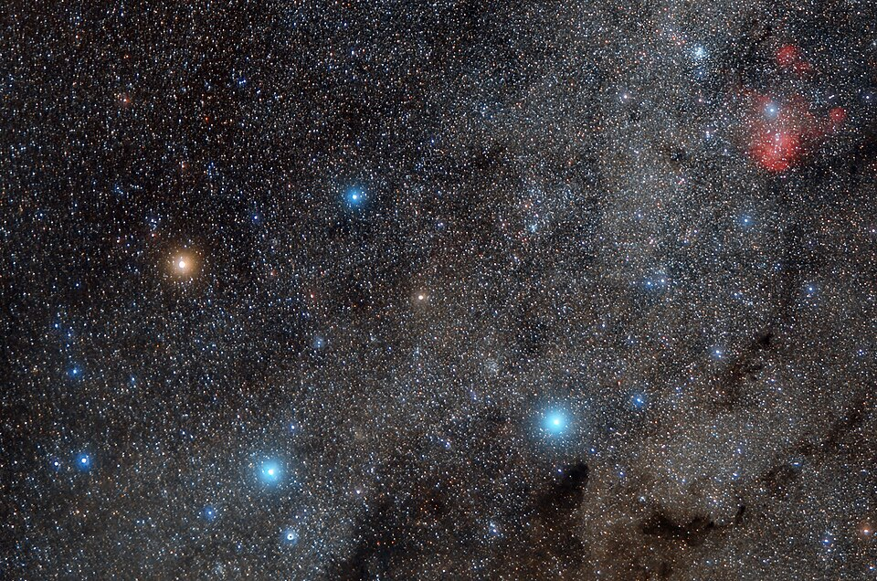

"Southern Cross -New Zealand" by Antonio Ferretti is licensed under CC BY-SA 4.0

