Voyager space mission
Year 2
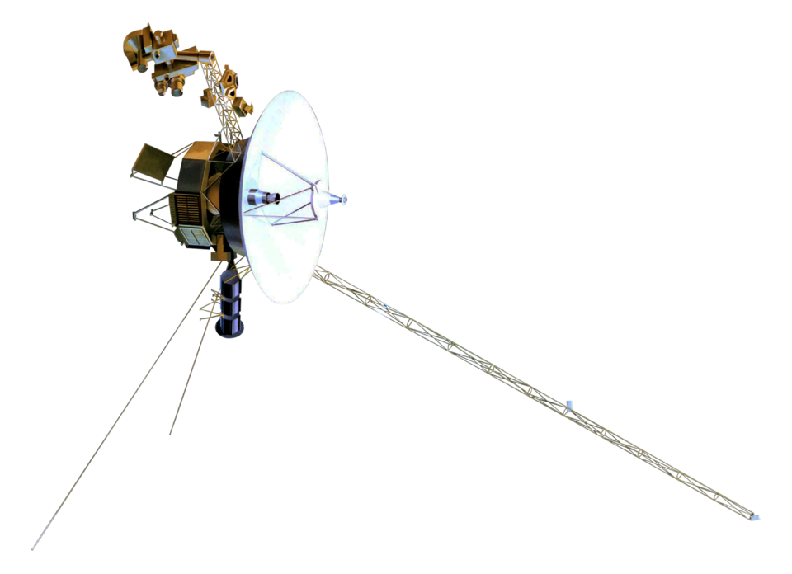

"Voyager spacecraft model" by NASA is in the Public Domain.

About 50 years ago, in 1977, the United States of America’s space agency, NASA, built and launched two space probes—Voyager 1 and Voyager 2.

They were sent into space to gather data about the planets Jupiter and Saturn. The Voyager spacecraft flew near each planet and the information they collected was sent back to Earth.

What the atmosphere around the planet was like, whether they had magnetic fields, and how many moons they had were just some of the questions the Voyager 1 and 2 spacecraft were trying to answer.

There were no humans on board the Voyagers, but what was on board each spacecraft was a ‘golden record’.

The Golden Records
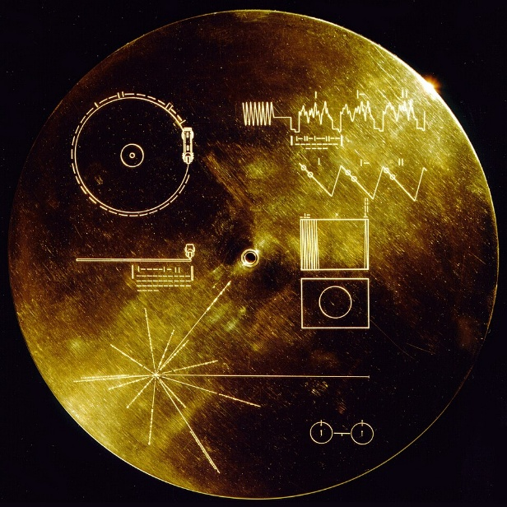
The Voyager Golden Records contain information, including images and sounds, about Earth.

"The Sounds of Earth Record Cover" by NASA is in the Public Domain.

They were included on the spacecraft just in case it came across any other lifeforms out in space—so that these lifeforms could know a little bit about our planet.

When Voyager 1 and 2 completed their missions to Jupiter and Saturn they just kept on going. They are still flying out in space today. Further away from Earth than any other human built object has ever been!

