Movement dice

**Year F**

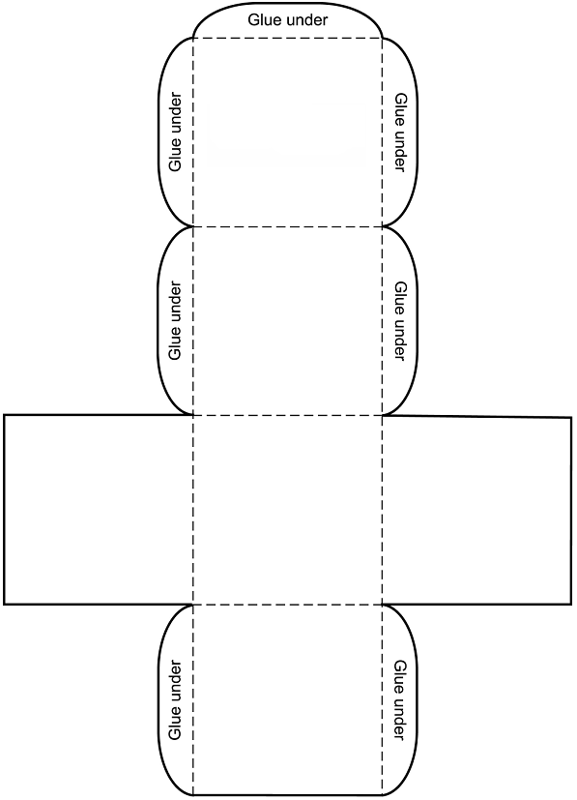

pull

push

spin

roll

slide

bounce

**Optional die**

close

far

slow

fast

soft

hard

