Year F

Measuring handprints
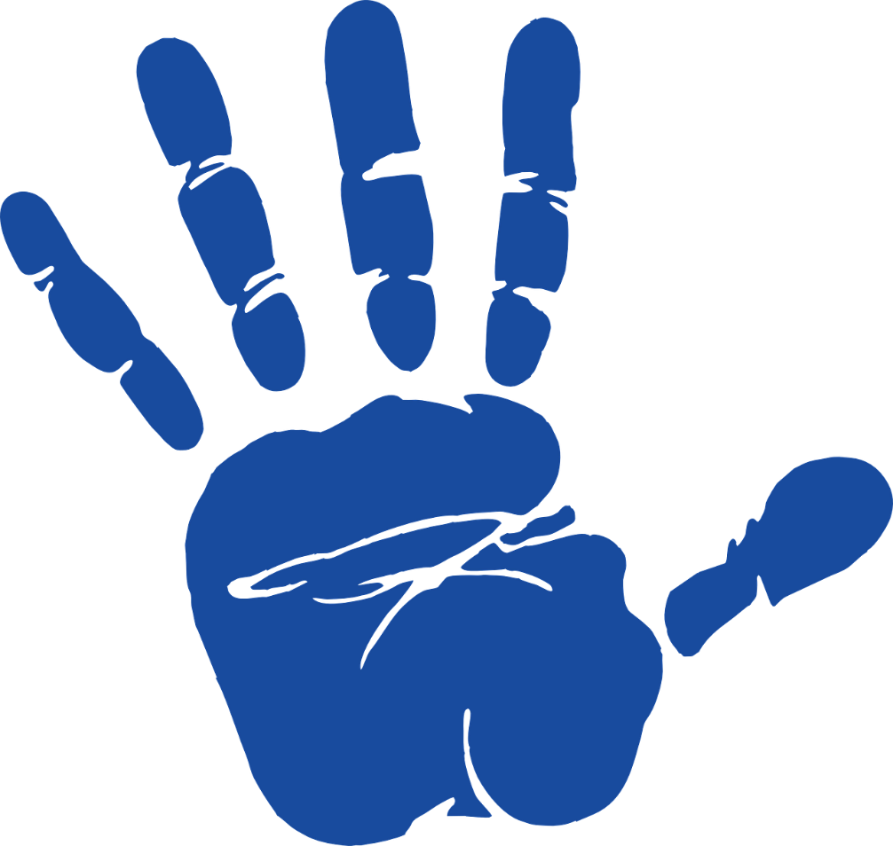

Hand, Print, Palm, Clker-Free-Vector-Images , via Pixabay

