Same food, different packaging

**Year 4**

**Year 4**

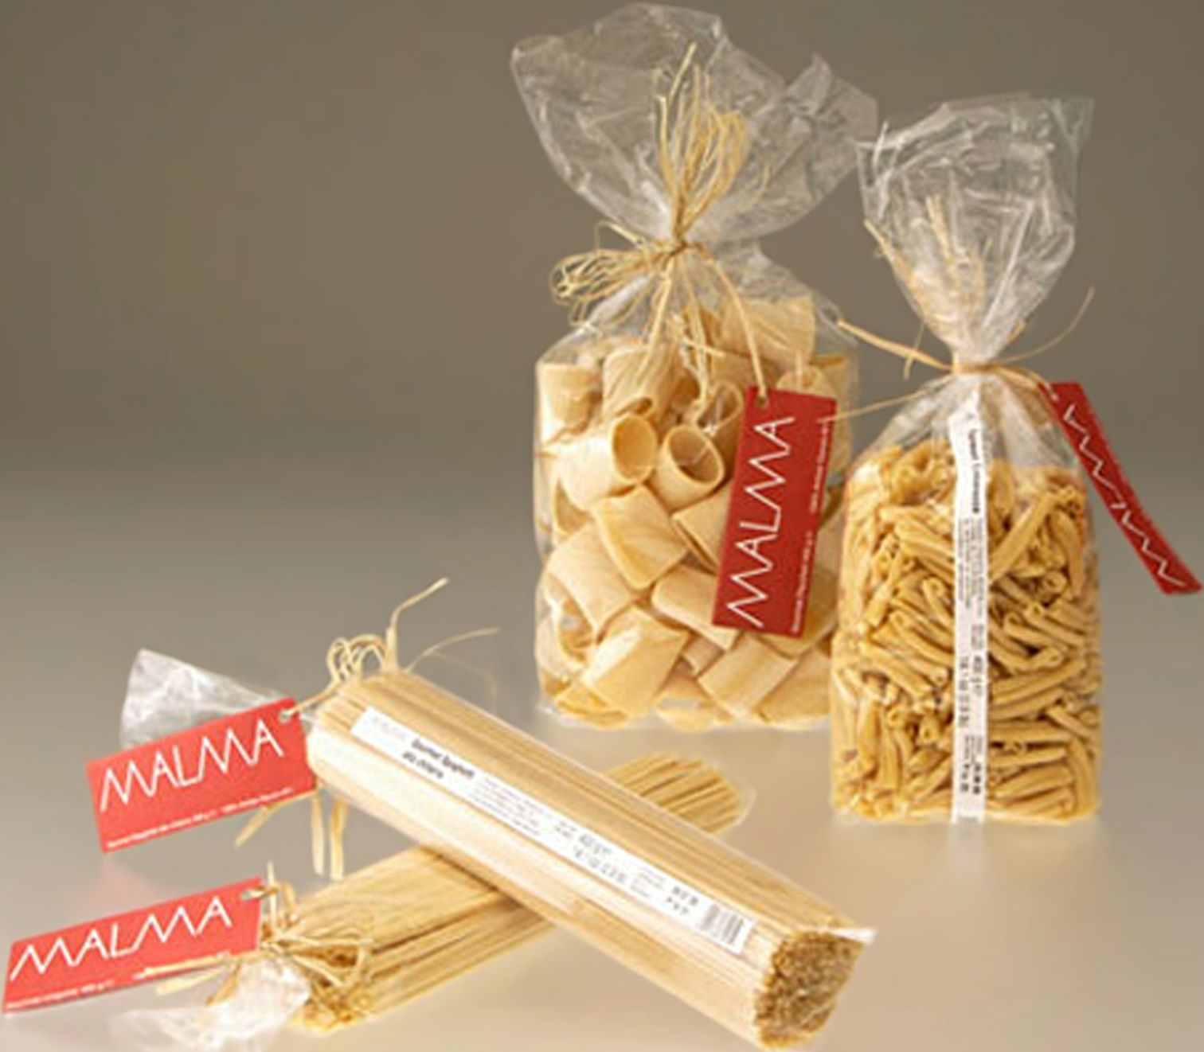

[New Malma packaging 1](https://commons.wikimedia.org/wiki/File:New_Malma_packaging_1.jpg), Designpasta, CC BY-SA 4.0,via Wikimedia Commons

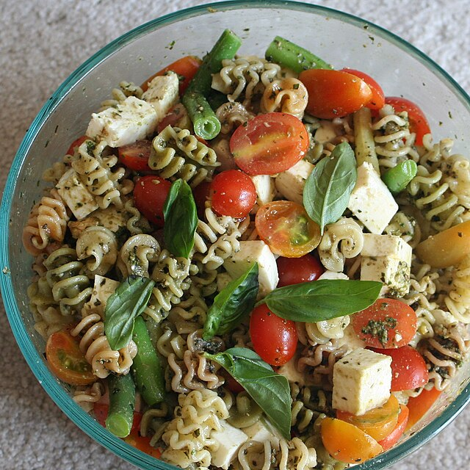

[Pesto Pasta Salad](https://www.flickr.com/photos/whitneyinchicago/3817399719/), Whitney, CC BY 2.0, via Flickr

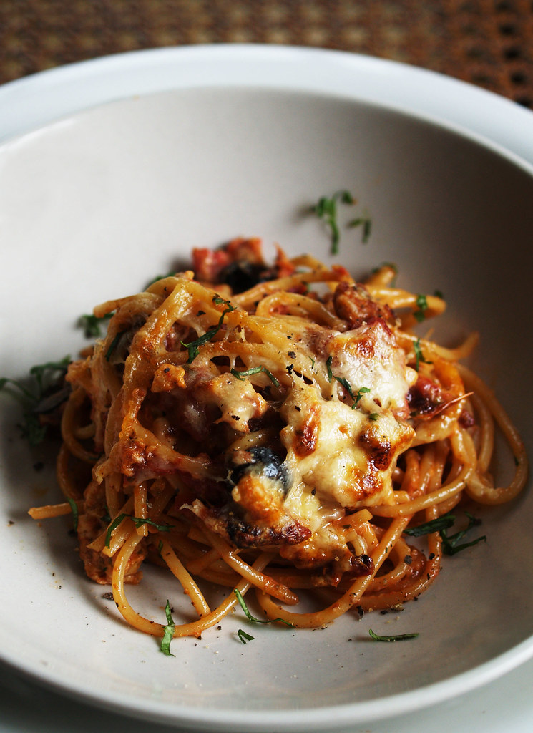

[Spaghetti baked](https://www.flickr.com/photos/58862846@N00/2054483268), Sebastian Mary, CC BY-NC-ND 2.0, via Flickr