Fish and chips packaging

**Year 4**

**Year 4**

1

[Modern Fish and Chips](https://www.flickr.com/photos/44282411@N04/8368723726/), LearningLark, CC BY 2.0, via Flickr

2

[Fish and Chips at Chip In Fish-n-Chips, Sai Kung, HK](https://commons.wikimedia.org/wiki/File:Fish_and_Chips_at_Chip_In_Fish-n-Chips,_Sai_Kung,_HK_(20181020113507).jpg), N509FZ, CC BY-SA 4.0, via Wikimedia Commons

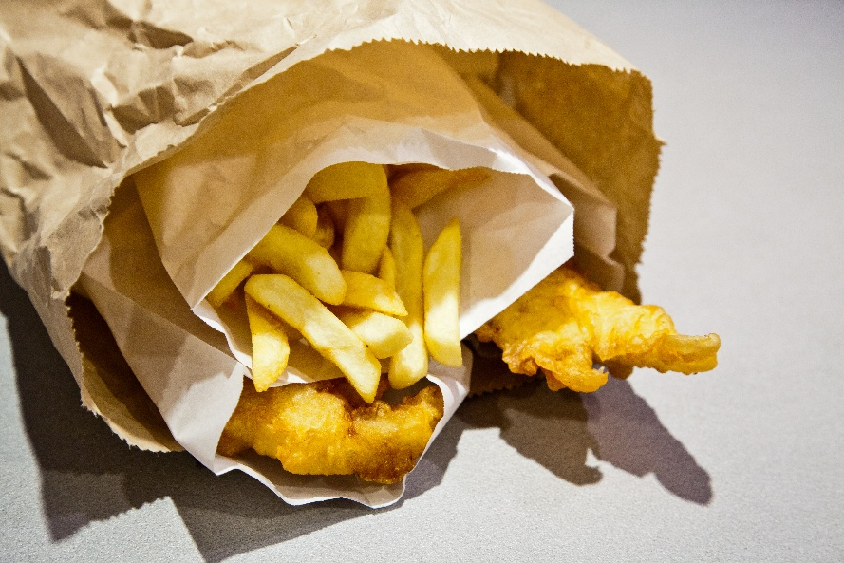

3

[Fish-and-chips-in-a-paper-bag](https://flickr.com/photos/27345927@N07/6055625308), russellstreet, CC BY-SA 2.0, via Flickr

4

[Arthur Treacher’s Fish and Chips at Miami Subs, Hollywood, Florida](https://www.flickr.com/photos/southbeachcars/52706118792/), Phillip Pessar, CC BY 2.0, via Flickr