Melting scenario cartoon

**Year 4**

Naseera and Codi both had a frozen treat in their lunchboxes to enjoy at recess. Both treats were the same size and same flavour, but Codi’s treat completely melted while Naseera’s treat was still mostly frozen. What might have caused that to happen?

My frozen treat is still mostly solid!

My frozen treat has completely melted into a liquid.

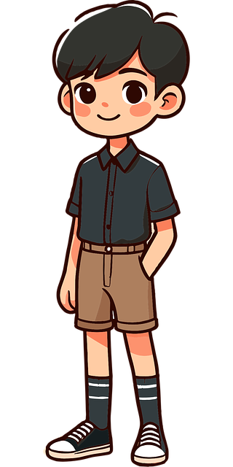

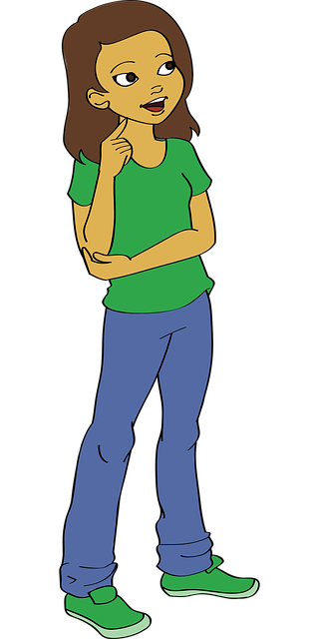

Codi

Naseera

Image by [OpenClipart-Vectors](https://pixabay.com/users/openclipart-vectors-30363/?utm_source=link-attribution&utm_medium=referral&utm_campaign=image&utm_content=2023899) from [Pixabay](https://pixabay.com/?utm_source=link-attribution&utm_medium=referral&utm_campaign=image&utm_content=2023899)

[alex](https://openclipart.org/detail/247671/alex), CC0, via OpenClipart

[Vannis](https://commons.wikimedia.org/wiki/File:Vannis.jpg), Henningklevjer~commonswiki,

CC BY-SA 2.5, via Wikimedia Commons