
Y4

Packaging pioneers • Lesson 1 • Pack it up
Lesson 1
LAUNCH
To read the most recent version of this lesson, download associated resources, and view embedded professional learning including classroom videos and work samples, visit: https://primaryconnections.org.au/teaching-sequences/year-4/packaging-pioneers/lesson-1-pack-it

Lesson overview
Students explore food packaging materials and their suitability for different purposes. They are introduced to the idea of designing a food packaging solution and are given opportunity to ask questions about materials and the design challenge.

Key learning goals
Students will:
- recall what they already know about materials and their properties.
- classify materials used to package their own lunches.
- consider why foods are packaged in different materials.
Students will represent their understanding as they:
- participate in a class discussion about materials.
- record the materials used to package their own lunches in a table, identifying the properties of each material.

Assessment advice
In the Launch phase, assessment is diagnostic.
Take note of:
- students’ ideas about materials and where the materials come from.
  - Can students confidently identify the materials used to make objects? Can they explain which properties make each material useful?
- the vocabulary students used to describe the properties of different materials.

List of materials
Whole class
- Class science journal (digital or hard-copy)
- Demonstration copy of the Frayer Model brainstorming technique Resource sheet
- Demonstration copy of the Unpacking our lunchboxes Resource sheet
- Demonstration copy of the Same food, different packaging Resource sheet
Each group
- Optional: A variety of food packaging and storage containers to examine (if students cannot examine the contents of their own lunchboxes)
- Optional: Magnifying glasses to look more closely at materials
Each student
- Individual science journal
- Their lunchbox, snack box, water bottle, or other food container, containing a variety of food and packaging. It is best to complete Step 1 of this lesson in the morning, when students’ lunchboxes are still full and will contain the most variety.
- Unpacking our lunchboxes Resource sheet

Lesson routine | Estimated time | Task type
Elicit and  Experience & empathise | 20 minutes | Whole class/Small group
Anchor | 15 minutes | Whole class
Connect | 5 minutes | Whole class
Question | 15 minutes | Whole class/Individual

Launch

Elicit and Experience & empathise • What’s in the (lunch)box?
In this activity students will unpack a lunchbox to examine the packaging materials contained within.

Before the unpacking
Using the Frayer Model (see the embedded professional learning The Frayer Model technique in the online version of this lesson), students consider what they know and understand about the terms ‘material’ and ‘packaging’. Remind them that it is acceptable to have multiple definitions/usages for the terms. The Frayer Model brainstorming technique Resource sheet is available to use if required.
Share students’ ideas and create a shared class understanding of what ‘material’ means in a scientific context: any substance that an object is made from. Record this shared definition in the class science journal.
During the discussion, note the difference between the common everyday use of ‘material’ (often used to refer to fabric, for example) and the scientific use. Also note the importance of differentiating between an object and the material it is made of, such as windows/glass or spoon/metal (or plastic or wood). Refer to specific examples where this might be confusing, for example a ‘drinking glass’ might be called a glass, and can be made of glass, but might also be made of plastic.
Share students’ ideas and create a shared class understanding of what ‘packaging’ means in the context of this sequence (materials used to wrap or protect goods during transport and storage). Record this definition in the class science journal.
List common packaging materials that students already know (e.g. metal, wood, plastic, glass, fabric, paper). Ask students if they know how any of these packaging materials are made, how the materials are used/what they are used to make, and where students would expect to find the materials around the classroom/school.
NOTE: The purpose of this question is to ascertain students’ prior knowledge (if any) about natural and processed materials. It is only necessary to gauge students’ initial ideas here. Students may have some knowledge of how, for example, trees are used to make paper, or that metal is melted and shaped to make other products, however this has not yet appeared in the curriculum, so they may not.

During the unpacking
In collaborative teams, students unpack each of their lunchboxes to examine how the food inside is packaged and/or stored, including the lunchbox itself, any drink containers, and any methods of keeping the lunch cool or warm.
Using the data table found on the Unpacking your lunchbox Resource sheet, students record the names of each food item, list the material/s the item is packaged in, describe the properties of the materials, and consider if the properties were suitable for this purpose.
Model how to complete this table using an example item if appropriate for your students.

After the hunt
Share and discuss what students found. Record students’ observations in the class science journal in an appropriate manner. See the table below for one example.
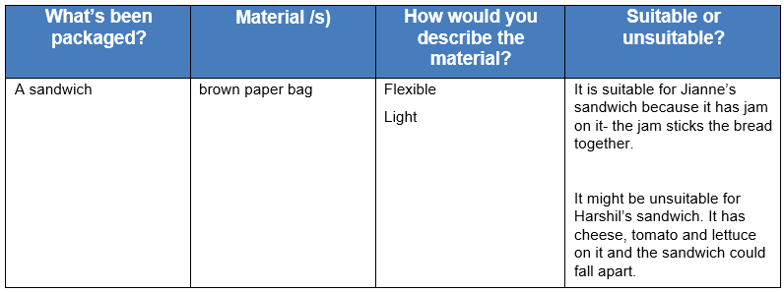
Potential discussion prompts
- What packaging materials did you find? What were they being used for?
- Did any food items use the same type of packaging?
- How would you describe the colour, weight, size, strength etc. of the packaging? Is it easy open, can it be re-used etc.?
- Could you describe one type of packaging in the same way as another?
  - For example, glass and plastic can both be see-through.
- Which packaging materials were made from more than one type of material?
  - For example, a jar is made of glass with a plastic or metal lid.
- How did you describe the materials?
  - Students might describe appearance (colour, shape, size) or the materials’ structural properties (hard, soft, strong, stiff, bendy/flexible) etc. You might consider how you record this information, but it is all important and will be explored later in the sequence.
  - Students might use more informal terms to describe materials, such as ‘bendy’, ‘can be scrunched’, ‘clear’, ‘doesn’t let water through’ etc. This is acceptable at this phase of the sequence. The specific term ‘properties’ and more formal language will be introduced as the unit progresses. Students may have already been introduced to the term ‘properties’ in Year 2, and it is acceptable to use this terminology with students if they offer it first.
- Could you describe a material in more than one way?
For example, cling wrap can be described as ‘bendy, clear and doesn’t leak’, or ‘flexible, transparent and waterproof’.

Anchor • Why is it packaged like that?
Using the Same food, different packaging Resource sheet, separately examine each of the images that show a food item in different ways—in this example, pasta is shown in uncooked form, cooked and served hot, and cooked and served cold.
First, identify the different states of the food item, and what is different about them. Note what the foods are packaged in and ask students to share their ideas about why they are packaged in this way. Ask students to consider what might happen if we switched the ‘packaging’ around, for example, we put the cooked, hot spaghetti bolognaise in a thin, clear plastic bag.
Potential discussion prompts
- What is the food item?
- Is it ‘raw’ or cooked?
- What material is it packaged in?
- Does it always come packaged in that material?
- If you wanted to bring it to school for lunch, how would you store and transport it?
After examining all three images, discuss what could happen if you swapped the packaging for something else.
- What would happen if I put the uncooked pasta into a paper bag to store it? Why do you think that?
- What about the cooked spaghetti that you eat hot? Could you store that in a paper bag? Why/why not?
- Why do you think the hot spaghetti has been stored in a foil tray?
- What about pasta salad? What material would be best to store that in?
Refer back to the lunchbox ‘unpacking’. Consider how foods were stored in lunchboxes, why they were stored this way, and what other suitable and unsuitable ways they could be packaged/stored. Record students’ ideas on a mind map.
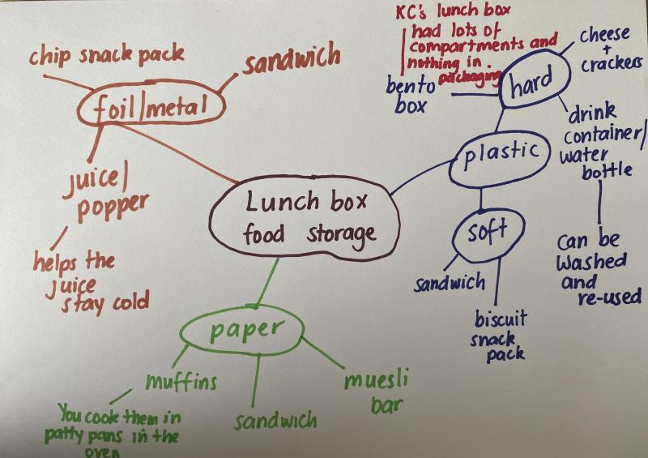
Optional: Discuss different materials/methods to serve and store food at home.
Optional: Explore the methods used by First Nations peoples to ‘package’ food for storage and transportation. Discuss the materials used, why they would have been used, and the differences in how we package things today. For example, look at this wallaby skin water carrier, and this dilly bag.

Connect • Applying to design
Explain that, during this sequence, students will examine the different ways food is packaged and stored, and conduct investigations to determine why certain materials are used and not others.
At the end of the sequence, students will design their own food packaging solution so that all different types of food—wet, dry, cold, and hot—can be transported and stored for a specific purpose. You should select a purpose relevant to your students and context. For example: transporting and storing student lunches, food for a school event such as a fete or cultural day, sports carnival, or a picnic.
Optional: Examine a selection of students’ or other lunchboxes/food storage containers, and list what students think about the way they are designed and what they are made from.
Jointly construct a list of foods (of all cultures) that all students might bring to school. Encourage students to suggest some criteria/properties their containers will need to transport the different types of food, for example, washable, sustainable, light, easy to carry, waterproof, etc.

Question • What do we what to know?
Use the Question Formulation Technique to brainstorm questions students have about packaging materials, the design task etc.

Reflect on the lesson
You might:
- begin a class word wall or glossary with relevant terms.
- begin a class TWLH chart.

Y4

Packaging pioneers • Lesson 2 • Testing, testing
Lesson 2
INQUIRE
To read the most recent version of this lesson, download associated resources, and view embedded professional learning including classroom videos and work samples, visit: https://primaryconnections.org.au/teaching-sequences/year-4/packaging-pioneers/lesson-2-testing-testing

Lesson overview
Students test food packaging and storage materials, identifying the properties of the materials that make them suitable for their intended use.

Key learning goals
Students will:
- identify the materials used in different packaging and containers.
- conduct simple tests to explore the properties of those materials.
- consider why those materials were selected for that purpose.
Students will represent their understanding as they:
- discuss ideas and test results with their team and the class.
- record test results.

Assessment advice
In this lesson, assessment is formative.
Feedback might focus on:
- students’ identification and description of the materials and properties.

List of materials
Whole class
- Class science journal (digital or hard-copy)
- Demonstration copy of the Materials property testing Resource sheet
Each group
- 3 different types of packaging material: one made of paper, one made of soft plastic, and one made of glass or hard plastic
- Access to water
Each student
- Individual science journal (digital or hard-copy)
- Materials property testing Resource sheet

Lesson routine | Estimated time | Task type
Re-orient | 5 minutes | Whole class
Question | 10 minutes | Whole class
Investigate | 25 minutes | Whole class/Small group
Integrate | 20 minutes | Whole class/Small group

Inquire

Re-orient
Recall the previous lesson, reviewing all the different types of packaging materials students saw and/or identified.

Question • Properties of materials
Create a list or mind map showing what students know about paper, plastic and glass packaging materials. Encourage the students to identify different types of paper (e.g. paper towel, deli/butchers paper), plastic (both soft such as salad bags and cling wrap, and hard, such as bottles and boxes) and glass packaging (e.g. jars, bottles), as well as their different uses.
Display three examples of these packaging materials that students will be testing during the investigation: one made of paper, one made of soft plastic, and one made of glass or hard plastic.
Introduce the term ‘properties’ as the qualities or attributes of a material that can be observed or measured. Review some properties identified in the previous lesson such as bendy/flexible or see-through/transparent.
Pose the question: What properties do these packaging materials have?

Investigate • Testing for properties
Name some of the properties of different packaging materials students might think are important. These might include:
- waterproof
- puncture resistant
- flexible
- lightweight
- heat resistant (e.g. doesn’t change when heated)
- cold resistant (e.g. doesn’t change under extreme cold conditions)
Note: The resource sheet lists the properties above for testing, however, these can be edited to suit your context or left blank so they can be filled in during the lesson. More columns might also be added.
Discuss what each property means and determine how students will test each property. For example:
- to determine if a material is puncture resistant, students might test if a hole can be made in the material with a pen.
- to determine if a material is waterproof, students might pour a cup of water into it and see if it leaks.
Describe each test in the relevant row on a demonstration copy of the Materials property testing Resource sheet.
Discuss how you will maintain ‘fairness’ during these tests. For example, by having the same students use the same pen to poke each material with the same amount of force, or pouring the same amount of water on each material at the same rate.
Discuss if there are any properties you cannot test in the classroom (e.g. extreme heat and cold). Explain that students will make a prediction about these properties rather than test for them.
If required, model how to record data for each test using the demonstration copy of the Materials property testing Resource sheet.
Teams carry out their testing and record the results using their own copy of the Materials property testing Resource sheet.

Integrate • Identifying properties
Teams share results with the class. Use the demonstration copy of the Materials property testing Resource sheet to tally/record each team’s results for each packaging material.
Reach a consensus decision about the properties of each packaging material. If teams recorded differing results for a material (for example, most teams could puncture the paper with a pen, but one team could not), discuss why this might have occurred.
Introduce the terms ‘natural’, ‘man-made’ and ‘processed’, and discuss their meaning:
- Natural materials occur within the natural environment and have undergone very little modification.
- Processed materials are often modified from natural materials for a particular use.
- Man-made materials often do not look like their original source. For example, plastic is usually made from fossil fuel.
Look at the materials tested and ask students to consider if they are natural or man-made/processed, and if they are man-made/processed, how much processing they went through to become that material. Allow them the opportunity to share any knowledge of experiences they have with these materials being produced.
Discuss how materials could be modified to change their properties (to improve food packaging and storage in the future). You might record some of their ideas and questions in the class science journal.

Reflect on the lesson
You might:
- add to the class word wall of vocabulary related to properties and materials
- re-examine the intended learning goals for the lesson and consider how they were achieved.
- discuss how students were thinking and working like scientists during the lesson. For example, if teams did end up with varying test results, consider what scientists might do to ensure this doesn’t happen.
- consider how this investigation will be helpful in designing their food packaging solution.

Y4

Packaging pioneers • Lesson 3 • Full steam ahead
Lesson 3
INQUIRE
To read the most recent version of this lesson, download associated resources, and view embedded professional learning including classroom videos and work samples, visit: https://primaryconnections.org.au/teaching-sequences/year-4/packaging-pioneers/lesson-3-full-steam-ahead

Lesson overview
Students consider how and why food packaging has changed over time. They investigate the tensile strength of paper, a common type of packaging.

Key learning goals
Students will:
- explore and identify properties of food packaging from the past.
- conduct an investigation to compare the properties of fish and chip packaging.
Students will represent their understanding as they:
- identify different materials used to package hot foods.
- record observations/measurements in a table.
- compare the strength of each material when wet and dry.
- draw conclusions from their findings and compare findings with their peers.

Assessment advice
In this lesson, assessment is formative.
Feedback might focus on:
- the accuracy and details of the data students have recorded during their investigation.
- whether students are using this data as evidence to justify their conclusions.
- students’ contributions to the discussions about keeping the tests fair.
- the appropriateness of other properties students identified for testing.

List of materials
Whole class
- Class science journal (digital or hard copy)
- 1 large clothes peg
- 1cm x 15cm strip of tissue paper (or some other paper-based material other than those the students will use, see below)
- Demonstration copy of the Fish and chips packaging Resource sheet
- Optional: Samples of the materials depicted in the Fish and chips packaging Resource sheet, including newspaper, thin cardboard boxes, paper cups, greaseproof paper, paper bags, Styrofoam.
- Demonstration copy of the Testing the strength of paper packaging Resource sheet
Each group
- At least 1 clothes peg
- 2 or more 1cm x 15cm strips of at least 3 paper-based materials, for example paper, newspaper, magazine paper, tissue paper, paper towel, greaseproof paper etc.
- Optional: 1 magnifying glass
Each student
- Individual science journal (digital or hard copy)
- Testing the strength of paper packaging Resource sheet

Lesson routine | Estimated time | Task type
Re-orient | 5 minutes | Whole class
Question | 15 minutes | Whole class
Investigate | 25 minutes | Whole class
Integrate | 15 minutes | Whole class

Inquire

Re-orient
Recall the previous lessons, focusing on the materials identified in students’ packed lunches.
Remind students of the difference between natural materials, processed materials and man-made materials.

Question • Hot food packaging
Ask students if they have ever had takeaway fish and chips or hot chips, and discuss their experiences.
Depending on your students you might substitute fish and chips/hot chips with another food that students have experience eating. See the embedded professional learning Adapting to your context below for more details.
Optional: Discuss the ‘healthiness’ of fish and chips/hot chips and if and why they are considered ‘sometimes’ foods, rather than food we should be eating regularly. Be mindful that students in Year 4 have no or very limited control over the foods they eat, as their food is provided to them by parents/carers.
Potential discussion prompts
- Have you ever had a fish and chips takeaway, or hot chips?
- What temperature are they when you buy them?
- How do you know that? What do you observe about the food to know that (see, touch, taste)?
- What type/s of packaging do they come in?
- Is the packaging made of a natural/processed/man-made material?
  - Common packaging for fish and chips/hot chips is paper, which comes from a natural material that needs to be processed.
- What happens to the food over time? What might it be like 5 minutes, 10 minutes, or 20 minutes after you buy it?
- Have you ever seen steam coming off the food?
- What is steam?
Look at a demonstration copy of the Fish and chips packaging Resource sheet. Discuss what students notice about the packaging that can be seen in each image. If possible, have an example of each type of packaging available for students to examine in person.
Teacher reference—fish and chips packaging
The following information is for teacher reference. Students should be guided to make their own observations first, before offering any supplemental information that may further their understanding.
- Image 1: Printed newspaper (a natural material with a small amount of processing involved), commonly used in the 1970s and 1980s. No longer used today, as condensation often made the ink bleed into and discolour the food.
- Image 2: Cardboard box, paper sauce container, wooden fork (processed natural materials). More likely to be seen now as it is more environmentally friendly and can be recycled.
- Image 3: Layered paper bags (a processed natural material). Also more likely to be seen now as it is more environmentally friendly and can be recycled.
- Image 4: Styrofoam boxes (a completely man-made material—a type of expanded plastic less common today for environmental reasons) and greaseproof paper (a processed natural material, paper often with a man-made silicone coating. More recently, some greaseproof papers are marked as ‘bio-degradable’ or ‘eco’ as the coating breaks down more quickly/easily.)
Potential discussion prompts
- What types of packaging can you see in the pictures?
- Which type do you think we still use today, and which ones don’t we use anymore?
- Why don’t we use them anymore?
- Can you see a difference between the ‘paper’ in images 3 and 4?
  - The paper in image 4 is shiny.
- What do you think makes the paper shiny?
  - The paper is coated in plastic so it doesn’t soak up the moisture created by the steam coming off the hot food.
- How has the packaging changed?
- Do you think all changes are ‘good’?
- What do you think might have informed these choices?
- What do you think would be important properties for fish and chips packaging?
Guide the discussion so that students identify strength as an important property in selecting packaging. Strength is important as the materials need to be able to hold the chips, so they don’t fall out and burn you.
Pose the question: Which packaging material is the strongest?

Investigate • Testing for tensile strength
Discuss what students think ‘strong’ means in terms of packaging materials.
Potential discussion prompts
- Which packaging materials are strong?
- Why do you think that?
- Is glass a strong material? Why/Why not?
- Would we package fish and chips in glass? Why/why not?
- What do we package fish and chips in today?
- Can paper or cardboard be strong?
- How would we know if a material is strong? How could we test it?
Explain that students are going to be testing some paper products to see which ones would be suitable for use as fish and chips packaging. They will test both wet and dry samples of different types of paper.
Discuss why it might be important to test the paper when it’s wet: the steam from the hot food makes the paper wet, so they need to know if it will be strong enough to hold the fish and chips after that.
Model the investigation by using a material other than those that the students will test (e.g. tissue paper). Model how to wrap the strip of paper around the clothes peg, how to hold it, and how to squeeze the ends of the peg until the material breaks or the peg opens to its limit.
Model how to use the magnifying glass to examine the snap, tear, or stretch in the material and how to record the observations.
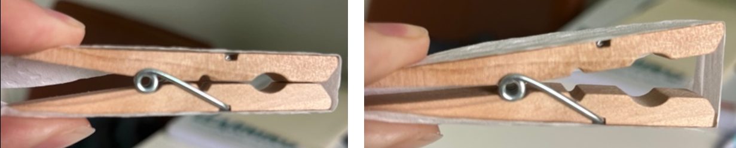 Discuss the fair testing procedure and explain that students will be undertaking two comparative fair tests (a test that changes only one thing to compare if the changed variable makes a difference).
For Test 1, they will test all the materials when dry.
- Change: The type of material
- Keep the same: The size of the material, how the material is wrapped around the peg, and the force used to open the peg
- Measure/observe/record: How the material snaps, tears, or stretches
In Test 2, students will test the same materials but when they are wet. Model how to wet each material and gently squeeze out the excess water.
- Change: The moisture in the material
- Keep the same: The size of the material, how the material is wrapped around the peg and the force used to open the peg, how much water we put on it
- Measure/observe/record: How the material snaps, tears or stretches
You may choose to complete all of Test 1 before introducing and explaining Test 2 to students. Determine the approach that is most suitable for your students’ needs and level of experience with fair-testing.
In collaborative teams, students carry out the investigation and record their results using the Testing the strength of paper packaging Resource sheet.
Optional: Students can collect quantitative data during this investigation regarding how far each material can stretch before it snaps (if at all). One way to do this is to measure and record the distance the peg will open without anything wrapped around it. Students could then measure how far the peg opens when the materials are wrapped around it, carefully observing when it begins to tear, and record this measurement. Using a ruler placed at the edge of the table is one way to provide a fixed measurement method, whilst allowing students to space to manoeuvre the peg as required.

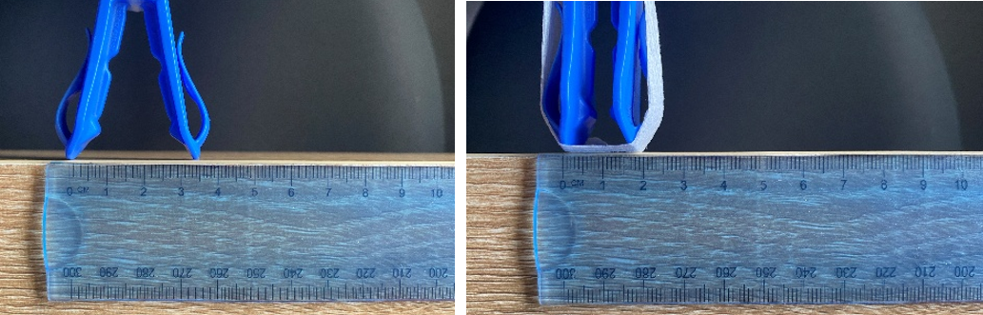 Integrate • What’s the strongest?
Share and discuss the results of teams’ investigations. Use the question prompts below, which also appear on the Testing the strength of paper packaging Resource sheet so that teams can consider their responses before sharing their results.
Potential discussion prompts
- Which material did your team find was the strongest?
- Why did you make that decision?
- Does that match what other teams found?
- Which material might be best for chips packaging (only based on its strength)?
- What other properties might be important to test?
Introduce the term ‘tensile strength’: a measure of the force needed to pull or stretch a material to the point where it breaks. Ask students why they think fish and chip packaging would need to have high tensile strength, especially when wet.
Model in the class science journal how to write a claim based on the test, using the data from the recording table and the term ‘tensile strength’. Ask students to write their own conclusions based on their own investigations.
Discuss why, if greaseproof paper has a higher tensile strength than regular paper, we don’t use it as much anymore to wrap fish and chips. Why do students think that decision was made? What is greaseproof paper made of that makes it stronger? In a later lesson, students will examine these ideas further.

Reflect on the lesson
You might:
- discuss how students were thinking and working like scientists during the lesson. When might scientists use comparative testing?
- consider how knowing about tensile strength is helpful in our everyday lives.
  - For example, when comparing two brands of the same product to determine which is best.
- update the TWLH chart by having students add what they have learned (L) and evidence/observations that show how they know that (H). They may also pose any additional questions that they are curious about (W).
- consider how the investigation will help students to design their food packaging solution.

Y4

Packaging pioneers • Lesson 4 • Keep it cool
Lesson 4
INQUIRE
To read the most recent version of this lesson, download associated resources, and view embedded professional learning including classroom videos and work samples, visit: https://primaryconnections.org.au/teaching-sequences/year-4/packaging-pioneers/lesson-4-keep-it-cool

Lesson overview
Students conduct an investigation into why thermal insulation is needed and which materials provide the best thermal insulation.

Key learning goals
Students will:
- use a provided scaffold to plan and investigate how to keep food colder for longer.
- follow procedures to make and record observations using timing devices.
- understand how data from investigations is used to develop scientific explanations about the best materials.
- explore the insulative properties of different materials for keeping things cool.
Students will represent their understanding as they:
- complete the Keeping cool investigation planner Resource sheet.
- record their observations.
- interpret data both collected and provided.

Assessment advice
In this lesson, assessment is formative.
Feedback might focus on:
- the claims made by students and if they are reliably supported by the data they collected.
In this lesson, assessment might also be summative.
Students working at the achievement standard (science inquiry) should have:
- be able to use provided scaffolds to plan and conduct investigations to answer questions or test predictions.
Refer to the Australian Curriculum content links on the Our design decisions tab for further information.

List of materials
Whole class
- Class science journal (digital or hard-copy)
- Demonstration copy of the Melting scenario cartoon Resource sheet
- Demonstration copy of the How fast will it melt? investigation planner Resource sheet
- 2 x small ice cubes (as close in size as possible). The larger the ice cubes, the longer they will take to melt, especially in cooler weather. We recommend using small ice-cubes.
- 2 x plates
- Timing device
- Demonstration copy of the Variables grid Resource sheet
- Optional: Demonstration copy of the Keeping cool investigation planner Resource sheet. This resource sheet includes a section where students can create their own data table to record results. You might modify the resource sheet to include a data table before printing it for student use. Alternatively you can model how to create an appropriate data table during Step 3 of the lesson.
- Demonstration copy of the Investigation data Resource sheet
Each group
- 3 x small ice cubes (as close in size as possible)
Note: the larger the ice cubes, the longer they will take to melt, especially in cooler weather. We recommend using small ice-cubes.
- 3 x small resealable bags
- A range of materials students can select to act as potential thermal insulators, for example, foil, cloth, plastic, bubble wrap, paper towel
- Stopwatch/timing device
Each student
- Individual science journal (digital or hard-copy)
- Keeping cool investigation planner Resource sheet

Lesson routine | Estimated time | Task type
Re-orient | 5 minutes | Whole class
Question | 15 minutes | Whole class
Investigate | 15 minutes | Whole class/Small group
Integrate and Question | 15 minutes | Whole class
Investigate | 25 minutes | Whole class/Small group
Integrate | 15 minutes | Whole class

Inquire

Re-orient
Recall the previous lesson, focusing on how students used comparative testing as material scientists to compare different materials’ properties—specifically, they tested tensile strength.
Revise the following terms, potentially using the Frayer Model if time permits.
Material: The substance that an object is made from, such as plastic, wood, or glass.
Physical properties: The features of a material that can be observed or measured.
Tensile strength: A measure of the force needed to pull or stretch a material to the point where it breaks.
Variable: Something that can be changed, measured or kept the same in an investigation.

Question • Still frozen?
Using a demonstration copy of the Melting scenario cartoon Resource sheet, read about what happened to Naseera and Codi’s frozen treats. Use the think-pair-share strategy to explore and share ideas as to why Naseera’s treat may have remained more frozen, while Codi’s completely melted.
NOTE: In Year 3 students will have learned about changes of state between solids and liquids, as well as about how heat is transferred from a warmer object to a cooler one until they are approximately the same temperature.
Pose the question: Did the location of Naseera and Codi's school bags cause their frozen treats to melt?

Investigate • Sun or shade?
Consider the different ways and locations that students store their lunch/school bags throughout the school day. A tour around the school might be one way to see if bags/lunchboxes are stored in sunlight outside the classroom, in internal shaded corridors, in tubs inside the classroom etc.
Discuss how the location of the school bag/lunch box over the course of the day may have caused Naseera and Codi's treats to melt, and why. Ask students if they think that something frozen will melt faster when placed in a warm, sunny location as compared to a cooler, shaded location and why they think that.
As a demonstration, investigate to answer the question: What happens to the time it takes an ice cube to melt when we change its location (a warm, sunny location compared to a cooler, shaded location)? Place two ice cubes of roughly the same size on a plate, putting one in a warm, sunny location, and one in a cooler shaded location, and time how long it takes them to completely melt.
Model how to plan an investigation and record data from it using a demonstration copy of the How fast will it melt? Resource sheet.
Design a simple data table to record the information before undertaking the investigation.

Integrate and Question • Which melted faster?
As a class, make a claim to answer the question What happens to the time it takes an ice cube to melt when we change its location (a warm, sunny location compared to a cooler, shaded location)? Refer to the evidence collected to back up your claim.
Return to the Melting scenario cartoon Resource sheet to ask students if they can use their evidence to say why they think Naseera’s frozen treat might have remained mostly frozen, while Codi’s completely melted.
Potential discussion prompts
- What did you notice about the ice melting?
- What evidence do you have?
- Is that what you expected to happen?
Pose the question: How can we stop/slow how quickly a frozen item will melt?

Investigate • Can we stop the melting?
In groups, ask students to discuss what they might do to keep an ice block from melting after it has been taken out of the freezer.
Consider the broad question: What things might affect how quickly something frozen will melt in a lunch box?
Using a demonstration Variables grid Resource sheet, brainstorm the potential variables. For example, the size of the frozen item, the type of lunch box the frozen item is stored in, if the item is wrapped up in anything, how long it’s been out of the freezer, its size, the temperature etc.
Explain that students will be testing if wrapping the frozen item in different materials will affect how quickly it melts, and compose an investigable question: How quickly will a frozen item melt when we change what it is wrapped in?
Optional: Discuss the difference between broad questions and investigable ones.
- Broad questions are designed to gather as many answers, or variables in a scientific sense, as possible. They are often a springboard to further investigation.
- An investigable question is much more narrow. It names what is going to be measured—in this case how fast a frozen item will melt—and what is going to be changed—the material the frozen item is wrapped in. A specific claim, backed up by evidence, can be made to answer an investigable question.
In collaborative teams, students use the Keeping it cool investigation planner Resource sheet to plan, conduct, and record data to answer the investigation question.
If required, model how to create a data table to record the time it takes each ice cube to melt. Students transfer this data table to the Keeping it cool investigation planner Resource sheet and use it to record results.
Students undertake the investigation, timing how long it takes each ice cube to melt completely.
Allow students time to analyse their results. Encourage them to, as a group, make a claim about which variable made the ice melt more quickly, referring to their data as evidence.
Teams might complete a sentence stem such as “The ice melted most quickly when... We think this because…”

Integrate • Which material is best?
Each team shares their claims about which ice cube melted the mostly quickly and the most slowly.
Record teams’ claims in a data table in the class science journal. Discuss similarities and differences between the results and materials used.
Potential discussion prompts
- What did you notice about the ice melting?
- What evidence do you have?
- Is that what you expected to happen?
- What was similar about all the teams’ results? What was different?
- What does this tell you about the properties of the materials you tested?
- What would you change about the method if you did it again?
Using a demonstration copy of the Investigation data Resource sheet, show students the ready-made images and data (shown below also), which replicates the investigation they just undertook. Discuss the difference between how the data was collected. In this instance, the ice cubes were weighed at specific time intervals to see how many grams/millilitres they had lost over that time. 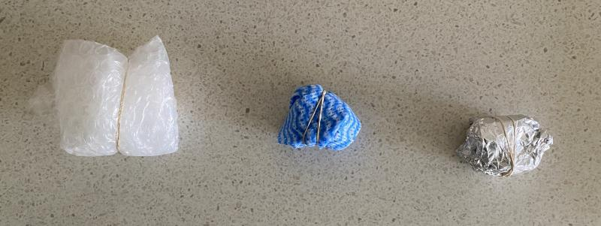
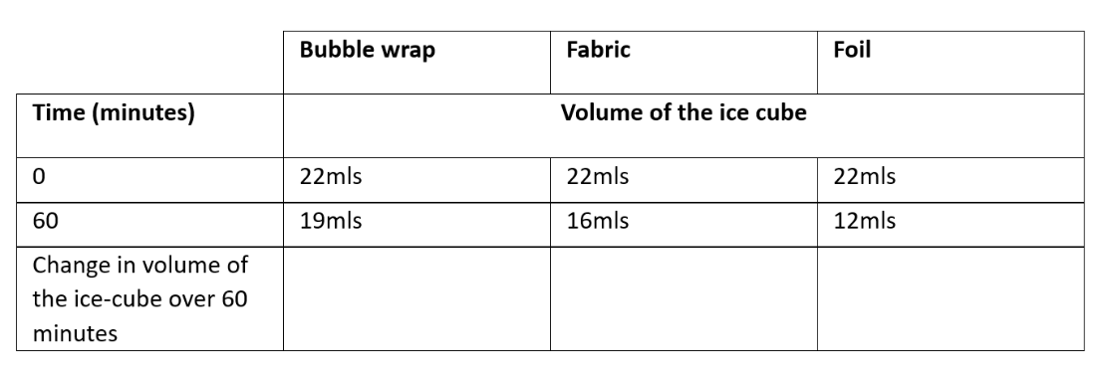
Discuss if this data matches the evidence that students collected with a different measuring method and why that might be.
Determine as a class which materials were the best and worst at stopping/slowing the melting of the ice cube, in reference to all the available evidence.
Introduce the term ‘thermal insulator’: a material that does not allow heat to pass through it easily. Using the data, determine which material was the best thermal insulator by calculating the volume of water that was lost (by calculating the volume of water lost, students are determining which material allowed the least amount of heat to pass through to the ice cube and melt it). Students share their ideas about what they think happened and why.
Consider the materials tested and ask students to think about why foil was not a good insulator, but bubble wrap is.
Discuss how people use this knowledge in everyday life. For example, insulated water bottles keep drinks cool for longer, and insulation in housing keeps out the heat in summer and keeps in the warmth in winter.

Reflect on the lesson
You might:
- add to the class word wall of vocabulary related to thermal insulation
- re-examine the intended learning goals for the lesson and consider how they were achieved.
- discuss how students were thinking and working like scientists during the lesson. Focus on looking at data to provide evidence.
- consider how what students have investigated will be helpful in designing their food packaging solution.

Y4

Packaging pioneers • Lesson 5 • Combining materials
Lesson 5
INQUIRE
To read the most recent version of this lesson, download associated resources, and view embedded professional learning including classroom videos and work samples, visit: https://primaryconnections.org.au/teaching-sequences/year-4/packaging-pioneers/lesson-5-combining-materials

Lesson overview
Students investigate how the properties of fabric can be modified by combining it with other materials.

Key learning goals
Students will:
- explore how the properties of materials can change when using them in combination.
- identify and compare the water resistance of fabrics combined with different substances.
- consider how Aboriginal and Torres Strait Islander Peoples’ knowledge of natural and processed materials informs the preparation of effective, vibrant and long-lasting paints.
Students will represent their understanding as they:
- make appropriate observations and measurements to compare properties of fabric combinations.
- use observations to explain how the properties of fabrics change when they are coated in different materials.
- share their ideas about the changes of properties to a material, and whether these changes make the material better or worse, listen to each other’s ideas and share unexpected findings/posing questions for further investigations.

Assessment advice
In this lesson, assessment is formative.
Feedback might focus on:
- students' identification of the properties of materials and how these properties influence their use.
OR:
In this lesson, assessment is summative.
Students working at the achievement standard (science inquiry) should:
- be able to use provided scaffolds to plan and investigate to answer questions or test predictions, including identifying the elements of fair tests, and considering the safe use of materials and equipment.
Refer to the Australian Curriculum content links on the Our design decisions tab for further information.

List of materials
Whole class
- Class science journal (digital or hard-copy)
- A variety of classroom items made of more than one material. For example a sharpener (plastic and metal), windows (metal or wood and glass), chairs (plastic, metal, foam, fabric) etc.
- A square of fabric 15 x 15cm approximately (a wash cloth for example)
- 3 x jars or cups
- 3 x elastic bands
- A pipette or water dropper
- A cup of water
- Demonstration copy of the Combining materials Resource sheet
- A square each of regular paper, baking paper, and cling wrap 15 x 15cm approximately
- Optional: a fourth jar/cup
- Optional: silicone baking sheet
- Examples of food packages that are made using more than one material, e.g. greaseproof paper, plastic-coated wrapping paper, and plastic-coated aluminium chip packets.
Each group
- 3 x jars or cups
- 3 x elastic bands
- A selection of fabrics in squares of 15 x 15 cm approximately (wash cloths work well)
- 1 cup of water
- A pipette or water dropper
- A selection of substances that can be used to coat each material (e.g. vegetable oil, wax crayons, glue, foil)
Each student
- Individual science journal (digital or hard-copy)
- Combining materials Resource sheet (or make their own)

Lesson routine | Estimated time | Task type
Re-orient | 5 minutes | Whole class
Question | 15 minutes | Whole class/Individual
Investigate | 20 minutes | Whole class/Small group
Integrate | 15 minutes | Whole class

Inquire

Re-orient
Recall the previous lesson, focusing on comparing the property of thermal insulation of different materials. Ask students to recall what they found out from their investigations, e.g. how the thermal insulation was affected by changing the number of layers, the colour or the material. Ask students to explain why some materials are better at preventing heat transfer than others.
Links can be made to what students learned about heat transfer in Year 3.

Question • Combinations of materials
Examine a variety of classroom items made of more than one material, and introduce the idea that most of these items use a combination of materials to make them more useful.
Identify the material components of each item, what each material is used for, and the properties that make them useful. For example, a pencil sharpener is usually made of metal and plastic. The plastic is lightweight and durable, so it doesn't break easily, and the metal can be sharp enough to shave a thin layer of wood off the pencil to reveal more lead.
Challenge students to list as many examples as possible of items made with combinations of different materials, within a given time limit, either individually or with a partner. Collate a list in the class science journal using the cumulative listing technique.
Optional: Introduce how some First Nations Peoples used saps and resins to waterproof animal hides so that they could be used to carry water. See the embedded professional learning Aboriginal and Torres Strait Islander Histories and Cultures in the online version of this lesson for more information.
Pose the question: How can we combine materials to make fabric waterproof?

Investigate • How can we change the properties of fabric?
Explain that fabric is a good material for a lunch bag because it is flexible, sustainable (because you can use it more than once), and light. However, fabrics are not always waterproof.
Model the investigation by stretching a square of fabric over a jar or plastic cup, securing with an elastic band, and using a pipette or water dropper to drop 20 drops of water onto the fabric. Observe and measure the length of time the water drops remain on the fabric before being absorbed, and any water that passes through the fabric.
Challenge students to work in collaborative teams to think about how they can change the fabric to make it more waterproof. In this investigation, students should discuss how they are going to observe/measure how waterproof their materials are. For example, they may choose to time how long it takes for the water to soak through the material, how much water goes through the material, or how easy it is to wipe off the water from the surface.
Task each team to choose two different combinations to compare to the original sample. For example, they may select fabric, fabric sandwiched together using glue, and fabric covered in wax crayon. Once they have set up their investigation, ask students to use 20 drops of water on each sample, and to record their descriptive and measured observations using the Combining materials Resource sheet.
Alternatively, they can construct their own table in their individual science journals, using the sample on the resource sheet as a guide.

Integrate • What happened?
Teams communicate their findings by answering the following questions:
- Which material combination was the most leakproof? What evidence do you have to support your claim?
- What were the downsides to your material combinations?
  - For example, it was sticky or would make the food smell.
- Were there any unexpected findings? What further questions could we investigate?
Remind students of how they found that greaseproof paper had a stronger tensile strength than regular paper, but that greaseproof paper is not always used to package fish and chips.
Set up a demonstration with three cups, with regular paper, baking paper, and cling wrap secured over the top.
Optional: Use a fourth cup with a silicone baking sheet placed over the top.
Place 10 - 20 drops of water onto the regular paper secured to the top of a cup and wait a length of time (10 or 15 seconds) before testing to see how easily something can be pushed through the paper, for example, a finger.
Repeat so that a few students get the opportunity to experience this.
Now repeat the process for the other materials and cups.
Determine which material was the weakest once it had been covered in water. Discuss what this might mean if it were used for food wrapping.
Potential discussion prompts
- Which material was the weakest?
- Does that match what we learned during our tensile strength testing?
- Could you describe the difference between regular paper and greaseproof paper? How does it feel? What happens when you scrunch it etc.?
  - Have some samples for students to manipulate and observe.
- Would you call the cling wrap strong in this case? Was it easy to put a hole in it?
- Do you think cling wrap is good for carrying food?
- What food is cling wrap not suitable for and why?
- How do you think they make greaseproof paper?
  - Greaseproof paper is covered in a thin layer of silicone.
- What property does the greaseproof paper have that normal paper doesn’t have?
  - It’s more waterproof.
- Why do we use greaseproof paper then, instead of just using cling wrap?
  - The cling wrap can melt if the food is hot enough, and plastic isn’t good for the environment. Baking paper decomposes faster than cling wrap, although the silicone or wax coating slows down the process a lot.
  - Some greaseproof paper is marked as ‘bio-degradable’ or ‘eco’. These are the most environmentally friendly ones available at the moment.
- Why do you think most shops use paper instead of greaseproof paper for fish and chips?
  - Greaseproof paper is not as easy to recycle as paper, because of the plastic coating. The plain paper soaks up some of the oil from the fish and chips, making it a bit healthier when we eat the food.
Present students with food packages that are made using more than one material, e.g. greaseproof paper, plastic-coated wrapping paper, and plastic-coated aluminium chip packets. Discuss what students observe about their different materials and properties.
Potential discussion prompts
- What combinations of materials have been used here?
- Why do you think they have been combined?
- What properties do they have together that they didn’t have when they were used separately?
- How does the combination make the materials more useful?
- How does the combination make the materials less useful?

Reflect on the lesson
You might:
- add to the class word wall vocabulary related to properties, e.g. absorbency, waterproof, airtight.
- re-examine the intended learning goals for the lesson and consider how they were achieved.
- discuss how students were thinking and working like scientists during the lesson. Focus on the importance of critical thinking when investigating properties of materials, thinking about the idea that there is more than one way to make observations.
- consider how what they have investigated will be helpful designing their food packaging solution.

Y4

Packaging pioneers • Lesson 6 • Can we make an environmentally friendly plastic?
Lesson 6
INQUIRE
To read the most recent version of this lesson, download associated resources, and view embedded professional learning including classroom videos and work samples, visit: https://primaryconnections.org.au/teaching-sequences/year-4/packaging-pioneers/lesson-6-can-we-make-environmentally-friendly-plastic

Lesson overview
Students consider environmental sustainability by making/manipulating bioplastics. They then explore the properties of bioplastics.

Key learning goals
Students will:
- critically discuss and retrieve what they already know about plastics.
- consider the components and properties of their corn flour bioplastics.
- explore the properties of bioplastics.
Students will represent their understanding as they:
- describe the properties of their bioplastics.
- engage in investigations safely and make observations using their senses.
- critically compare the properties of bioplastics and think about how bioplastics might be used.

Assessment advice
In this lesson, assessment is formative.
Feedback might focus on:
- students’ examination of the properties of materials, considering how these properties influence their use.
In this lesson, assessment might also be summative.
Students working at the achievement standard (science inquiry) should have:
- compared findings with those of others, consider if investigations were fair, identify questions for further investigation and draw conclusions.
Refer to the Australian Curriculum content links on the Our design decisions tab for further information.

List of materials
Whole class
- Class science journal (digital or hard-copy)
- Demonstration copy of the Types of plastic Resource sheet
- How is plastic made? (5:16)
- Demonstration copy of the Bioplastics recipes Resource sheet
- Measuring cups/spoons
- Saucepan
- Stovetop
- Cornflour
- Water
- Vinegar
- Glycerin (available in the health/beauty aisles of many supermarkets)
- Optional: Food colouring
- Optional, if also making milk-based bioplastic:
  - Milk
  - Cookie cutters
- Safety note: Making bioplastics requires access to a stove. Modify the activity to suit your context and the needs of your students. For example, you might make the recipe away from students, showing them a video recording of the process.
- Note: Bioplastic will take 1-2+ days, (depending on the weather) to dry.
Each group
- A variety of materials to test the properties of bioplastics, for example:
  - water
  - cups
  - elastic bands
  - pipettes/water droppers
  - skewers
  - rulers
Each student
- Individual science journals (digital or hard-copy)

Lesson routine | Estimated time | Task type
Re-orient | 5 minutes | Whole class
Question | 15 minutes | Whole class
Investigate | Variable | Whole class/Small groups
Integrate | 15 minutes | Whole class

Inquire

Re-orient
Review the discussion from the previous two lessons about paper vs greaseproof paper, and the environmental reasons people choose to wrap fish and chips in regular paper rather than greaseproof paper.

Question • Talking about plastic
Using a demonstration copy of the Types of plastic Resource sheet, discuss the differences between the types of plastic represented. Ask students what they know about the use and the recyclability of each type of plastic.
Construct a definition/description of ‘plastic’ with students, using their own knowledge and experience. You might:
- list types of plastics.
- list items made of plastic.
- list the properties of plastics (for example rigid, malleable and flexible, transparent or opaque).
  - If students use a non-scientific term, accept the response and introduce the correct term. For example, students might offer that plastic is bendy (flexible) or shaped easily (malleable).
- describe the recyclability of plastics.
Explain that, although it is cheap, most plastics that people use are made from oil or gas, so they can take a very long time to decompose, resulting in about 5 trillion pieces of plastic in the ocean. Give some examples of types of plastics and their uses:
- PET (Polyethylene terephthalate) us used to make drink bottles.
- PP (Polypropylene) is used to make heat resistant containers.
- PE (Polyethylene) is used to make lots of flexible products including plastic bags.
Watch the video How is plastic made? (5:16).
Explain that material scientists are constantly inventing new plastic alternatives that are better for the environment, such as bioplastics. A bioplastic is a plastic made from biological resources, such as plants, rather than fossil fuel oil. Plastics can be biodegradable (able to naturally break into small parts, including microplastics) or compostable (able to naturally break down into new materials that can be used by plants and animals). Bioplastics are usually compostable in the right conditions.
Pose the questions: What is the best bioplastic recipe? Are bioplastics waterproof?

Bioplastic fantastic • Investigate

Investigation Part 1
As a class work together to make cornflour-based bioplastic, following the first recipe found on the Bioplastics recipes Resource sheet.
Safety note: This recipe requires access to a stove. Modify the activity to suit your context and the needs of your students. For example, you might make the recipe away from students, showing them a video recording of the process.
After the bioplastic has fully dried (1-2+ days, depending on the weather), examine the bioplastic and identify its potential properties.
Optional: In collaborative teams, students plan their own investigation to find out what happens to the bioplastic when they change an element of the recipe. For example: What will happen to the bioplastic if we change the amount of vinegar, heat (or milk)?
Optional: Follow the second, milk-based bioplastic recipe, also found on the Bioplastics recipes Resource sheet. Compare the two different types of bioplastics.

Investigation Part 2
Repeat the testing process used in Lesson 5 to observe if the bioplastic is waterproof: stretch a preprepared square of the bioplastic over a jar, securing with an elastic band and using a pipette or water dropper to drop 20 drops of water onto the bioplastic. Observe and measure the length of time the drops stayed on the material before being absorbed and any water that dropped through.
Optional: Discuss and devise testing you might undertake to test the bioplastics’ other properties, such as flexibility and tensile strength. Allow students to undertake these tests.

Integrate • Is bioplastic useful?
List, then discuss, the properties that students might/have tested of the bioplastics, for example, the ability to be moulded (malleable), hardness, stretchiness, flexibility, strength, water solubility, and water resistance.
Potential discussion prompts
- How were the bioplastics similar/different from the plastic items we buy?
- Why do you think this was?
- How might you invent your own bioplastic?
- Was your experiment testing fair? Why or why not?
- What questions might you ask now?
- Do you think bioplastic could be used for food packaging? Why do you think this is?
Challenge students to think about the difference between fossil fuel-based plastic and bioplastic. Explain that material scientists around the world are looking for solutions to our plastic problem by creating a ‘compostable’ plastic, which means that it can be broken down by living things so that it can safely go back into the soil.

Reflect on the lesson
You might:
- add to the class word wall vocabulary related to properties, e.g. compostable, biodegradable, plastic, polymer
- re-examine the intended learning goals for the lesson and consider how they were achieved.
- discuss how students were thinking and working like scientists during the lesson. Focus on the importance of systematic testing when inventing a new material.
- consider how what they have investigated will be helpful designing their food packaging solution.

Y4

Packaging pioneers • Lesson 7 • Designing a food packaging solution
Lesson 7
ACT
To read the most recent version of this lesson, download associated resources, and view embedded professional learning including classroom videos and work samples, visit: https://primaryconnections.org.au/teaching-sequences/year-4/packaging-pioneers/lesson-7-designing-food-packaging-solution

Lesson overview
In this lesson students consolidate their learning by designing packaging to carry different types of food, considering the properties that are required by each food type.

Key learning goals
Students will
- be guided through the design process to create appropriate packaging to keep their food cool, sealed and leak-free.
Students will represent their understanding as they:
- create a package design with labels and descriptions of the materials and properties of their food packaging.
- share their food packaging design and communicate their design choices to a chosen audience.

Assessment advice
In the Act phase, assessment is summative.
Students working at the achievement standard should be able to:
- name the possible properties of common materials.
- link the properties of materials to their use.
- apply their understanding to make recommendations about materials suitable to package, store and transport food.
Refer to the Australian Curriculum content links on the Our design decisions tab for further information.

List of materials
Whole class
- Class science journal (digital or hard-copy)
- Optional: Demonstration copy of the Package design plan Resource sheet
- Optional: Demonstration copy of the Designing food packaging evaluation Resource sheet
Each student
- Individual science journals (digital or hard-copy)
- Package design plan Resource sheet
- Designing food packaging evaluation Resource sheet
- A variety of materials students can use to make a prototype of their food packaging solution, including plastics, foils, paper, cloth, scissors, glue, markers, stapler and staples, tape (plant-based if possible), paper, card, etc.

Lesson routine | Estimated time | Task type
Anchor | 15 minutes | Whole class
Connect | 10 minutes | Whole class
Design | Variable | Whole class/Individual
Communicate | 20 minutes | Whole class/Small groups

Act

Anchor • What have learned?
Re-examine the data and ideas collected in the class journal over the course of the teaching sequence.
Discuss what conclusions students have drawn about:
- the tensile strength of different types of paper.
- materials that are the best thermal insulators.
- material combinations that are most waterproof.
- plastics that are compostable and biodegradable.
- the properties that are suitable for food and drink packaging.
- how we can make packaging more sustainable and environmentally friendly.

Connect • What do people need from our design?
Discuss the properties a food packaging solution would require. Relate the discussion to any specific context you have selected.
Potential discussion prompts
- What sort of foods do people transport?
- What properties are they looking for when they pack food for transport?
- What else do they have to consider (temperature, flexibility, etc.)?
- Do people have to transport and store the same food every day?
- How will you provide different options for all types of foods?
Use the identified properties to produce a set of criteria for designing the food packaging solution that students can use as an evaluation and reflection tool. See the Designing food packaging evaluation Resource sheet for an example that can be used as is or modified to suit your needs.

Design • Designer lunch
Using the steps of the design thinking process, students use their understanding of materials and their properties to design a food packaging solution.

Define
In order to create the design brief for the challenge as a class, outline the problem in a simple manner.
How can we create a food packaging solution that someone could use to pack, transport and store all different types of food?
Potential discussion prompts
These are some example question prompts. These should be modified and added to suit any specific design focus/context you have selected.
- Who will you design for? A hiker going camping for four days, or a student at school?
- What types of food will they need packed?
- What will they put the food in?
- What else will be packed next to the food? Will it get squashed?
Alternatively, you might provide a pre-prepared design brief to the students.

Ideate
Brainstorm ideas related to the design of food packaging. At this stage, to support creative thinking, every idea offered by students should be recorded in the class science journal. No idea should be discounted, as the practicality/possibility of each idea will be considered in the next stage of design.
As students offer ideas, ask probing questions (Why do you think… or How do you know that…) to draw out the reasoning and evidence behind the idea.
Potential discussion prompts
- What food are you transporting?
- What properties are important?
- What will happen to the packaging once you have finished the food?
- Will the food be protected from unwanted changes?

Prototype
Provide students time to draft design ideas for their food packaging solution. Students might create many drafts during this process. At each stage of the prototype designs, encourage students to consider how the design would work for different food types. Encourage students to keep each prototype drawing (even if they decide that it is not appropriate) so they can record how their thinking has changed and their design has improved over time.
At the end of the allocated time, students should have one clearly identified, labelled, and annotated final design, naming parts of the package, the materials that they have selected, and why they have selected them
Optional: Once students have drawn their design, they can use available materials to create a prototype for their design. Encourage students to be creative about the idea of their prototype. For example, they may not be able to make their own bioplastic in time, but they could use a different material to ‘represent’ the bioplastic for the prototype.

Communicate • Sharing our design

Test and share
Students use the Packaging design plan Resource sheet to develop a testing procedure for their preferred design. Discuss what criteria students’ food packaging solution would need to meet in order to satisfy the design brief, e.g. containers need to be waterproof and resistant to impact.
Brainstorm ideas for testing the food packaging solutions against the criteria, such as spraying with water, dragging or squeezing the package into a school bag, and dropping the containers. Ask students to record what criteria each team member’s packages need to meet in the ‘Criteria’ section of their Packaging design plan Resource sheet.
Ask students to negotiate what tests they will use and to provide reasons for their choices. For example: We chose to drop the package from a height of 1 m because it is unlikely the lunch containers will be dropped from higher than that, and we chose to spray it with water because the lunch might be rained on. Allow students time to complete their planning and to conduct their tests.
Ask students to discuss their package with team members. Encourage team members to ask questions to provide peer support and informal peer assessment of students’ procedural text and package. Team members might ask questions, such as:
- Is the material natural or processed? Why did you use that material?
- How did you construct your food packaging solution?
- What changes did you make to your procedural text? Why?
- What steps in your procedural text were not effective in the construction of your food packaging solution?
Students share their designs with an appropriate audience, pitching their food packaging solution and its properties to them.
They might do this by organizing a class presentation, by recording a video of the students’ design pitches, or by taking photographs of each design for students to annotate.
Use the Designing food packaging evaluation Resource sheet for self- and peer assessment.

Reflect on the sequence
You might:
- refer to the list of student questions asked in the TWLH chart during the launch phase. Determine which questions have been answered throughout the learning sequence, what the ‘answers’ to the questions are, and the evidence that supports these claims. Address questions that have not been answered during the learning sequence, discuss why they might not have been addressed, and potential investigations that might support students to answer them.
- consider what students have learned about properties of materials, and how new materials can be invented and developed in ways that are environmentally conscious.
- discuss why it is important to understand how we can test and change the properties of materials. Discuss kinds of jobs that would need to use this understanding? Discuss how it might apply to everyday life and how it might make you think about the packaging used for your lunch.
Watch the video A Scientist Just Like Me: Pearl Agyakwa a Materials Scientist (3:28) and discuss what a materials scientist does.

