Who shelters here?
Year F

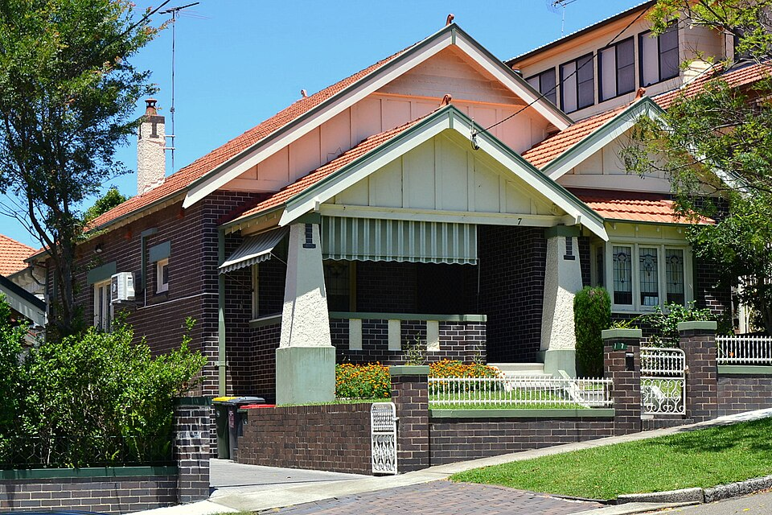
California Bungalow Sydney-4, Sardaka, CC BY 3.0, via Wikimedia commons

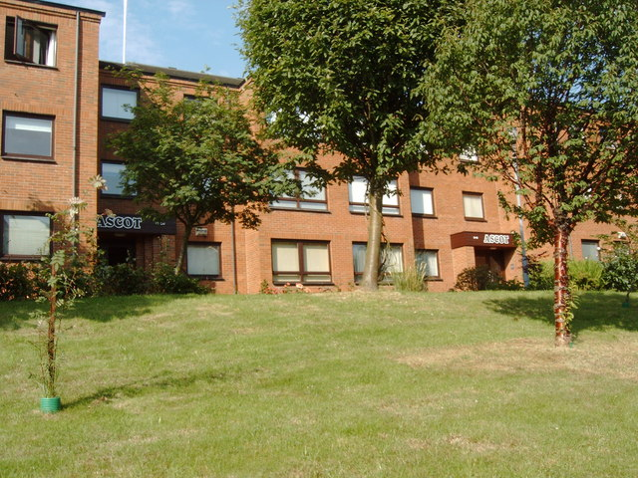
Ascot apartments, Darrin Antrobus, CC BY-SA 2.0, via Geograph.co.uk

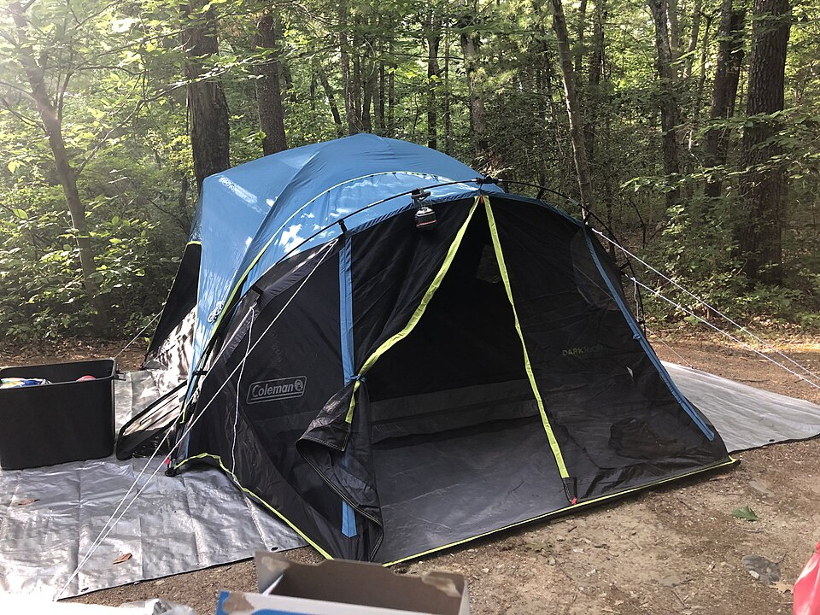
Camping_tent_on_tarp, Eden Aviv, in the Public Domain, via Wikimedia Commons
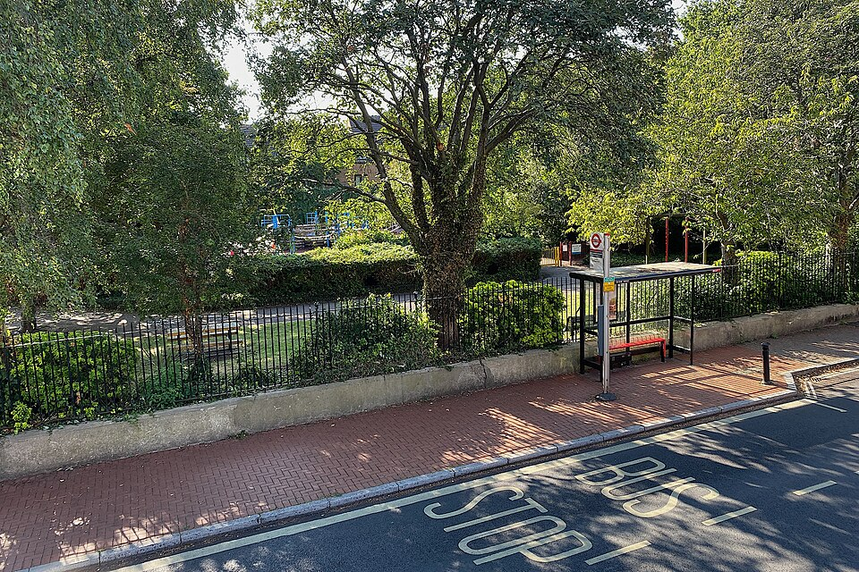
Bus_stop, Rotherhithe_Street, Robin Stott, CC BY-SA 2.0, via Geograph.co.uk

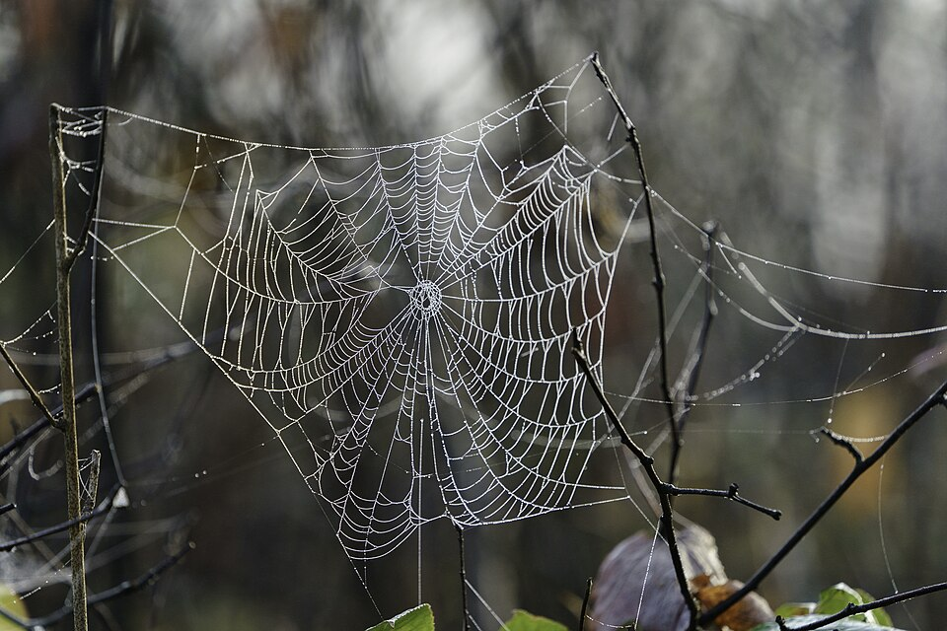
Spider web in Aitkin County, Minnesota, Lorie Shaull, CC BY 2.0, via Wikimedia Commons
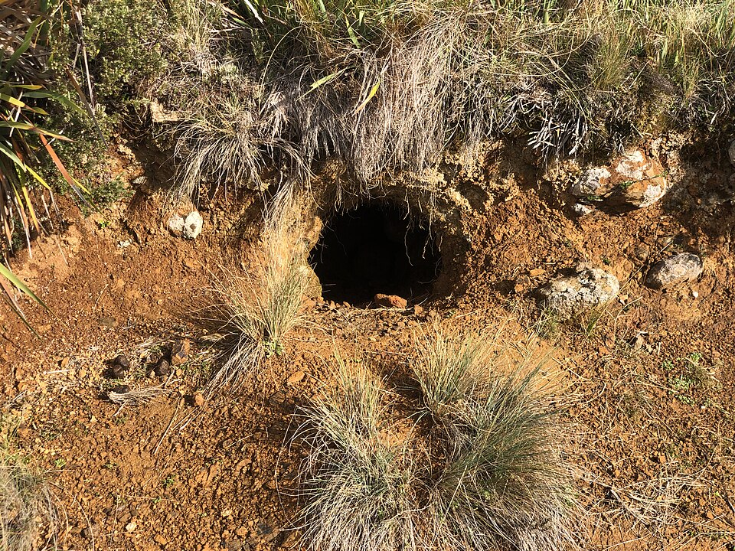
Vale of Belvoir conservation area. Wombat burrow, AnnaHackett, CC BY-SA 4.0, via Wikimedia Commons

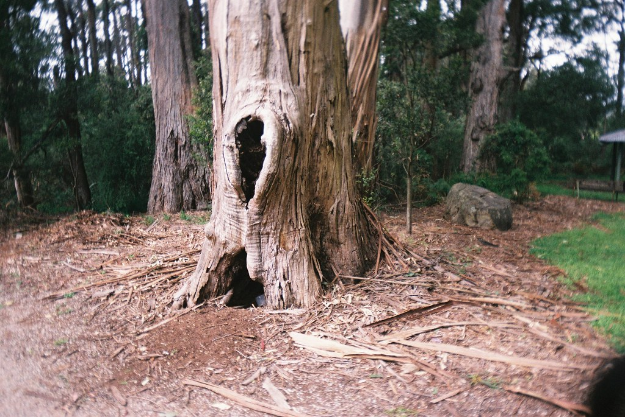
Tree hollow, Matthew Paul Argall, CC BY 2.0, via Flickr
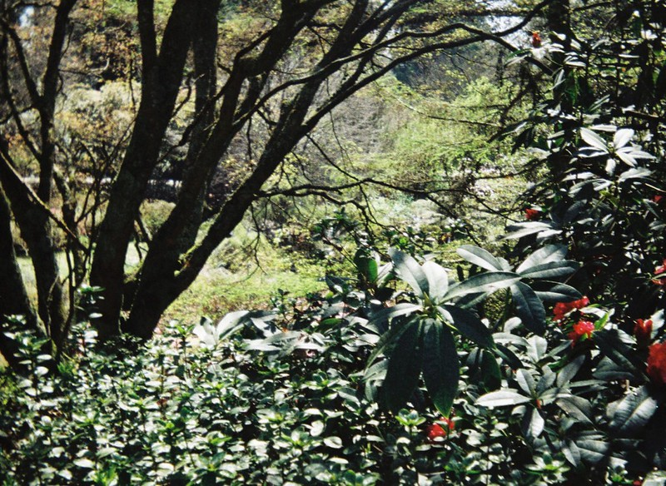
Lots of leaves and tree branches, Matthew Paul Argall, CC BY 2.0, via Flickr

