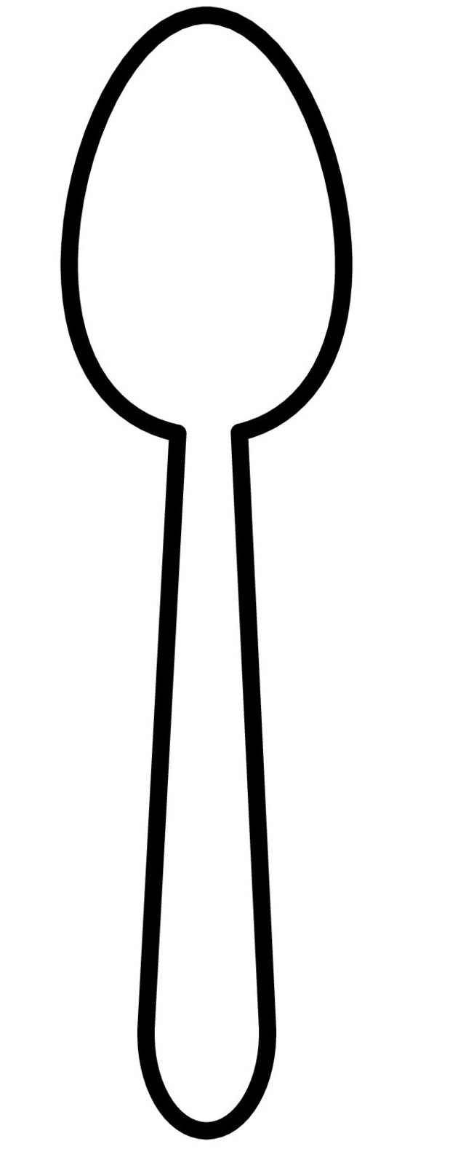
Paper spoon
Year F

Resize this image to match the physical spoon you are using before printing it and cutting it out.

