Year 6

How does a lens work?

A convex lens
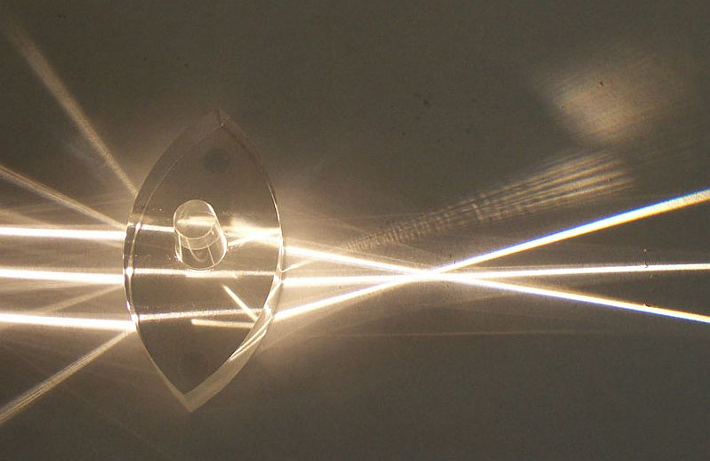
Large convex lens, Fir0002, CC BY-SA 3.0, via Wikimedia commons

A concave lens
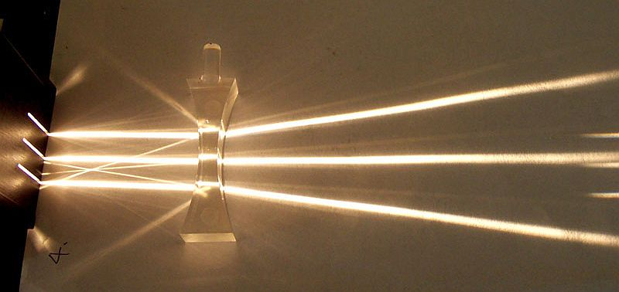
Concave lens, Fir0002, CC BY-SA 3.0, via Wikimedia commons

