Investigating claims
Year 6

- Read each claim and look carefully at its diagram.
- Select three different sized balls (one to represent the Earth, one for the Sun and one for the Moon) and model the claim by placing the ‘Sun’, ‘Earth’ and ‘Moon’ in the positions suggested by the claims.
- Use the balls to model each claim. Think about what you already know about day and night, and how the Sun and Moon appear from Earth, and consider if you think the claim is correct or incorrect and why. If you’re not sure, that’s fine too.
- Record your thinking about each claim in the relevant section.
Claim 1: The Moon and the Sun both circle around the Earth.
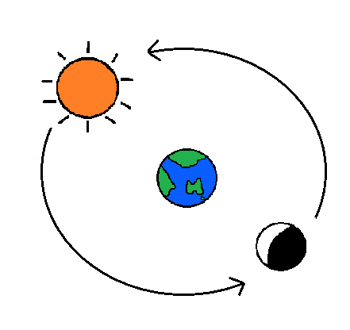

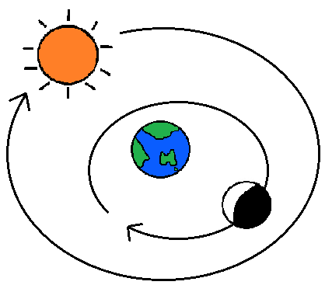
Claim 2: The Moon circles the Earth and the Sun circles them both.

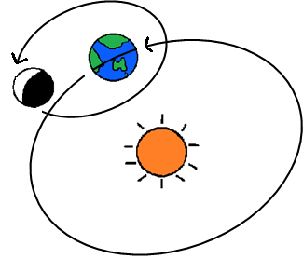
Claim 3: The Moon circles the Earth while the Earth circles the Sun.

