A scientific history of the heavens
Year 6

Part 1
Around 2000 years ago, an astronomer named Ptolemy used mathematics to explain the idea that the planets moved around the Earth in circles. He called this the geocentric model (Claim 1 or 2). His explanations were widely accepted for 1400 years!
Along the way, other astronomers, particularly Islamic astronomers such as Ibn al-Shatir (about 700 years ago in ~1371), did question some of his work and added their own explanations to his theory.
Some of these Islamic astronomers even suggested that the planets were not moving around the Earth but were moving around the Sun (Claim 3–the heliocentric model).
In 1510 Nicolaus Copernicus, a Catholic monk from Poland who studied mathematics and the stars, proposed the first mathematical model that showed the Earth and the other planets moving around the Sun.
His work built on some of the ideas of astronomers before him, but because he was the first person to show the heliocentric model in detail, everyone remembers his name.
But still, people could not agree. In ~1573, a man from Denmark named Tycho Brahe liked Copernicus’ ideas, but he just couldn't explain how a massive thing such as the Earth could be moving so quickly, or why people couldn’t feel it moving. Tycho thought that that this meant that the Earth must not be moving, so he suggested that the Sun and Moon moved around (orbited) the Earth but that all the other planets orbited the Sun.
Tycho’s assistant, a German mathematician named Johannes Kepler, suggested that the planets did not travel in circles at all. He thought they moved in elliptical (or oval-shaped) orbits rather than circular ones (~1609).
Kepler’s idea of elliptical orbits helped explain some of the problems people had with Copernicus’ model, but he was largely ignored—including by the person who would go on to become a very important astronomer indeed: Galileo Galilei.

Part 2
Galileo, an Italian astronomer, scientist, mathematician and engineer, lived in the early 1600s. He believed in the heliocentric ideas proposed by Copernicus and he wanted to find the evidence to prove it.
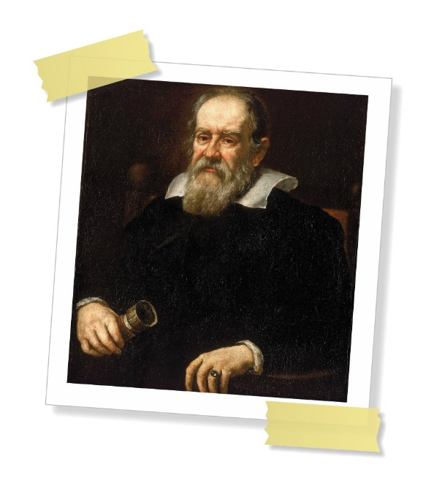
He’d heard about the lenses and telescopes his fellow scientists were using to observe things more closely, so he spent some time learning how to polish the special glass lenses so that his telescopes were the best. He used his telescopes to observe space in more detail than anyone had managed before.

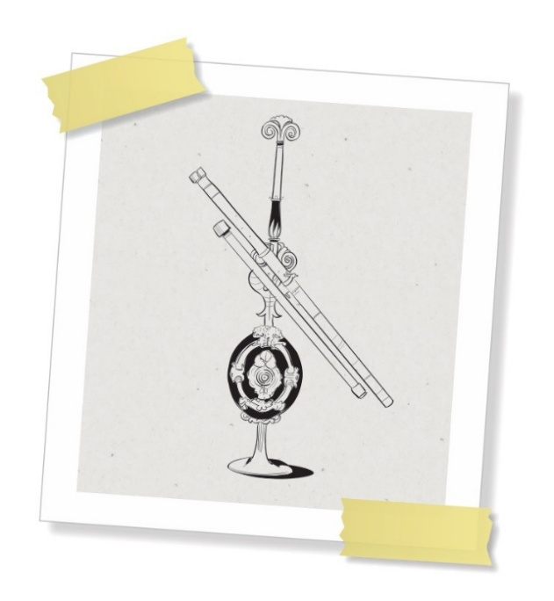
For example, he observed that Venus had phases like Earth’s Moon, and that Jupiter appeared to have four moons. None of the geocentric models explained these things, but the heliocentric model did.
He gathered and shared lots of evidence to show that Copernicus was right and that the planets orbited the Sun.
Some people strongly believed that the Earth was the centre of the universe, so they complained to the authorities and Galileo was put under house arrest. This meant that he could not leave his home or receive visitors for the remainder of his life.
Over time, scientists created better telescopes to observe the movement of planets and their moons.
By ~1687, Sir Isaac Newton was able to use his understanding of gravitation to further explain Kepler’s ideas about elliptical orbits.
The geocentric models were becoming increasingly complicated as they tried to explain all the new evidence that was being collected.
However, the heliocentric model explained this new evidence easily, and so it was finally widely accepted that the Earth and all the other planets, orbited the Sun.

Timeframe | Who? | What was their theory? | Other interesting facts
2000 years ago | Ptolemy | The planets moved around the earth in circles. | His ideas were widely accepted for 1400 years.

