Telescopes

**Year 6**

**Image 1: Refracting telescope**

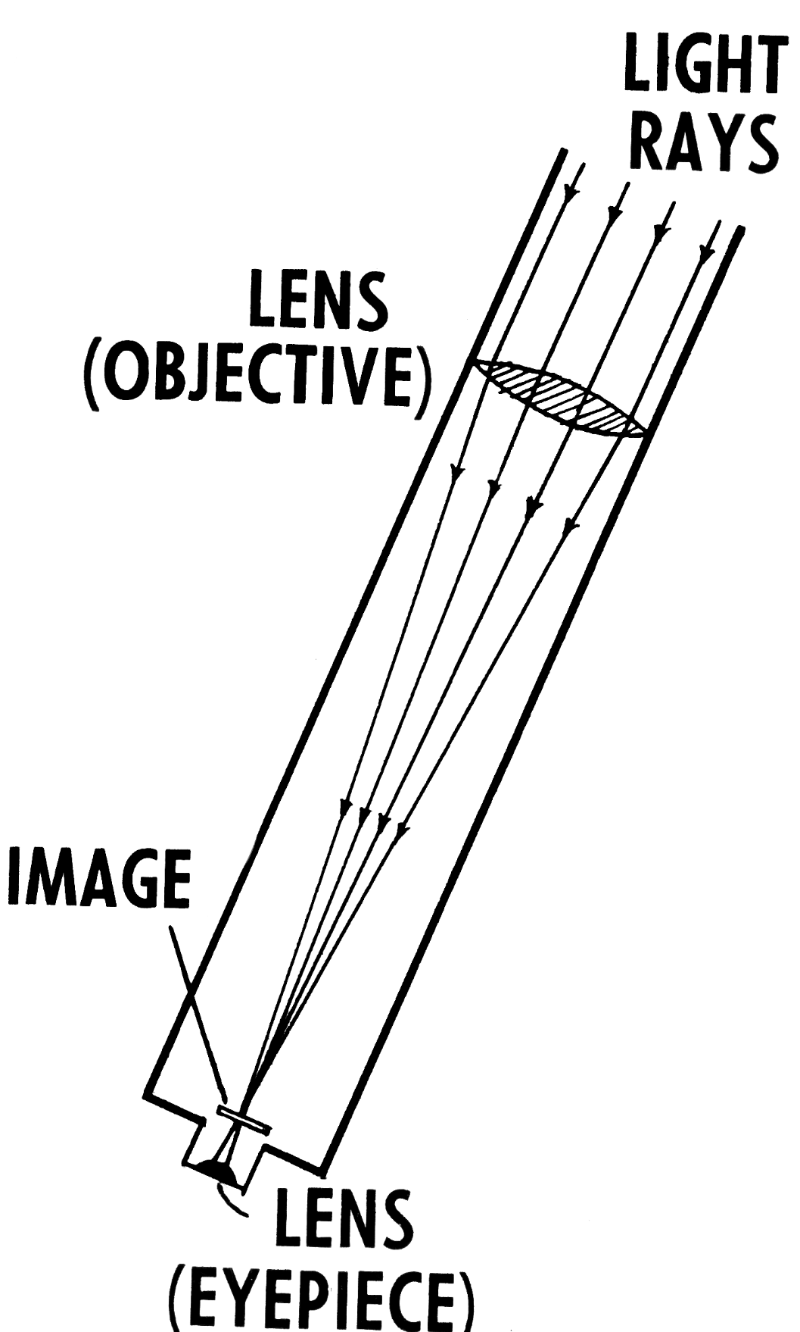

[Refracting telescope](https://commons.wikimedia.org/wiki/File:Refracting_Telescope_(PSF).png), Archives of [Pearson Scott Foresman](https://en.wikipedia.org/wiki/Pearson_Scott_Foresman), in the Public Domain, donated to the [Wikimedia Foundation](https://en.wikipedia.org/wiki/Wikimedia_Foundation)

**Image 2: Reflecting telescope**

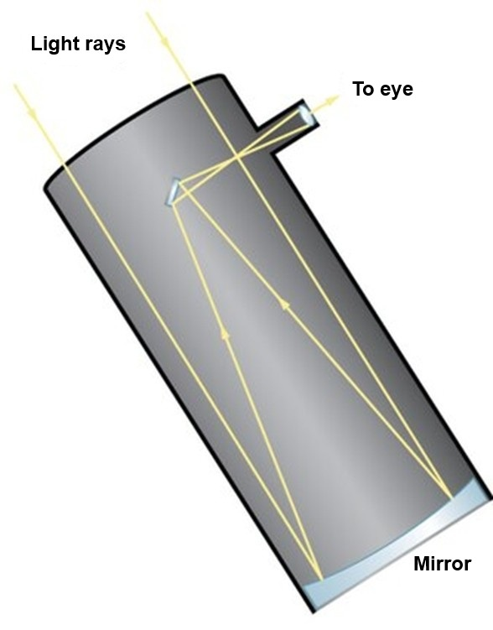

[OpenStax Astronomy refracting and reflecting telescopes.jpg](https://commons.wikimedia.org/wiki/File:OpenStax_Astronomy_refracting_and_reflecting_telescopes.jpg), by Open Stax, Creative Commons Attribution 4.0 International, via Wikimedia commons