View finder

**Year 6**

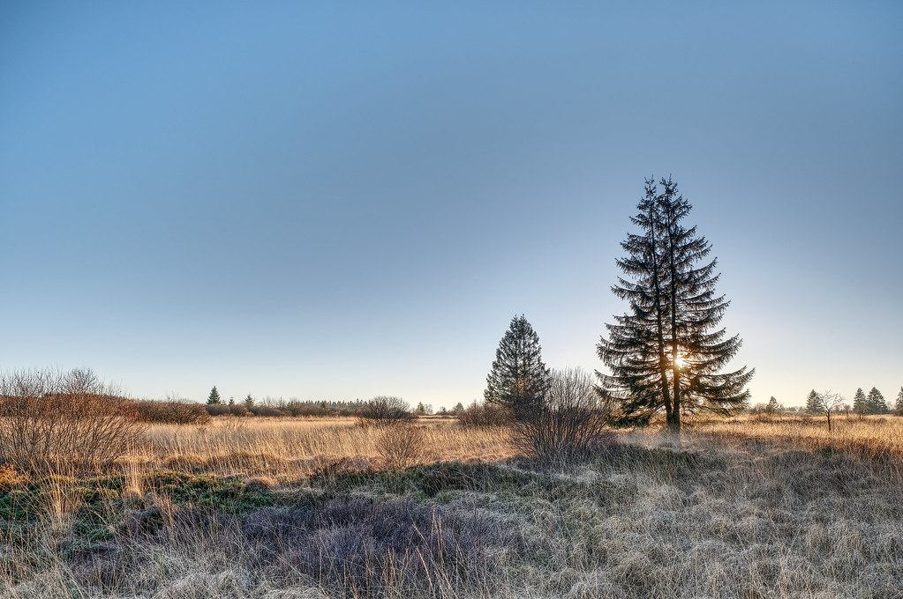

[High Fens](https://www.flickr.com/photos/75612671@N03/46574928172), Johan Neven, CC BY 2.0, via Flickr

[Midday Sun & Blue Sky](https://commons.wikimedia.org/wiki/File:Midday_Sun_%26_Blue_Sky.jpg), Pilotpinkkeyboard, CC BY-SA 4.0, via Wikimedia Commons

[Moonlit night sky looking south](https://commons.wikimedia.org/wiki/File:Moonlit_night_sky_looking_south_(49458657118).jpg), Dave Young, CC BY 2.0, via Wikimedia Commons

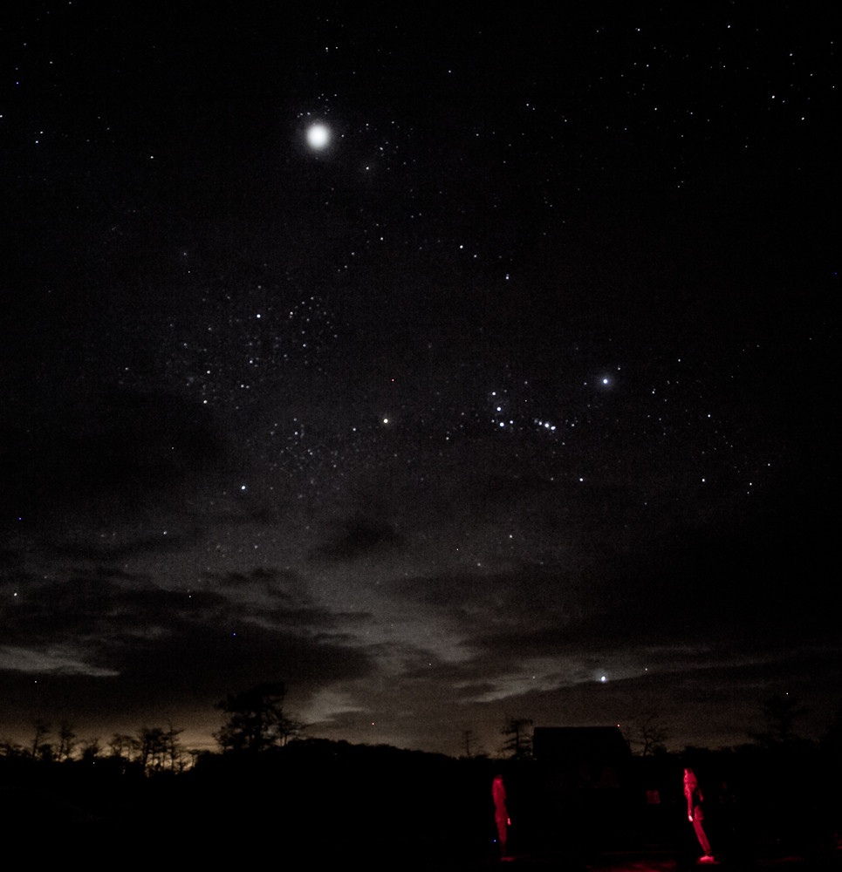

[Night Sky over Big Cypress National Preserve](https://www.flickr.com/photos/48893959@N03/8280157620), TierraLady, CC BY-SA 2.0, via Flickr

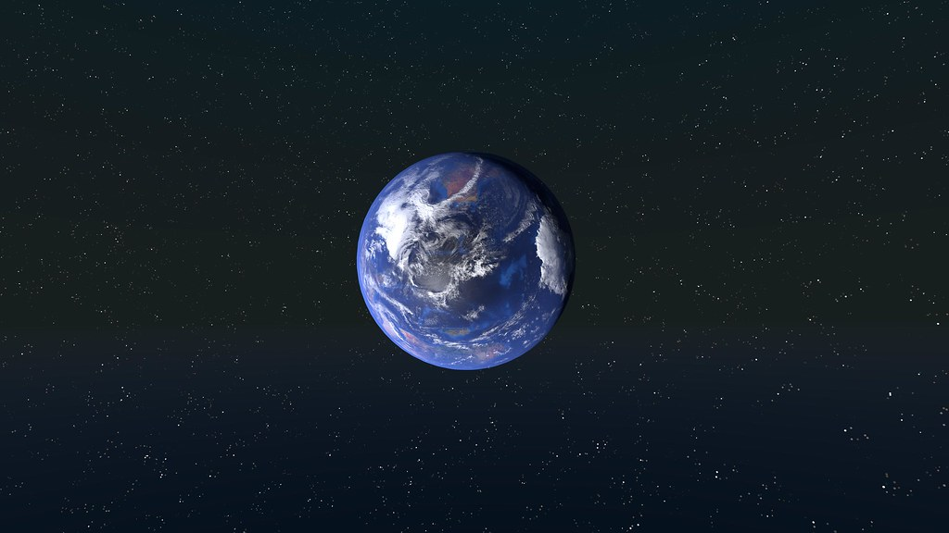

[Earth](https://www.flickr.com/photos/147764143@N07/32995070824), kristian fagerström is licensed under CC BY-SA 2.0, via Flickr

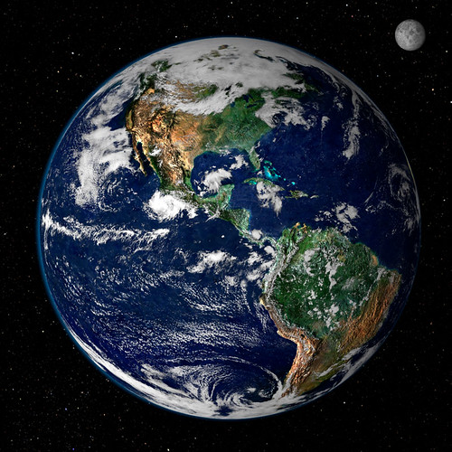

[Earth from Space](https://www.flickr.com/photos/24662369@N07/6049973495), NASA Goddard Photo and Video, CC BY 2.0, via Flickr