Earth from space

**Year 6**

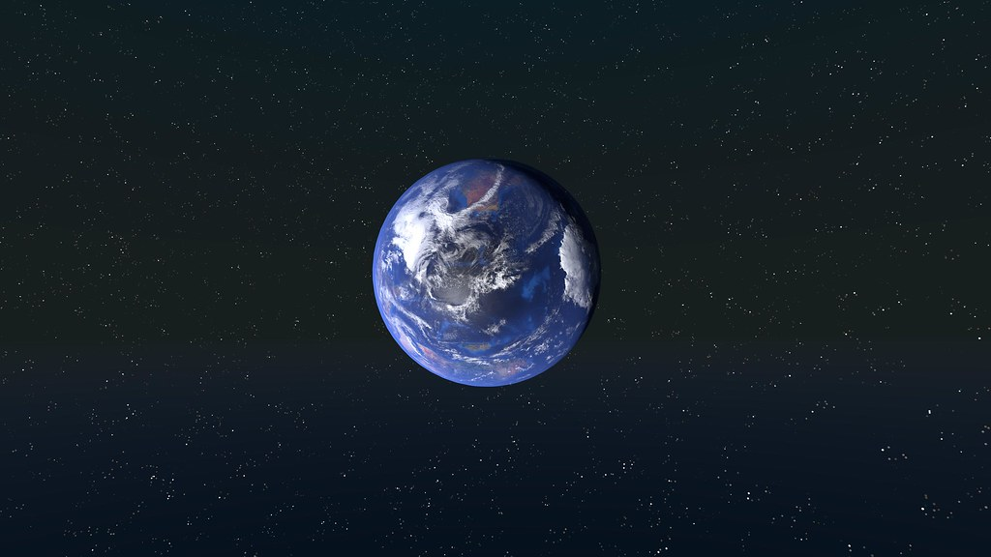

"[Earth](https://www.flickr.com/photos/147764143@N07/32995070824)" by [kristian fagerström](https://www.flickr.com/photos/147764143@N07) is licensed under [CC BY-SA 2.0](https://creativecommons.org/licenses/by-sa/2.0/?ref=openverse).

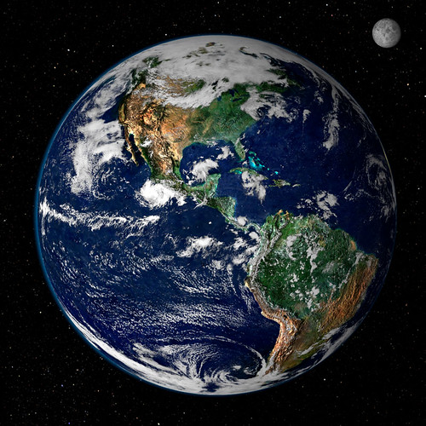

"[Earth from Space](https://www.flickr.com/photos/24662369@N07/6049973495)" by [NASA Goddard Photo and Video](https://www.flickr.com/photos/24662369@N07) is licensed under [CC BY 2.0](https://creativecommons.org/licenses/by/2.0/?ref=openverse).

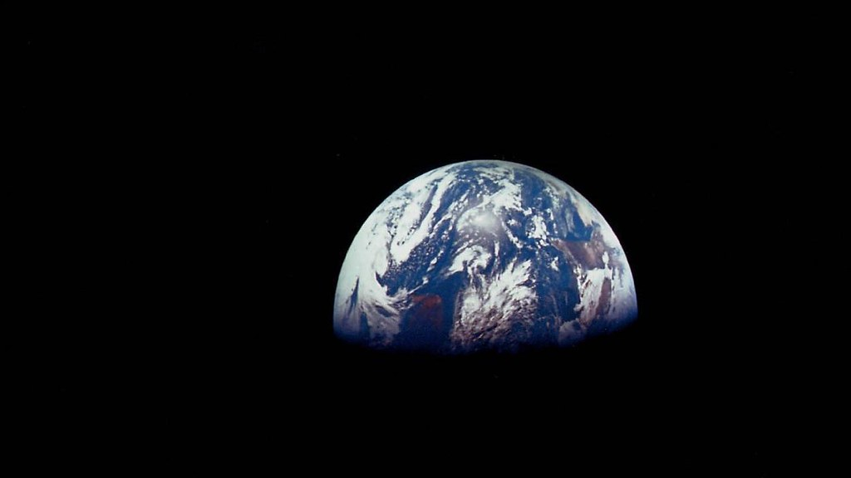

"[Earth from space - Apollo 8](https://www.flickr.com/photos/74903905@N00/8276107526)" by [Marc Van Norden](https://www.flickr.com/photos/74903905@N00) is licensed under [CC BY 2.0](https://creativecommons.org/licenses/by/2.0/?ref=openverse).

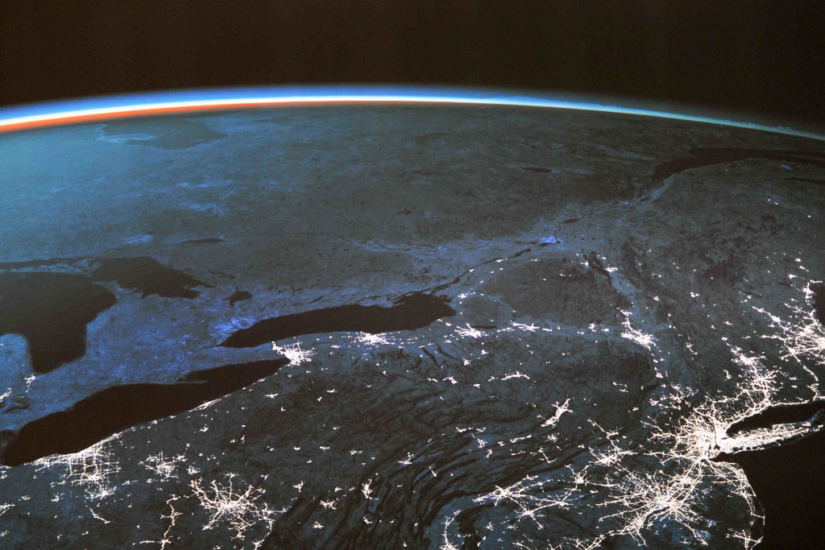

"[Earth from space](https://www.flickr.com/photos/48213136@N06/7628218100)" by [DLR/Alejandro Morellon](https://www.flickr.com/photos/48213136@N06)  is licensed under [CC BY 3.0](https://creativecommons.org/licenses/by/2.0/?ref=openverse).