Map of Australia
Year 6

Re-size this map of Australia so that it fits on the ball you have selected to represent the Earth.
Whilst the map does not need to be scaled perfectly, it should be large enough for students to see clearly, but not so large that it appears out of proportion.

Print it and cut around it, ready to attach to the ball during the lesson.

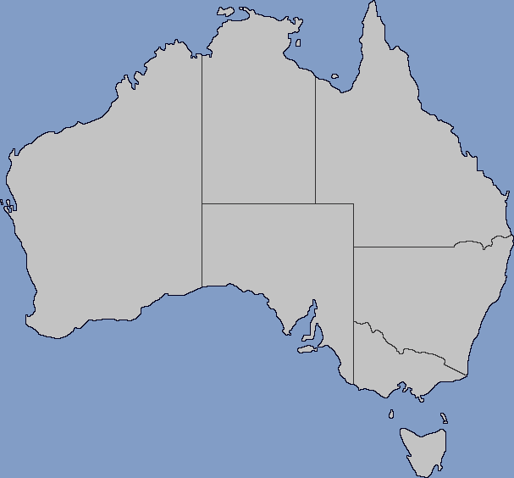

Blank Map of Australia with Subdivisions (2024) from Wikimedia Commons licensed under CC BY-SA 4.0.

