Sunrise Sunset
Year 6

Map 1: This map represents Australia at nighttime (no sunlight).
Map 2: Colour this map to show where in Australia experiences sunrise first, whilst most of Australia is still experiencing nighttime. Shade the part of the map experiencing nighttime with lead pencil. Use arrows to show the direction the light is coming from.
Map 3: Colour this map to show that part of Australia is experiencing sunset whilst the rest has already entered nighttime. (Shade the part of the map experiencing nighttime with lead pencil. Use arrows to show the direction the light is coming from.)
Map 4: This map represents Australia during daylight.

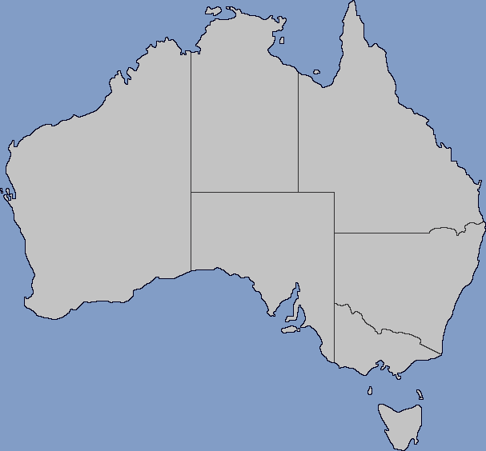
2
1

4
3

Blank Map of Australia with Subdivisions (2024) from Wikimedia Commons licensed under CC BY-SA 4.0.

