What’s in a rocket?

**Year 6**

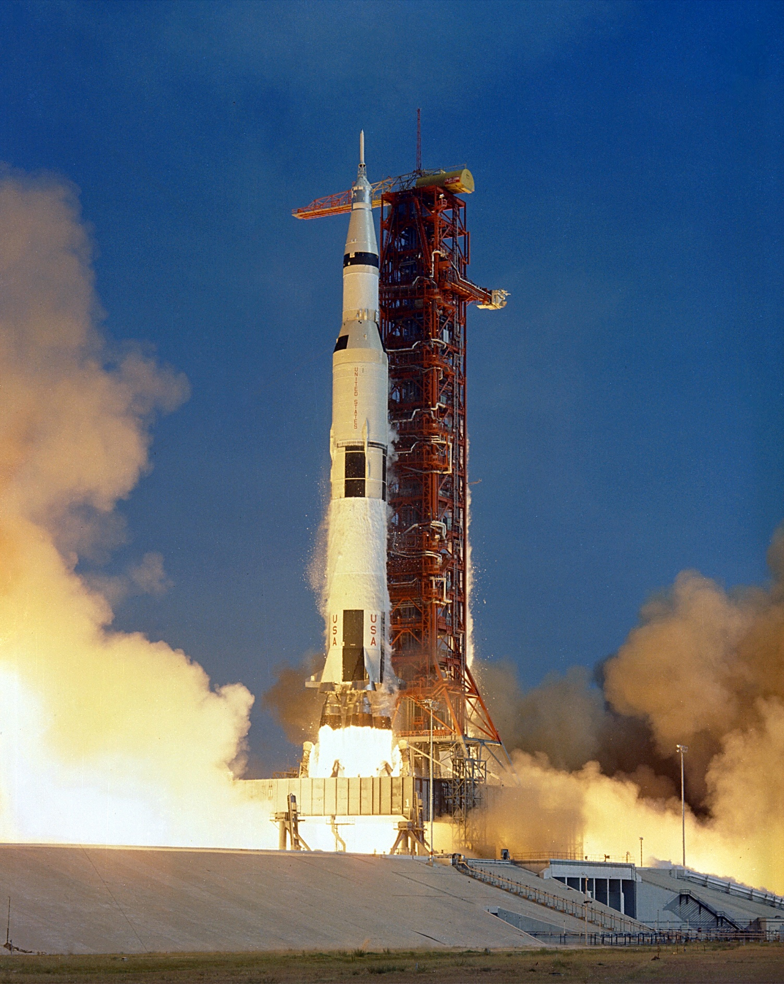

"[Apollo 11](https://www.flickr.com/photos/127744844@N06/40571967453)" by NASA is marked with [Public Domain Mark 1.0](https://creativecommons.org/publicdomain/mark/1.0/?ref=openverse).