Thinking about landscapes
Year 5

Answer the following questions using words, diagrams and symbols as required.
Question 1
Where does soil come from?

Question 2
Where does sand come from?

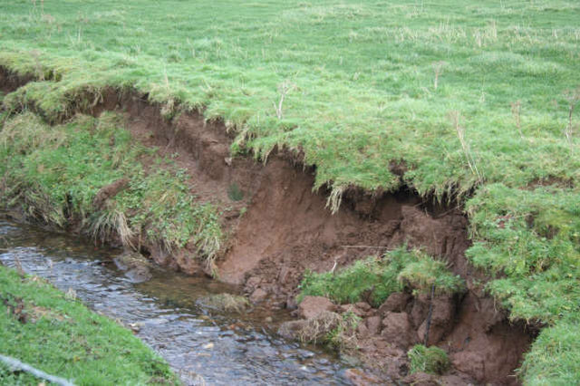
Question 3
What do you think caused this river bank to look like this? What do you think might happen if there was some very heavy rain in/around this site?

Stream e_n, Bob Forrest, CC BY-SA 2.0, from geograph.org.uk

Question 4
This rock formation is called ‘London Bridge’. It can be found in the Port Campbell National Park along the Great Ocean Road in Victoria.

Look at the two photographs taken almost 50 years apart. Label what is the same and different about the rock formation. Write, draw or use symbols to show what you think happened and how.

Photo taken in March 1961
London Bridge arch Victoria March 1961, Don Christie,
CC BY-SA 4.0,via Wikimedia Commons

Photo taken in April 2009
London Arch, Alistair Cunningham,
CC BY 3.0, via Wikimedia Commons

Question 5
This is Katter Kich, or Wave Rock in Hyden near Perth in Western Australia.

Why do you think it’s called Wave Rock? How do you think it came to be shaped like that?
Do you think it happened slowly or quickly?
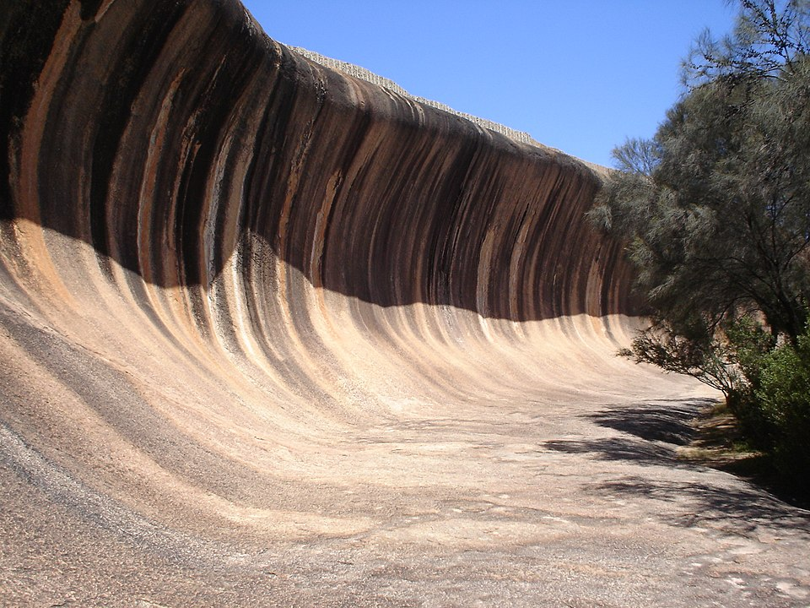

Wave Rock (2005), Kaliumfredrik, CC BY-SA 3.0, via Wikimedia Commons

Question 6
Imagine you use a time machine to travel five thousand years into the future.
What do you think Uluru will look like by then?
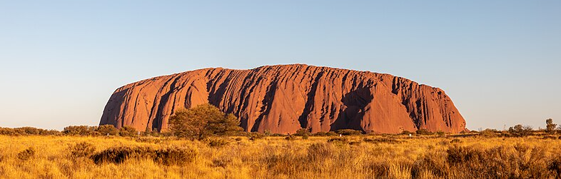
Petermann Ranges (AU), Uluru-Kata Tjuta National Park, Uluru 2019, Dietmar Rabich, CC BY-SA 4.0, via Wikimedia Commons

Tick ‘Yes,’ ‘No’ or ‘I’m not sure’ for each statement.
 | Yes | No | I’m not sure
Uluru will be the same as it is now, because it is a hard rock.
Water will run down the grooves when it rains and will make the grooves deeper.
Wind and rain will move some of the surrounding sandy soil away from Uluru.
The landscape will look totally different and Uluru won’t be visible anymore.

