Vulnerable to erosion?

**Year 5**

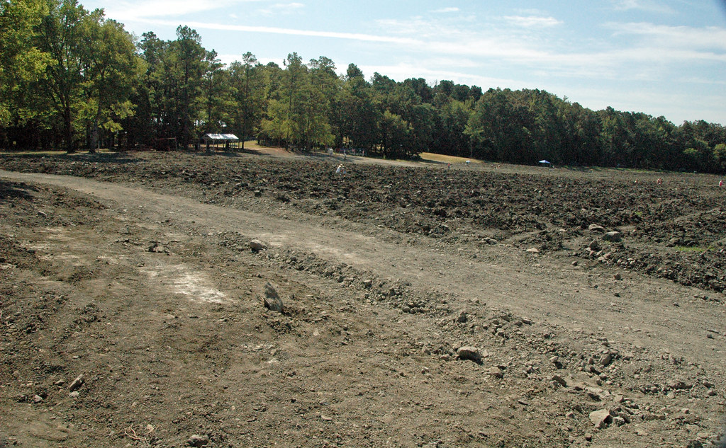

[Diamondiferous lamproite rocks (Prairie Creek Lamproite, Early Cretaceous, 106 Ma; Crater of Diamonds, Pike County, Arkansas, USA) 6](https://www.flickr.com/photos/47445767@N05/51735537750), James St. John, CC BY 2.0, via Flickr

[Newly planted field](https://www.geograph.org.uk/photo/7196959), John H Darch, CC BY-SA 2.0, via geograph.org.uk

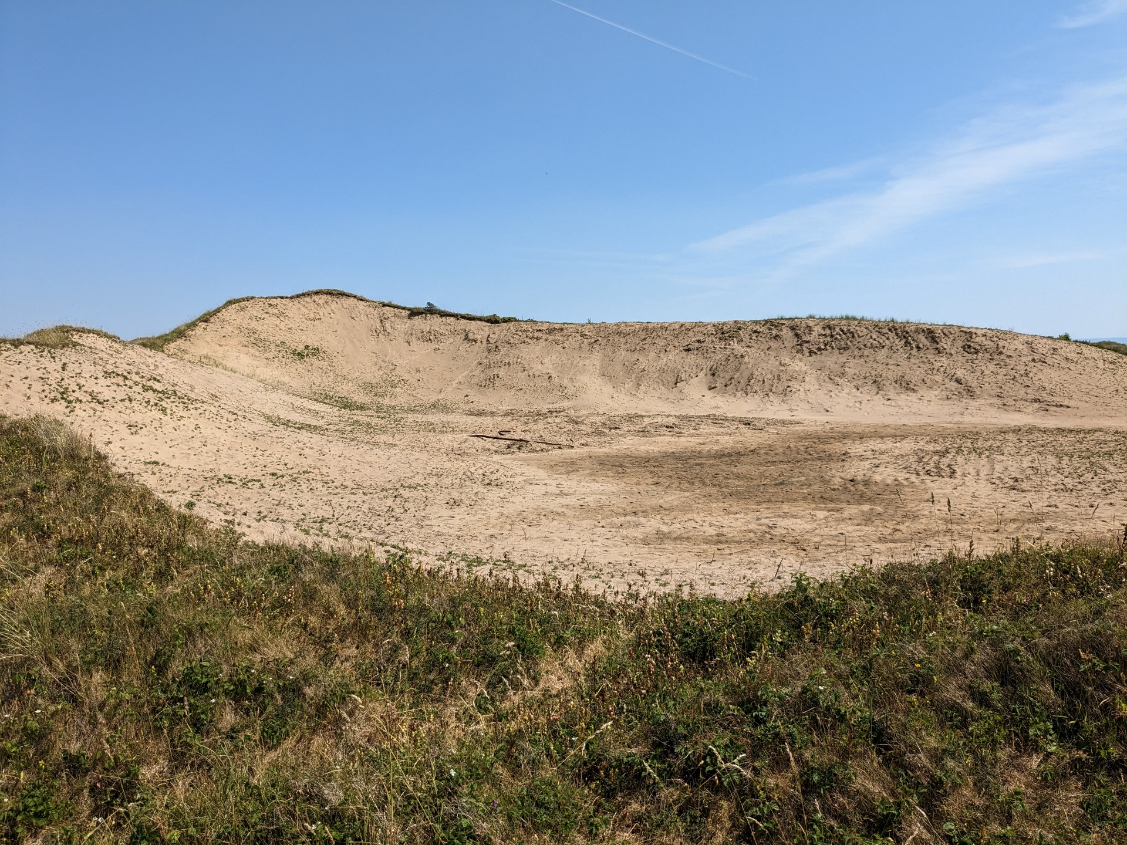

[Exposed sand dunes](https://www.geograph.org.uk/photo/7513247), don cload, CC BY-SA 2.0, via geograph.org.uk

[Sand dunes and the Indian Ocean in Swanbourne, Western Australia](https://commons.wikimedia.org/wiki/File:Sand_dunes_and_the_Indian_Ocean_in_Swanbourne,_Western_Australia..JPG), Zigzig20s, CC BY-SA 3.0**,** via Wikimedia Commons