What broke the bottle?
Year 5
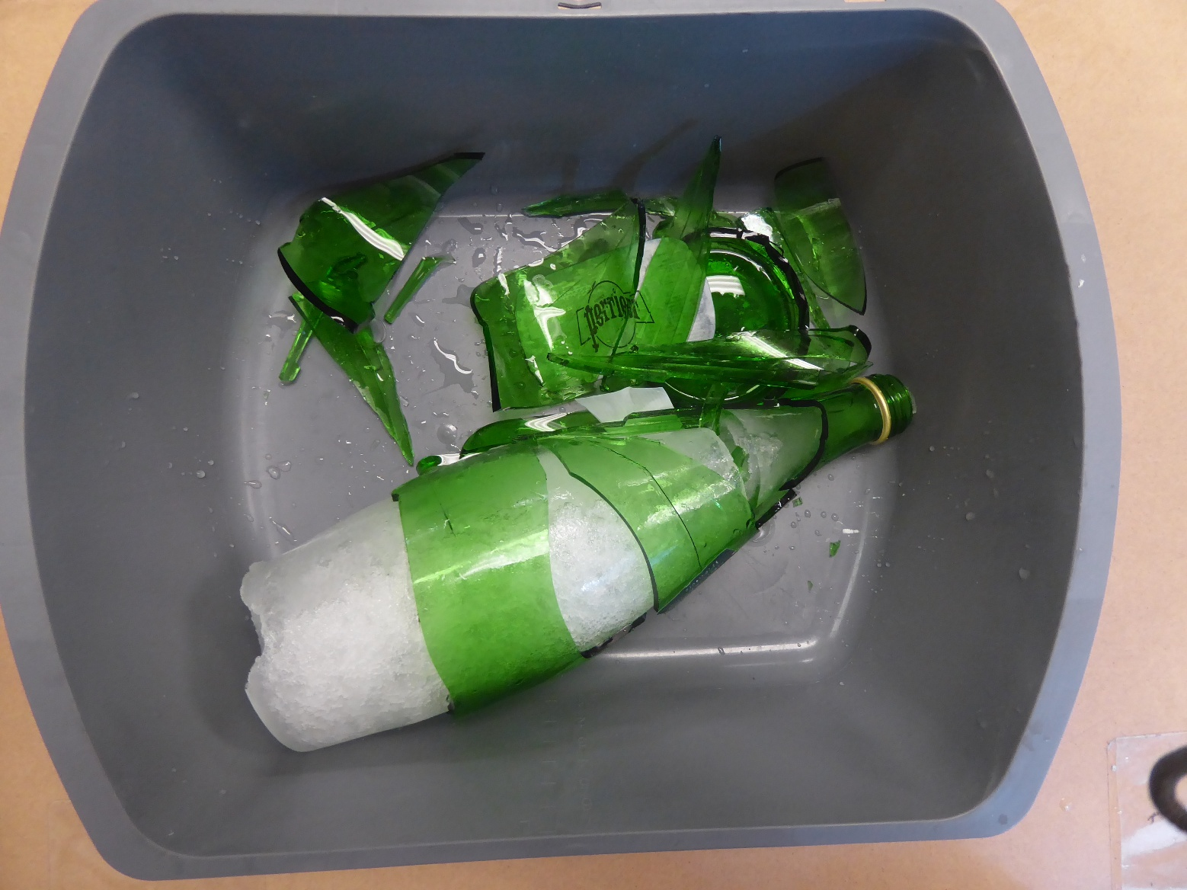

Ice weathering experiment (gelifraction), Juanjosehermosillacalvo, CC BY-SA 4.0, via Wikimedia Commons

