Habitats
Year 1

A habitat is where living things can live and grow.
A habitat provides food, water, shelter.

There are many different habitats, such as:
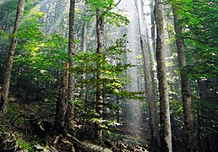  Biogradska suma, Snežana Trifunović, CC BY-SA 3.0, via Wikimedia Commons  Forest | 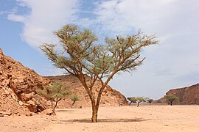  Acacia in Ein Khadra Desert Oasis 00 (87), لا روسا, CC BY-SA 4.0, via Wikimedia Commons  Desert
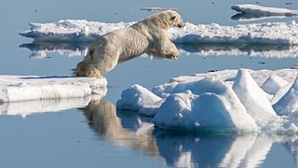  Polar bear (Ursus maritimus) in the drift ice region north of Svalbard, Andreas Weith, CC BY-SA 4.0, via Wikimedia Commons  Arctic | 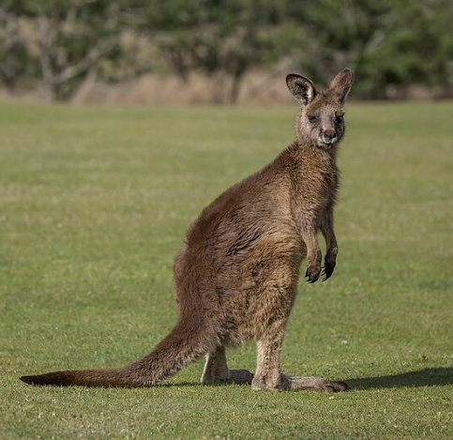  Forester kangaroo (Macropus giganteus tasmaniensis) Esk Valley, Charles J. Sharp, CC BY-SA 4.0, via Wikimedia Commons  Grassland/ meadow

