

Survive and thrive • Lesson 1 • Living in the schoolyard
Lesson 1
Launch
Year 1

To read the most recent version of this task, download associated resources, and view embedded professional learning including classroom videos and work samples, visit:
https://primaryconnections.org.au/teaching-sequences/year-1/survive-and-thrive/lesson-1-living-schoolyard

Lesson overview

Students participate in a plant and animal observation walk, record their findings and develop investigation questions about the needs of plants and animals.

Learning Goals
Students will:
- make observations, using the five key senses, about the places that plants and animals live.
- explore the importance of using senses for observation in the context of learning about the needs of plants and animals.
- describe and compare healthy/unhealthy plants.
- compare the needs of pets and humans.

Students will represent their understanding as they:

explore the use of a class science journal.

draw and label a healthy plant.

participate in and contribute to discussions, to share information, experiences and ideas about plants and animals and their needs.

Assessment advice
In the Launch phase, assessment is diagnostic.
Take note of:

Can students recognise a variety of plants and animals in the school grounds?

Do students recognise that some plants prefer shade while others prefer full sunlight?

Do students recognise that some plants grow better in different conditions?

Can they identify the conditions which plants need to grow (water, light, soil, space)?

Do students recognise humans as animals?

What basic needs of plants and animals have students identified?

What alternative conceptions did they have?

What vocabulary are students using?

List of materials
Whole class
- Demonstration copy of Code for caring and hygiene Resource sheet
- Optional: Demonstration copy of My five senses Resource sheet
- 1 x healthy and 1 x unhealthy seedling/plant (See Preparing for this sequence for advice)
- Class science journal (digital or hard-copy)
- Optional: Camera to photograph plants and animals in the schoolgrounds
- Small hand trowel

Each student
- Individual science journal (digital or hard-copy)

Lesson Routine | Estimated time | Task type
Experience and empathise | 20 minutes | Whole class
Elicit | 20 minutes | Whole class, Individual
Anchor and Connect | 10 minutes | Whole class

Launch

Experience and empathise • Observation walk
Take students on a student-led plant and animal observation walk.
Before the walk
Explain that students are going for a walk in the school grounds to look for different plants and animals living there. Discuss the areas of the school you might visit and predict what you might see there. Use the Code for caring and hygiene Resource sheet to establish accepted standards for animal protection and student safety.
Potential discussion prompts
- What parts of the school would we visit if we wanted to observe plants and animals?
- Why would we choose those parts of the school?
- Where will we find plants? What places will have no plants?
- What plants do you think we’ll see?
- What are the features of plants? How will we know what is a plant?
- Where will we find animals? What places will have no animals?
- What animals do you think we’ll see? Why do you think that?
- What are the features of animals? How will we know if it is an animal?

Optional: Discuss what ‘observation’ means and how it’s done, referring to the five key senses (sight, hearing, touch, smell and taste) using the My five senses Resource sheet. Discuss the dangers of tasting things (germs, poisonous, makes us sick….) and how we don’t taste things in science unless we have special permission from the teacher.

During the walk
Go to the area/s of the school identified by the students as places plants and/or animals would likely be found. Encourage students to look up high, at eye level and on the ground to find plants and animals. Use the trowel to gently move dead leaves etc that may be covering small insects or animals.
Encourage and model asking questions about what students see/hear/smell/feel. Listen for noises that indicate dogs, birds, rustling leaves and bees. Share these observations with your students, reinforcing that as scientists we use many senses including our hearing.
Encourage students to notice the 'conditions' in which the plants and animals are living. Ask them to identify what they notice is the same and different about where they find plants and animals.
Example observations
- Plants tend to grow in the ground.
- Large plants like trees might have a lot of space around them, whilst smaller plants might be closer together.
- Plants looked healthier when the area they were in was 'wet' or 'moist', but not too 'wet'.
- Plants didn't grow so well in areas of the school where it was dark.
- Animals tend to be found close to plants
- Animals are also found in the soil.
- Some animals were 'by themselves', like snails or worms, whereas others were in groups, like ants.

Invite students to share their own experiences about observing plants and animals (home, playground, zoo, on holidays etc.).
Repeat at another location in the school.
Optional: Photograph plants and animals that students identify for display in the classroom.
Optional: Make an audio recording of the soundscape in the playground (i.e. birds or nearby pets).

After the walk
Record the types of plants and animals that were observed on the walk in the class science journal. See the image below for one suggested recording method.
Discuss the variety of animals that students identified, including those they could see, smell, hear and feel.
Record what they noticed was the same and different about the place they saw plants and animals (see During the walk section for ideas). Record as much information as possible, as students will refer to this as their 'evidence' in later lessons.
If possible, categorise what students saw. For example animals might be categorised as insects and birds, and plants might be categorised as trees, bushes/shrubs, flowers etc.
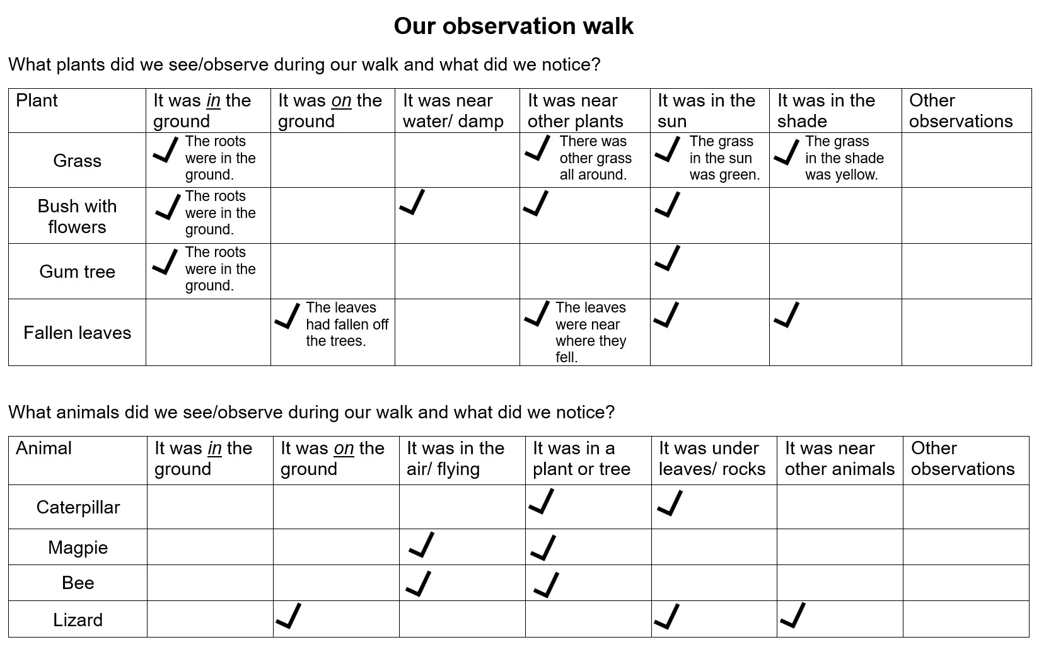
Observation walk recording work sample—retrieval chart

Elicit • Staying healthy
Explain that students will be learning about and investigating what plants and animals need to stay alive, and why they live where they do. Students will use their senses to make observations and use these observations to make claims about what plants and animals need, and how they get what they need from the places they live.
Plants
Display the healthy and unhealthy demonstration seedlings and discuss healthy and unhealthy plants.
Potential discussion prompts
- What are the differences between these two plants?
- Does this plant look like it is growing well?
- Why do you think that?
  - It is green. It has lots of leaves. It might have flowers. Insects and birds are near it. It looks healthy.
- How can we tell if a plant is not healthy?
- What might a plant need to stay healthy?

Do not provide any formal definitions or correct students’ answers as the purpose of the Launch phase is to elicit students’ prior knowledge.
Ask students to do a drawing in their science journal of the plant that is growing well. Remind students to draw, and with assistance if required, label all parts of the plant.
Ask students to add words or pictures to show what they think the plant needs to grow and stay healthy.
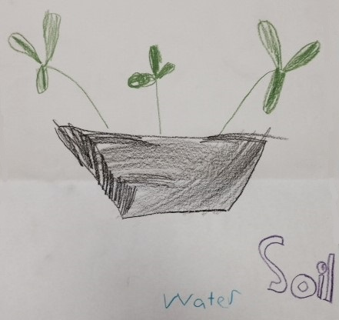
Conduct a gallery walk to share students’ drawings.
Potential discussion prompts
- What parts of the plant have you drawn?
- What does the plant need to grow and stay healthy?
- How might parts of the plant help it get what it needs?

Referring both to these drawings, and the observation table created after the observation walk, pose the question: What do plants need to stay alive?
Record students’ ideas in the class science journal. Through discussion and reference to the observations, draw out four factors needed for plant growth: soil, water, light, and space.
Retain both seedlings for the next lesson, keeping one healthy and one unhealthy/dying.
Work sample of a student's labelled drawing of a healthy plant.

Animals
Pose the question: What do animals need to stay alive?
Support students to answer the question by asking them to think of a specific animal and what it might need to grow and stay healthy (stay alive).
Record students’ ideas in the class science journal.
Potential discussion prompts
- What animal are you thinking of?
- What does the animal need to grow and stay healthy/stay alive?
- How do parts of the animal help it to get what it needs?
  - Fur to keep warm, legs to move around and find food/shelter.
Compare the needs of people and animals. Include questions to support students to differentiate between needs and wants. Record student ideas in the class science journal on a page titled ‘What do humans need?’
Potential discussion prompts
- What do humans need to stay alive?
- Is this the same as, or different from, what animals need?
- What do you think is the difference between something we need and something we want?
- Does an animal, like a dog or a cat, need a ball (or other toy) to stay alive?
  - A dog or a cat doesn't need a ball (or other toy) to stay alive, but having opportunities to play and have fun helps them feel happier.
- What about people, do they need toys to play with?
- Do you think toys are a need or a want?
  - Technically, having opportunities to play and have fun are wants. However, it could be said that emotional well-being depends on this and other factors such as love, care and relationships. If students bring these ideas to the discussion they should be acknowledged and validated as important to health through happiness. This idea will be addressed again in Lesson 5.
Referring both to this discussion, and the observation table created after the observation walk, record students’ ideas in a table in the class science journal, under the title ‘What do animals need to stay alive?’

Anchor and Connect • How can we use our learning?
Introduce and link the context of the unit—that students will be:
- learning about the needs of plants and animals.
- learning how as humans we can help plants and animals to stay alive by protecting their homes in the wild and giving pets the things they need to survive.
- learning about how plants and animals also help us to survive by providing us with some of the things we need, such as fruit to eat and honey from bees.
- creating a diorama (model) of a place where a plant or animal lives.

Ask students what they would like to know about how plants and animals grow and stay healthy (stay alive). Record student questions in the class science journal and group together similar questions.
Model asking further questions, including these questions that will be covered during the lesson sequence, by creating a T-chart entitled 'Our questions'. Invite students to add their own questions to the chart.
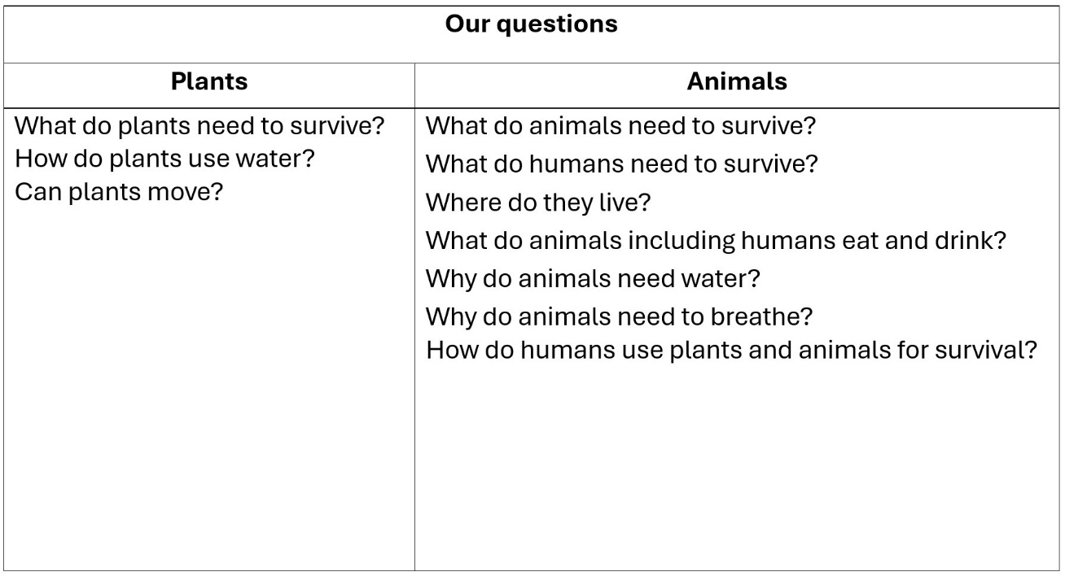
Our questions T-chart work sample.

Reflect on the lesson
You might:
- add to the class word wall (words, drawings, photos) vocabulary related to plants and animals staying alive and healthy.
- discuss how students were thinking and working like scientists during the lesson. Focus on how they were generating ideas based on their what they already thought and the observations made during the observation walk.
- invite students to bring along a photo of their pet to add to the class word wall.

Year 1

Survive and thrive • Lesson 2 • Investigating plant growth
lesson 2
inquirE

To read the most recent version of this task, download associated resources, and view embedded professional learning including classroom videos and work samples, visit:
https://primaryconnections.org.au/teaching-sequences/year-1/survive-and-thrive/lesson-2-investigating-plant-growth

Lesson overview

Students investigate the growth of plants by planting seedlings. They also develop a method for tracking plant growth.

Key learning goals
Students will:
- explore the scientific method to set up a ‘fair test’ on the needs of plants, to confirm or disprove their predictions.
- consider and begin plant growth tracking using informal measurement (marks on popsticks).
- record the first plant observations for their investigation.

Students will represent their understanding as they:
- record investigation predictions as teams/pairs on My plant predictions Resource sheet.
- contribute to discussion and predictions about the needs of plants (water, sun, space, soil) and whether plants can move to meet any of those needs.

Assessment advice
In this lesson, assessment is formative.
Feedback might focus on:
- students’ ideas about the needs of plants to help them grow. Are they able to identify some/all needs?
- students’ thinking about how to take accurate measurements of plant growth. Do they recognise the potential errors that would affect the accuracy of the data?
- students’ predictions about plant growth in the decided upon time frame. Are their predictions reasonable?
- students’ ideas about fair-tests. Able they able to articulate what would make a test fair or not fair?

List of materials
- Whole class
- Class science journal (digital or hard-copy)
- Demonstration copies of My plant predictions Resource sheet
- Healthy/unhealthy teacher demonstration seedlings (retained from previous lesson)
- Watering equipment such as sprayer(s) or bucket of water with milk bottle caps etc.
- Popsticks
- Markers

Each group
- 2 x potted seedlings (see "Plant preparation" on the Preparing for this sequence tab for further guidance)
- 2 x pot labels

Each student
- Individual science journal (digital or hard-copy)
- My plant predictions Resource sheet

Lesson Routine | Estimated time | Task type
Re-orient | 5 minutes | Whole class
Question | 5 minutes | Whole class
Investigate (ongoing) | 40 minutes | Collaborative teams, Whole class
Integrate | 15 minutes | Whole class, individual
Investigate | 20 minutes | Collaborative teams, Whole class
Integrate | 10 minutes | Whole class

Inquire

Re-orient
Students add items to the nature table and pet photos to the word wall.
Recall the previous lesson, focusing on the healthy/unhealthy plants.
Show the students the two plants again. Recall students drawing and labelling the healthy plant in the class science journal.
Review students' responses to the question What do plants need to stay alive?

Question • What do plants need?
Pose the question: How do we know what plants need to stay alive?
Discuss how the current list of ideas are our ‘predictions’—what we ‘think’ plants need to survive. As scientists we want to understand the world around us, and we can do experiments to see if our predictions are right or wrong.

Investigate • Investigating plant growth (ongoing)
Explain that students will be working with a partner to investigate and confirm/prove their thinking about what things plants need to grow and stay healthy.
Show students the seedlings they will be growing and discuss how seedlings are young plants. Explain that the class will be using these to confirm whether plants need water, light, space, and soil to grow and stay healthy.
Gather student ideas on how the investigation into plant growth might be carried out.
Potential discussion prompts
- Where could we put the seedlings to make sure they have sunlight?
- What might happen if they stay in direct sunlight too long?
- How much water will we give the seedlings?
- Where should we put the water?
  - On the ground around the plant. Plants do not absorb water through their leaves.
- What might happen if we water them too much?
- How can we test to find out if seedlings need soil to grow?
- How can we test to see if they need space to grow?
- How will we know if our seedings are staying healthy? What signs will we look for?
- How might we measure how much they're growing?

Introduce the idea of fair testing by asking: Can we use just one seedling to test all of our ideas about what plants need to grow? Why or why not?
Explain to students that if we test all of our ideas on one seedling, we won't know which test had the biggest impact on its growth. For example, if we put a seedling in a cupboard with no water, and it doesn't grow, how will we know if it was the lack of sunlight, lack of water, or both that made it not grow?
Explain that scientists try to make a test fair by identifying all the things that might change how a seedling grows, and only changing one of these things at a time. This is what we call a fair test.
Refer to the things plants need for healthy growth that were identified earlier in the sequence: water, sunlight, space, and soil.
Introduce the following questions for investigation recorded in a "How will we carry out this investigation?" table in the class science journal:
- Do plants need water to grow and stay healthy?
- Do plants need sunlight to grow and stay healthy?
- Do plants need soil to grow and stay healthy?
- Do plants need space to grow and stay healthy?
Referring to the table, explain that teams/pairs will be investigating one question. Remind students that to make sure the test is fair, teams will only be changing the one thing that will help them answer their question.

Discuss why each team will need two seedlings: the first seedling will be planted: by itself; in soil; be left in the sunlight; and given water. The second seedling will have one of these things changed. By comparing how the seedlings grow, we can see if that need is important to its growth. Explain that observing what happens to each seedling will help us to answer each question. If the first seedling is healthier than the second seedling that has, for example not been getting water, we'll be able to tell that water helps plants to grow and stay healthy.

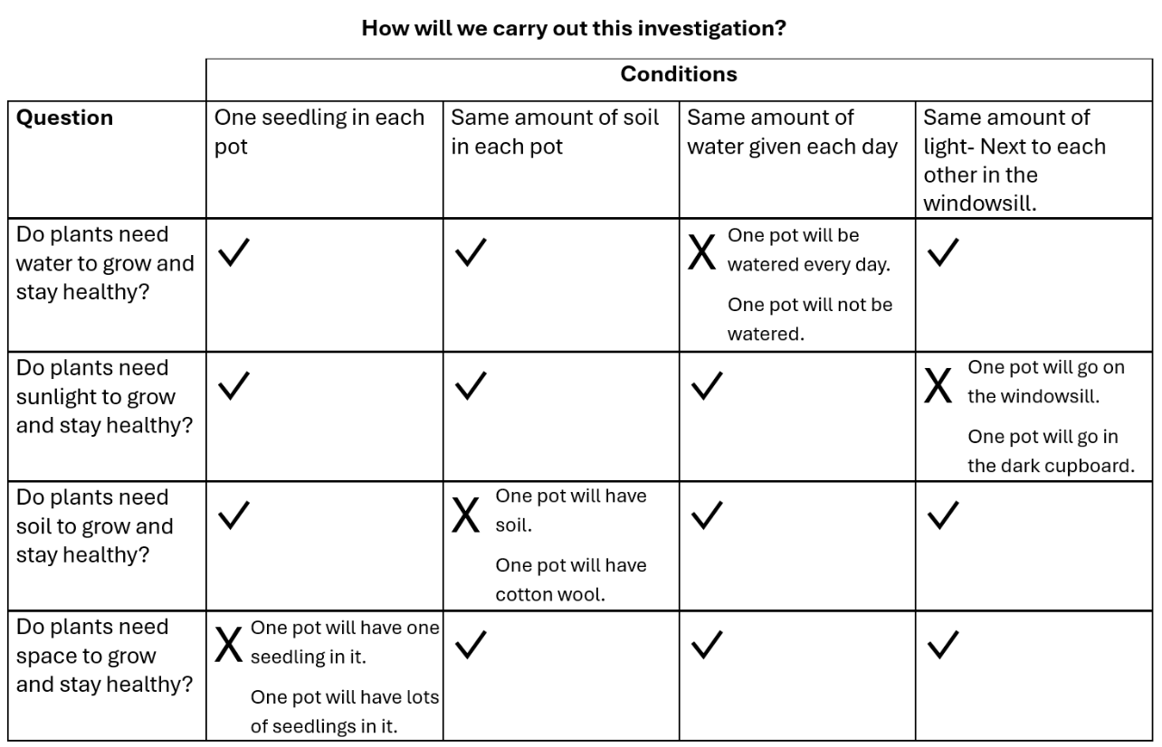
The above table is a sample. It will need to be customised to suit your classroom. For example, you may choose to place seedlings outside for sunlight, rather than on a windowsill.

You might fill out some or all of the fields in the table with your students depending on their prior knowledge and experiences, needs, and capabilities. Some discussion prompts that might support you to fill in the table with student input are:
- How much water would a plant normally be given?
  - This establishes a normal watering pattern, determines an appropriate limit (numbers of milliliters, sprays, or 'pouring seconds' a day) and prevents over-enthusiastic watering.
- How could we make sure a plant does not get sunlight?
  - Place the plant in the cupboard with the door staying shut.
- What could we use instead of soil?
  - Sand, perlite beads, cotton wool.
- How could we remove all the soil from the seedlings?
  - Gently washing the soil from the roots.
  - All roots have small hairs on them to support the uptake of water. Take care not to damage them when replanting.
- How could we make sure the seedlings don’t have space to grow?
  - Plant a lot of seedlings close together.
Form teams, recording which teams will be answering which question in the space underneath each question in the table. Distribute seedlings and allow time for students to label them (see image below), using pre-prepared labels or sticky labels as appropriate.

Integrate • Predicting plant growth
Discuss how students predict the seedlings will grow over the next few weeks.
Potential discussion prompts
- What is likely/unlikely to happen to the seedlings over the coming days/weeks?
- Why do you think this?
- Do all the seedlings currently look the same or have differences?
- Do you think they will all grow at the same rate? Will some grow faster than others)?

Using a demonstration copy of My predictions Resource sheet, model how student will make predictions about the growth of their seedlings, explaining to students that the wording will differ as groups are investigating different things (water, sunlight, space, soil).
Allow time for students to complete their My predictions Resource sheet.
Optional: Ask students: Can plants move in order to fulfill their needs? Can plants move to get to the water, sunlight or space that they need?
- Whilst plants may move/grow in the direction of the main source of sunlight and/or water in order to fulfill those needs, they mostly remain held in place by their roots, as the soil their roots are planted in is a source of minerals.
- This concept is separate to the idea of plant reproduction, which sees pollen or seeds spread by various methods.

Investigate • How will we measure plant growth?
Pose the question: How can we measure how much the plants grow?
Discuss students’ ideas about how they could collect and record information about what happens to their seedlings.
Potential discussion prompts
- How might drawings help us to keep track of how much the plants have grown?
- What about photos? Would they be better/more accurate than drawings? Why? Why not?
- What about counting the number of leaves that appear as the seedling grow?
- How could we keep track of the height of the seedling?

Explain that, whilst all these are good ways to keep track of the seedling's health and how they are growing, in this investigation we are going to measure the growth of the seedlings by measuring their height and seeing how it changes.
Discuss possible methods for measuring the height of the plant. Emphasise the need to make accurate measurements by being careful and ensuring that the same process is followed each time.
One way to keep track of the height of the seedlings each week is to use popsticks. Alternatively, students might cut crepe paper or string to size each time they take a measurement or mark the date and height growth on a long strip of paper.
Potential discussion prompts
- How often should we measure the growth of the plant?
  - The plant may not grow quickly enough to justify measuring the growth each day, or it may grow too quickly to measure it once weekly. The interval should be determined by the seedlings you have selected, and the timeframe in which you will be measuring growth.
- How should I hold the popstick to take the measurement?
- What would happen if I pushed it into the ground? How would that change the measurements? Would that be fair?
- What would happen if I held it above the ground? How would that change the measurements? Would that be fair?
- How will we judge the top of the plant? Will it be the top of the stem or the top of the highest leaf? Why is it important for everyone to do it the same each time?

Model using a marking pen to note when the measurement was taken (date, day or a number to indicate the week), the team taking the measurement (initials on the back) and drawing a mark height of a plant with a line. Then model colouring beneath this line to show the measurement as clearly and accurately as possible.
Optional: If teams have several seedlings in their pot, ask them to use the measurement of the shortest one.
Optional: Assist pairs to take photos of their plants to keep a visual record of the plant’s growth.

Integrate • Sharing results
Invite students to share their investigation with the class.
Potential discussion prompts
- What question are you trying to answer with your investigating?
  - For example: "We're trying to find out if plants need (water/sunlight, soil/space) to grow."
- By pointing at the popstick, show us how tall you think each of these seedlings will be by the time we take out next measurement? Why do you think that?
- What are you going to do to make sure your investigation is fair?

Teams place their pots in the appropriate spot.
Water all seedlings in pots if necessary (except the ‘No water’ pots).
Set up a watering and measurement schedule to ensure the seedlings are watered each day (with the exception of the 'no water' seedlings), and that students are recording data on their growth. Make sure to keep to this schedule as the sequence progresses.

Reflect on the lesson
You might:
- add to the class word wall of vocabulary related to plant growth and needs.
- discuss how students were thinking and working like scientists during the lesson. Focus on making observations using our sight, setting up a ‘fair’ test and making predictions.


Year 1
lesson 3
INQUIRE

Survive and thrive • Lesson 3 • Watering deep
To read the most recent version of this task, download associated resources, and view embedded professional learning including classroom videos and work samples, visit:
https://primaryconnections.org.au/teaching-sequences/year-1/survive-and-thrive/lesson-3-watering-deep

Lesson overview
Students conduct an experiment to understand how plants absorb water and continue their ongoing observations of their seedlings.

Key learning goals
Students will:
- discuss plant observations and record plant growth.
- explore the parts of a plant.
- investigate where the water/rain goes.

Students will represent their understanding as they:
- verbally share observations from the water investigation.
- complete a labelled diagram showing how water is absorbed by plants.

Assessment advice
In this lesson, assessment is formative.
Feedback might focus on:
- students’ ideas about how plants absorb water. Are they able to recognise that plants first absorb water through their roots, then the water is transported through the plant via the xylem?

List of materials
Whole class
- Class science journal (digital or hard-copy)
- Teacher demonstration seedlings from previous lesson
- 3 x celery stalks, 1 x left unchanged and 2 x stalks that have had the ends trimmed and been placed in water coloured with food colouring. It will take several hours for the celery to absorb enough food colouring to make a noticeable difference. The time required will also be dependent on the length of the celery stalks, and the ratio of food colouring to water used. It is best to prepare the celery stalks the night before, and use a lot of food colouring in the water.
- After the food colouring has been absorbed, the leaves of the celery should be clearly coloured with the food colouring. One stalk should be left whole and the other cut into thin slices to be distributed to each student.
- Demonstration copy of Parts of a plant Resource sheet. This resource sheet includes a sketch and a photograph, both showing the roots, stem, leaves etc. of a plant. Use the version that is most suitable for your students and context.
- Access to the school grounds, in particularly to plants growing in the school grounds. Having a variety of surfaces surrounding these plants would be helpful, such as grass, exposed dirt and mulch.
- Demonstration copy of the Where does it go? Resource sheet
- Magnifying glasses (optional)

Each group
- Water source e.g. hose, watering cans, buckets or recycled plastic tubs/bottles

Each student
- Individual science journal (digital or hard-copy)
- A thin slice of celery stalk
- Optional: A4 copy of the Where does it go? Resource sheet
Lesson Routine | Estimated time | Task type
Re-orient | 5 minutes | Whole class
Question | 5 minutes | Whole class
Investigate | 30 minutes | Collaborative teams, Whole class
Integrate | 10 minutes | Whole class
Investigate | 15 minutes | Whole class, Individual
Integrate | 15 minutes | Whole class, Individual

Inquire

Re-orient

Discuss again the watering requirements of the seedlings set up during the previous lesson’s investigation.
Potential discussion prompts
- Have all of the plants been receiving the same amount of water? (with the exception of the ‘no water’ seedlings?)
- Do both of your seedlings look the same? Are they both growing?

If required, water and measure seedling growth using the agreed upon methods.

Question • How do plants use water?
Refer to any questions asked by students in Lesson 1 about plants and water, for example: How do plants use water?
Ask students if they think the plants with no water are going to grow as well as the plants that are being watered, and why they think that.

Pose the question: When we water a plant, where does the water go and how does the plant use it?

Investigate • Water where and why?
Show students the healthy demonstration seedling from Lesson 1 and discuss the plant’s features. Lead the class on a ‘directed hunting’ expedition around the school grounds.
Potential discussion prompts
- How do you know it is a plant?
- What parts of the plant can you see?
- How would you describe these parts, for example the leaves?
- Do you think this plant is the healthy seedling we have looked at before?
- Why do you think this is the healthy seedling?
- What do you think the unhealthy seedling might look like?
- Do you think we could make the unhealthy seedling healthy again? How?
Students would have learned about the parts of a plant in Foundation. Revise this by labelling the demonstration copy of the Parts of a plant Resource sheet or create your own sketch for students to label.

Discuss why we water plants and record student ideas in the class science journal.
Potential discussion prompts

- Why does a plant need water?
- Where do we water the plant? On the roots or the leaves? Why or why not?
- Do we need to water plants in the garden on rainy days? Why or why not?
- Do we need to water plants in the garden more or less on hot days? Why or why not?

Explain that students will work in collaborative teams to investigate where water goes once it falls onto the ground around a plant. Take students to a location in the school grounds where there are plants growing.

Discuss:
- how to fill a watering can or similar, and how much water they should give their chosen plant.
  - Highlight that if a plant is given too much water all at once it might not be healthy for the plant, and it also might impact our investigation results.
- the ground surface that the plant is growing out of. For example, is it in grass, exposed dirt, mulch?
- how students might see where the water has gone once it has been poured on their plant. For example, they might push aside the blades of grass to see if the dirt underneath is wet.

Discuss and record students’ predictions in the class science journal.
Allow time for teams to fill their watering cans, pour the water around the base of a plant, and observe what happens. Compare the damp ground under the plant to the dry ground elsewhere in the garden.

Optional: Take photos or video of teams watering plants and explaining what they think is happening; this can be shared with other students on return to the classroom.

Optional: Move to a location where plants grow from a different sort of ground surface, and water the plants for further opportunity to observe where the water goes.

Integrate • Where did the water go?
Form a yarning circle (outside or inside) and ask students to share their observations about what happened to the water.
Potential discussion prompts
- Did your observations match your predictions? Why or why not?
- Where did most of the water end up?
  - The water soaked into the ground/grass/dirt.
- Did the water stay on the plant? Why do you think that is?
- What do you think happens to the water?
  - The water wets the soil/dirt around the plant and goes into the plants’ roots.

Record students’ ideas in the class science journal.
Using Where does it go? Resource sheet, discuss with students how plants can be big like trees or small like seedlings (refer back to the seedling image labelled earlier in the lesson). Explain that big trees can have lots of roots under the ground, spread out over a wide area, whereas smaller plants will have smaller or fewer roots, spread out over a smaller space.
As a class, discuss how rain gets to the roots. Draw lines to show how rain gets to the roots of the tree.

Investigate • Now where does it go?
Pose the question: What happens to water once it enters the roots of a plant?
Show students the unchanged celery stalk and ask them to describe it. Next show them the stalk that you put in coloured water earlier and discuss the changes that have occurred.
Potential discussion prompts
- What can you see that is different?
- What do you think has happened?
- What do you think the change tells us about how the water gets from the roots to the stems and leaves of plants?

Distribute the slices of food colour-stained celery. Ask students to hold the piece of celery up to the light and observe carefully.
Optional: Students can examine their piece of celery with a magnifying glass.

Integrate • How plants drink
Share students’ observations about their celery slice. Discuss what they think has happened to the celery, and how the food colouring got inside the celery and up to the leaves at the top.
Potential discussion prompts
- What did you observe when you looked closely at your celery slice?
- How would you describe it?
- Does it look like what you expected?
- What feature can you see that might be a way for the water to move through the plant?

Look closely again at the whole stalk of celery that has been soaking in food colouring, pointing out how 'lines' of the food colouring can be seen all the way from the bottom of the stalk, to the top, where it spreads out into the leaves.
Potential discussion prompts
- How would you describe these lines? What do they remind you of?
- How do you think they help the water move through the celery?

Explain that the small dots on the celery slice are called ‘xylem’, narrow tubes for water and nutrients to move through—much like water moving through a drinking straw. Water moves from the roots, up through the xylem to the leaves. Students might choose to refer to the xylem as ‘tubes’ or ‘straws’ which is acceptable language at this level.
Students draw a labelled diagram to represent the coloured water being absorbed into the celery. Alternatively (or additionally), they might use their own copy of Where does it go? Resource sheet to individually represent the movement of the water from the soil to the root and then into the leaves on the tree.

Reflect on the lesson
You might:
- add to the class word wall (vocabulary, drawings, images) related to plants and their watering needs.
- discuss how students were thinking and working like scientists during the lesson. Focus on making and recording observations.

Year 1

Survive and thrive • Lesson 4 • Move with the sunlight
lesson 4
inquire

To read the most recent version of this task, download associated resources, and view embedded professional learning including classroom videos and work samples, visit:
https://primaryconnections.org.au/teaching-sequences/year-1/survive-and-thrive/lesson-4-move-sunlight

Lesson overview

Students examine how plants move to receive more sunlight, and continue their ongoing observations of their seedlings.

Key learning goals
Students will:
- observe and discuss a time-lapse video of seedlings moving towards the Sun’s light.
- represent and explain their understandings about the basic needs of plants.
- discuss how different plants live in different places where their needs are met (habitats).
- complete final observations and measurements of plant growth (optional—you may wish to continue tracking plant growth for an extended time period).

Students will represent their understanding as they:

discuss the class observations and time-lapse video of plant movement.

verbally share the findings of their ongoing plant investigation with the class.

create a graph of each plant’s growth (optional).

Assessment advice
In this lesson, assessment is formative.
Feedback might focus on:
- students' ideas about the needs of plants. Have students identified the basic needs of plants?
- what students think about plants in different environments. Are they able to recognise that plants live in different places and that these places meet their needs?
- how students are using their data and evidence to make claims. Are their claims based on the evidence they have collected?
In this lesson, assessment might also be summative, in relation to the needs of plants for survival.
Students working at the achievement standard should have:
- made a claim about the basic needs of plants.
- used the data and evidence they have collected to support their claim.
- identified that plants live in places where their needs are met.
- used scientific vocabulary when appropriate.
Refer to the Australian Curriculum content links on the Our design decisions tab for further information.

List of materials
Whole class
- Class science journal (digital or hard-copy)
- The seedlings from the investigation begun in Lesson 2
- The video Changing the direction of the light during plant growth - Time lapse (2:09 min)
- Printed copy of Sun Resource sheet
- 1 x torch (optional)
- If the two seedlings students have been nurturing since Lesson 2 have grown enough, and a difference in the growth between the seedlings is obvious, then students will be able to answer their investigation question and the investigation can be concluded.
- However, for a number of reasons you might also need or want to continue to allow students to nurture and track their seedlings’ growth for a longer time frame. In this case, these activities can be returned to at a time that suits.

If you choose to conclude the plant growth investigation in this lesson
- Demonstration copy of Which grew tallest? Resource sheet
- Demonstration copy of Different plants in different places Resource sheet

Each group
- Optional: Sorting plant needs Resource sheet

If you choose to conclude the plant growth investigation in this lesson
- Which grew tallest? Resource sheet
- Glue

Each student
Individual science journal (digital or hard-copy)

If you choose to conclude the plant growth investigation in this lesson
- Completed copies of the My plant predictions Resource sheet from Lesson 2

Lesson Routine | Estimated time | Task type
Re-orient | 15 minutes | Whole class
Question | 10 minutes | Whole class
Investigate and Integrate | 15 minutes | Whole class
Investigate | 20 minutes | Collaborative teams
Integrate | 20 minutes | Collaborative team, Whole class

Inquire

Re-orient
View and review the growth of the seedlings since Lesson 2. Compare each group’s two seedlings to see if there are any obvious differences in the growth of the plants, and if they can answer their investigation question.
Potential discussion prompts

Are both seedlings growing?

Is one growing better/faster/taller than the other?

Does one look healthier than the other?

Why do you think this is happening?

What might this tell us about what plants need to grow and stay healthy?

Question • Do plants move?

Review the four factors students are investigating to see if they help plants grow and stay healthy: sunlight, water, space and soil.

Discuss with students what they would do if they were thirsty and wanted a drink of water, for example: walk to fridge/kitchen, get their drink bottle, have a drink.

Pose the questions: Can plants move to get to water if they need it? Can they move to get sunlight or the space that they need? Can plants move so that their needs can be met?

Discuss students’ initial ideas.

Investigate • Time lapse observations
Watch and discuss the plant movement time-lapse video. To support students to see where the source of light is coming from, you can place a large label, sketch or photograph of the sun next to the screen where the direction of light is indicated in the video.
Potential discussion prompts
- This is a time-lapse video, what does that mean?
  - They film something that takes a long time to happen, then they make the video play faster, so that we can see things that would normally take a long time to happen, in just a few minutes.
- In what direction were the plants first growing in the video? What were they growing towards?
  - The plants were growing towards the sun/light.
- Did you see the plants move in the video, or change direction? Where did they move to? Why did they move?
  - The plants were growing diagonally/on a slant/towards the sun, then they started to grow straight upwards. They moved when the light moved. They were moving to grow towards the sun.
- If this is a time-lapse video, what does that tell you about how long it took the plants to move? Do you think they moved quickly or slowly?
- Have you ever seen plants move before?
- What made the plants move? Did they move by themselves, or did something else move them?
  - Students may have seen plants moved by wind, or animals. They may have seen them dug up and moved around a garden or moving when they are bringing them home. These movements are caused by outside factors and are not independent movement caused by the plant itself.
- Can a plant move around like a person can? If it doesn't like where it's planted in the garden, can it move to another location?
- What would happen to a plant if it was planted somewhere where it couldn't get what it needed?
- Why is it difficult to observe plant movement?
  - Plants grow and move very slowly, so it's hard to see it without special equipment or a time-lapse video.
Role-play with students the movement of plants. Students spread out around the classroom, imagining they are the plants they have been investigating. Discuss what parts of their bodies can be used to represent the different parts of the plants—e.g. students’ legs/tummy/chest could represent the stem of the plant, their arms might represent leaves or branches, their head might represent the flower.
Holding a picture of the sun (Sun Resource sheet), ask students to show what direction they would be leaning if they were plants trying to get sunlight. Move around the classroom, with students changing their direction to follow the source of sunlight as you move.
SAFETY NOTE: Encourage students to not repeat this role-play when outside. Discuss why you are using a cartoon-style image of the sun, the dangers of looking directly at the sun, and why they should not do this.
Discuss the role-play, and how students were exploring how plants move by acting like them: creating a model of how plants move, to support their understanding.
Pose the question: Would plants move as quickly as we did during our role-play modelling?
Discuss how they were moving much faster than plants would, and how sometimes when we model something we have to make changes, like speeding up the movements, so we can see it more quickly. Relate this to the time-lapse video watched earlier.
Optional: As an additional model, use a torch to simulate how plants change the angle of their leaves (hand) to receive more sunlight (torch light).

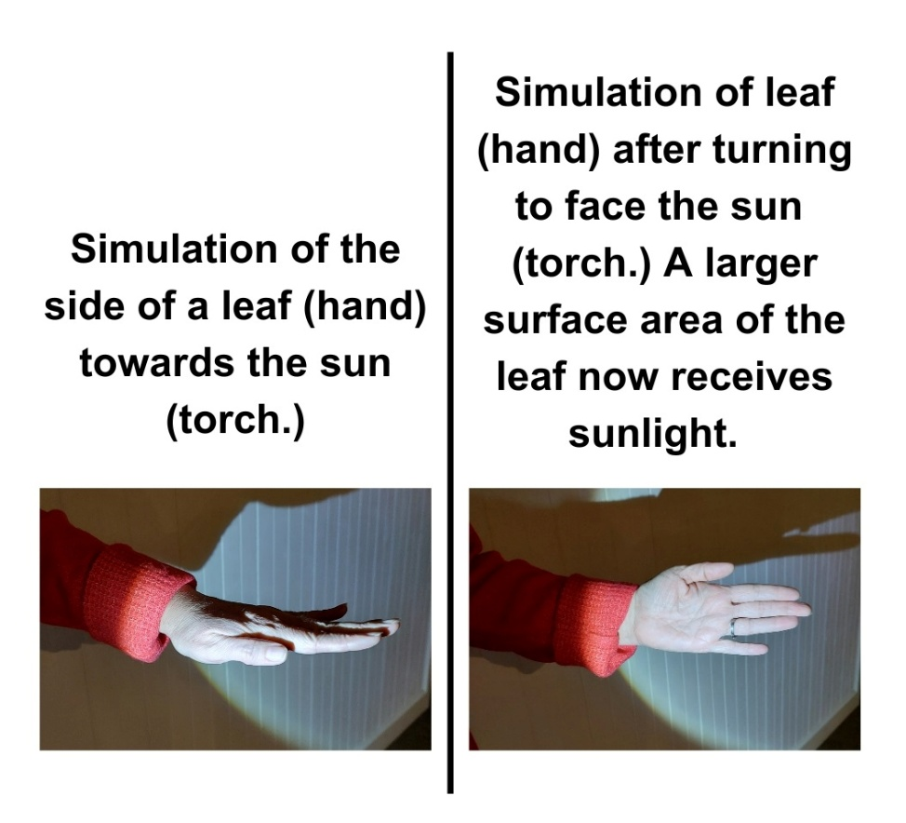
Optional: Discuss students’ ideas about whether plants move to get water as well as sunlight. Consider if roots might grow deep into the ground, or in specific directions if there was a source of water in that direction.

Investigate • What do plants need? | Concluding the plant growth investigation
This lesson is the last exploration into plants. In Lesson 5 students will begin to explore the needs of animals.

This is a good time to conclude the plant growth investigation (begun in Lesson 2) if the seedlings have grown enough. If not, return to this step, and the subsequent integrate discussion, in a later lesson.

Using Which grew tallest? Resource sheet, teams glue the popsticks (or other measurement method) to the relevant graph in the order they were taken, creating a graph that allows them to track and compare the seedlings' growth over time.

By reviewing their graphs, they make a claim and draw conclusions about what plants need to grow and be healthy by completing the following sentence stems:
- The plant with ______________________ grew the tallest. It was healthy.
- This tells me that plants need _______________________ to grow and stay healthy.
- Write three words below to describe the plant that didn’t get what it needed.

After each team has completed the Which grew tallest? Resource sheet, they compare their findings with their predictions made on the My plant predictions Resource sheet during Lesson 2.

Integrate • Sharing results | Concluding the plant growth investigation
Teams share their claims and evidence with the class. You might review the questions recorded in the class science journal in Lesson 2. Pose each question one-at-a-time and invite students who investigated that question to share their results.
Write a series of concluding sentences to answer each investigation question, included what happened to the plant that didn't receive what it needed. For example:
- Plants need sunlight to grow and stay healthy.
- Plants need water to grow and stay healthy.
- Plants need space to grow and stay healthy.
- Plants need soil to stay healthy.
Compile a list of words to describe the unhealthy plants that did not get what they needed.
Ask students if they think that all plants have similar needs for growing and staying healthy.
Explain that scientists think that plants have similar needs to grow and stay healthy:
- Water and nutrients from the soil.
- Light (although depending on the plant, the amount required may vary)
- Water, but not too much
- Space or room to grow.
Using Different plants in different places Resource sheet discuss how different plants need different types and amounts of nutrients, water, and sunlight. So, plants live in places where their needs are met.

Potential discussion prompts

- Are these two environments the same?
- What kind of environments are they?
- How would you feel if you were walking amongst these ferns in the forest?
- What is a forest environment like?
- How would you feel if you were walking in the outback or in a dry, dusty place on a sunny day?
- What is an outback/dry/desert environment like?
- How do the plants in each of these places look different?
  - Tall straight trees and ferns compared to grasses and few trees.
- How do the plants look similar?
  - Both have greenish colours.
- Which of these places do we think gets more rain? How do you know? Why do you think that?
  - The forest gets more rain. You can see it is very green, which happens in rainy places. It is also misty. The outback is dry and dusty. This happens when there is no rain.
- What might this tell us about the plants that grow in a forest compared to the plants that grow in a desert?
  - Plants that grow in a desert must need less water to grow. They don't get much water, but the plants are still growing and look healthy, so they must get enough.
  - The plants in a forest must need more water to grow. Forests get lots of water, and the plants are still growing and look healthy, so they need to have lots of water.
- What do you think happens if we try to grow a plant somewhere that its needs are not being met?

See the embedded professional learning available in this lesson step Adapting to your context—going further for advice on consolidating and extending your students’ learning about plants.

Reflect on the lesson
You might:
- discuss what will happen to the seedlings now the investigation has finished.
- add to the class word wall (vocabulary, drawings, images) related to the needs of plants.
- discuss how students were thinking and working like scientists during the lesson. Focus on the evidence, such as the growth data, and whether the evidence supported their initial claims.
- consolidate students' learning about the needs of plants by completing the Sorting plant needs Resource sheet, as a class, individually or in pairs. Cut around and sort the items into two groups: things that plants need and things that plants don’t need.

Year 1

Survive and thrive • Lesson 5 • Animal needs—space and shelter
lesson 5
inquire

To read the most recent version of this task, download associated resources, and view embedded professional learning including classroom videos and work samples, visit:
https://primaryconnections.org.au/teaching-sequences/year-1/survive-and-thrive/lesson-5-animal-needs-space-and-shelter-5-animal-features

Lesson overview
Students identify and compare the needs of an animal to their own needs. They explore the importance of adequate space and shelter.

Key learning goals
Students will:
- identify their own needs for survival.
- compare these needs to the needs of another animal, for example, a peregrine falcon.
- consider the need for animals (including humans) to have space and shelter.
Students will represent their understanding as they:

identify their own needs for survival using the About me Resource sheet.

contribute to class discussions about the needs of humans and animals.

Assessment advice
In this lesson, assessment is formative.
Feedback might focus on:
- the needs students identify for their survival. Are students able to recognise all of the basic needs of humans?
- what students describe as the food and shelter requirements of animals, including pets.
- students’ recognition of space as a requirement for animal survival. Are students able to name ‘space’ as a requirement for all animals, including humans, to survive and thrive?

List of materials
Whole class
- Class science journal (digital or hard-copy)
- Demonstration copy of About me Resource sheet
- Demonstration copy of Animals at home Resource sheet
- Access to the Charles Sturt University FalconCam Project and the FalconCam Project YouTube channel
- Newspaper or sticky tape, used to define an area 120cm wide and 65cm deep (the approximate size of the falcon's nest, excluding the dimension of height)

Each student
- Individual science journal (digital or hard-copy)
- About me Resource sheet
- Optional: Magazines

Lesson Routine | Estimated time | Task type
Re-orient | 5 minutes | Whole class
Question | 10 minutes | Whole class
Investigate | 15 minutes | Collaborative teams, Whole class
Integrate | 15 minutes | Whole class
Investigate | 25 minutes | Whole class
Integrate | 10 minutes | Whole class

Inquire

Re-orient
Revisit students’ ideas about what animals need to stay alive, recorded during the Launch phase in lesson 1.

Reflect on the four needs students have investigated for plants (soil, water, light, space). Ask students: Do animals need the same things as plants to stay alive? What do animals need most to stay alive?

Question • Do we need the same things?
Pose the question: Are humans animals?
Students may have explored this concept in Foundation when learning about the external features of plants and animals. You might like to revise the idea in more detail using the prompts found in Lesson 6: Animal movement of the Foundation sequence Finding features. The step "Animal movement" explores how animals use their legs to move/walk, supporting students to see the similarities between humans and other animals, and confirming that humans are, scientifically speaking, also animals.
Review students’ ideas about what humans need, recorded during the Launch phase in lesson 1, and discuss how humans are similar and different to animals.
Potential discussion prompts
- How are humans similar to other animals?
  - We eat food, move around, have babies.
- Looking at our notes in our class science journal, what did we think animals need to survive?
- Do humans and animals need the same things to survive?

Investigate • Things I need
Using About me Resource sheet and an ideas generation strategy such as Think, pair, square, share; Inside outside circle or Give one, get one, (see the embedded professional learning on Ideas generation strategies) students create a list of things they think they need to survive. Students share their ideas with a partner, adding any new ideas they hear to a second list, or putting a tick next to one of their ideas if their partner thought the same thing.
You might need to remind students about the difference between needs and wants, as discussed in Lesson 1.
List students' ideas in the class science journal as they share them. As each idea is given, ask the class if they also had that idea, and number next to each one how many students had the same idea. If students offer ideas regarding things needed for emotional well-being, these too should be validated and added to the list.
Optional: Provide magazines for students to cut out pictures of the things they need to stay alive and paste them on the About me Resource sheet.
Optional: Create a graph showing the most 'popular' responses to what students thought they needed to stay alive.

Integrate • Things we all need

Using the list of ideas as a reference, lead a discussion about what people need to survive, categorising the ideas from the list and creating a class mind map about what we need to survive.
Potential discussion prompts
- From the things we listed, what do you think we need to stay alive?
  - Students may have named 'categories', or specific things from that category, for example, ‘food’, ‘vegetables’, or ‘carrots’. Guide students to recognise the primary categories ‘food’, ‘water’, ‘air’, ‘space’ and ‘shelter’, and any specific things that might be part of these categories. Include emotional needs as a category if students offered these ideas.
- Why do you think you need those things?
- What do you think would happen if you didn’t have those things?
- Is there anything else you think you need to stay alive?
- How do you keep safe?
- Do we all need the same things?
- Do we need our friends or family (emotional/social/non-physical needs)?
- What do we need to stay alive?
- What do we need to make sure our lives are happy and fulfilling?
Add other ideas students have to the mind map after each category is determined.
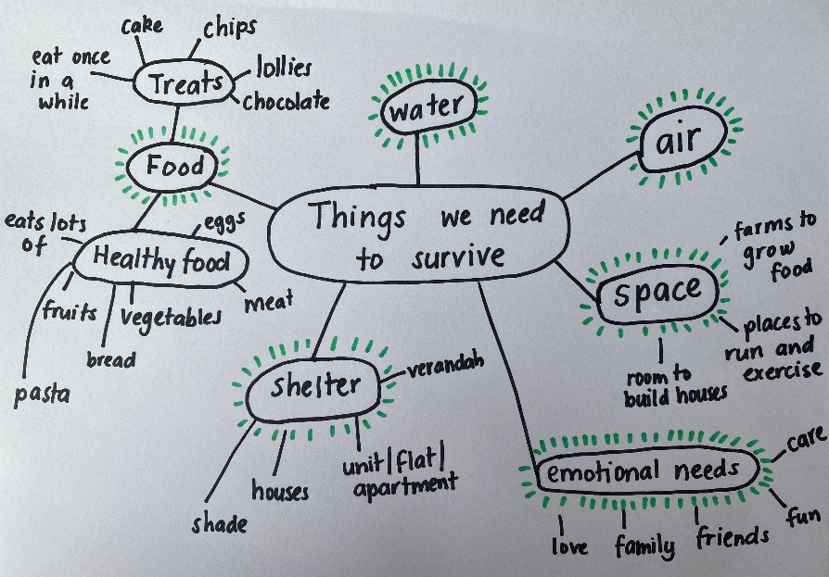
A sample mind map.

Investigate • What do animals/pets need?
Using a demonstration copy of the Animals at home Resource sheet, identify the animals that people typically keep as pets, where these animals live and sleep, and what they eat. Add any animals that students may have as pets that are not represented on the resource sheet. Students might also describe and share information about their pets (or a family member’s or neighbour’s), where they sleep and what they eat.
The following lessons require students to observe an animal closely. Whilst it would be optimum to provide students with the opportunity to observe an animal in real-life, this is not a feasible possibility in many classrooms. Therefore the main activities outlined will involve observing a peregrine falcon via live webcam.
For prompts to support the observation of an animal in real-life, in the form of a class pet, see the embedded professional learning Adapting to your context below.

Peregrine falcon observation
Introduce the peregrine falcons to the class by visiting the FalconCam Project's YouTube channel to observe what the falcons are doing. Explain to students that the video is live and that they are observing what the falcons are doing at that very moment. If the live cameras fail or the falcons are not in the nest, pre-recorded videos are available in the channel’s Videos section.
NOTE: Take care to check the live feed privately before showing it to students. Falcons bring their prey, which are smaller birds, back to the nest to consume or stash for later. It may be confronting for students in Year 1 to see images of this without warning or prior discussion. A discussion about the falcon's diet and opportunity to view related footage is provided in Lesson 6.
Record students' questions about the peregrine falcons in the class science journal—what do they expect to see, learn, hear and find out about whilst observing them?
Highlight the location of Charles Sturt University in Orange, NSW on a map of Australia. Discuss how far away or close it is from the students’ current location. Discuss possible differences in the environment compared to what students are used to.
Observe the peregrine falcon's shelter/nesting box.
Potential discussion prompts
- What is the nest made out of?
- Where is it located? How do you know?
  - Students should be able to infer from their observations that the nest is high up off the ground. If not, point out details that help them to notice this, such as how small and far away the trees appear, particularly when viewing the box camera.
- What size do you think the nest would be?
- How many birds are living in there? Are they all adult birds?
- How many birds do you think could comfortably live in this nest?
  - Providing some information about the size of the birds might be helpful here. Peregrine falcons can range between approximately 35-50cm tall, with a wingspan between approximately 75-110cm.
- What do you think the birds do in the nest?
- Where would they sleep? Lay their eggs?

In order to highlight the need for adequate space, the following role-play simulates what it would feel like if the falcon's nest was overcrowded. Modify the activity as needed for students with sensory or other needs who do not wish to be crowded close to other students.
- Outline a space in the classroom that is 120cm wide and 65cm deep—the size of the falcon's nest (excluding the height dimension). You might do this with masking tape, or by using newspaper stuck together to size.
- Discuss with students that the area outlined is the same size as the falcon's nest. You might also discuss why the height dimension has been excluded—students are much bigger than the birds, and though they can role-play standing in their nest, they would be much too tall to fit if the space was enclosed. You might also relate this to the role-play of plants the previous lesson, remind students that when we model something we sometimes have to change things to make the model work.
- Predict how many students could fit in the space.
- Ask students if they would make the same prediction for themselves as for a group of adults. Discuss why they think that.
- Challenge students to fit as many of themselves standing in the space as possible. Provide opportunities for all students to participate and experience being crowded.
Discuss how it felt to be crowded onto the newspaper.
Potential discussion prompts
- Did you feel comfortable on the newspaper?
- Would you like to stay like that for a long period of time?
- Was there enough room for eating or drinking on the newspaper?
- Does it change your thinking about how many birds could live in the nest?

Ask students to recount times when they have experienced being crowded in a space with a lot of other people. Suggestions could include lining up at school, going to a show or large event, travelling on buses or trams, shopping before Christmas or queuing at a sporting venue etc.
Potential discussion prompts
- How did you feel?
- What could you see when you were crowded?
- Were you comfortable in that space?
- What happened to your body when you were crowded?
  - I couldn’t breathe, I couldn’t see, I couldn’t move, I got hot.

Optional: Organise students to move to a place in the school that has a lot of space (assembly area or playground) and explore the movements they can make in that area, such as jumping, stretching, and running. Then return to the classroom and discuss/compare to the squashed newspaper experience.
Potential discussion prompts
- How did you feel?
- Did this activity make you feel uncomfortable?
- What could you do here that you couldn’t do when you were crowded on the newspaper?
- What do you think would happen to your body if you didn’t have enough space to move in?

Optional: View the location of the peregrine falcons on Google maps. Show students the location of the two nearest other nesting pairs of peregrine falcons—one about 20km away at Ophir, and another about 30km away at Mount Canobolas. Give students a sense of these distances by comparing it to the distance from the school to a familiar local place such as a shopping centre, park or local landmark. Discuss why the birds would live so far away from each other (so that they each have enough space to hunt).
NOTE: This optional discussion might also be relevant at the end of the next lesson about the falcons‘ need for food.

Integrate • My own space and shelter
Invite the students to reflect on their homes or another safe place that provides them with shelter and protection from the weather. Be sensitive to students’ personal experiences.
Using a Venn diagram in the class science journal, compare students’ own home space with the peregrine falcon’s nest by discussing what is similar and different about the two spaces.
Discuss why it is important for animals to have space and shelter for protection.
Potential discussion prompts
- What does the falcon use its shelter for?
- How is our ‘shelter’ the same as the falcon?
- How is it different?
- What if we put our bed outside in winter or in the wet season?
- What if it was too noisy?
- What if there was no roof on our house and it rained?
- What if all the students at school came into our classroom?
Complete the sentence "Animals needs space and shelter because..." This might be done as a whole class in the class science journal, or students may complete the sentence independently in their individual science journals.
Reflect on the lesson
You might:
- add to the class word wall (vocabulary, drawings, images) related to animal needs, Peregrine falcons, space and shelter.
- revisit the FalconCam Project's YouTube channel to observe the peregrine falcon's behaviour, shelter and open space for flying and hunting.

Year 1

Survive and thrive • Lesson 6 • Animal needs—food, water, air
lesson 6
inquire

To read the most recent version of this task, download associated resources, and view embedded professional learning including classroom videos and work samples, visit:
https://primaryconnections.org.au/teaching-sequences/year-1/survive-and-thrive/lesson-6-animal-needs-food-water-air

Lesson overview
Students compare a peregrine falcon's diet to a human's, and why animals move around to find what they need to survive. The investigate what happens to an animal's body as it moves, with a focus on the need for air and water.

Key learning goals
Students will:
- examine and compare the food they eat with the food eaten by a peregrine falcon.
- predict and describe changes that occur to their body during movement/exercise.
- observe and discuss the air and water needs of a peregrine falcon.

Students will represent their understanding as they:
- contribute to a class T-chart to compare the food needs of humans and peregrine falcons.
- contribute to class Y-charts to record observations of how they look, feel and sound before and after exercise.
- contribute to the construction of a class graph about the amount of water consumed by a sample of students.
- discuss findings to reach consensus on animals’ need for food, air and water.

Assessment advice
In this lesson, assessment is formative.
Feedback might focus on:
- students’ recognition of food as a requirement for animal survival. Are students able to recognise that all animals need food? Are students able to describe the different foods needed by different animals/humans?
- students’ recognition of air and water as requirements for animal survival. Are students able to recognise that all animals (including humans) need air and water to survive?

Resources
Whole class
- Class science journal (digital or hard-copy)
- Access to the Charles Sturt University Falcon Cam Project and the FalconCam Project YouTube channel
- Demonstration copy of Predator or prey Resource sheet
- What are Lungs? video (2:35)
- Access to view the location of the peregrine falcons on Google maps
Lesson Routine | Estimated time | Task type
Re-orient | 5 minutes | Whole class
Question | 5 minutes | Whole class
Investigate | 20 minutes | Whole class
Integrate | 15 minutes | Whole class
Investigate | 25 minutes | Whole class
Integrate | 15 minutes | Whole class

Inquire

Re-orient
Recall the previous lesson, focusing on animals’ need for space and shelter. Review students’ ideas about the basic needs of animals using the mind map created in the previous lesson.
Discuss with students what they have done so far this morning to fulfill their needs.

Potential discussion prompts
- When you get up in the morning, what do you do?
- Do you eat breakfast?
- Do you have a drink?
- Do you yawn? Stretch?
- How do these things fulfill your needs?

Question • Eating what and why?
Refer to any questions about food as a need asked by students and recorded at the end of the Launch phase. Ask students to consider these questions in the context of the peregrine falcons from the previous lesson.

Potential discussion prompts
- Do you think we eat the same foods as a peregrine falcon?
- How can we compare the falcon’s food/diet to ours?
- Why do we need to eat food?

Record ideas, and any further questions students have about animal food needs.

Pose the question: What food does a peregrine falcon eat?

Investigate • Who eats what?
Students recount footage they have seen of the Charles Stuart peregrine falcons either eating or bringing food back to the nest.
Ask students what it means to say that these falcons are wild—they live in their natural habitat without human help. They are not fed by people, but have to find their own food.
Introduce the terms 'predator' and 'prey' and ask students for ideas about their meaning. Use the demonstration copy of the Predator or prey Resource sheet to discuss the meaning of these terms.
Using the Predator or prey Resource sheet discuss and label the body features of a peregrine falcon, such as their sharp, powerful claws, hooked beak, and their wings and tail that allow them to fly very fast. Discuss that adult peregrine falcons often live and hunt in pairs. Through this discussion determine that these things all assist the peregrine falcon to hunt, catch and eat their prey. See the embedded professional learning Peregrine falcon's diet for further information.
Consider if watching footage of the Charles Stuart peregrine falcons whilst they are eating is appropriate for your students. You might have a discussion with students before viewing any footage about what they might see, and allow them opportunities to not watch the footage if they find it distressing.
Use either the live video feed (if the falcons happen to be eating), or pre-recorded videos such as Diamond brings and stashes prey, Stashed night prey, or Tug of war if you determine that watching the footage is suitable for your students. Always watch the content of any clips in full before showing them to your students.
Potential discussion prompts
If discussing diet only:
- What features does a peregrine falcon's body have?
- Why do you think they have these features? What do they use them for?
- What do you think a peregrine falcon eats?
- Would they have sharp claws and a sharp beak of they ate plants?
- What do animals with sharp claws, beak, teeth, horns etc. usually eat?

If watching footage of the peregrine falcon's eating:
- When the falcons arrive back to the nest, what do they have with them?
- What part of their body are they using to hold their prey?
- How do they eat it?
- How do you think they catch it?
- What sort of things are they eating? What can you see on the prey that helps you figure out what it might be?
- Do you think the peregrine falcons are predators or prey? Why do you think that?

Begin a T-chart comparing the diet of a peregrine falcon and a human by listing the food a peregrine falcon would eat in the first column. Refer to the embedded professional learning Peregrine falcon diet.
Complete the T-chart by listing the food that humans eat.

Integrate • Eating more, eating less
Discuss the differences in a human and peregrine falcon's diet. Be sensitive to students’ personal experiences when facilitating this discussion. In particular, be aware of student perceptions of eating meat and reasons for vegetarian dietary choices.
Potential discussion prompts
- What is the same about what humans and peregrine falcons eat?
- What is different?
- Do falcons have fingers/knives/forks? How do you know?
- How do falcons eat their meat?
- How do humans eat their meat?

Discuss the signs of hunger in humans, and what students think about how animals know they're hungry.
Potential discussion prompts
- How do you know that you are hungry?
- How do you feel when you eat something?
- Why do you think we get hungry?
  - Our bodies need food for energy, to keep healthy and to grow.
- What other sensations might we have when it comes to food?
  - We might feel not hungry, feel full, or crave a particular food. Sometimes people like certain foods more than others, or dislike specific foods.
- Do you think animals feel hungry, not hungry or full like humans do?
- How do you know?
  - You can see that, at times, when a falcon brings food back to the other in the nest it does not eat it, and the falcon takes it away again. This must mean that sometimes they don't feel 'hungry'.

Record students' ideas in the class science journal.
Compare the food needs of the students with the food needs of the peregrine falcon by reviewing the T-chart.
Potential discussion prompts
- Do you eat more or less food than the peregrine falcon?
- Why do you think you need to eat more or less food than the peregrine falcon?
  - Bigger animals need more energy for movement and more nutrients for their bodies.

Record students’ ideas in the class science journal under the question ‘Why do animals eat?’.

Investigate • The effects of exercise
Discuss how animals need to move around to find food, water and shelter.
Potential discussion prompts
- Why do animals move from one place to another?
  - To find food, water, shelter, mates.
  - Students might give other valid responses. However, focus on these four for the purpose of this lesson.
- Can animals find everything they need to survive if they stay in one place?

Explain that we are going to move around to see what happens to our bodies and what changes we can observe.
As a class, complete a ‘Before Exercise’ Y-chart in the class science journal.
Potential discussion prompts
- Look
  - While you are sitting there now, look at the person next to you, describe how they look…
  - What colour are their cheeks? Can you see any red?
  - Are they sweating? Can you see any droplets of water on their skin?
- Feel
  - How do you feel at the moment?
  - Can you feel anything happening inside your body?
  - Can you feel your heart beating?
  - Is it beating fast or slow?
- Sound
  - Can you hear yourself breathing?
  - Can you hear someone else breathing?
  - How fast are they breathing?

Students predict what changes they will notice once they start running around and playing games. Record their predictions in the class science journal.
Lead the students through some simple games or exercises to get them puffing and sweating.
After the games or exercises, complete an ‘After exercise’ Y-chart to capture the changes that are occurring to their bodies.

Discuss with students how and why their breathing rate and heart increased after physical activity.
Potential discussion prompts
- Did you use lots of energy when you were exercising? How do you know?
  - We feel tired.
- Why do you think you started breathing faster when you exercised?
- What is happening inside your body when you take big breaths?

Watch the video What are Lungs? (2:35).
Ask students if all of the running around made them thirsty, and why they think exercise makes them feel this way.
Take students to have some water and select three students to count how many times they swallow (reminding them that it is not a competition). In the class science journal, create a simple data table and/or graph to illustrate how many mouthfuls of water the selected students swallowed.
Ask students if they felt sweaty during the exercise, what happens when people perspire or sweat, and why our bodies need water.

Potential discussion prompts
- Did you feel sweaty when you were running around?
- What happens when people perspire or sweat?
  - 'Water' comes out of their bodies. Usually you see it on people’s faces, or underneath their arms.
- Where do you think the water comes from?
  - The water is stored in our bodies.
- When do people sweat?
  - When they do physical activity, or when it is hot. Sometimes people sweat when they are sick because their bodies are hotter than normal.
- Why would people sweat?
  - To help their bodies cool down.
- Do children sweat as much as adults? Why not?
  - Students may not know they answer to this. You might explain to them that, whilst children do still sweat, they don't sweat as much/ as effectively as adults because their bodies are still developing. This means that children's bodies don't cool down as easily and they have to be extra careful in the heat. As people get older (and reach puberty) the hormones in their bodies cause changes that means they will sweat more.
- Do you sometimes drink more water when you are hot or exercising? Why do you think that is?
  - Your body needs to sweat to cool down, and water is part of sweat, so your body needs more water if it is sweating more.
- How did you feel after drinking water?
- On our graph, who swallowed the most mouthfuls of water? Who swallowed the least?
- Why do some people drink more than others?
  - Some may have had other recent drinks; some people may have been exercising harder than others; some people sweat more and need more water to replace the water they lose through sweating.
- Is sweat made up of only water?
  - 99% of sweat is water, but it also contains other things that are in your body, like salt and fat.
- What would happen if we didn't have enough water in our bodies?
  - Our bodies would not work properly. Water is important for more than just sweating, and it helps our bodies function. But it is also a main component of sweat, so if we don't have enough water, especially when it's hot, our bodies couldn't cool down and we would overheat and get very sick.

Integrate • Do all animals need air and water?
Observe and discuss the air and water needs of the peregrine falcon.
Potential discussion prompts
- Have we observed the peregrine falcon drinking water?
- Do you think it is drinking water? Why do you think that?
- Do we have any evidence of the falcon drinking?
- Does that mean it isn’t drinking any at all? Why/why not?

View the location of the peregrine falcons on Google maps and point out any nearby water sources in the landscape.
View and discuss the peregrine falcon drinking and bathing (this is not the Charles Sturt peregrine falcons). Through discussion determine that peregrine falcons do indeed need water to survive.
Pose the questions: Does the peregrine falcon have access to fresh air to breathe? and Do you think the peregrine falcon’s breathing also changes after exercise like fast flying, just as it does for humans after physical exercise?
Watch the video showing the Peregrine falcon breathing more rapidly after returning to the nest with a bundle of grass. Ask students to watch the bird's abdomen closely and describe what they are seeing. Compare the movement observed here to footage of the birds in a resting/relaxed state.
Ask students what claim they could make about peregrine falcons and their need for air. Through discussion, determine that peregrine falcons do indeed need air, and that they often breathe more heavily after higher levels of physical exertion. Encourage students to use their observations from the videos as evidence for their claim.
Potential discussion prompts
- Do we have any evidence that the peregrine falcon needs air?
  - It is breathing.
- How do we know the peregrine falcon is breathing?
  - The stomach moves in and out like ours does.
- Do you think the peregrine falcon exercises like we do? How do we know? What evidence do we have?
- Did the exercise affect the peregrine falcon's breathing?
- How is the peregrine falcon's breathing like our breathing?
- Do you think other animals are the same?

Optional: Discuss the air and water needs of other animals, particularly those that don't have the same anatomy as mammals. For example, a fish uses its gills to extract the oxygen it needs from the water it lives in.

Reflect on the lesson
You might:
- revisit the FalconCam Project's YouTube channel to observe behaviours related to food, air and water.
- add relevant words and images to the class word wall of vocabulary related to food, water, air etc.
- discuss how students were thinking and working like scientists during the lesson, focusing on predictions and observations.

Year 1

Survive and thrive • Lesson 7 • Food and fibre (optional lesson)
lesson 7
inquire

To read the most recent version of this task, download associated resources, and view embedded professional learning including classroom videos and work samples, visit:
https://primaryconnections.org.au/teaching-sequences/year-1/survive-and-thrive/lesson-7-food-and-fibre-optional-lesson

Lesson overview

Students explore how humans use food and fibre to stay alive, considering the numerous products that come from sheep and identifying other sources for products that humans use. Students examine the needs of sheep and draw conclusions about the needs of all animals.

Key learning goals
Students will:
- identify things used in their everyday lives that are sourced from food and fibre production.
- recognise products from sheep that help humans stay alive.
- identify the source of essential food and fibre products.
- determine the common needs of animals for survival.

Students will represent their understanding as they:
- contribute to class discussions about the needs of sheep and the products they are used to produce.
- match food and fibre products to their sources.
- list the needs of an animal and answer yes/no questions about its needs.

Assessment advice
In this lesson, assessment is summative.
Students working at the achievement standard should have:
- demonstrated an understanding of the basic needs of animals.
- communicated their understanding verbally to their peers.
- used scientific vocabulary when appropriate.
Refer to the Australian Curriculum content links on the Our design decisions tab for further information.

Resources
Whole class
- Class science journal (digital or hard-copy)
- Image of a sheep (either source your own, or enlarge the one available on the Food and fibre match up Resource sheet)
- An item made of wool (e.g. jumper, gloves, beanie)
- Sam the Lamb - Properties of Wool video (2:54)
- Cards made using Food and fibre match up Resource sheet, laminated for future use
- Sam the Lamb - Needs of Sheep video (3:02)
- Demonstration copy of My Animal Resource sheet
- 2 x A4 sized posters, one showing the word YES and one showing NO
- Demonstration copy of Bird beaks Resource sheet

Each student
- Individual science journal (digital or hard-copy)
- My Animal Resource sheet

Lesson Routine | Estimated time | Task type
Re-orient | 5 minutes | Whole class
Question | 10 minutes | Whole class
Investigate | 20 minutes | Whole class
Integrate | 15 minutes | Whole class
Investigate | 20 minutes | Whole class, Individual
Integrate | 20 minutes | Whole class

Inquire

Re-orient

Use the class science journal to review what students have learnt so far about the needs of animals.

Question • Meeting human needs
Discuss items students use at home and school that have been made from parts of plants and/or animals.
Potential discussion prompts
- What did you eat for breakfast today? What is it made from?
- Other than food, have you used something made from a plant or animal?
  - Pencils, timber desk, clothing such as leather shoes, cotton T-shirt etc.
  - Students' prior knowledge will impact how they answer this question. If required, guide students through the process by identifying specific items and having a discussion about what each one is made of, and where that material comes from.
Go on a scavenger hunt around the classroom, to find things made from plants and animals. Discuss which items are needed to survive (clothing, shelter) compared to things that are nice to have/make our lives a bit better (pencils, baskets, door mats, etc.).
Ask students if they have heard of plants and animals being called ‘food and fibre.’ Discuss what the words mean and add them to the word wall.
Ask students if they have any other questions about ‘food and fibre’ and add them to the ‘our questions’ list.
Pose the question: How do humans use plants and animals to stay alive?

Investigate • Sheep helping people
Show students an image of a sheep and identify the animal.
Students share what they know about products used by humans that are made from parts of a sheep. Record their ideas in the class science journal.
Show the students a woollen item and discuss what it is used for. Encourage students to touch it and describe how it feels.
Watch the video Sam the Lamb - Properties of Wool. Discuss the video and add more student ideas about the ways people use the parts of a sheep to the class science journal.
Potential discussion prompts
- What are some of the ways people use wool that Sam the lamb told us about or that you can see in the video?
  - The video begins by using the terms clothing, textiles, furnishing and insulation. However, it focuses mostly on clothing and blankets.
- What shape is the wool fibre?
- Why does this shape make it useful?
- What are some of the other useful things about wool?
  - It returns to its shape after being stretched, so it doesn't get wrinkled easily, and it stretches with your body as you play.
  - It's soft because it is really fine—finer than a human hair.
  - It reacts to body temperature, helping you stay warm when its cold and cool when it's hot. This also makes it a good choice of material for blankets.
  - It doesn't burn easily, doesn't melt, and won't keep burning.
  - It doesn't stain easily.
  - It can protect your skin from sunburn.
  - It's 100% natural, renewable, biodegradable and recyclable.
Optional: Allow time for students to examine the woollen item with magnifying glasses/microscopes to see if the shape matches what is described in the video. Discuss why it might or might not. Watch Wonderful wool! or Wool Production and Processing to see how wool goes from the sheep, to being used for the product identified in the lesson.
NOTE: The Wonderful Wool! video is aimed at students of this age group. It explains the process in a much simpler way, using age appropriate vocabulary. The Wool Production and Processing video is aimed at an adult audience and uses much more complex vocabulary. However, it shows the process in much more detail, and will allow students to see more clearly how the wool goes from being on the sheep, to becoming the fibres they looked at under the magnifying glass/microscope.

Integrate • Matching products and their sources
Using the cards made from Food and fibre match up Resource sheet, work together as a class to match each product to its source.

Support students to make a claim about how plants and animals help humans to stay alive by completing the sentence:
‘Plants and animals are used by humans for ____________. This helps humans to stay alive (grow and be healthy).’

Record the agreed upon completed sentence (claim) in the class science journal.

Investigate • Comparing the needs of different animals
Revisit the class science journal and discuss the needs of the peregrine falcon that have been studied over the previous lessons.
Pose the question: Do all animals have the same needs?
Watch the video Sam the Lamb - Needs of Sheep and compare the needs of a peregrine falcon to Sam the Lamb.
Potential discussion prompts
- What does Sam the Lamb need to help it to stay alive?
- Which needs of Sam the Lamb are the same as a peregrine falcon?
- Which needs are different?
Using My Animal Resource sheet, model for students how to:
- Select an animal (pet at home, a peregrine falcon, Sam the Lamb, a human).
- Draw what the animal looks like.
- Draw or list the things the animal needs to stay alive.
Allow time for students to complete the activity, ensuring a variety of animals are being represented (as their needs will be compared later in the lesson)

Integrate • Yes or no?
Place Yes and No posters on opposite sides of the classroom.
Ask the following questions one at a time, allowing students (with My Animal Resource sheet in hand) time to move to the Yes or No side of the room after each question.
- Does your animal need food to stay alive?
- Does your animal need music to stay alive?
- Does your animal need water to stay alive?
- Does your animal need clothes to stay alive?
- Does your animal need air to stay alive?
NOTE: These questions highlight needs, wants, and the differences between animals’ needs (for example, humans need clothes to stay alive, but peregrine falcons do not). You may modify or add to these questions as desired, whilst still ensuring they maintain this focus.
After each question students might share the animal they wrote about, and why they think the animal does/does not need the thing in question, with someone standing near them.
Record the most common answer given by students for each question.
Discuss and compare the needs of different animals.
Potential discussion prompts:
- Did all animals need the same things? Why do you think that is so?
- Can you think of something that only your animal needs? What is it?

Ask students what words they can use to complete the sentence (claim): ‘Animals need ____________ to stay alive (grow and be healthy).’ Record the agreed upon sentence (claim) in the class science journal.
Reflect on the lesson
You might:
- add to the class word wall of vocabulary related to food and fibre, and different animal needs.
- encourage students to ask their family which items at home are made of natural fibres (carpets, rugs, baskets, blankets, clothing), which of those items are needed for survival and which ones are ‘nice to have’ but not ‘needed.’

Year 1

Survive and thrive • Lesson 8 • Communicating learning through dioramas
lesson 8
ACT

To read the most recent version of this task, download associated resources, and view embedded professional learning including classroom videos and work samples, visit:
https://primaryconnections.org.au/teaching-sequences/year-1/survive-and-thrive/lesson-8-communicating-learning-through-dioramas

Lesson overview

Students consolidate their learning by identifying the features in various habitats that help plants and animals to survive, then design and make a diorama to share with a selected audience.

Key learning goals
Students will:
- identify that plants and animals live in habitats where their needs are met.
- recognise variation in habitats.

Students will represent their understanding as they:
- design and make a physical or digital diorama of a place where a plant or animal lives and its needs are met.
- complete My Scientific Model Resource sheet.
- communicate what they have learned to an audience with reference to their diorama.

Assessment advice
In the Act phase, assessment is summative.
Students working at the achievement standard should have:
- created a diorama that shows how a specific plant or animal lives in a place where its needs are met.
- represented their understandings about the needs of plants and animals with labels, verbal and/or written explanations.
- communicated their learning with others via their diorama.
Refer to the Australian Curriculum content links on the Our design decisions tab for further information.

List of materials
Whole class
- Demonstration copy of Habitats resource sheet
- Demonstration copy of the Rhinoceros diorama Resource sheet
- Optional: Code for caring and hygiene Resource sheet
- Optional: The Habitats Song video (0:58)
- Optional: Guess What Habitat It Is video (3:17)

Each student
- My scientific diorama Resource sheet

Lesson Routine | Estimated time | Task type
Anchor | 5 minutes | Whole class
Connect | Variable | Whole class
Design | Variable | Whole class, Individual
Communicate | Variable | Whole class, Individual

Act

Anchor • Understanding the science
Briefly revisit the questions that were asked and answered over the course of the unit. Add any further questions that the students pose to the class science journal, to honour their interest and curiosity.
Anchor to the core science concept by discussing with students how all of their investigations in this unit have been about:
- the needs of plants and animals.
- using our senses as scientists to make observations about plants and animals.
- comparing the needs of humans to other animals.

Connect• Favourite plants and animals
Discuss with students how sometimes scientists use their knowledge to make models. Models help scientists to show others what they know, and can also help them to think about something in a different way, and understand it better.
Explain that students will work like scientists to design and/or make a model of a place where a plant or animal lives. Their model should include all of the things that the plant or animal needs to stay alive. Use the class science journal to again recap what specific elements plants and animals need to grow and stay alive.
Using a demonstration copy of the Habitats resource sheet, introduce/revisit the term ‘habitat’. Discuss the four habitats shown and list things students can see in each habitat, and the plants and animals that might live there.
Optional: You might listen to ‘The Habitats Song’ (0:58). At 0:41 there are examples of two physical dioramas made by students.
Optional: Play the guessing game ‘Guess What Habitat It Is’ (3:17) to consider numerous habitats.
Optional: Go ‘habitat hunting’ in the schoolyard to find and observe different habitats, such as bushland, ponds, fish tanks, orchards etc. Habitats could be photographed for display back in the classroom. You might also refer to the Code for caring and hygiene Resource sheet.
SAFETY NOTE: Refer to the Lungworm risk mitigation information found in the Preparing for this sequence tab on the Sequence overview page.
Using the demonstration copy of the Rhinoceros diorama Resource sheet, display and discuss an image of a habitat model at a museum. Students can use this sheet a model for reference during this task.
Potential discussion prompts
- What can we see in the display that helps to keep the rhinoceros alive?
  - Grasses to eat, trees to eat and for shade, soil for these plants to grow in
- What else does a rhinoceros need to survive that we can’t see in this display?
  - Water, air (isn't labelled, but it is all around the model)
- Why has the museum added a small sign to the display? How does it help us?
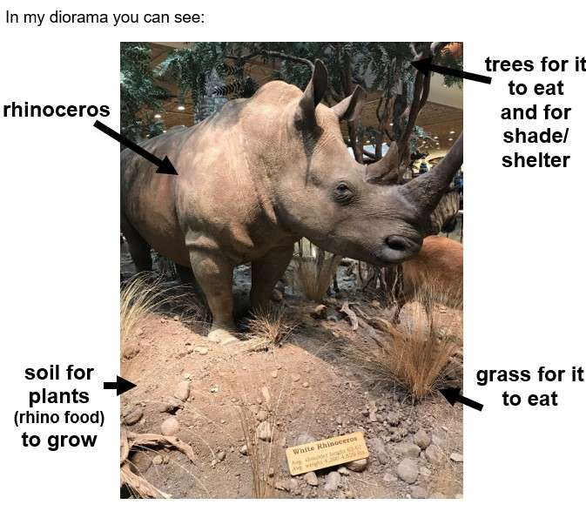
Rhino diorama work sample

Design • Design and make a diorama
Using the steps of the design thinking process, students use their understanding of the needs of plants and animals to design a diorama (physical or digital). You might present students with a design brief to outline what you would like them to do.
Consider if you will add some parameters around the design (for example, it needs to contain examples of at least three things the plant/animal needs, or it needs to fit on a standard classroom table etc.). Also consider if the diorama should adhere to a specific theme related to your school or community context and who the audience for the dioramas will be.

Define
Outline the problem in a simple manner such as:
How can we … (use the available materials) ... to ... (make a diorama that shows the habitat where the plant/animal lives where its needs are met) …for… (gallery walk/foyer display/community exhibition)?

Ideate
As a class, brainstorm ideas related to the plant/animal diorama relating to:
- how it might be constructed.
- the resources required.
- the details it might include.
At this stage, to support creative thinking, every idea offered by students should be recorded in the class science journal. No idea is discounted, as the practicality/possibility of each idea will be considered later.
As students offer ideas, ask probing questions (why do you think…? or how do you know that…?) to draw out the reasoning and evidence behind the idea.
Potential discussion prompts
- What materials could we use?
- What materials could represent other things?
  - For example, blue paper to represent water and small twigs to represent trees.
- Why do you think that material is a good choice?
- How might we show something new or interesting that we have learned?
- Why do you think labels are important on a diorama?

Once all ideas are listed, discuss which ones might be easy to include in a design and which ones might not be.
Introduce the criteria that could be used to make a good design (potential summative assessment). Invite students to add to these criteria if appropriate.
Potential discussion prompts
- Does it matter how tall or wide the diorama is?
- Does it need to be colourful?
- Will it need to be moved? How will this affect your design?

Prototype
Assign, or allow students to choose, the plant or animal students will design a habitat for, according to any parameters determined at the beginning of the sequence (see Diorama decisions for the Act phase in the Preparing for this sequence tab of the Sequence overview).
Students draw a design of their model, with labels stating the materials to be used.
Optional: Students construct their plant/animal habitat model using the materials/resources available.
Students complete the explanatory sheet My Scientific Diorama Resource sheet to go with their diorama. They might attach their design, or include a drawing or photo of their built diorama and labels to explain its features.

Communicate • Diorama sharing

Test and share
Students share their dioramas with an appropriate audience. You might do this by organising a gallery walk within the classroom for other classes or buddies, creating a display in a communal space such as a library/hallway or involve the broader community during an open day, special person’s day or local show.
Optional:
- Students record a short video about their model to communicate with their audience.
- Photograph the student with their model and explanatory sheet for assessment, display, student and parent feedback etc.

Reflect on the sequence
You might:
- refer to the list of student questions asked in Lesson 1. Determine which questions have been answered over the course of the learning sequence, what the ‘answers’ to those questions are, and the evidence that supports these claims. Address questions that were not answered during the learning sequence, discuss why they might not have been addressed and potential investigations that might support students to answer them.
- review what students have learned about the needs of plants and animals and how these needs compare to human needs.
- review what students have learnt about using their senses to make observations about plant and animal needs.
- review the word wall to consolidate the topic-specific vocabulary used throughout the sequence.
- ask students to represent this learning in words, symbols and pictures.

