Code for caring and hygiene

**Year 1**

Code for caring

1. Look, film, photograph, but don’t touch the animals.
2. If you move something while looking, like leaves, rocks or dirt, put them back.

1. If you see an animal that might bite or sting you, stay calm, move away immediately and tell the teacher.

# Code for hygiene

1. Wash your hands with soap and water after touching leaves, rocks, and dirt.
2. 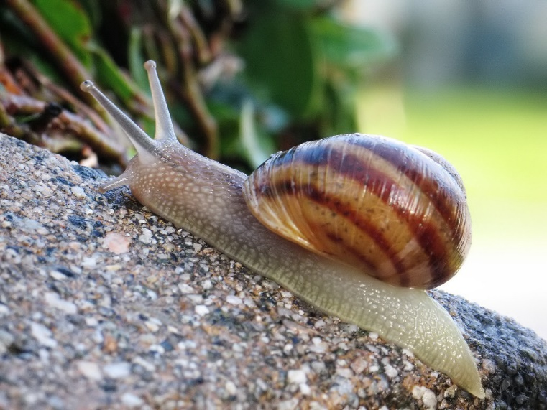Take extra care if you have touched snails, slugs or their slime. Don’t touch your mouth afterwards and wash your hands with soap and water.